A project write-up · November 2026

Can a company's own filing tell you what its stock will do next?
What I built, what I found, and what went wrong on the way. A study of 150 S&P 500 stocks, 2000 to 2026, using 64,213 SEC filings.
Krishna Harsha Tangirala
Code and data | https://github.com/harshatangirala/sec-filings-price-impact
Interactive dashboard | https://sec-filings-study.streamlit.app/ (free apps go to sleep; if you see a "wake this app up" button, press it and wait a minute)
Models used | ChronoBERT, BGE-base, BGE reranker, Qwen2.5-7B (all on Hugging Face)

The short version
Public companies in the US have to file reports with the SEC: yearly ones (10-K), quarterly ones (10-Q), and short "something just happened" ones (8-K) for anything that just happened, like earnings, a merger or a CEO walking out. I wanted to know whether you could read one the moment it lands and say anything useful about how the stock will react. Underneath that sat a second question. Once you already know the numbers, do the words in a filing add anything?
The reaction is partly predictable, but only its size. On the final test period the best model without language models scored a macro-F1 of 0.384 (the one with them scored 0.383), against about 0.33 for pure luck. It can tell which filings will move a stock (AUC 0.63) and is a coin flip on which way (AUC 0.49). The text didn't help. Adding language models changed the score by -0.001, with an interval centred on zero, and a later check with no text at all did about as well. One result looked surprising and turned out to be my own mistake: an apparent fall in stocks after very good earnings came from how I measured abnormal returns, and it goes away when that is fixed.
Most of this report is about how I got there, because that's where most of the work went. Several bugs along the way would have flattered the results. I've left them in.

1. The idea, and the one rule I kept to
The obvious way to do this badly: take every filing, look up what the stock did around it, fit a model, enjoy the lovely score. The catch is that you've quietly used information nobody had at the time. A filing that came out at 4:30 in the afternoon can't use that day's closing price as an input, and you can't trade at that close either. So I kept to one rule: act like a trader sitting at the screen the moment the filing becomes public. Every input has to be something that trader could have known, and whatever I predict has to be something they could actually have captured.
I split the work into three tracks and tried not to mix them. Track A is an event study of how prices move around filings. It describes the data and predicts nothing. Track B is the prediction problem. Track C asks whether the facts a language model pulls out of a filing match what a human would pull out, and it is judged on the text, never on prices. Track C turned out to need hand-labelled examples that I haven't made, so only half of it exists.
The questions, in order:
1. Can we predict the next reaction at all?
2. Does the text add anything beyond numbers that are already public (price history, company size, accounting)?
3. Does the well-known post-earnings drift show up in this data?
4. Could any of it make money?
I wrote these down before looking at the final test, along with the metric and the pass or fail rules. That's called pre-registering. It's dull, but it stops you quietly changing the question once you've seen the answer.
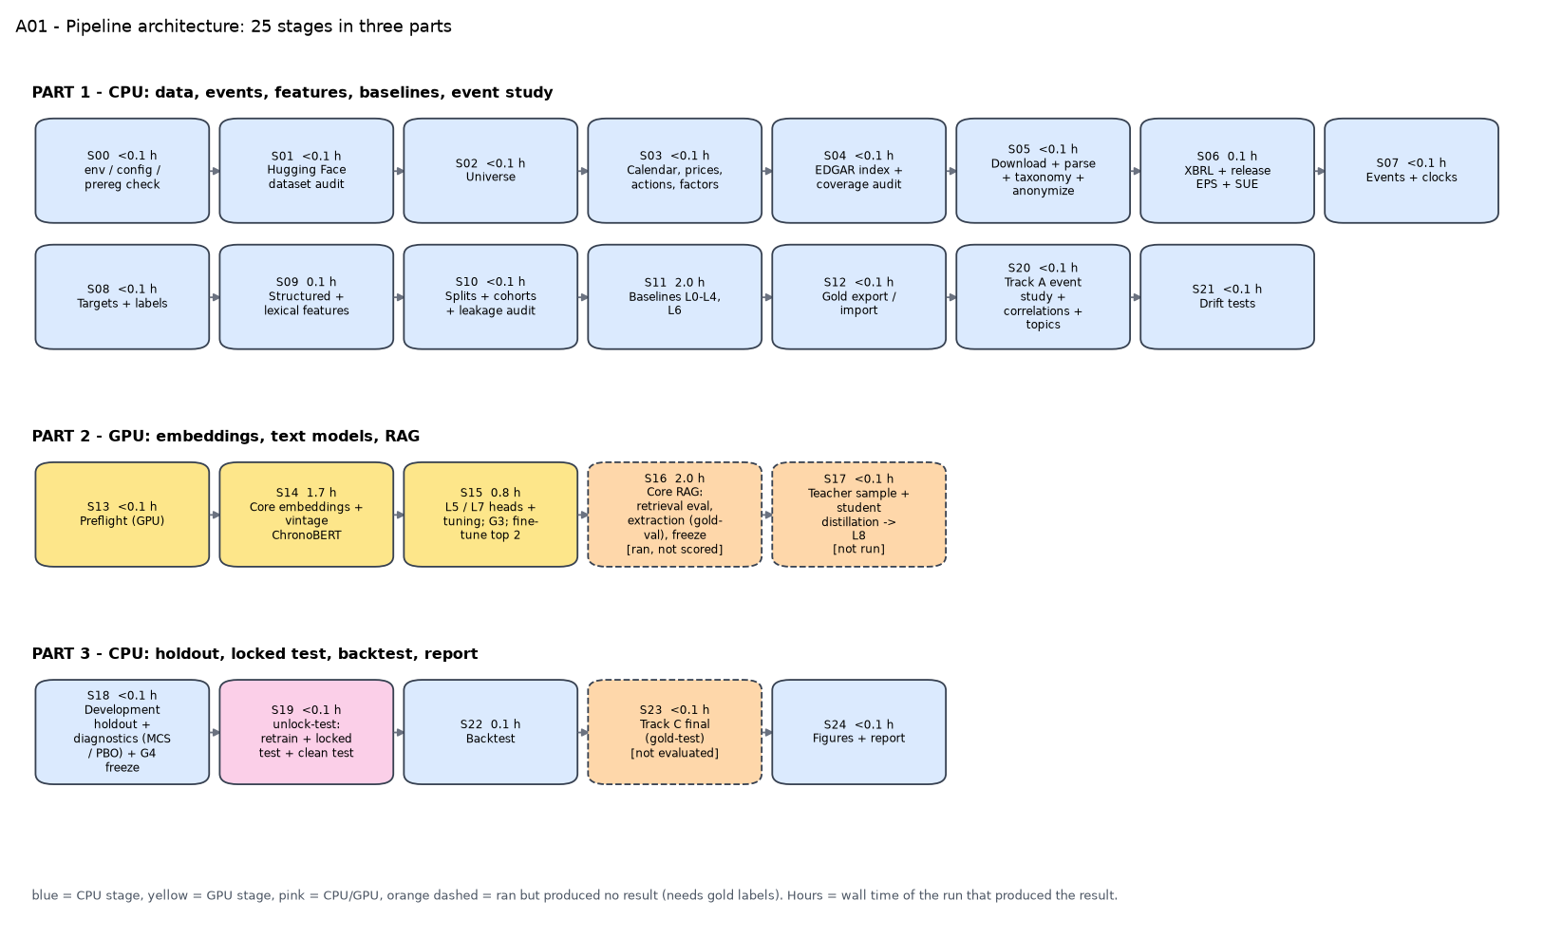
Figure 1. The whole pipeline: 25 stages in three parts. Part 1 ran on my laptop, Part 2 on a Colab GPU, and Part 3 back on CPU. The two orange boxes ran but couldn't produce a result because they need human-labelled data I don't have.

2. The data
Everything comes from free, public sources, and I pinned the version of each so someone else can rerun it.
source | what I used it for | how much | access
SEC EDGAR | all 10-K, 10-Q and 8-K filings for the 150 firms, plus exhibits | 64,213 filings | public, free
EDGAR XBRL | balance-sheet and income numbers, as first reported | 304,348 facts | public, free
Earnings press releases | the EPS figure in each release, to build an earnings surprise | 14,981 results releases | parsed from EDGAR exhibits
Daily prices | returns, volatility, the benchmark, the backtest | 1,024,405 daily bars | my own price files, filled in with Yahoo Finance
Fama-French factors | to measure what is 'abnormal', and for the alpha test | daily factors | Kenneth French's data library
S&P 500 membership list | to choose the firms | history since 1996 | a public GitHub list, pinned to one commit
Loughran-McDonald dictionary | counts of positive and negative finance words | 1993–2025 edition | free for academic use
Hugging Face SEC corpus | only to pick firms and to check my parser (never as study text) | 10-Ks up to 2020 | JanosAudran/financial-reports-sec

I picked 150 companies that were members of the S&P 500 at some point since 2000, using a fixed random seed and spreading them across 12 industries. They came from 743 firms that had prices in my files and at least one 10-K in the Hugging Face corpus. That gave 60,261 events: 45,193 8-Ks, 11,271 10-Qs and 3,797 10-Ks. If a firm filed several 8-Ks on the same day I merged them into one event. Events run from January 2000 to July 2026.
I started out planning 500 stocks, 353 from the S&P 500 and 147 that were not. The first half of that run finished. Then, while checking it, I found a bug in how I looked up accounting numbers (more on that later). Rather than re-run everything at the larger size, I dropped to the 150-stock version, which I could finish properly. So the final study is 150 S&P stocks only, and I don't compare S&P with non-S&P firms.
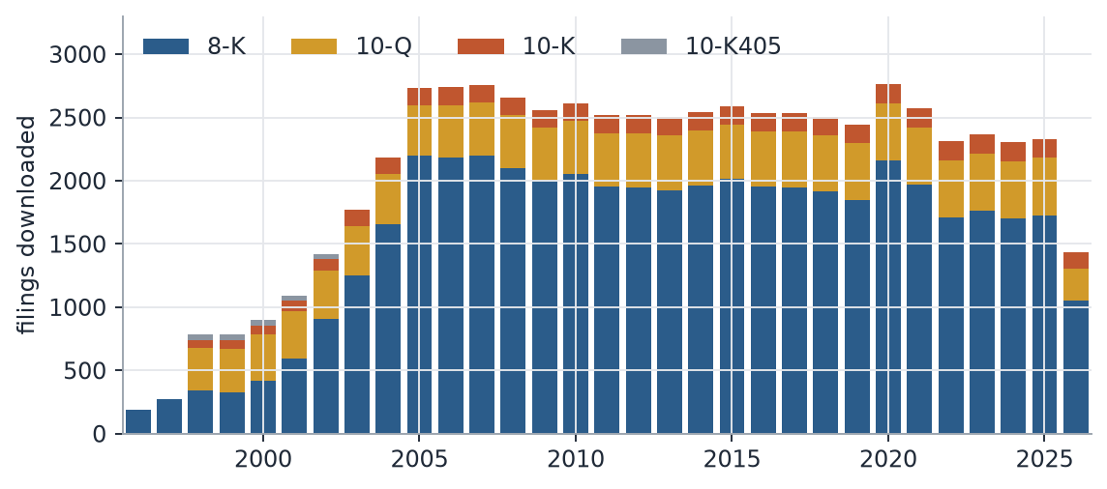
Figure 2. Filings downloaded per year. Quarterly and yearly reports take off in the early 2000s, and most of the volume is 8-Ks.
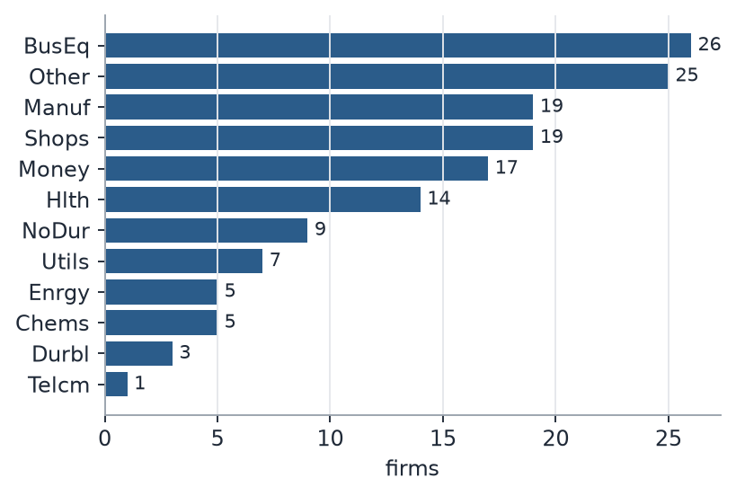
Figure 3. The 150 firms by Fama-French industry. "BusEq" is business equipment (software, chips, hardware) and "Other" is a grab bag.
All 150 firms still exist today. Companies that were delisted, bought, or went bust are not in the sample. That's survivorship bias, and it matters most for the earnings-drift result later. Of the 1,094 tickers that were ever in the index during these years, I had usable data for about a third (353), and this study uses 150 of those. Free price data was the limit, and I couldn't get around it.

3. Turning filings into text a model can read
The raw filings are messy HTML, sometimes ancient SGML, full of tables and page numbers. Getting from there to clean text took a big chunk of the project.
I downloaded 64,213 filings from EDGAR at a polite few requests a second, with my contact details in the header, as the SEC asks. 63,933 parsed cleanly, and 280 had none of the sections I wanted. I turned the HTML into plain text and flattened the tables into rows, because the earnings numbers I wanted live in tables. That came to 2,550,579 tables.
A 10-K is mostly boilerplate, so I kept only the parts that carry news: the business description, risk factors, MD&A and market-risk sections from 10-Ks; MD&A, market-risk and risk-factor sections from 10-Qs; and the item text plus the press-release exhibit from 8-Ks. Finding those sections is harder than it sounds, because the table of contents repeats every heading. I took the candidate start with the longest span before the next heading. That left 121,398 sections.
Next I replaced each firm's own names, former names and ticker with a placeholder: 881,908 name mentions and 249,224 ticker mentions in all. Without that, a model can quietly learn "this is Apple" instead of "this text sounds bad", which is a form of leakage.
Last, I dropped number-heavy lines, capped section length, and cut each section into 350-word windows that overlap by 50 words. That gave about 900,694 chunks, roughly 474 million tokens, and the same chunks went to every model.
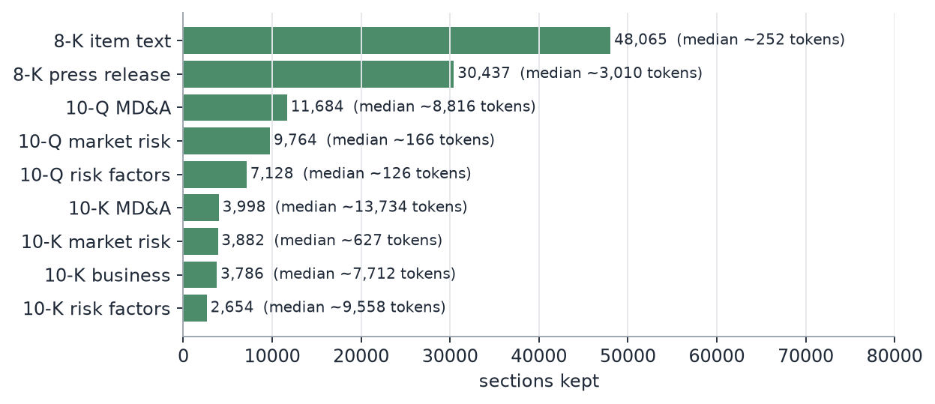
Figure 4. How many sections of each type I kept, and how long a typical one is. 10-K sections are long (thousands of tokens), 8-K item text is short.
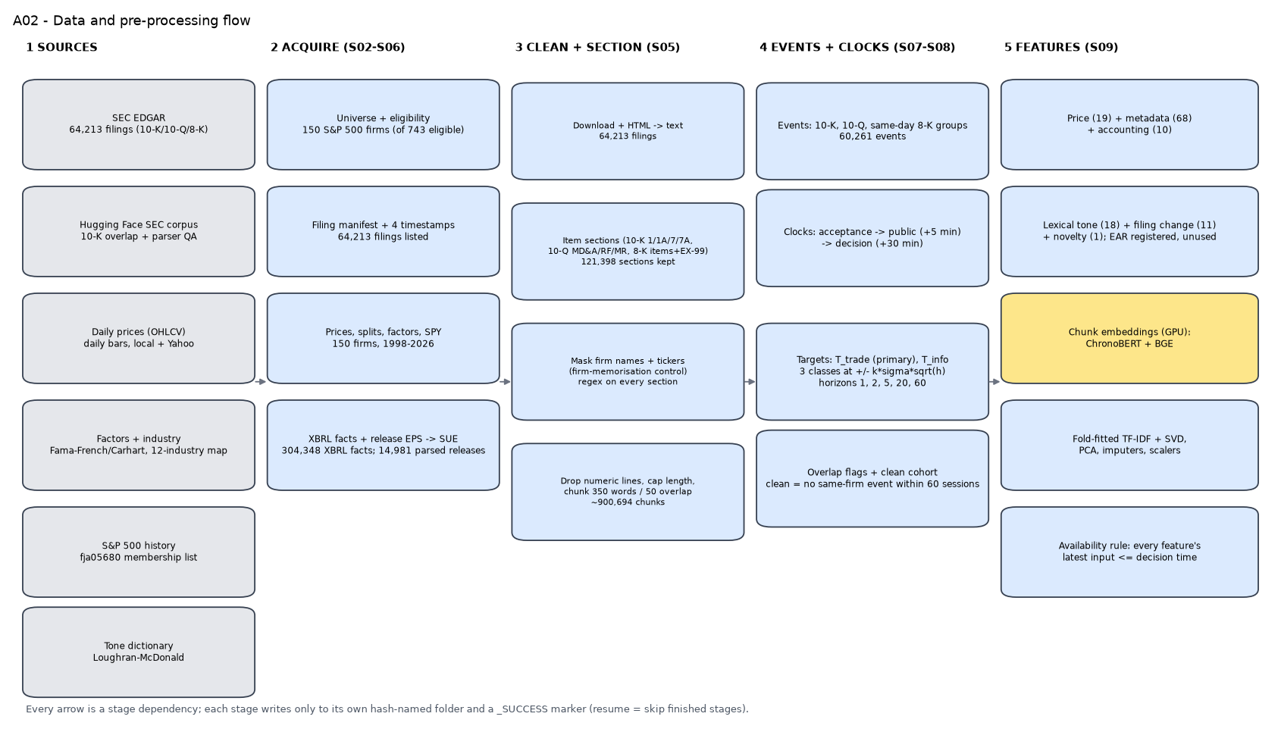
Figure 5. From sources to features. The blue boxes ran on my laptop, the yellow one needed the GPU.
I also built some old-fashioned word features, because I wanted a fair baseline for the fancy models to beat. These are counts of positive and negative finance words (Loughran-McDonald), how much a filing's language changed since the same firm's previous one, and how much of it was new. None of these learn a vocabulary from the future. The change features use a fixed hashing trick, and where I did fit something like TF-IDF, I refitted it inside each training fold only.

4. What counts as "the stock reacted"
Every event carries four timestamps: when the SEC accepted the filing, when I assume it was public (five minutes later), when a trader could decide (thirty minutes after that), and the next time the market opens. Exact acceptance times come from the filing header for 96% of events. The SEC's own JSON feed turned out to follow two different time conventions mixed together, which I only noticed because I checked it against the headers on a sample. The five and thirty minute gaps are assumptions, and I say so wherever the results appear.
The thing I predict is the stock's abnormal return in the first tradable session: the stock's return from the open to the close, minus what its market sensitivity says it should have done given what the S&P 500 did over exactly the same hours. I turn that into three classes. A move bigger than half the stock's own typical daily swing is Up or Down, and anything smaller is Sideways. Using each stock's own volatility keeps quiet utilities and wild tech names comparable. The result is roughly 29% Down, 41% Sideways and 30% Up.
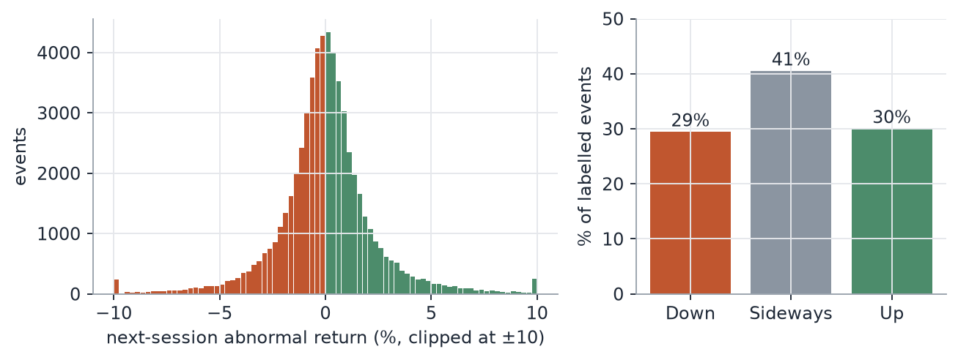
Figure 6. Left: abnormal returns on the next session cluster tightly around zero, with fat tails. Right: how the three classes come out.
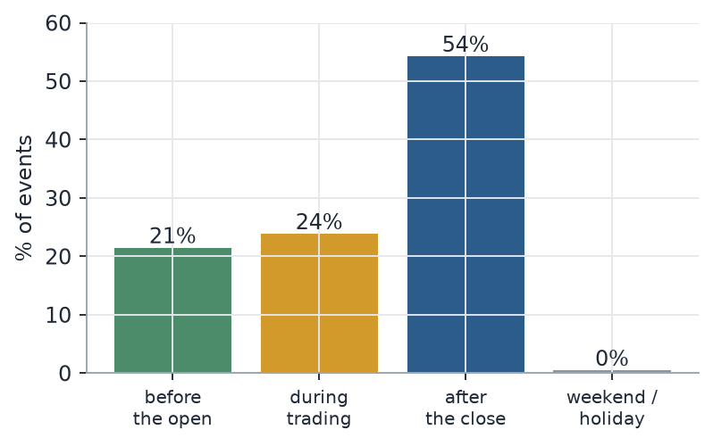
Figure 7. More than half of filings land after the market closes. That is why the trade happens at the next open rather than at the filing time.

5. The features, and the leaks I went looking for
Each event gets 128 features in seven groups: 19 about price and market state, 68 metadata (what type of event, which 8-K categories, which sections exist, the industry, the calendar, the time of day), 10 accounting numbers including an earnings-surprise score, 18 word-tone counts, 11 change-since-last-filing measures, and one novelty score. Each feature carries the latest time of any information it used, and a check runs on every single row that this time is no later than the decision time. The count of violations was 0.
For the earnings surprise (SUE) I don't have analyst forecasts, so I defined "surprise" as this quarter's earnings per share minus the same quarter last year, divided by how variable that gap has been in the past. It is a crude version of the real thing, and I'll come back to why that matters.
Then I tried to catch myself cheating. I wrote a list of 24 leakage checks, each with an assertion in the code, and planted four deliberate leaks (a feature built from future returns, an earnings reaction used for its own event, a surprise taken from a later filing, and a future document slipped into retrieval) to see whether the audit would notice. All four were caught. More usefully, the checks caught three real problems of my own while I was building.
The first was same-day 8-Ks. When several arrived on one day, I had clocked the merged event at the first filing, so text and numbers from later filings leaked in. An assertion failed and I moved the clock to the last acceptance. The second was a 10-Q hiding in an earnings surprise: a quarterly report filed minutes after the earnings release was feeding that release's own surprise history, and another assertion caught it. The third was the worst, and it needs its own paragraph.
A filing reports this year's balance sheet and last year's at the same moment. My lookup for "the latest total assets known at decision time" sorted by publication time only, so it picked between the two more or less by accident. It didn't look into the future, so no alarm went off. But I found it by comparing the 150-stock run with the earlier 500-stock run on the same firms: events and returns matched exactly while six accounting features did not, in a third to a half of rows. Checked against the raw data, the old code returned last year's figure in 52% of a random sample of events. After the fix it was wrong in 0 of 1,500. This is what made me discard the earlier 500-stock results.

6. How I tested it
A random split would be wrong here, because market conditions in 2015 tell you about 2014 and 2016. So I only ever train on the past. The pipeline trains on everything up to 2008 and tests on 2008-2009, then trains up to 2010 and tests on 2010-2011, and so on for six two-year folds ending in 2019. The 2020 to 2022 period is a separate development set that I used to choose the final model. The 2023 to July 2026 period is the locked test. I scored it once, after the final model was frozen and its settings were hashed. Events whose outcome window crossed a boundary are dropped, and there is a 90-day gap between blocks.
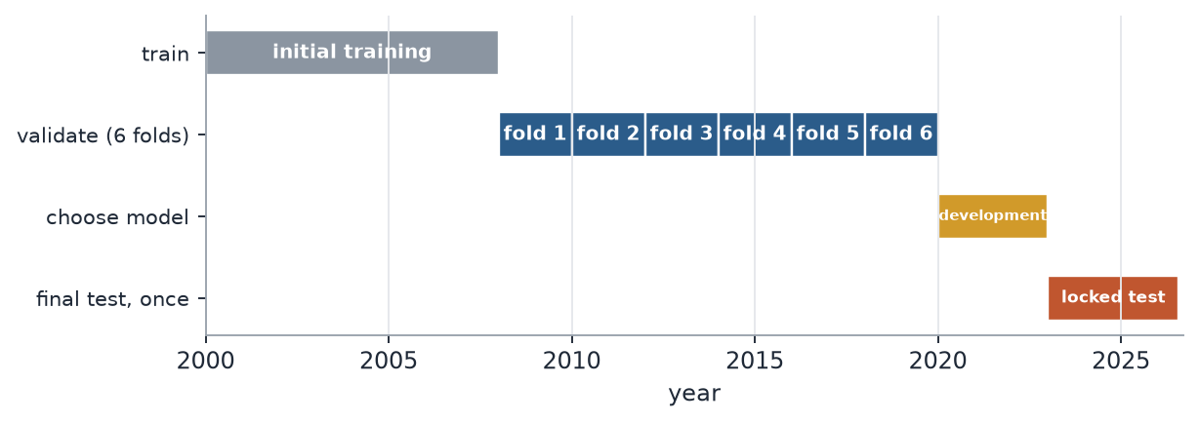
Figure 8. How the 26 years were used. The first folds start in 2008 because the model needs at least eight years of history to learn from.
My main number is macro-F1: the average of how well the model does on Down, Sideways and Up, weighting the three equally. It stops a model scoring well just by predicting the biggest class. I also report accuracy, AUC (how well the probabilities rank events), log-loss and calibration error (do the stated probabilities match reality), and every interval comes from resampling whole months, since events in the same month share market shocks.
To read a score of 0.38 you need the right comparison, and it is easy to get this wrong. An earlier version of my report compared scores to a "majority class" baseline of 0.19, which makes everything look great. But a model with balanced predictions gets about 0.33 by luck on three roughly equal classes. I measured that directly by shuffling a model's own predictions against the true labels (0.33), so that is the line to read scores against.
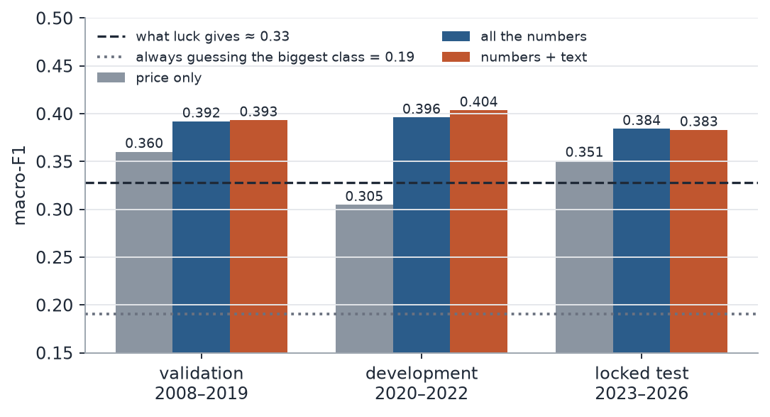
Figure 9. Macro-F1 for three models in three periods. The dashed line is what luck gives you.

7. The models: what I trained, what I borrowed
There are two quite different kinds of models in this project, and I don't want to blur them. The ones that make the predictions are small, classical models that I trained on my own data. The big neural models are borrowed and frozen: I use them only to turn text into numbers or to answer questions, and I never changed their weights.
model | status | size (approximate) | why I picked it | where to find it
LightGBM | trained here | tree ensemble; the all-numbers model used about 25 leaves per tree | fast on tables with lots of mixed features | —
CatBoost | trained here | tree ensemble | a second, different tree method as a cross-check | —
Elastic net | trained here | about 400 weights | simple and convex, so it can't hide overfitting | —
ChronoBERT (26 yearly versions) | borrowed, frozen | about 150 million each | each version only saw text up to its own year | Hugging Face
BGE-base-en-v1.5 | borrowed, frozen | about 110 million | strong general text encoder; also does the passage search | Hugging Face
BGE reranker-base | borrowed, frozen | about 280 million | puts the best retrieved passages first | Hugging Face
Qwen2.5-7B-Instruct | borrowed, frozen | about 7.6 billion | open model I can run myself, no paid API | Hugging Face
SEC-BERT | planned, dropped | about 110 million | trained on 10-Ks; left out to save GPU time | Hugging Face
FinBERT-tone | planned, dropped | about 110 million | finance tone classifier; left out to save GPU time | Hugging Face

For the trained models I used LightGBM, CatBoost and an elastic-net logistic regression. They are the standard tools for tables of mixed features, and they're quick to tune. Three different ones works as a cross-check too: if they all agree, the result isn't an accident of one library. The elastic net is a conservative baseline, and its optimisation problem is convex, so I could check that it found the global optimum, which you can't say for trees. It ended up the best model on the all-numbers rung.
I tuned settings with Optuna on the three most recent validation folds, then refit on every fold. The class weights balance the three classes and also down-weight events that overlap in time. Predicted probabilities are corrected back to the real class frequencies, and the final class is whichever has the highest probability relative to its frequency.
On tuning: I expected it to matter more than it did. Across 32 combinations of rung and model, the median change in the validation score from tuning was +0.000, and only 44% improved at all. The few big improvements were the elastic net, whose default settings were bad. The search budgets were also tiny (6 to 15 trials), smaller than the ten random starts Optuna uses by default, so several rungs ended up with identical settings. I would not call any of these models "fully tuned".
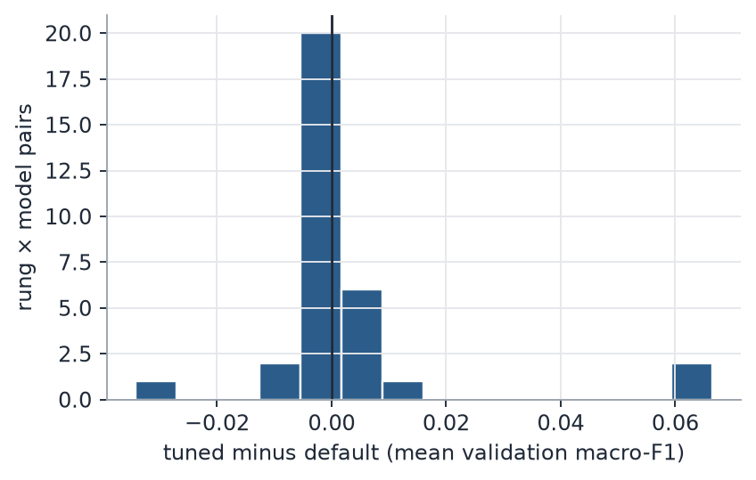
Figure 10. Almost nothing changed when I tuned. A few elastic-net models improved a lot, which is the right-hand bump.
The experiment is built as a ladder, always on identical events. L1 to L5 each use one kind of information on its own, despite the plus signs in the diagram. L6 combines everything except the language models, including word counts and TF-IDF, and L7 adds the language models.
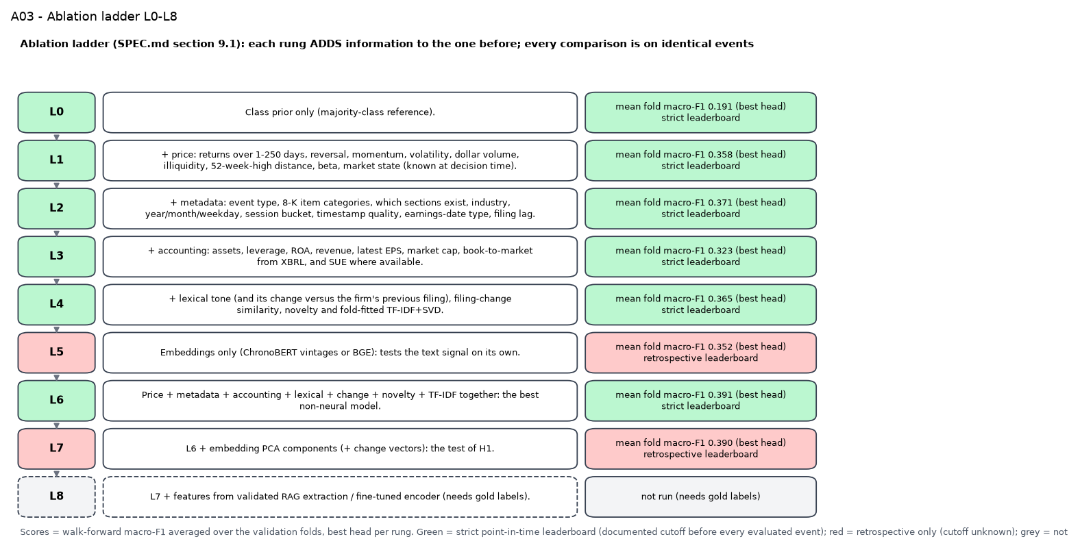
Figure 11. The ablation ladder. Green rungs only use information that was clearly available at the time, red ones use a model whose training cutoff is unknown.
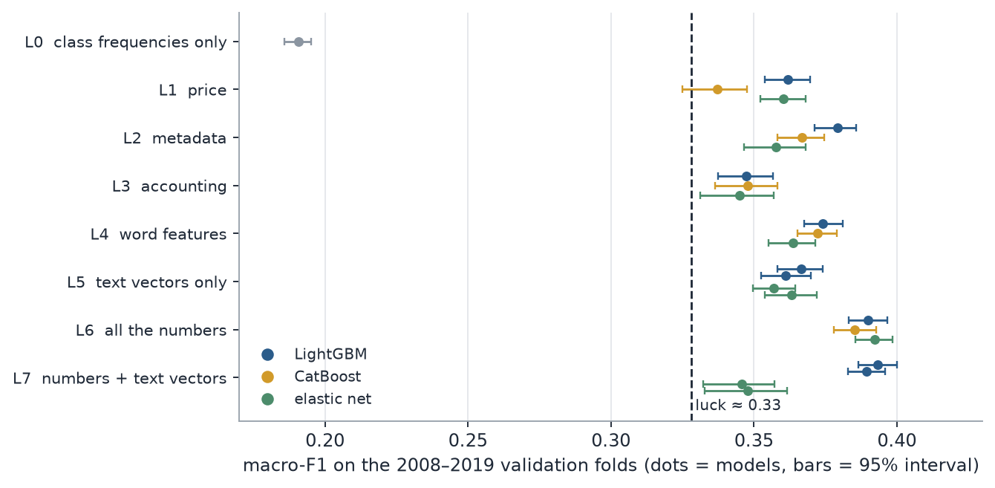
Figure 12. Validation results for every rung and model. Metadata (L2) is the strongest single group. Accounting alone (L3) is the weakest, and putting everything together (L6) is best.
Two results surprised me. Text vectors on their own (L5) come close to the word features, a little below them, so the language models do contain some real signal. And the elastic net got much worse when I added the text vectors to everything else (0.39 down to 0.35 on the pooled score). With hindsight that is not shocking: a regularised linear model drowning in hundreds of correlated extra columns is going to struggle. More features is not more information.

8. The pre-trained models, and where the embeddings come from
A common question is where the embeddings were downloaded from. They weren't. I downloaded the models from Hugging Face, at fixed versions, and ran my own filing text through them on a Colab GPU. The embeddings exist only for my 60,030 filing events and never saw a price.
ChronoBERT is the encoder I trust most for a study like this. It comes as 26 yearly versions, and each was trained only on text written up to its date. For an event in year Y I use the version trained to the end of year Y-1, so the encoder cannot know anything from after the filing. If a model has read the future, it can look clever for the wrong reason, and this removes that worry. BGE-base is a strong general-purpose encoder with no stated cutoff, so it only counts on the less strict leaderboard. It also drives the passage search I describe later.
Each of the 900,000 chunks becomes 768 numbers. I averaged and took the maximum over a section's chunks, then combined sections into one vector of 1,536 numbers per event, and also stored how far the vector moved compared with the same firm's previous filing of the same type. Before using them I shrank the vectors with PCA, fitted inside each training fold. Embedding took 56 minutes with ChronoBERT and 39 minutes with BGE on the Colab GPU.
Two other encoders, SEC-BERT and FinBERT, were in my original plan. I dropped them to fit the GPU budget. That was a time decision, not a result: I have no evidence they would have done worse, and a domain model like SEC-BERT might have done better.

9. Fine-tuning: what I planned and why I didn't do it
I had a fine-tuning stage in the plan: take the two best encoders and train them end to end on my labels, with a grid over learning rate, batch size and weight decay. I made it conditional, because fine-tuning is expensive and multiplies the number of configurations you try, which is how people fool themselves. So the rule was: fine-tune only if adding text to the numbers improves the score by at least 0.01, with an interval that excludes zero.
It didn't come close. Across the validation folds the change was −0.001 with an interval from −0.007 to +0.005, and on the development and locked periods the estimates were +0.007 and −0.001, neither with an interval that excluded zero. So the gate stayed closed and no encoder was fine-tuned. The right description of the language side of this project is "frozen embeddings, plus a retrieval and extraction pipeline", not "fine-tuned models". If you do want to see what fine-tuning would have looked like, the code is in the repository and runs on a smoke test, but it has never run on the real data.

10. The RAG experiment, and why its results are not in the results
The other use of a language model was to pull specific events out of a filing: did the company give guidance, record an impairment, announce a restructuring, a buyback, a dividend, a merger, a lawsuit, a change of management. Embeddings blur all of that into one vector, and I wanted facts I could check.
The pipeline works like this. A filing's text is cut into chunks, and I search them two ways at once, by keywords and by embedding similarity, then merge the two rankings and let a reranking model sort the top thirty. The best eight passages go to Qwen2.5-7B, which answers twelve questions in a fixed JSON format with a quote and a chunk id for every answer. Then a set of guards checks the answer. Every quote has to appear word-for-word in the chunk it cites, any number has to appear in its evidence, and anything that fails is blanked out.
It ran on 149 filings from the development period, at about 47 seconds each, two hours in total. That is as far as it got. To say whether it is any good I need human-labelled examples to compare against, and I haven't made them. The templates are pre-filled and ready, but I haven't annotated them. So I can't report accuracy for the extraction, I couldn't test whether the extracted events improve the predictions, and I could not train the smaller student model I'd planned. The chart below only shows how often the model said each event was present. It shows what the system produces and is no evidence that the system works.
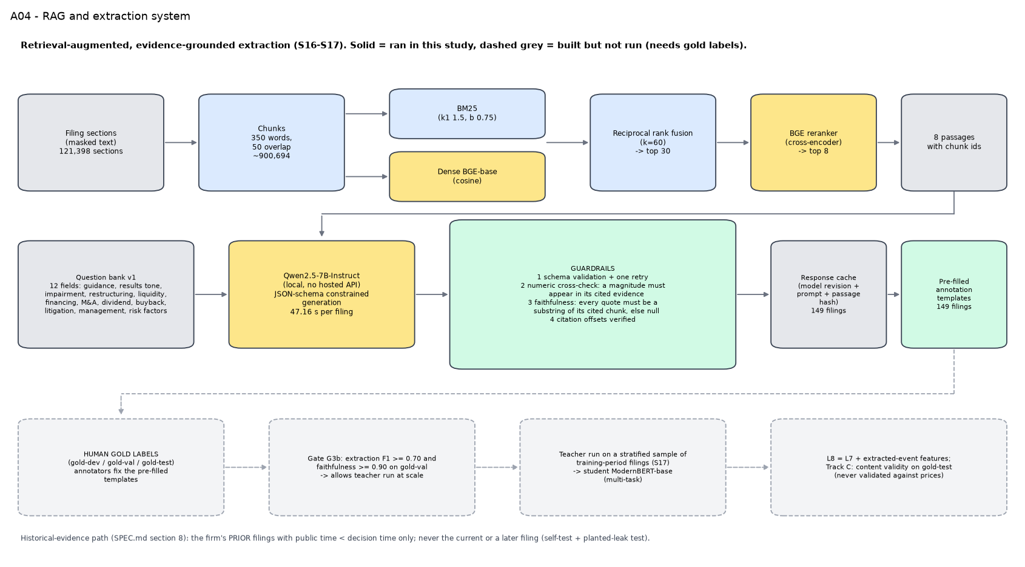
Figure 13. The retrieval and extraction system. Solid boxes ran. Dashed grey boxes are built but waiting on human labels.
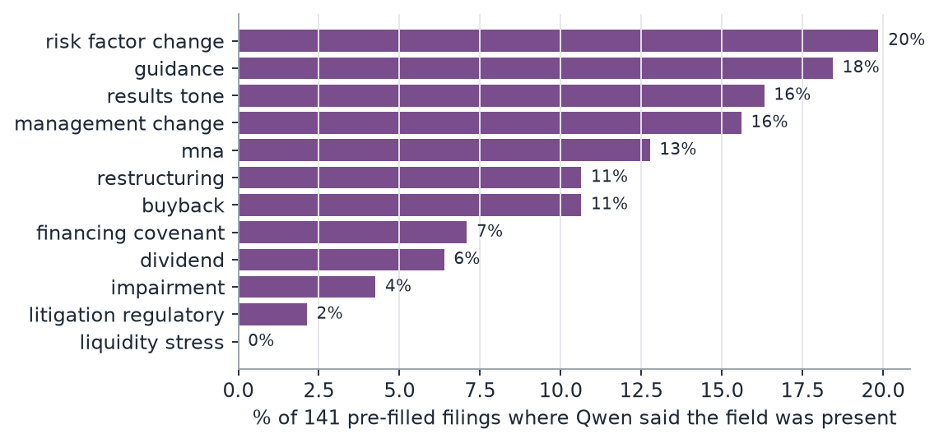
Figure 14. How often Qwen said each field was present in 141 filings that returned a valid answer (8 returned nothing usable). Unchecked output.

11. Results
"All the numbers" is the best model without language models (it does include word counts and TF-IDF), and "numbers + text" adds the embeddings. The development and locked periods are the ones where the model never saw the data it was scored on.
model | period | events | accuracy | macro-F1 (95% interval) | AUC | log-loss | calibration error
price only | validation 2008–19 | 28,533 | 0.366 | 0.360 [0.352, 0.368] | 0.549 | 1.083 | 0.018
all the numbers | validation 2008–19 | 28,533 | 0.416 | 0.392 [0.385, 0.398] | 0.591 | 1.069 | 0.005
numbers + text | validation 2008–19 | 28,533 | 0.413 | 0.393 [0.387, 0.400] | 0.587 | 1.067 | 0.008
price only | development 2020–22 | 7,453 | 0.359 | 0.305 [0.286, 0.322] | 0.572 | 1.078 | 0.024
all the numbers | development 2020–22 | 7,453 | 0.428 | 0.396 [0.383, 0.408] | 0.605 | 1.060 | 0.011
numbers + text | development 2020–22 | 7,453 | 0.428 | 0.404 [0.391, 0.415] | 0.602 | 1.060 | 0.011
price only | locked test 2023–26 | 8,199 | 0.361 | 0.351 [0.339, 0.363] | 0.526 | 1.097 | 0.040
all the numbers | locked test 2023–26 | 8,199 | 0.401 | 0.384 [0.375, 0.394] | 0.590 | 1.071 | 0.009
numbers + text | locked test 2023–26 | 8,199 | 0.403 | 0.383 [0.371, 0.395] | 0.590 | 1.071 | 0.028

A few things to take from it. The scores are modest but real, and they hold up: validation, development and the final test all land around 0.38 to 0.40. The calibration error is small for the all-numbers model (0.009 on the locked test), so when it says 40%, something like 40% happens. And the log-loss is only slightly better than just using the class frequencies (about 1.096), which is a fair summary of how much there is to find here.
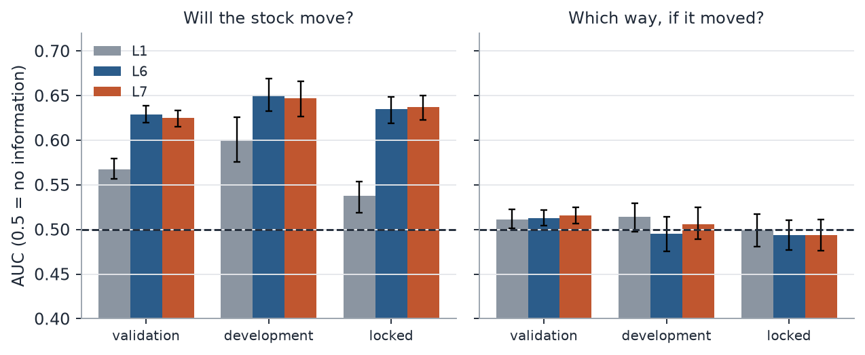
Figure 15. The most important chart in the project. The model is good at telling which events will produce a big move, and no better than a coin at telling which direction. An AUC of 0.5 means no information.
That split says a lot about what the model is doing. Metadata like event type, time of day, and the stock's recent volatility predict how much the stock will react. An earnings release after the close for a volatile stock is going to move, whatever the content. Whether the move is up or down depends on whether the news is better or worse than expected, and my numbers contain almost nothing about that. The accounting-based surprise is the nearest thing, and as the earnings section shows, it predicts little. On the earlier validation folds the direction AUC was a little higher (0.51), barely above a coin, so "a coin flip" is a fair summary of the locked test and close to true before it.
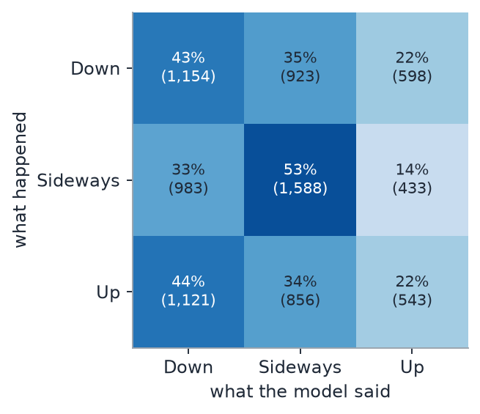
Figure 16. The all-numbers model on the locked test. It finds the Sideways events best (53%) and does little better than chance on telling Down from Up.
The text did not help. The comparison I care about is the same model with and without the language-model embeddings, scored on identical events. On the locked test, adding text changed macro-F1 by -0.001 (95% interval -0.012 to +0.010). On the earlier folds and the development period it was equally flat. The yearly ChronoBERT versions did not behave differently from the single BGE model either, and a stacked ensemble did not beat the best single model. The numbers beat price alone by about 0.03 in the validation and locked periods, so the structured features are doing real work, and the language models add nothing on top. Because that baseline already contains word counts and TF-IDF, I later fitted a model with no text at all, using the same settings. With LightGBM on both sides, adding all the text changed macro-F1 by +0.003 [-0.004, +0.009], +0.002 [-0.008, +0.012] and -0.005 [-0.014, +0.005] across the three periods. With an elastic net, word features showed a small gain of about 0.01 in the two later periods, so text may help a little in some models, but I would not rely on it. That check came after the final test, so treat it as exploratory.
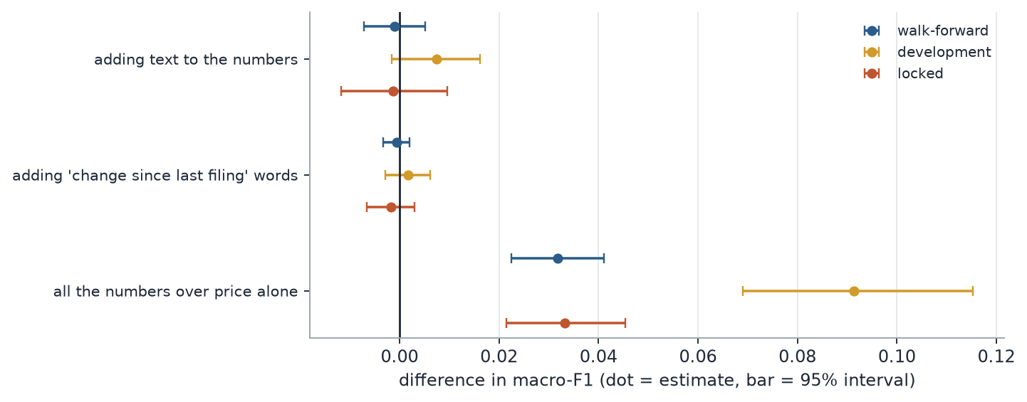
Figure 17. Every comparison I pre-registered, with its interval. Where the bar crosses the vertical line, I can't tell the difference from zero.

12. The earnings drift test, and a mistake of mine
The classic finding in this area is that stocks keep drifting in the direction of an earnings surprise for weeks afterwards. So I sorted earnings reports into five groups by the size of the surprise and tracked abnormal returns for the next 2 to 60 trading days. In the three days around the announcement the news moves prices the right way: the best-news group rose 0.81% and the worst-news group fell 0.54%.
My pre-planned test then gave a striking answer: over the next two months the best-news group did worse than the worst-news group, by -2.66% after adjusting for market, size, value and momentum. It held in every period and every sample split I tried, and earlier versions of this report presented it as a puzzle.
It was a measurement error. The abnormal return I used subtracts each stock's average outperformance over the previous year (its alpha) for each of the 59 days. Stocks with good news have usually had a good year, with an average past return of 27% in the best-news group and 5% in the worst. So the subtraction took 2.40% from the best-news group and added 0.38% to the worst, and that gap is the whole result. Every robustness check used the same subtraction, which is why they all agreed.
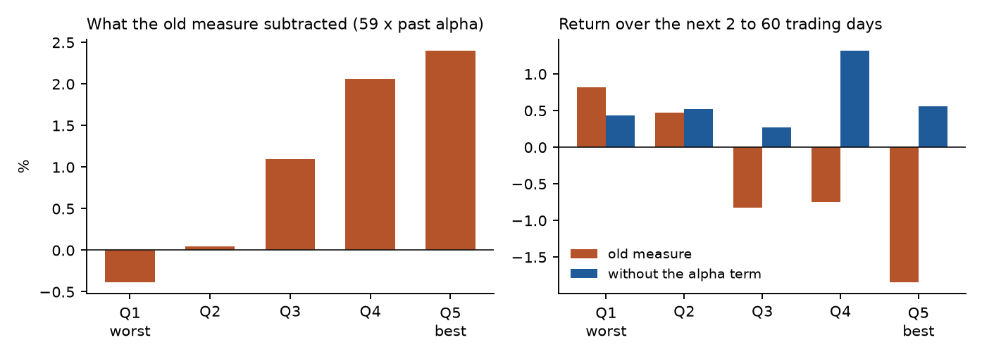
Figure 18. Left: how much the old measure subtracted from each group. Right: the return over days 2 to 60 with and without that term, on the same reports.
Without the alpha term the gap is +0.12%, with an interval from -0.80% to +0.88%. A calendar-time portfolio, which estimates nothing from before the event, gives +0.25% (t = 0.46). So there is no reversal, and no detectable drift in either direction. That fits other work finding the effect has faded in large stocks, though this sample is biased against finding it: my surprise is a crude one, and firms that kept falling after bad news are missing. The research paper in this repository sets out the full diagnosis.

13. Could you trade it?
I added a simple backtest as a sanity check, not as a strategy. The signal is the probability of Up minus the probability of Down from the frozen model. Go long the top fifth, short the bottom fifth, enter at the first open after the decision time, hold for five sessions, and charge 10 basis points a side (20 in a second run), plus a borrow cost on shorts. I also ran a version with a one-session delay.
Under the same rules (no delay, 10 basis points), the development years looked decent: the long book returned 7.1% a year, +2.0% a year ahead of the S&P 500 on the same days. On the locked test it fell apart. The long book earned 1.3% a year, the long-minus-index line -5.6% a year, and the hypothetical long-short -2.0%. Over the 3.6 years the long book gained about 4% while the index, on the same days, gained about 27%. The one-session-delay version looked better on the development years (11.8% a year, +3.7% ahead of the index) and still lost on the locked test (-0.9% a year, -7.3% against the index).
A good-looking result on the set you used to choose the model is not the same as a result on data you haven't touched, and the locked test did what it was there to do.
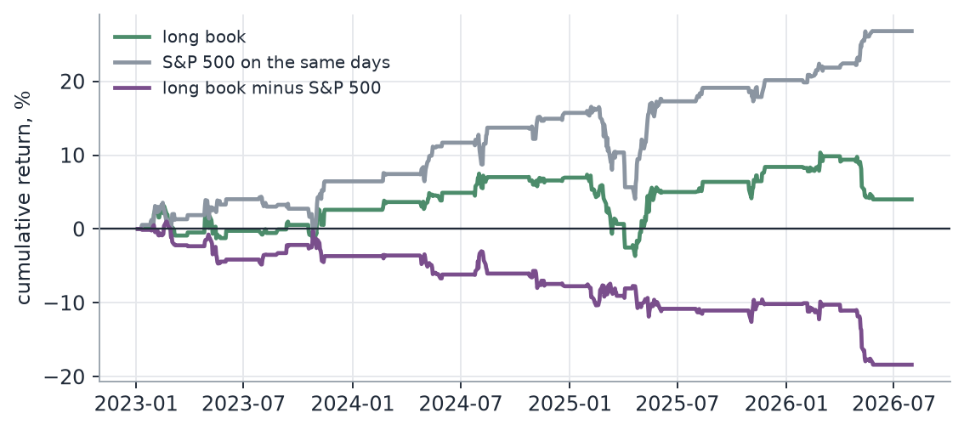
Figure 19. The locked test period, with no delay and 10 bps per side. Shorts are hypothetical, there is no capacity or delisting model, and this is a sanity check rather than a strategy.

14. Things that went wrong
Most of what I learned came from things going wrong. Besides the three data bugs in section 5, these are the ones I remember.
The first time I ran the GPU part on Colab it refused to start, saying the embeddings would take 19 GPU-hours against a 10-hour budget. The cause was my speed test, which timed a cold start including the one-off cost of waking the GPU. After I added a warm-up the run was accepted, and it took 1.65 hours.
A regular expression for table rows had a bad backtracking case, and three worker processes sat at full CPU for half an hour on one filing. Every parsing pattern now gets an adversarial timing test.
A burst of HTTP 503 responses from the SEC quietly dropped 63 filings. A retry pass now recovers them on the next run, and all 63 came back.
In the drift-robustness check, a p-value of exactly zero was being read as missing, which marked a real effect as non-robust. I fixed it and added a test.
The worst of them is in section 12: a drift measure that subtracted past alpha and produced a convincing false reversal. A long end-to-end test also hung for two hours because Windows had put the laptop into standby, and the timeout fired when it woke up. The test was fine. The setup wasn't.
Google Drive on Windows would not sync thousands of small files, so I uploaded zips through the browser. The dashboard also took two attempts to get online: the first deployment stalled, so I added a requirements file listing only the six packages it needs instead of the whole project's.
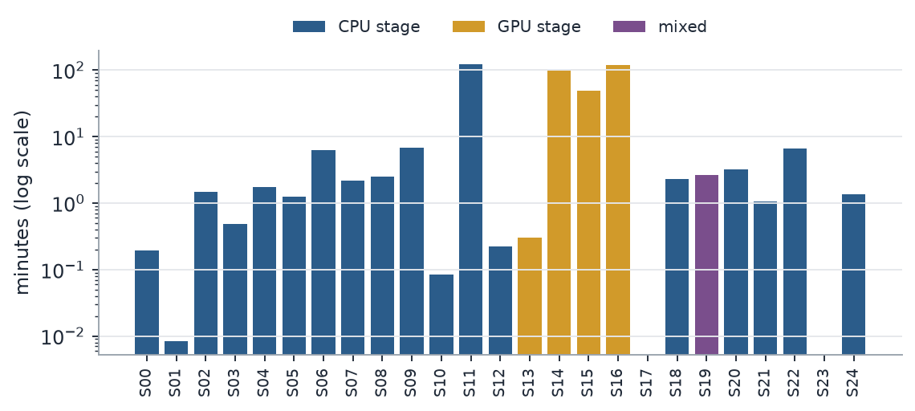
Figure 20. Wall-clock time per stage. The long bars are the tuning of the tree models (S11, two hours, on my laptop), the embeddings (S14) and the extraction run (S16).
The pipeline has 114 automated tests (plus one skipped), and most of the code bugs above have a test that fails on the old version. The alpha problem is a method choice, not a code bug, so the stored pipeline output keeps the old measure and the paper's scripts compute the corrected ones.

15. What the results do and don't show
What I'm comfortable claiming: on 150 surviving S&P 500 stocks, with careful point-in-time controls, adding language-model embeddings of filing text to price, metadata and accounting features gave no out-of-sample gain. The models beat chance mostly by predicting whether a stock moves, not which way. I found no detectable post-earnings drift in this survivor-only sample. An apparent reversal came from my abnormal-return measure.
I'm not claiming that text never helps. I only tested two encoders with small tuning budgets, on 150 big companies, with daily prices. I'm not claiming the drift is gone, because this sample is biased against finding it. I'm not claiming anyone could trade on these models either, and the backtest says otherwise. And I'm not claiming the language-model extraction works, because I haven't scored it.
The known limits: the universe is survivors only, with daily bars only. The choice between the two top models was a statistical tie, though the rule froze the one with text: scored in the same run the model without text was slightly ahead, and LightGBM's predictions changed for about 20% of events when I re-scored the same model on a different machine. The firm-held-out and sector-held-out stress tests are built but I never ran their scores. The GPU model used on Colab was not recorded in the manifest. And everything about Track C is waiting for human labels.

16. What I'd do next
1. Run the 500-stock version, including non-S&P firms, on the corrected accounting code. Tighter intervals and a chance to compare index and non-index stocks.
2. Add delisted companies, which is the only real fix for the survivorship problem.
3. Label a few hundred filings by hand so the extraction can be scored, and then see whether extracted events beat plain embeddings.
4. Make LightGBM deterministic and compare the final candidates inside one run, preferring the strict model on a tie.
5. Run all four encoders, and consider real analyst forecasts for the earnings surprise.

17. Look at it yourself
Everything is public. The repository (https://github.com/harshatangirala/sec-filings-price-impact) has the pipeline, the configuration, the decision log (78 entries explaining each choice and bug), the notebook for Colab, the dashboard and its data, the automated tests, the slide deck, this report, and the analysis scripts behind the earnings-drift numbers. The interactive dashboard is at https://sec-filings-study.streamlit.app/. It walks the same story as a clickable flowchart of 16 steps with the charts behind each one, plus an 18-slide deck. If the app has gone to sleep, press the button and give it a minute.
To rerun it: open the notebook in Colab, set the profile and stock count in the first cell, and run all. Finished stages are skipped, so a disconnect costs nothing. You do not need any paid API or key, only a contact email for the SEC if you re-download. Parameter counts in this report are approximate, taken from model cards and file sizes, and nothing here is investment advice.

Appendix: where each thing is
what | where (in the repository)
pipeline code | src/secprice
decision log (every choice and bug) | docs/decision_log.md
Colab notebook | notebooks
dashboard code and data | dashboard
automated report, figures, results tables | reports
this report, the slide deck, and how I built them | docs/write-up
earnings-drift analysis scripts | analysis

References
Seven peer-reviewed articles from 2024 to 2026 that sit closest to this project. I checked the authors, journal, volume and DOI of each against the publisher's or an indexing page. I read abstracts and the parts available online, not every paper end to end, so the notes say what each paper is about and why I list it, not more.
1. He, S., Lv, L., Manela, A., & Wu, J. (2026). Chronologically consistent large language models. Journal of Financial Economics, 185, 104374. https://doi.org/10.1016/j.jfineco.2026.104374
The ChronoBERT paper. The models are trained only on text that existed at each date, and the authors find look-ahead bias in news-based return forecasts to be modest. It is the reason I used a different yearly vintage for each event year (section 8).
2. Fink, J., Palan, S., & Theissen, E. (2024). Earnings autocorrelation and the post-earnings-announcement drift: Experimental evidence. Journal of Financial and Quantitative Analysis, 59(6), 2799-2837. https://doi.org/10.1017/S0022109023000881
A lab experiment showing the drift appears whether or not earnings surprises are correlated, and is stronger when they are. Useful background for the drift test in section 12.
3. Karolyi, S., Ruchti, T., & Truong, P. (2025). Number processing constraints and earnings news. Management Science, 71(3), 2413-2442. https://doi.org/10.1287/mnsc.2023.01722
Finds investors react less in the short run to earnings news for stocks with a high earnings-per-share level, which strengthens the later drift. A reminder that the drift depends on how the surprise is measured and who the firms are.
4. Zhang, S., Gregoriou, A., & Wu, H. (2024). Asymmetric post earnings announcement drift and order flow imbalance: The impact on stock market returns. International Review of Financial Analysis, 94, 103316. https://doi.org/10.1016/j.irfa.2024.103316
An event study of earnings announcements in which the drift differs between good-news and bad-news cases and is linked to order flow. Related to the quintile comparison in section 12.
5. Lan, Q., Xie, Y., Mi, X., & Zhang, C. (2024). Post earnings announcement drift: A simple earnings surprise measure, the medium effect of investor attention and investing strategy. International Review of Financial Analysis, 95(PB), 103460. https://doi.org/10.1016/j.irfa.2024.103460
Builds a surprise measure from the overnight return around the announcement, tested on Chinese stocks. Similar in idea to the price-based announcement-return feature in my model, though the market is different.
6. Magner, N., Henríquez, P. A., & Sanhueza, A. (2025). Decoding risk sentiment in 10-K filings: Predictability for U.S. stock indices. Finance Research Letters, 81, 107472. https://doi.org/10.1016/j.frl.2025.107472
Reports that the tone of the risk-factors section of 10-Ks predicts weekly returns on major U.S. stock indices. It works at the index level, whereas my study is firm by firm and next day.
7. Fengler, M. R., & Phan, T. M. (2025). Unveiling themes in 10-K disclosures: A new topic modeling perspective. International Review of Financial Analysis, 103, 104121. https://doi.org/10.1016/j.irfa.2025.104121
Uses word embeddings to find topics in the MD&A section of 10-Ks and relates topic-level sentiment to returns over different horizons. Related to how I turned filing sections into embeddings.
Several of these report that filing text or earnings news carries information about returns, while I found no added value from text over the structured features. That is not necessarily a conflict: the studies differ in level (index versus single stock), horizon, market and controls, and I did not test whether those differences explain the gap.
Quartile: International Review of Financial Analysis and Finance Research Letters are listed as best quartile Q1 on Scimago (SJR 2025). Quartiles change between years and ranking systems, so check the one your institution uses.

