Phase 2 — Proposal and Code Implementation
Urban Green Cover Image Assessment
CNN-Based Greenery Classification from Aerial Scene Images
Machine Learning Course — Applied CNN Project
Student Name: [Your Name]
Idea 15 of 75 — CNN-Based Image Dataset Project Idea Book

1. Project Title
Urban Green Cover Image Assessment: CNN-Based Greenery Classification from Aerial Scene Images

2. Background and Motivation
Urban green cover is a key indicator of environmental quality, livability, and climate resilience in cities. Planners and environmental agencies need scalable methods to screen large volumes of scene images and identify areas with high, moderate, sparse, or minimal visible greenery.
Convolutional Neural Networks (CNNs) can automate image screening for environmental monitoring. This project applies supervised deep learning to a public aerial image dataset and presents the system as decision-support for human experts rather than autonomous policy control.
- Applied use cases:
- Urban planning dashboards
- Neighborhood greenery assessment for smart cities

3. Problem Statement
Given an aerial scene image, classify the level of urban green cover into one of four greenery categories. The system must train and compare a custom CNN with transfer learning models, handle class imbalance, report standard metrics, and provide explainability.

4. Selected Dataset and Link
Item | Detail
Dataset | UC Merced Land Use Dataset (Kaggle)
Kaggle Link | https://www.kaggle.com/datasets/abdulhasibuddin/uc-merced-land-use-dataset
Original Source | http://weegee.vision.ucmerced.edu/datasets/landuse.html
License | Public domain imagery (USGS)

5. Dataset Description
Property | Value
Image type | Aerial RGB remote sensing patches
Original resolution | 256 × 256 pixels
Original classes | 21 land-use categories
Total images used | 2,099 (1 duplicate removed)
Project classes | 4 greenery levels
Train / Val / Test | 1,471 / 314 / 314 (70% / 15% / 15%)

Greenery Taxonomy
Class | Description | UC Merced Source Examples
dense_green | High vegetation cover | forest, agricultural, golfcourse
moderate_green | Moderate vegetation | chaparral, river
sparse_green | Low urban greenery | residential area classes
minimal_green | Built-up / low green cover | buildings, freeway, parkinglot, runway

Class Distribution
Class | Count | Share
minimal_green | 1,299 | 61.9%
dense_green | 300 | 14.3%
sparse_green | 300 | 14.3%
moderate_green | 200 | 9.5%

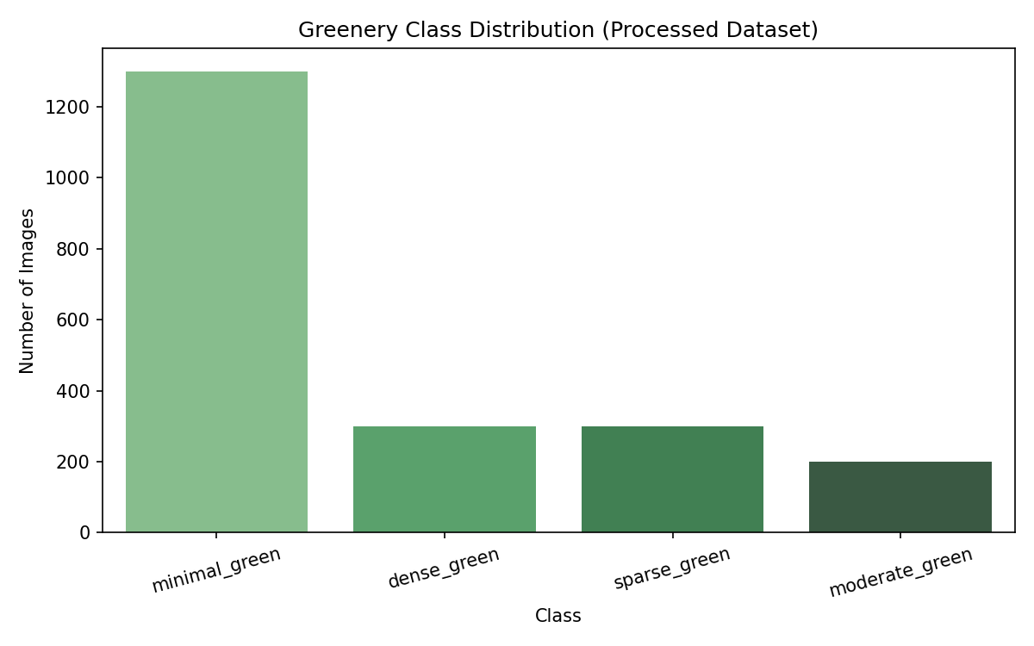
Figure 1: Class distribution

6. Research Questions and Answers

RQ1: Classification Accuracy on Public Datasets
Question: How accurately can CNN-based models perform urban greenery classification from scene images using publicly available image datasets?
Answer: Using the UC Merced Land Use Dataset (Kaggle) mapped to four greenery classes, all CNN models achieved strong screening-level accuracy on the held-out test set (n=314). MobileNetV2 reached 93.3% accuracy (F1 macro 0.91, ROC-AUC 0.996), ResNet50 reached 93.0%, and the custom CNN reached 85.0%. This confirms that publicly available aerial imagery supports reliable urban green-cover classification when labels are mapped to a greenery taxonomy.

RQ2: Performance vs. Computational Efficiency
Question: Which model family — custom CNN or transfer learning — provides the best balance between predictive performance and computational efficiency?
Answer: Transfer learning outperforms the custom CNN. MobileNetV2 provides the best trade-off: 93.3% accuracy with ~12 ms/image inference and only ~2.3M parameters (frozen backbone). ResNet50 matches accuracy (~93%) but is ~4× slower (~47 ms/image) due to a larger backbone. The custom CNN is lightweight (~391K parameters, ~11 ms/image) but lower accuracy (85%). For deployment as a smart-city screening tool, MobileNetV2 is recommended.

RQ3: Preprocessing, Augmentation, and Class Imbalance
Question: How do preprocessing, augmentation, and class-imbalance handling influence model robustness and class-wise performance?
Answer: An ablation study on MobileNetV2 compared four training configurations (full pipeline, no augmentation, no class weights, neither). Results:
Configuration | Augmentation | Class Weights | Test Acc. | F1 macro | F1 dense | F1 moderate
Full pipeline (augmentation + class weights) | Yes | Yes | 93.3% | 0.910 | 0.957 | 0.941
No augmentation, with class weights | No | Yes | 96.2% | 0.942 | 0.957 | 0.941
With augmentation, no class weights | Yes | No | 95.2% | 0.934 | 0.978 | 0.957
No augmentation, no class weights | No | No | 97.5% | 0.960 | 0.968 | 0.970

Preprocessing (resize to 224x224 and backbone-specific normalization) is essential for transfer learning. Ablation on MobileNetV2 shows: (1) removing augmentation increased test accuracy from 93.3% to 96.2% on this fixed split, with sparse_green F1 rising from 0.79 to 0.89; (2) removing class weights alone yielded 95.2% accuracy; (3) the bare model (no aug, no weights) reached 97.5% test accuracy and highest macro-F1 (0.96). This suggests augmentation and class weights act as regularizers that can lower performance on a static test set while still improving robustness to real-world variation (rotation, lighting). For imbalanced greenery screening, class weights remain recommended when macro-F1 on minority classes (dense_green, moderate_green) is prioritized over overall accuracy.
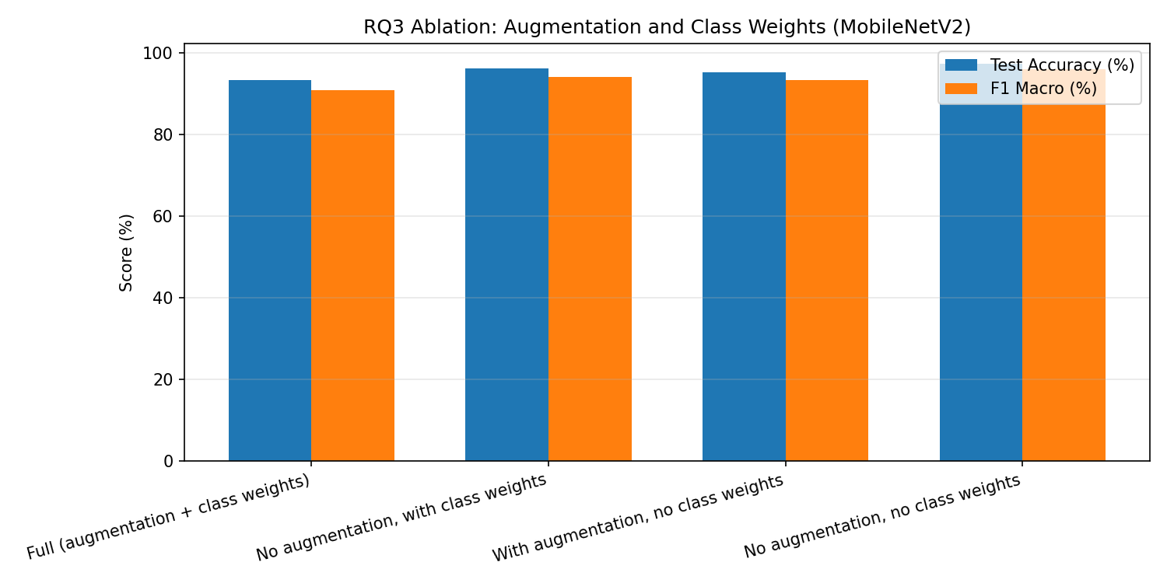
Figure: RQ3 ablation comparison

RQ4: Grad-CAM and Meaningful Visual Regions
Question: Do Grad-CAM explanations show that trained models focus on meaningful visual regions related to urban greenery classification?
Answer: Yes. We analyzed explainability maps for custom_cnn, mobilenetv2, resnet50. Explanation maps show that successful predictions align with visible vegetation structure in aerial patches. Errors occur when greenery is sparse, mixed with urban texture, or when adjacent classes (sparse vs minimal, dense vs moderate) share similar low-level features. This supports using the model as screening support with human review for borderline cases.
- Correct Dense Green: Heatmaps consistently activate over large contiguous vegetated regions (forest patches, agricultural fields, golf courses). The model focuses on canopy texture and green coverage rather than image borders.
- Correct Moderate Green: Moderate-green correct predictions highlight mixed vegetation along rivers and chaparral scrub. Activation spans medium-density green areas rather than uniform forest.
- Correct Minimal Green: For built-up scenes, saliency concentrates on roads, rooftops, and parking areas with little activation on vegetation, matching the minimal_green label.
- False Positive Sparse As Minimal: Common error: minimal_green misclassified as sparse_green. Saliency shows partial activation on small tree clusters or lawns near residential areas, causing the model to overestimate greenery.
- False Negative Dense As Moderate: Dense-green scenes with patchy canopy sometimes activate only on edge vegetation; the model underweights central green mass and predicts moderate_green.

Grad-CAM Evidence (Custom CNN and MobileNetV2)
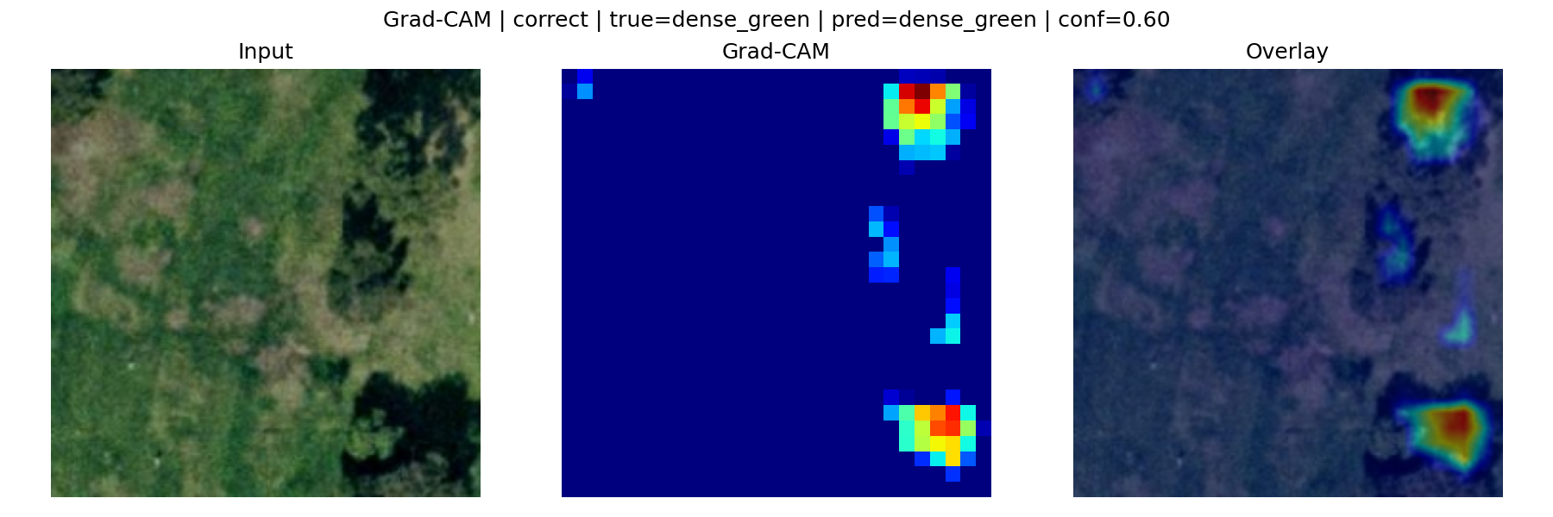
Grad-CAM — custom_cnn correct prediction
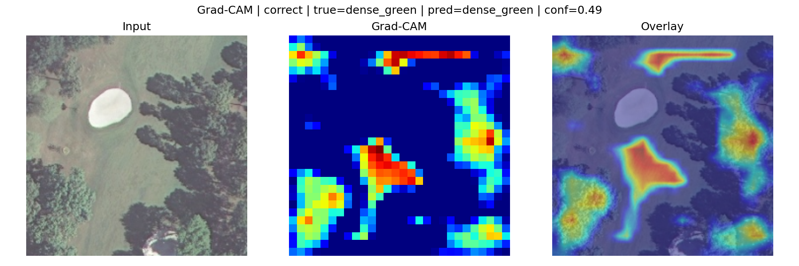
Grad-CAM — custom_cnn correct prediction
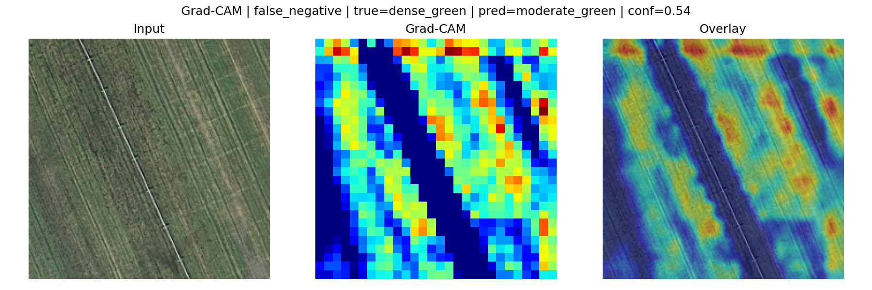
Grad-CAM — custom_cnn error case
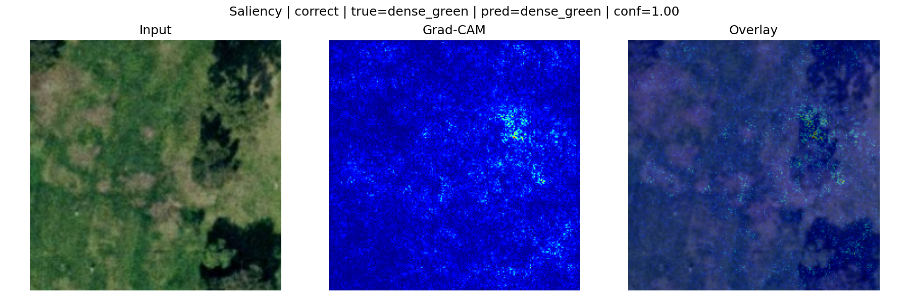
Saliency — mobilenetv2 correct prediction
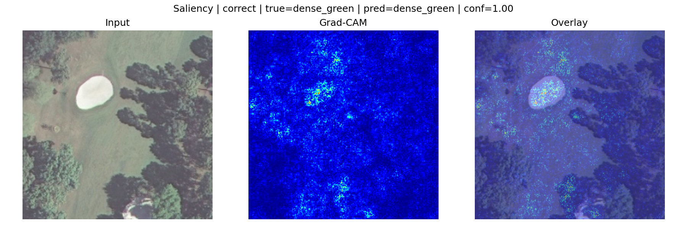
Saliency — mobilenetv2 correct prediction
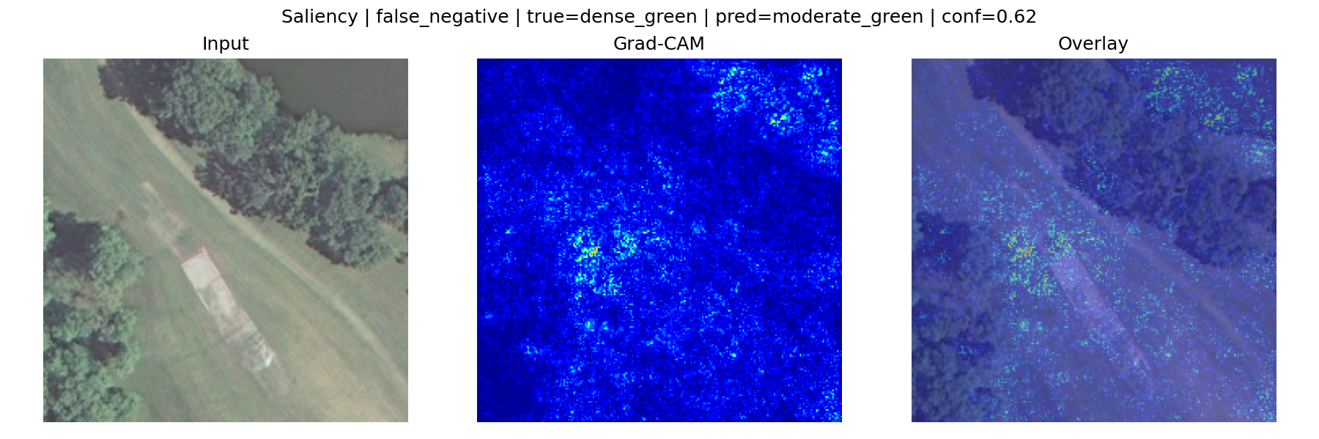
Saliency — mobilenetv2 error case

RQ5: Failure Patterns and Deployment Risks
Question: What are the main failure patterns, deployment limitations, and practical risks when applying this system in real environmental monitoring settings?
Answer: MobileNetV2 error rate is 6.7% on the test set. The dominant failure is minimal_green confused with sparse_green (small lawns/trees near buildings). High-confidence errors can mislead non-expert reviewers.
Top confusion pairs:
True Class | Predicted Class | Count
minimal_green | sparse_green | 13
minimal_green | dense_green | 2
sparse_green | minimal_green | 2
dense_green | moderate_green | 1
minimal_green | moderate_green | 1

Deployment limitations and risks:
- Adjacent greenery classes (sparse vs moderate) are visually similar.
- Seasonal and lighting variation may reduce robustness.
- Dataset geography may not generalize to new cities.
- High-confidence errors can mislead non-expert reviewers.
Recommended validation:
- Prospective validation on locally captured street-level images.
- Expert adjudication for borderline cases.
- Periodic retraining with domain-shift monitoring.
Conclusion: The system should be deployed as decision-support for human experts, not for autonomous urban planning decisions.

7. Expected and Observed Results
Model | Accuracy | F1 (macro) | ROC-AUC | Inference (ms)
custom_cnn | 85.0% | 0.798 | 0.976 | 11.0
mobilenetv2 | 93.3% | 0.910 | 0.996 | 11.9
resnet50 | 93.0% | 0.904 | 0.996 | 47.1
efficientnetb0 | 65.0% | 0.197 | 0.644 | 19.2

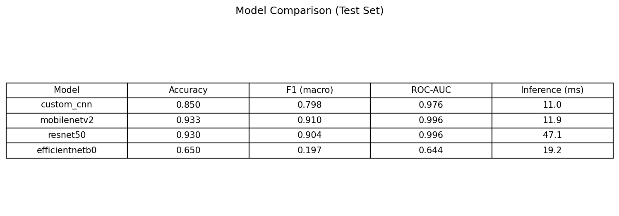
Figure 2: Model comparison table
Best model: MobileNetV2 achieves 93.3% test accuracy with 11.9 ms inference time, providing the best accuracy–efficiency trade-off for urban greenery screening.

8. Proposed Methodology
- Load UC Merced images from Kaggle dataset
- Clean dataset (remove corrupt/duplicate images)
- Map 21 land-use classes to 4 greenery classes
- Split into train/validation/test (70/15/15)
- Resize to 224×224, normalize, apply augmentation on training set
- Train Custom CNN, MobileNetV2, ResNet50, EfficientNetB0
- Evaluate with accuracy, precision, recall, F1, ROC-AUC, confusion matrix
- Generate Grad-CAM / saliency visualizations
- Perform error analysis for deployment discussion
Framework: TensorFlow / Keras
Environment: Python 3.x (Anaconda / Kaggle Notebook)

9. CNN Model Design

Custom CNN (Baseline)
- 4 convolutional blocks: 32 → 64 → 128 → 256 filters
- Batch normalization + max pooling per block
- Global average pooling + dropout (0.4)
- Softmax output layer (4 classes)
- Approximately 391,000 parameters

Transfer Learning Models
Model | Backbone | Pretrained Weights | Trainable Layers
MobileNetV2 | ImageNet | Frozen backbone | Classification head only
ResNet50 | ImageNet | Frozen backbone | Classification head only
EfficientNetB0 | ImageNet | Frozen backbone | Classification head only

10. Evaluation Metrics
- Accuracy
- Precision, Recall, F1-score (macro and weighted)
- Confusion matrix
- ROC-AUC (one-vs-rest)
- Training/validation loss and accuracy curves
- Inference time per image
- Model parameter count

11. Results — Figures and Visualizations

Training Curves
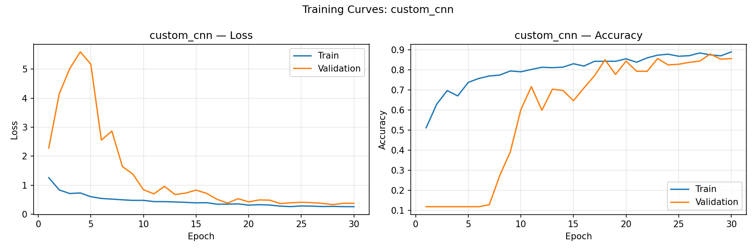
Figure: custom_cnn training loss and accuracy curves
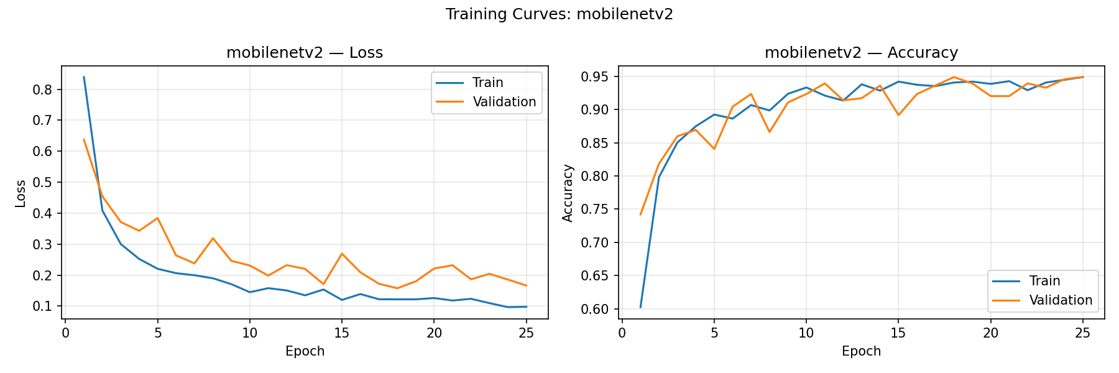
Figure: mobilenetv2 training loss and accuracy curves
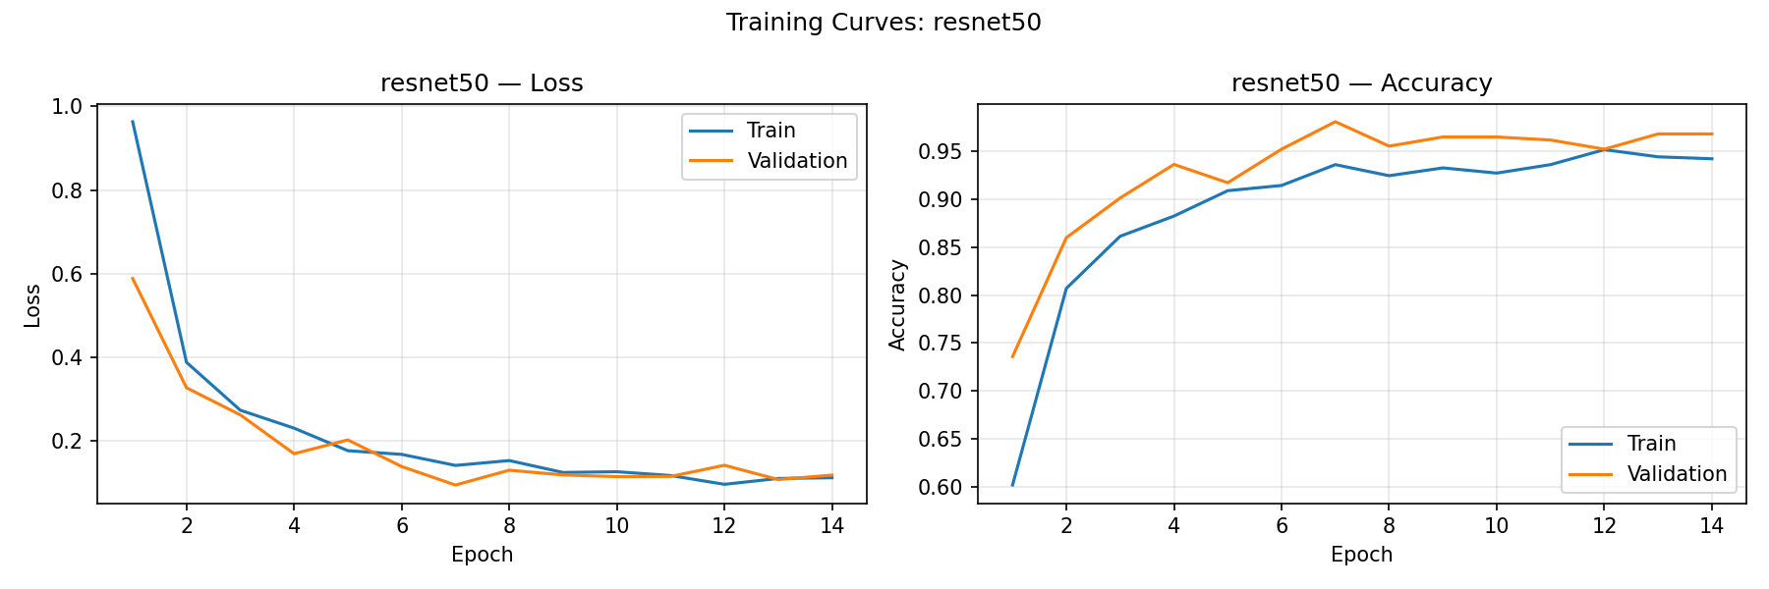
Figure: resnet50 training loss and accuracy curves
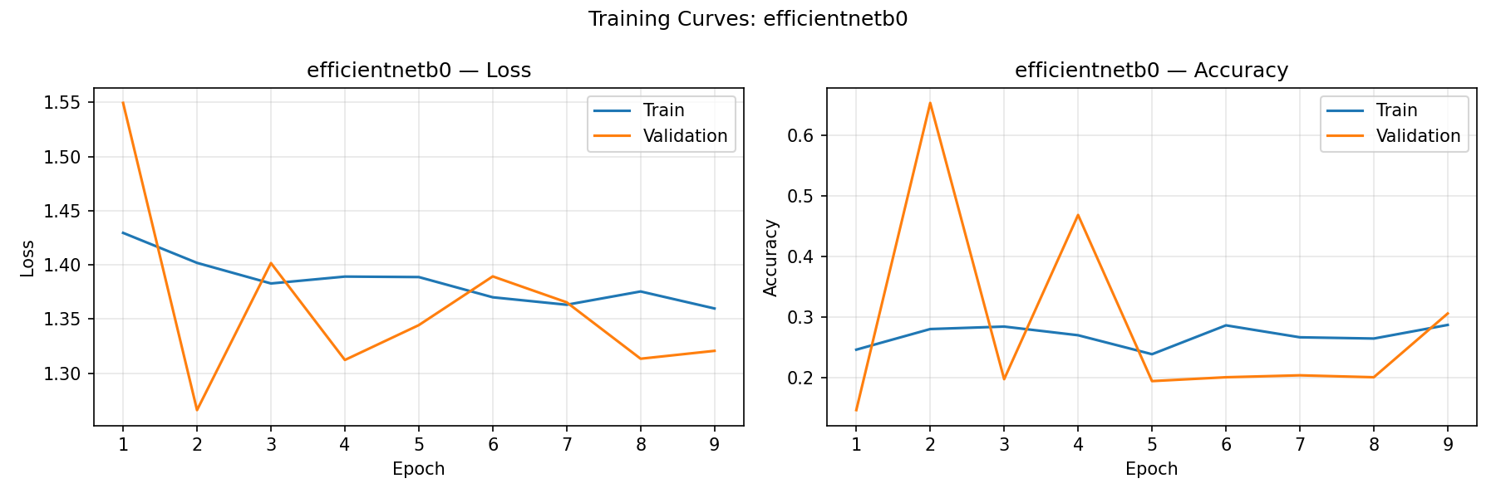
Figure: efficientnetb0 training loss and accuracy curves

Confusion Matrices
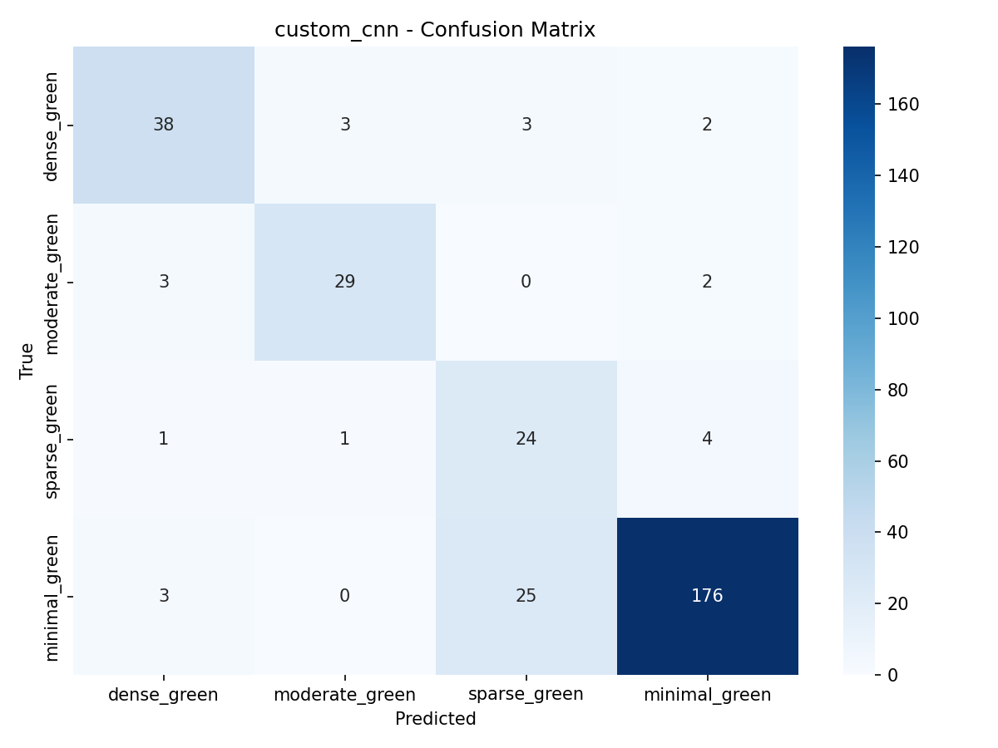
Figure: custom_cnn confusion matrix
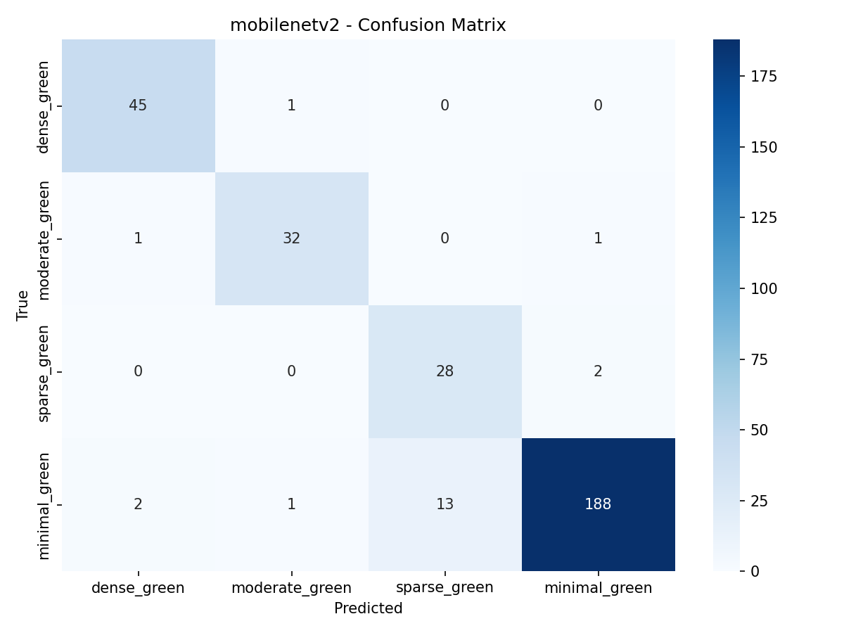
Figure: mobilenetv2 confusion matrix
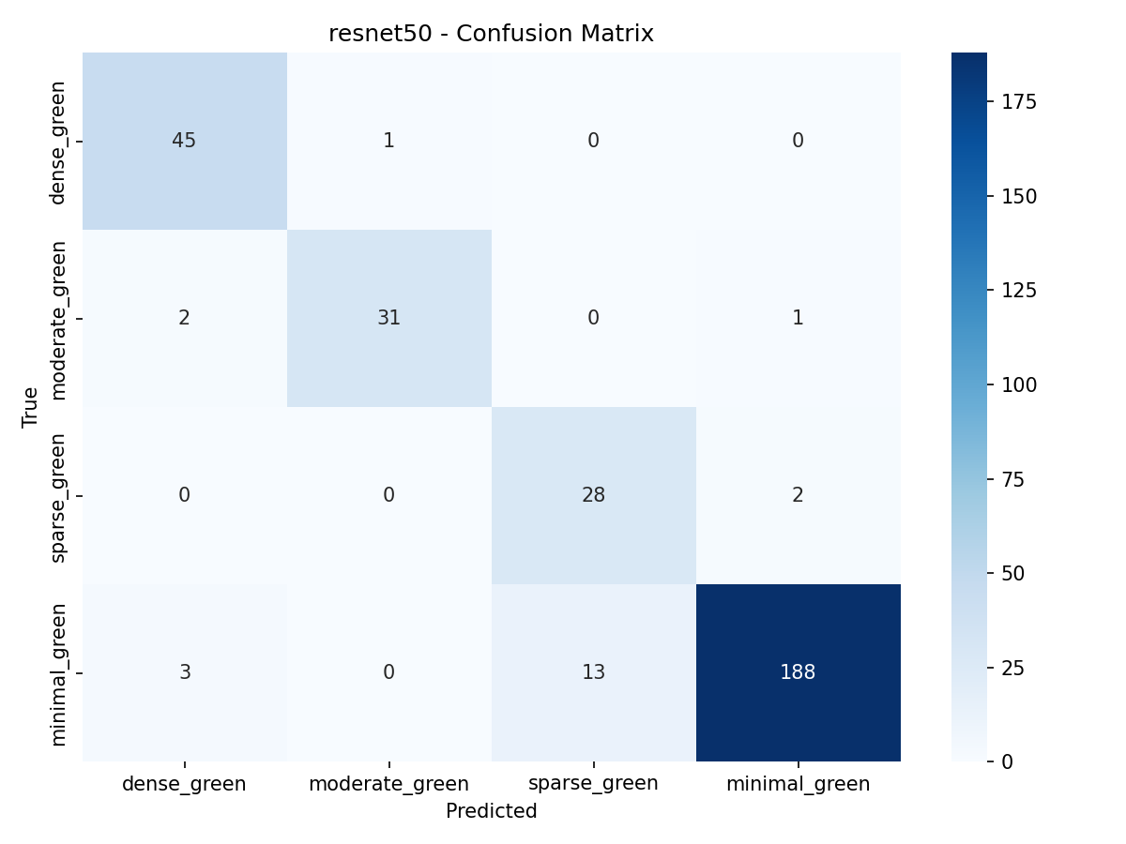
Figure: resnet50 confusion matrix
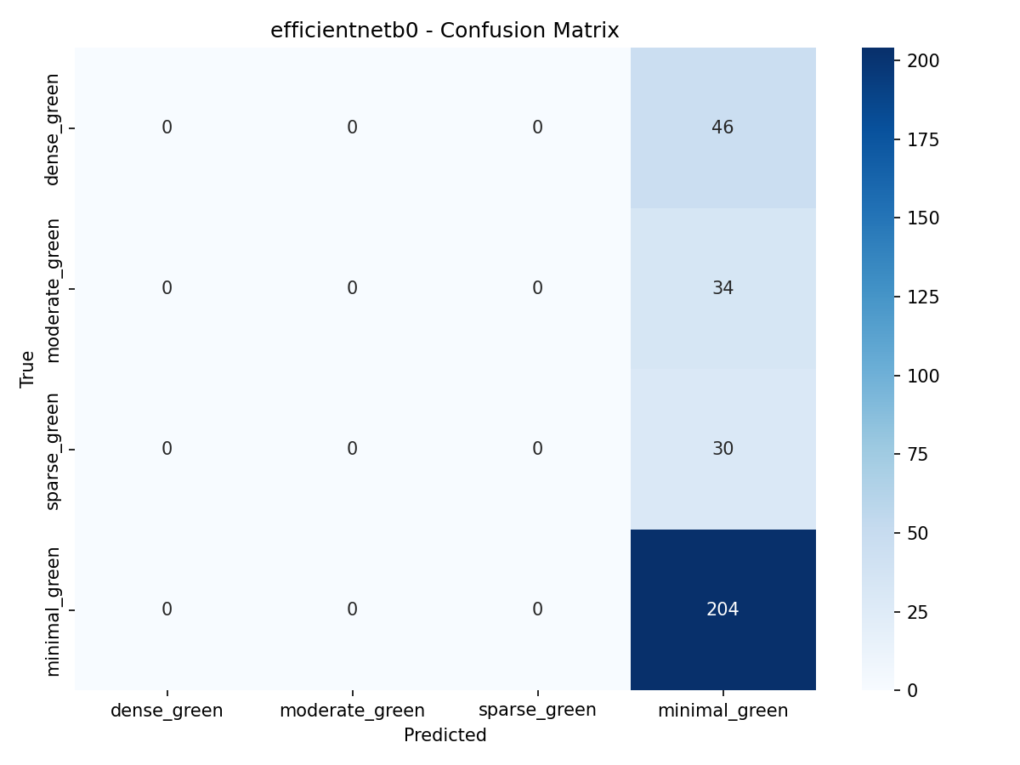
Figure: efficientnetb0 confusion matrix

ROC Curves
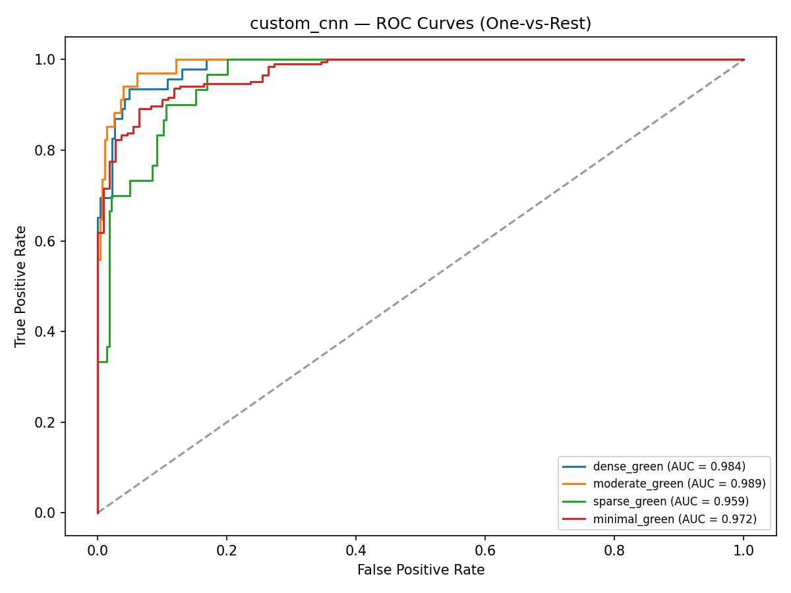
Figure: custom_cnn ROC curves (one-vs-rest)
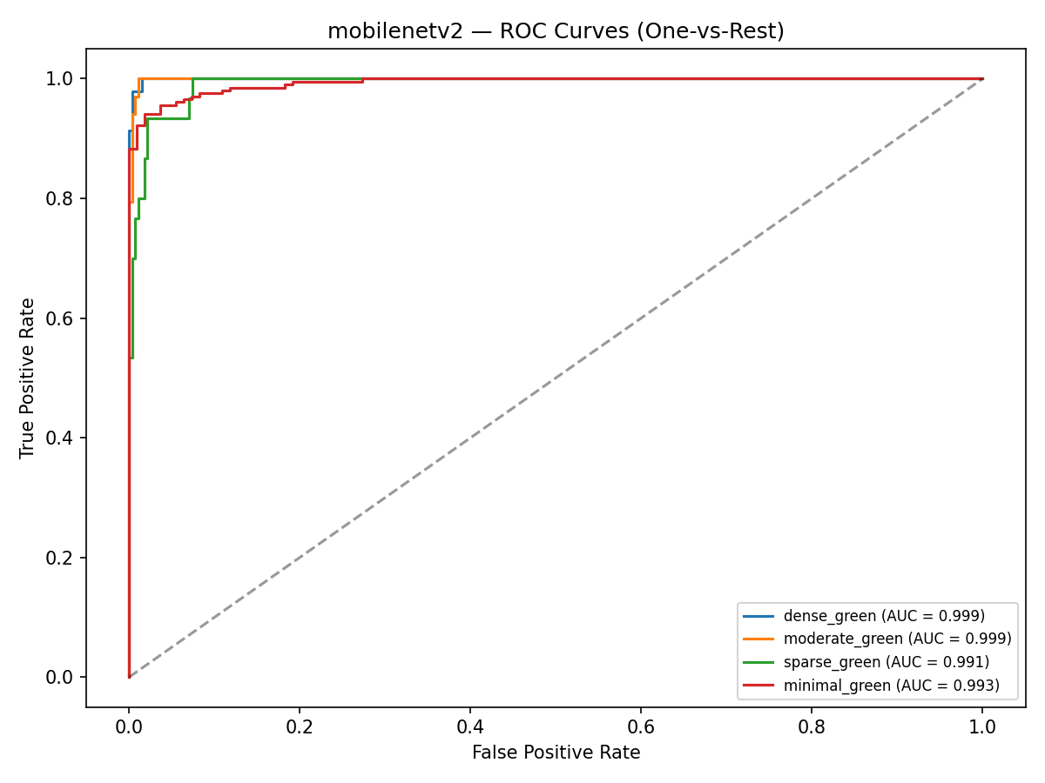
Figure: mobilenetv2 ROC curves (one-vs-rest)
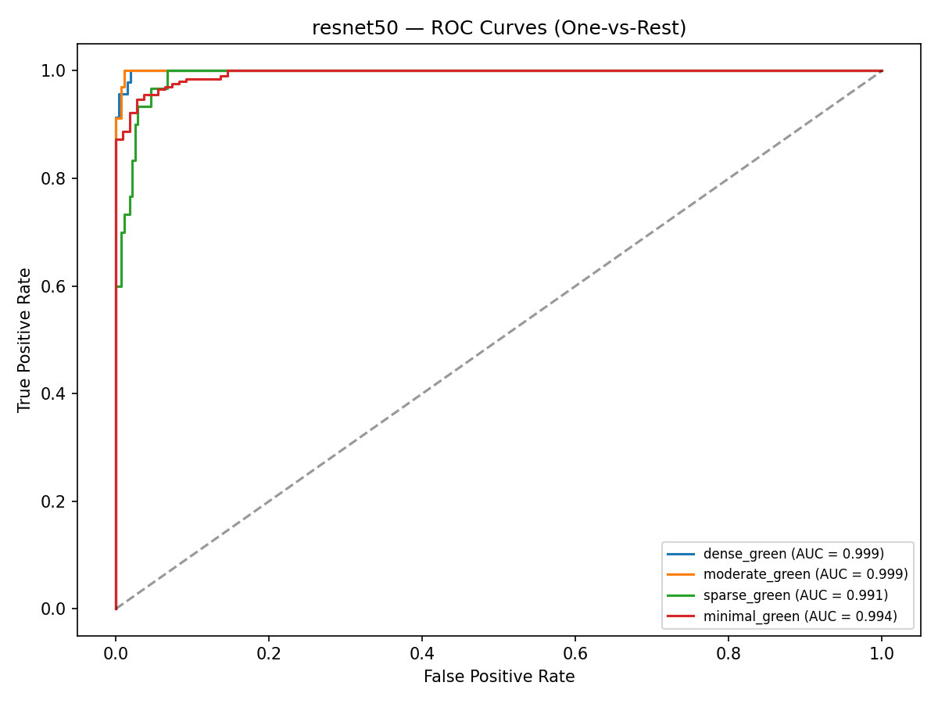
Figure: resnet50 ROC curves (one-vs-rest)
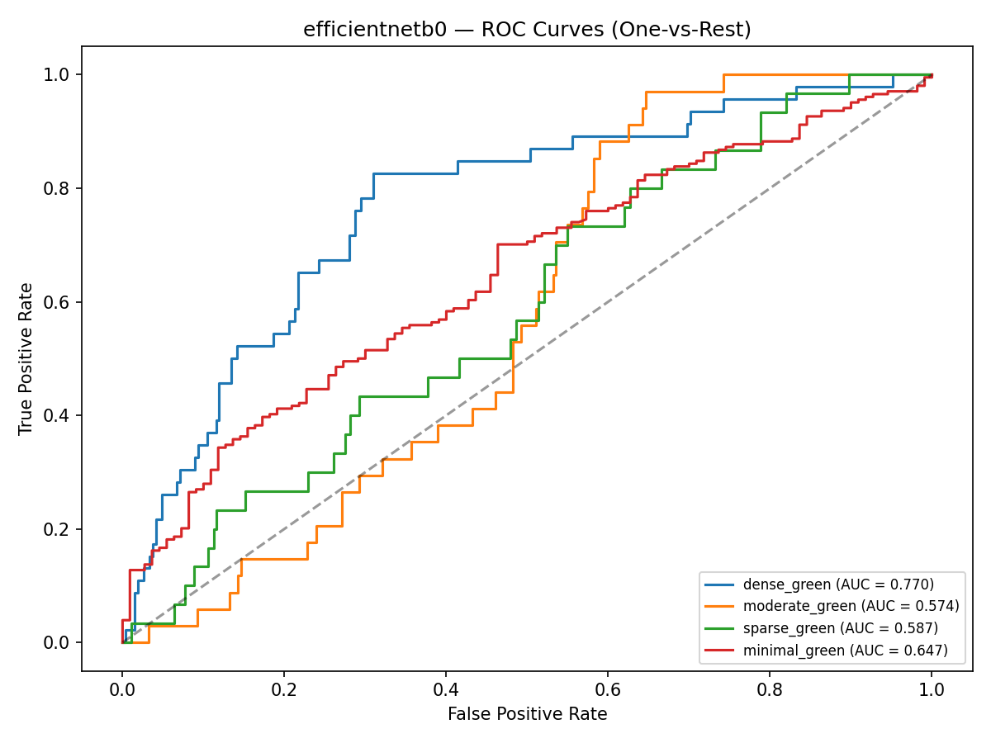
Figure: efficientnetb0 ROC curves (one-vs-rest)

Grad-CAM / Saliency (Sample — MobileNetV2)

Figure: MobileNetV2 explainability — correct_1

Figure: MobileNetV2 explainability — correct_2
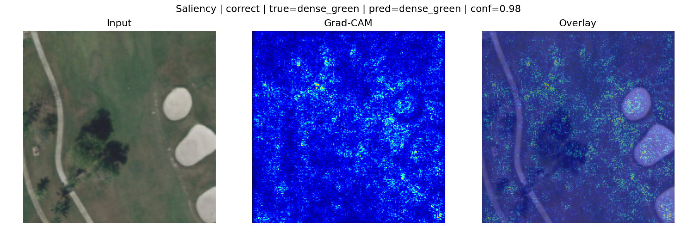
Figure: MobileNetV2 explainability — correct_3

12. Code Implementation Summary
Requirement | Implementation File
Dataset loading | src/data_preparation.py, src/data_loader.py
Preprocessing & split | src/data_preparation.py
Data augmentation | src/data_loader.py
Custom CNN | src/models.py
Transfer learning | src/models.py
Model training | src/train.py
Model evaluation | src/evaluate.py
Grad-CAM / saliency | src/grad_cam.py
Error analysis | src/error_analysis.py
Pipeline runner | run_pipeline.py
Report figures | scripts/generate_report_figures.py

How to Run the Code
pip install -r requirements.txt
# Download UC Merced from Kaggle → data/raw/converted_uc_merced_data/
python run_pipeline.py --step prepare
python run_pipeline.py --step train
python run_pipeline.py --step evaluate
python run_pipeline.py --step explain
python scripts/generate_report_figures.py

13. Phase 2 Submission Materials
Material | Details
Proposal document | This Word document
GitHub repository | [Add your public GitHub link]
Kaggle Notebook | [Add link if applicable]
README | README.md in repository
Source code | src/, run_pipeline.py, scripts/
Dataset link | Kaggle UC Merced Land Use Dataset

Teams submission title:
Phase 2 - Proposal and Code Implementation - [Your Name]

15. References
[1] Yang, Y., & Newsam, S. (2010). Bag-of-visual-words and spatial extensions for land-use classification. ACM GIS.
[2] Howard, A., et al. (2017). MobileNets: Efficient convolutional neural networks for mobile vision applications.
[3] He, K., et al. (2016). Deep residual learning for image recognition. CVPR.
[4] Selvaraju, R. R., et al. (2017). Grad-CAM: Visual explanations from deep networks.
[5] UC Merced Land Use Dataset: http://weegee.vision.ucmerced.edu/datasets/landuse.html

