# WEEK-5

## AIM: To implement indexed allocation technique in file allocation in file allocation methods.

## DESCRIPTION:

**Indexed Allocation**

In this scheme, a special block known as the **Index block** contains the pointers to all the blocks occupied by a file. Each file has its own index block. The ith entry in the index block contains the disk address of the ith file block. The directory entry contains the address of the index block as shown in the image:

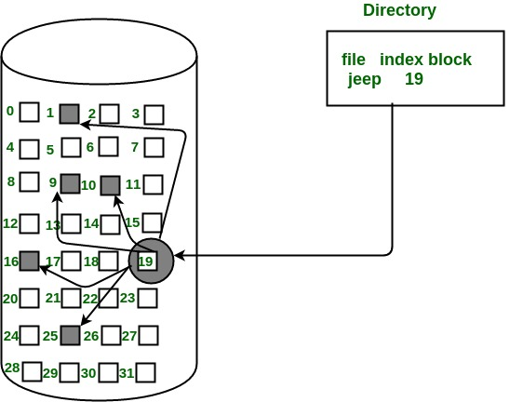

## IMPLEMENTATION:

#include<stdio.h>

#include<stdlib.h>

void main()

{

int f[50], index[50],i, n, st, len, j, c, k, ind,count=0;

for(i=0;i<50;i++)

f[i]=0;

x:printf("Enter the index block: ");

scanf("%d",&ind);

if(f[ind]!=1)

{

printf("Enter no of blocks needed and no of files for the index %d on the disk : \n",

ind);

scanf("%d",&n);

}

else

{

printf("%d index is already allocated \n",ind);

goto x;

}

y: count=0;

for(i=0;i<n;i++)

{

scanf("%d", &index[i]);

if(f[index[i]]==0)

count++;

}

if(count==n)

{

for(j=0;j<n;j++)

f[index[j]]=1;

printf("Allocated\n");

printf("File Indexed\n");

for(k=0;k<n;k++)

printf("%d-------->%d : %d\n",ind,index[k],f[index[k]]);

}

else

{

printf("File in the index is already allocated \n");

printf("Enter another file indexed");

goto y;

}

printf("Do you want to enter more file(Yes - 1/No - 0)");

scanf("%d", &c);

if(c==1)

goto x;

else

exit(0);

}

## OUTPUT:

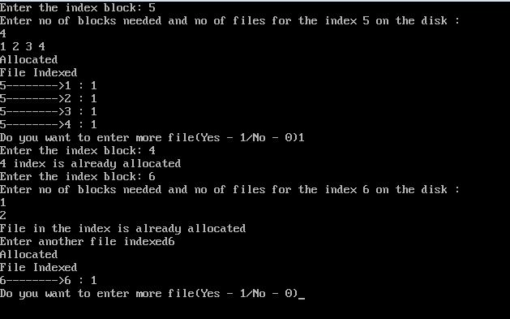

## OBSERVATIONS:

For files that are very large, single index block may not be able to hold all the pointers.

Following mechanisms can be used to resolve this:

1.Linked scheme

2.Multilevel scheme

3.Combined scheme

**Advantages:**

* This supports direct access to the blocks occupied by the file and therefore provides fast access to the file blocks.
* It overcomes the problem of external fragmentation.

**Disadvantages:**

* The pointer overhead for indexed allocation is greater than linked allocation.
* For very small files, say files that expand only 2-3 blocks, the indexed allocation would keep one entire block (index block) for the pointers which is inefficient in terms of memory utilization. However, in linked allocation we lose the space of only 1 pointer per block.