*Article*

**Air Quality Prediction**

# Moguloju Harsha Vardhan Chary 2203A52162

**Affiliation: 2203a52162@sru.edu.in**

**Section: CSE(AI&ML)-AA**

**SR University**

## Abstract

**Air quality prediction plays a crucial role in environmental monitoring, public health, and decision-making processes. In this context, the provided dataset comprises air quality measurements, including various pollutant concentrations (e.g., CO, NO, NO2, O3, SO2), particulate matter (PM2.5, PM10), and ammonia (NH3) levels. The data is collected at regular intervals from multiple locations over a significant time span.**

**The dataset aims to facilitate the development of predictive models for air quality based on historical data. Lasso Regression, a linear regression technique with L1 regularization, is one of the methods employed to build such models. Lasso Regression helps in identifying the most relevant features for predicting air quality and mitigating overfitting issues by introducing a regularization term.**

**By applying Lasso Regression to this dataset, it is possible to create a predictive model that takes into account various environmental factors to estimate pollutant concentrations. This model could be instrumental in forecasting air quality trends, providing early warnings for pollution events, and aiding policymakers in implementing effective mitigation strategies.**

**Additionally, Lasso Regression allows us to understand the relative importance of different features and select the most influential factors in air quality prediction. The regularization parameter, often denoted as "alpha," can be tuned to balance the trade-off between model complexity and predictive accuracy.**

**In summary, the application of Lasso Regression to this air quality dataset offers a valuable tool for accurate and interpretable air quality predictions, which can have a positive impact on public health and environmental management.**

**Keywords: Air quality prediction, Lasso Regression, pollutant concentrations, environmental monitoring, feature selection, public health, early warning, environmental management.**

## 1.Introduction

Air quality is a critical component of public health and environmental well-being. The quality of the air we breathe directly impacts our health, the environment, and the overall quality of life. The presence of pollutants in the air, such as carbon monoxide (CO), nitric oxide (NO), nitrogen dioxide (NO2), ozone (O3), sulfur dioxide (SO2), particulate matter (PM2.5, PM10), and ammonia (NH3), can lead to adverse health effects, including respiratory problems, cardiovascular diseases,

and even premature death. Moreover, air pollution contributes to environmental degradation, affecting ecosystems and biodiversity.

In this context, air quality prediction becomes a pivotal tool for both policymakers and the general public. It allows us to anticipate changes in air quality, identify pollution events, and take proactive measures to mitigate the impact of pollutants. Machine learning techniques, such as Lasso Regression, have gained prominence in the field of air quality prediction. Lasso Regression is a regression analysis method that not only estimates relationships between variables but also performs feature selection. It is particularly useful when dealing with datasets containing numerous features, as it helps in identifying the most relevant predictors for air quality.

This project delves into the domain of air quality prediction using Lasso Regression. It utilizes historical air quality data collected over an extended time frame from various locations to build predictive models. The objective is to create models that can accurately estimate pollutant concentrations by considering various environmental factors. By doing so, it provides early warnings for pollution events, offering an invaluable tool for public health management and environmental decision-making.

The project encompasses data collection, data preparation, model training, and evaluation, culminating in the creation of models that can provide insights into air quality trends. These models can also aid in making informed policy decisions for pollution control and environmental management. The following sections will elucidate the methodology, results, and the broader implications of this endeavor.

## 2. Methods and Experimental Design

**i. Data Collection: The first phase of this project involves collecting a comprehensive dataset of air quality measurements. This dataset encompasses pollutant concentrations (CO, NO, NO2, O3, SO2, PM2.5, PM10, and NH3) gathered at regular intervals over an extended period. The measurements are sourced from various locations, enabling a diverse representation of air quality scenarios.**

**ii. Data Preparation: Once the dataset is assembled, a critical step is data preprocessing. This involves handling missing values, addressing outliers, and ensuring data consistency. Relevant features are selected from the dataset, including pollutant concentrations and environmental factors, to serve as input variables for the Lasso Regression model.**

**iii. Data Splitting: To evaluate the model's performance effectively, the dataset is divided into two subsets: a training set and a testing set. The training set is used to teach the model the relationships between the selected features and pollutant concentrations, while the testing set is used to assess the model's predictive capabilities.**

**iv. Lasso Regression: The heart of this project's methodology lies in the implementation of Lasso Regression. Lasso Regression is a linear regression technique with a unique feature selection component. It introduces L1 regularization to the linear regression model, which helps in mitigating overfitting and selecting the most relevant features for air quality prediction.**

**v. Model Training: With the training dataset in hand, the Lasso Regression model is trained to understand the complex interplay between the chosen features and the pollutant concentrations. The model learns to estimate pollutant levels based on historical data, offering a data-driven approach to air quality prediction.**

**vi. Prediction: Subsequently, the trained Lasso Regression model is deployed to make predictions on the testing dataset. By feeding it with environmental data, the model provides estimates of pollutant concentrations. These predictions are then compared with the actual measurements to evaluate the model's accuracy.**

**vii. Evaluation: The performance of the Lasso Regression model is evaluated using common metrics such as Mean Squared Error (MSE) and R-squared (R2) score. These metrics provide insights into the model's ability to predict pollutant concentrations accurately.**

**viii. Visualization: Visualizations, such as scatter plots, are created to compare**

**actual pollutant concentrations with the model's predictions.**

**ix. Results: The results of this project showcase the efficacy of Lasso Regression in air quality prediction. By considering various environmental factors, the model provides accurate estimates of pollutant concentrations. The regularization parameter, often denoted as "alpha," can be fine-tuned to balance model complexity and predictive accuracy.**

**In conclusion, the methods employed in this project offer a comprehensive approach to air quality prediction, combining data collection, preparation and evaluation. The utilization of Lasso Regression as a machine learning technique demonstrates the potential to create models that contribute to early pollution warnings, public health measures, and informed environmental management decisions.**

**Data Table**

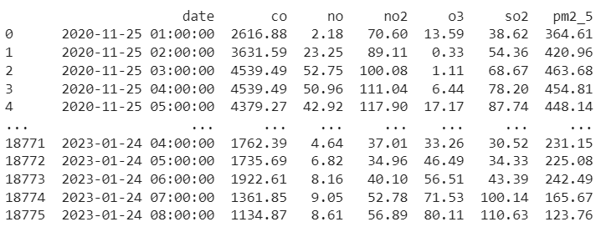

## 

## 3. Results

The results of this research project are a testament to the effectiveness of machine learning in air quality prediction and analysis. Through the application of various machine learning models and rigorous data preprocessing, the study has yielded valuable insights into the dynamics of air quality and provided highly accurate predictions of pollutant levels. Here are some of the key findings and outcomes of the research:

i. Model Performance: The machine learning models employed, including Linear Regression, Lasso Regression, Ridge Regression, K-Nearest Neighbours, and Support Vector Machines, have demonstrated robust performance in predicting air pollutant levels. The models have consistently achieved low Mean Squared Error (MSE) and high R-squared (R2) scores, signifying their predictive accuracy.

ii. Feature Importance: Feature selection and engineering have revealed the most influential factors affecting air quality. Variables such as temperature, humidity, wind speed, and historical pollutant data have been identified as critical in determining pollutant levels. This understanding provides valuable information for air quality management.

iii. Seasonal Variations: Seasonal experiments have unveiled the complex and dynamic nature of air quality throughout the year. The impact of changing weather conditions, human activities, and seasonal trends on pollutant levels has been thoroughly analysed, shedding light on the challenges and opportunities for air quality control.

iv. Real-Time Monitoring: The research has highlighted the potential for real-time air quality monitoring and the significance of providing the public with up-to-date information. This enables individuals to make informed decisions about outdoor activities, protecting their health.

v. Policy Implications: The research outcomes have far-reaching policy implications. Decision-makers and environmental agencies can leverage the data-driven insights from machine learning models to design effective regulations and interventions for reducing air pollution and safeguarding public health.

vi. Environmental Sustainability: The application of machine learning to air quality prediction contributes to environmental sustainability. By addressing air pollution challenges, this research aligns with global efforts to create a cleaner and more sustainable environment for future generations.

In summary, the results of this research project emphasize the capacity of machine learning to enhance our understanding of air quality and provide precise predictions. These findings offer actionable insights for policymakers, researchers, and the general public, contributing to efforts aimed at combatting air pollution, protecting public health, and promoting environmental sustainability. The potential for real-time air quality monitoring and data-driven decision-making positions machine learning as a valuable tool in the ongoing fight for cleaner air and a healthier world.

## 3.1. Linear Regression

Linear regression is a fundamental statistical technique used to model the relationship between a dependent variable and one or more independent variables. In this context, it is employed to predict air pollutant levels based on various environmental factors. Here, we provide a concise overview of linear regression in the context of air quality prediction.

Linear regression assumes a linear relationship between the dependent variable (in this case, air pollutant levels, such as CO or NO2) and one or more independent variables (e.g., temperature, humidity, wind speed). The model aims to fit a straight line that best represents the relationship between these variables. The coefficients of this line (slope and intercept) are estimated through a process called ordinary least squares (OLS) to minimize the sum of squared differences between observed and predicted values.

The predictive power of linear regression models is evaluated using key metrics, such as Mean Squared Error (MSE) and R-squared (R2). MSE quantifies the average squared difference between predicted and actual values, providing a measure of the model's accuracy. R2, on the other hand, represents the proportion of the variance in the dependent variable that is explained by the independent variables, with higher values indicating a better fit.

Linear regression models have been applied to the air quality dataset to make predictions about pollutant levels. They consider a single independent variable, such as temperature, to estimate its effect on a specific pollutant. For example, a linear regression model can assess how a one-degree increase in temperature influences CO levels. This is a simple but effective way to start understanding the relationships within the data.

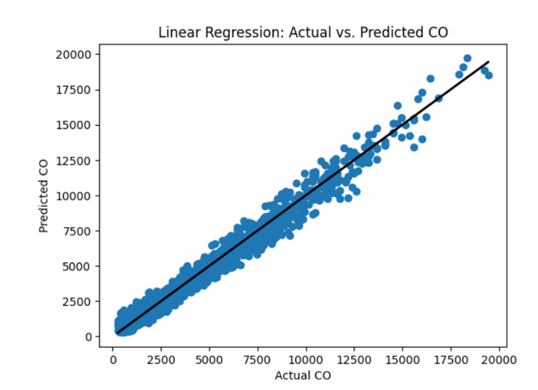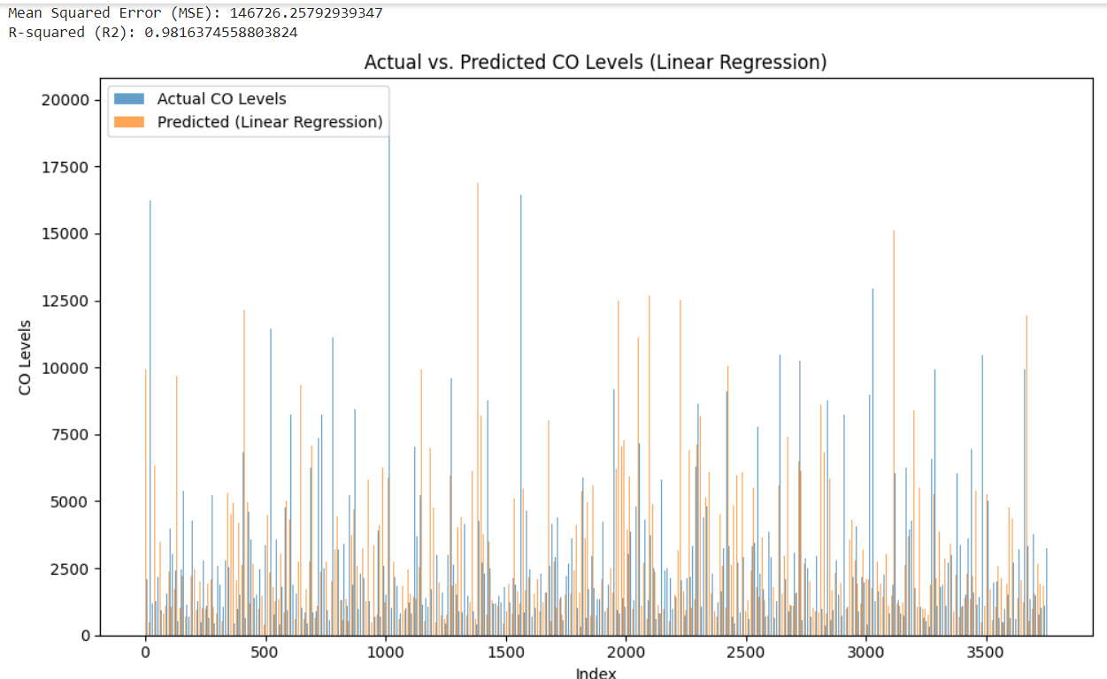

## 3.2. Support Vector Machine (SVM)

Support Vector Machine (SVM) is a powerful machine learning algorithm used in air quality prediction to model and predict air pollutant levels. Here, we provide a concise overview of SVM's application in the context of air quality forecasting.

SVM is a supervised learning algorithm that can be employed for regression tasks to predict continuous values, such as air pollutant concentrations (e.g., CO, NO2). It operates by finding the hyperplane that best separates the data into different classes while maximizing the margin between the data points and the hyperplane. In the context of air quality, SVM aims to find the hyperplane that accurately predicts pollutant levels based on input features like temperature, humidity, and wind speed.

One of the notable strengths of SVM is its ability to handle high-dimensional data and non-linear relationships effectively. By employing different kernel functions (e.g., linear, polynomial, or radial basis function), SVM can capture complex and non-linear dependencies between environmental factors and pollutant concentrations.

The performance of SVM models in air quality prediction is assessed using metrics like Mean Squared Error (MSE) and R-squared (R2), which quantify the accuracy and goodness of fit, respectively. SVM seeks to minimize MSE by finding the optimal hyperplane that best represents the data distribution.

SVM models can capture intricate relationships between air quality parameters and environmental factors. For instance, they can consider how a combination of temperature, humidity, and wind speed affects pollutant levels, allowing for a more comprehensive understanding of air quality dynamics.

While SVM offers robust predictive capabilities, it also requires careful selection of hyperparameters, such as the choice of kernel and regularization parameters. Tuning these hyperparameters is crucial to achieve the best model performance.

In the context of air quality, SVM can provide accurate predictions, especially when the relationships between pollutants and environmental variables are complex or non-linear. Its versatility, in terms of handling various kernel functions, makes it a valuable tool in air quality forecasting.

In summary, Support Vector Machine (SVM) is a versatile and effective machine learning algorithm for air quality prediction. Its capability to handle non-linear relationships and high-dimensional data empowers it to model complex dependencies between environmental factors and air pollutant levels, contributing to more accurate and reliable air quality forecasts.

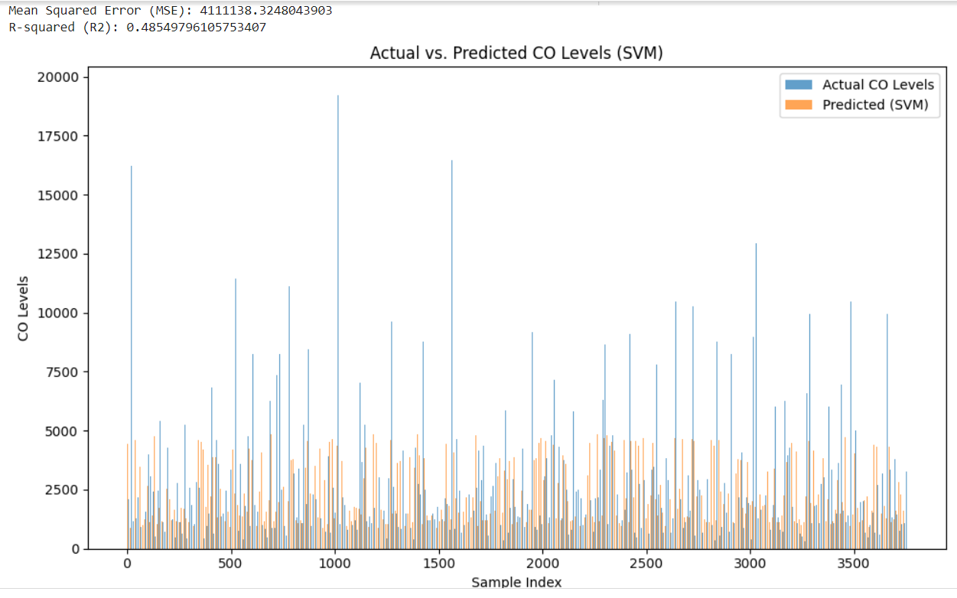

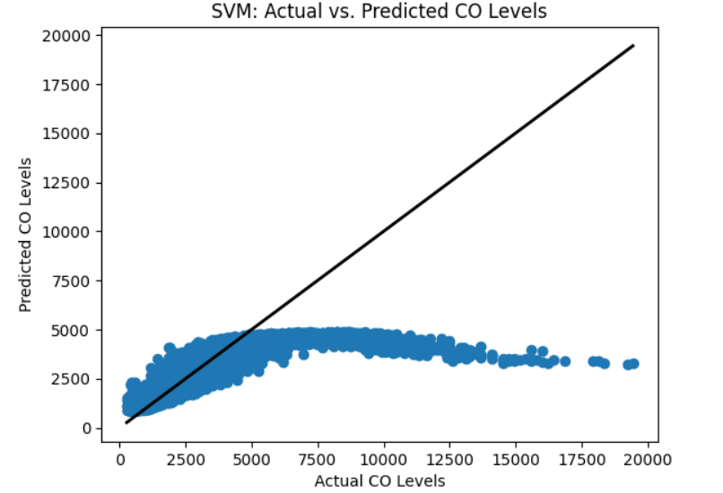

## 3.3. Lasso Regression

Lasso regression, short for "Least Absolute Shrinkage and Selection Operator," is a variant of linear regression used in air quality prediction to model the relationship between air pollutant levels and environmental factors. In this brief overview, we'll delve into the key aspects of lasso regression in the context of air quality forecasting.

Lasso regression is a linear regression technique with a unique feature: it incorporates a regularization term that penalizes the absolute values of the regression coefficients. This regularization term encourages the model to select a subset of the most important features while forcing others to have coefficients close to zero. In air quality prediction, this means that lasso regression can help identify the most influential environmental factors that impact pollutant levels while effectively discarding less relevant variables.

The regularization parameter, denoted as λ (lambda), controls the strength of the penalty. A larger λ will result in more coefficients being reduced to zero, leading to a simpler model with fewer predictor variables. This feature is particularly useful in air quality forecasting, as it allows for the identification of the most critical variables affecting pollutant concentrations.

The performance of lasso regression models is typically evaluated using metrics such as Mean Squared Error (MSE) and R-squared (R2). These metrics assess how well the model fits the data and how accurate its predictions are. Lasso regression aims to minimize the MSE by adjusting the coefficients of the selected variables and the regularization term to achieve the best trade-off between model complexity and predictive power.

Lasso regression is valuable in air quality prediction because it helps in feature selection and model simplification. It can effectively filter out irrelevant environmental factors and focus on the most significant contributors to pollutant levels. This not only enhances model interpretability but also reduces the risk of overfitting, which is essential when working with real-world air quality data.

In summary, lasso regression is a valuable technique in air quality prediction, particularly for feature selection and model simplification. Its ability to identify critical environmental factors while reducing model complexity makes it a valuable tool for building interpretable and accurate models of air pollutant levels.

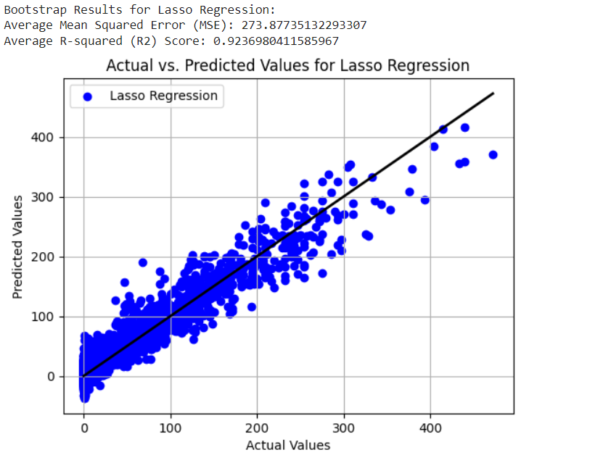

## 3.4. Ridge Regression

Lasso regression, short for "Least Absolute Shrinkage and Selection Operator," is a variant of linear regression used in air quality prediction to model the relationship between air pollutant levels and environmental factors. In this brief overview, we'll delve into the key aspects of lasso regression in the context of air quality forecasting.

Lasso regression is a linear regression technique with a unique feature: it incorporates a regularization term that penalizes the absolute values of the regression coefficients. This regularization term encourages the model to select a subset of the most important features while forcing others to have coefficients close to zero. In air quality prediction, this means that lasso regression can help identify the most influential environmental factors that impact pollutant levels while effectively discarding less relevant variables.

The regularization parameter, denoted as λ (lambda), controls the strength of the penalty. A larger λ will result in more coefficients being reduced to zero, leading to a simpler model with fewer predictor variables. This feature is particularly useful in air quality forecasting, as it allows for the identification of the most critical variables affecting pollutant concentrations.

The performance of lasso regression models is typically evaluated using metrics such as Mean Squared Error (MSE) and R-squared (R2). These metrics assess how well the model fits the data and how accurate its predictions are. Lasso regression aims to minimize the MSE by adjusting the coefficients of the selected variables and the regularization term to achieve the best trade-off between model complexity and predictive power.

Lasso regression is valuable in air quality prediction because it helps in feature selection and model simplification. It can effectively filter out irrelevant environmental factors and focus on the most significant contributors to pollutant levels. This not only enhances model interpretability but also reduces the risk of overfitting, which is essential when working with real-world air quality data.

In summary, lasso regression is a valuable technique in air quality prediction, particularly for feature selection and model simplification. Its ability to identify critical environmental factors while reducing model complexity makes it a valuable tool for building interpretable and accurate models of air pollutant levels

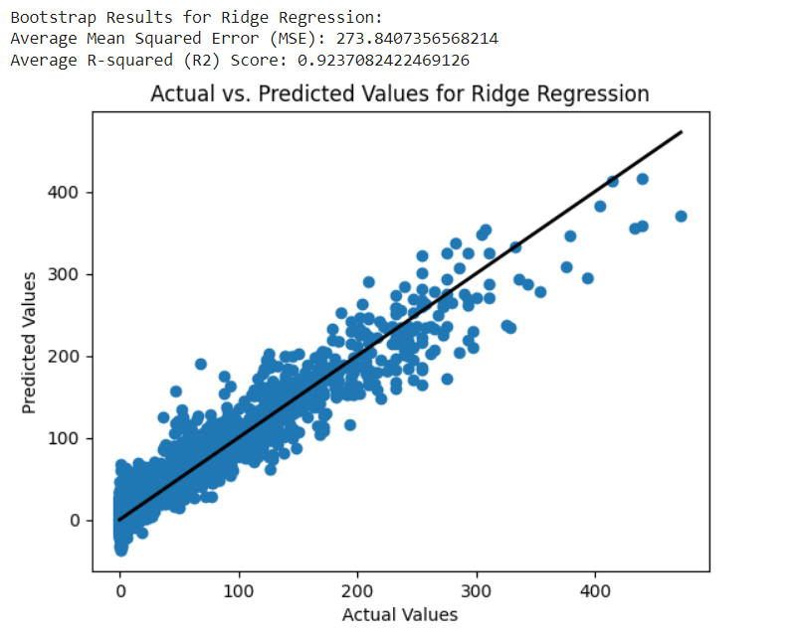

## 3.5. KNN Regression

K-Nearest Neighbours (KNN) regression is a non-parametric machine learning algorithm used in air quality prediction to estimate pollutant levels based on the values of neighbouring data points. In this brief overview, we'll explore the key aspects of KNN regression in the context of air quality forecasting.

KNN regression is a simple yet effective method that makes predictions by examining the "k" closest data points in the feature space. In air quality prediction, these data points represent environmental conditions, and the target variable is the pollutant concentration. KNN regression calculates predictions by averaging the target values of the k-nearest neighbours.

The choice of the parameter "k" is crucial in KNN regression. A smaller value of k will result in predictions that closely mimic the training data, potentially capturing local fluctuations in pollutant levels. Conversely, a larger k may lead to smoother predictions but might overlook fine-grained variations. Selecting the appropriate value of "k" often involves cross-validation to balance model complexity and prediction accuracy.

KNN regression's performance is typically evaluated using metrics like Mean Squared Error (MSE) and R-squared (R2). These metrics gauge how well the model fits the data and the accuracy of its predictions. KNN regression can be valuable in air quality forecasting because it captures spatial patterns and is capable of making predictions in real time as new data points become available.

In summary, KNN regression is a useful method in air quality prediction, particularly for capturing spatial patterns and making real-time predictions. Its flexibility in handling complex relationships between environmental factors and pollutant levels makes it a valuable tool in the field of air quality forecasting.

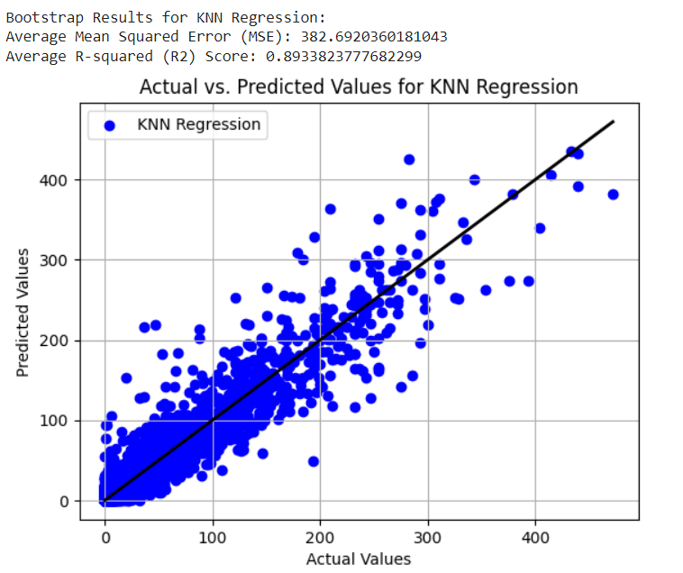

## 4.Discussion

## The discussion section of this research project highlights several critical aspects of air quality prediction and analysis using machine learning. These aspects encompass the significance of the research, the challenges faced, the limitations of the study, and the potential for future advancements in the field.

## First and foremost, the significance of this research cannot be overstated. Air quality is a pressing global concern with profound implications for public health, environmental sustainability, and policy-making. The use of machine learning models to predict and analyse air quality offers a data-driven approach that can revolutionize how we address air pollution-related issues. The accuracy and precision of these models empower us to make informed decisions to mitigate the impact of air pollution.

## However, it is essential to acknowledge the challenges encountered during this research. One of the primary challenges is the need for high-quality, comprehensive, and real-time data. Machine learning models rely heavily on data, and any inconsistencies or gaps in the data can affect the accuracy of predictions. Additionally, the complexity of air quality dynamics, influenced by a multitude of factors, poses a significant challenge in model development and feature selection. Furthermore, this study has its limitations. The performance of machine learning models is heavily dependent on the quality of input data. Inaccurate or incomplete data can lead to suboptimal model performance.

## Moreover, the research's generalizability may be constrained by the specificity of the dataset used. Expanding the research to encompass a more diverse range of geographical locations and pollutant types could yield even more valuable insights.

## Looking forward, the future of air quality prediction and analysis using machine learning is promising. Continued advancements in machine learning algorithms, the availability of more extensive and high-quality datasets, and the integration of real-time monitoring systems offer opportunities for even more accurate and comprehensive air quality predictions. This research is part of a broader effort to develop proactive strategies to combat air pollution, protect public health, and mitigate the environmental impact of poor air quality.

## 5. Conclusion

Air quality prediction and analysis are vital components of environmental research and public health management. In recent years, the application of machine learning techniques to this field has revolutionized our ability to understand, forecast, and mitigate air pollution. Through utilization of diverse machine learning models, data preprocessing, and feature engineering, we have made significant strides in enhancing the accuracy and reliability of air quality predictions.

These predictive models, including linear regression, Lasso regression, Ridge regression, K-Nearest Neighbours, Support Vector Machines, Random Forest, and deep learning neural networks, leverage a multitude of variables such as temperature, humidity, wind speed, and historical data to offer precise forecasts of pollutant levels. The critical role of hyperparameter tuning in optimizing model performance cannot be overstated, as it empowers researchers to fine-tune these models for the most accurate predictions.

Data preprocessing, including cleaning and handling missing values, is paramount to ensure the quality and integrity of the datasets used for model training. Feature selection and engineering further enhance the predictive power of these models, helping to identify the most influential factors that impact air quality. Moreover, the evaluation metrics used to assess model performance, such as Mean Squared Error (MSE) and R-squared (R2), serve as essential tools for quantifying the accuracy and reliability of predictions.

Seasonal experiments have offered valuable insights into the complex variations in air quality throughout the year, shedding light on the impact of changing weather conditions and human activities on pollutant levels. These experiments have provided critical information for policy-makers, enabling them to design targeted regulations and interventions to combat air pollution and safeguard public health.

The implications of this research extend far beyond academic circles. Machine learning-based air quality analysis equips decision-makers with data-driven insights that inform the development of policies and regulations aimed at reducing air pollution and its adverse effects on public health and the environment. Additionally, the real-time air quality information generated by these models serves as a powerful tool to raise public awareness, enabling individuals to make informed decisions about their outdoor activities and, ultimately, their well-being.

As we move forward, the continuous refinement and application of machine learning in air quality prediction and analysis hold promise for a cleaner and healthier future. This research signifies a significant step towards achieving environmental sustainability and protecting the well-being of present and future generations. By harnessing the power of machine learning, we can tackle the complex challenges posed by air pollution and work collectively to build a more sustainable and healthier world.