**Experient-9**

**Data Link Layer Traffic Simulation using Packet Tracer Analysis of CSMA/CD & CSMA/CA.**

**Step1:**  1 hub and 6 PCs

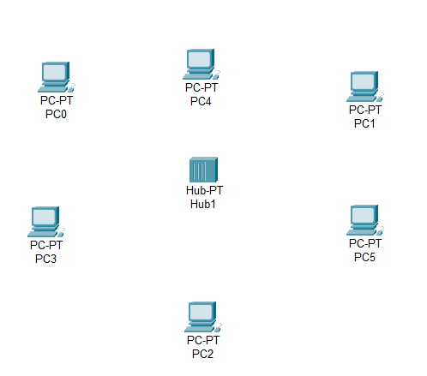

**Step2:** connect fast ethernets from hub to PCs

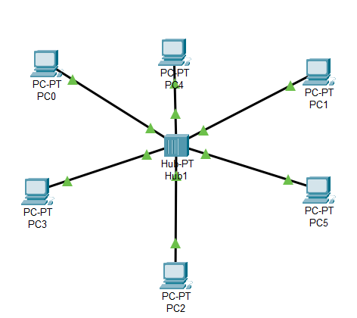

**Step3:** Assign IP address for each PCs

IP address for PC38:192.168.1.7

IP address for PC39: 192.168.1.8

IP address for PC40: 192.168.1.9

**Step4:** allocate the message

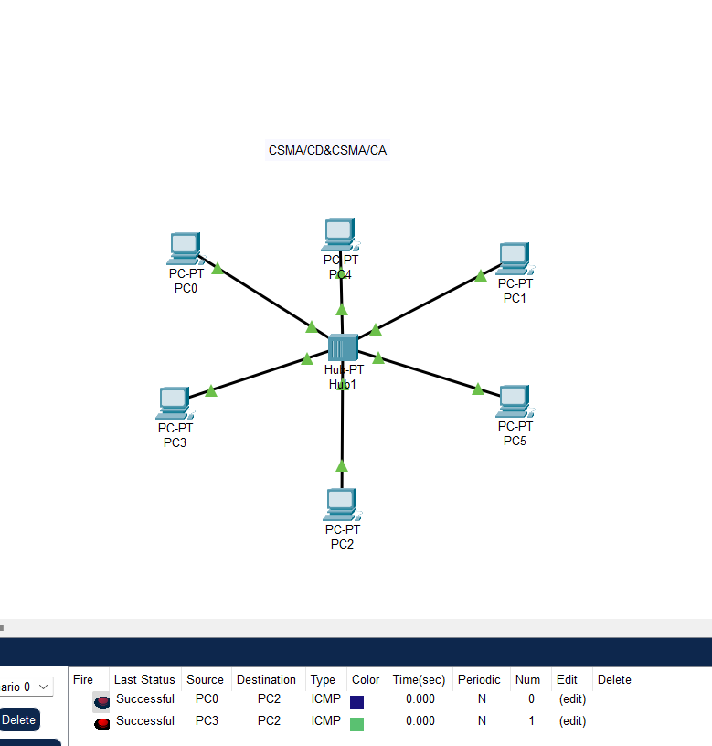

**Result:** message sent successfully from PC38-PC40