**CHAPTER-1**

**INTRODUCTION**

OFDM (Orthogonal Frequency Division Multiplexing) is currently one among the most commonly used modulation techniques in present wireless communication systems. It is a multi-carrier modulation technique that divides the available frequency spectrum into multiple orthogonal sub-carriers, each of which carries a portion of the transmitted data. OFDM is found in many wireless communication systems such as Wi-Fi, LTE, and 5G. OFDM is a modulation technique employed in both 4G and 5G networks. It is used to divide a wide frequency band into multiple narrow sub-bands, allowing for more efficient use of the available spectrum. OFDM is used in both 4G and 5G networks because it is a very efficient way of transmitting data over a wide frequency band. It is also very robust against interference, making it an ideal choice for wireless networks. Implementing an OFDM transceiver with GNU Radio is a very effective way to learn about the fundamentals of OFDM and gain hands-on experience with the technology. Software-defined radios and signal-processing systems can be implemented using GNU Radio, which provides signal processing blocks for open-source developers. It can be combined with external RF hardware in order to design software-defined radios, or without using hardware in a simulation-like environment. Besides being widely used in research, industry, government, and hobbyist environments, it can also be used for real-life radio communication systems. Using GNU Radio to implement an OFDM transceiver requires a basic understanding of the OFDM modulation technique and the GNU Radio environment. The first step is to create a flow graph in GNU Radio Companion (GRC) that implements the OFDM transceiver. This flow graph will contain blocks for the transmitter and receiver, as well as blocks for signal processing and data manipulation. Once the flow graph is created, it can be tested using software-defined radio (SDR) platforms. Once the flow graph is tested and verified, it can be used to transmit and receive data over the air. This is a very practical way to gain hands-on experience with OFDM and to learn more about the fundamentals of communication systems. Implementing an OFDM transceiver through GNU Radio is a very effective way to gain a deeper understanding of the technology and to gain valuable experience with communication systems.

# **CHAPTER-2**

# **LITERATURE SURVEY**

**[1] “Performance Analysis of MIMO-OFDM System with Transceiver Hardware Impairments”**

Presented by Anuj Singal,Deepak Kedia, Naveen Jaglan of GJUS&T Hisar Haryana in 2017,pg no. 102-106.

This paper aims to improve channel capacity and SNR multiplexing gain through MIMO-OFDM, with and without hardware impairments. Channel capacity and SNR are compared using MIMO-OFDM at various SNR levels.

**[2] “A Review on Design and Analysis of 5G Mobile Communication MIMO System with OFDM”**

Proposed by Saurabh B.Ramteke,A Y Deshmukh, Prof. K N Dekate of G H, Raisoni College of Engineering, Nagpur, India.

In this paper channel capacity was increased using MIMO and OFDM with AODV routing protocol. BDMA and FDMC modulation techniques were also used in order to improve channel capacity.

**[3] “5G New Radio, Prototype Implementation Based on SDR”**

Presented by Loma Y. Hosni, Ahmed Y. Farid, Abdelrahman, A. Elssadany, Mohammad A. Safwat.

In this paper, the Physical Downlink Shared Channel (PDSCH) of 5G NR is implemented on an SDR. The design incorporates LDPC and NOMA techniques.

**[4] “Software Defined Radio Prototype with Visual C++ Express and Code Composer Studio”**

Proposed by Sverre Wichlund in 2012.

This document shows a demonstration of a IEEE 802.11a processor scaled down to 6kHz on the DSK6713 using C++ coding. Limited bandwidth and slow process.

**[5] “Performance Evaluation of OFDM Based 256- and 1024-QAM in multipath Fading Propagation Conditions”**

Presented by Tomoki Ota, Mitsutoshi Nakamura, Hiroyuki Otsuka in 2017.

In this paper simulation of an OFDM-based transmission model with 256- and 1024- QAM under multipath fading propagation conditions. No real-world applications.

**[6] “OFDM System Implementation in DSP Platform TMS320C6678”**

Proposed by Rafael Masashi Fukuda, Taufik Abrao in 2016.

This paper presents the basic OFDM implementation on a DSP and the evaluation of DSP resources by sending image data.

**CHAPTER-3**

**PROBLEM STATEMENT**

The Orthogonal Frequency Division Multiplexing (OFDM) is a popular multiplexing technique used in modern wireless communication systems, such as 4G/5G cellular networks and Wi-Fi. It has several advantages, such as high spectral efficiency and robustness to fading and interference, which make it suitable for high-data rate applications. However, its performance can be affected by various factors, such as the choice of the modulation scheme, the number of subcarriers, the type of channel coding, and the implementation platform.

Software-Defined Radio (SDR) platforms, such as GNU Radio, provide a flexible and cost-effective solution for implementing and experimenting with different communication systems, including OFDM. However, the performance of OFDM on SDR platforms is not well understood, and it is not clear how different design choices and implementation factors affect the overall performance.

Following are the drawbacks that we identified from our literature survey:

* Paper, I compared the channel capacity and SNR of MIMO-OFDM systems with the goal of improving these two properties. However, no hardware was considered in the analysis of these systems.
* Paper II uses the AODV routing protocols to improve the throughput of systems with MIMO-OFDM, which was verified by simulation tools.
* Paper III explores the possibility of creating a 5G New Radio on an SDR platform. 5G New Radio is a new generation of mobile communication technology that offers faster speeds and more efficient use of available spectrum. It also enables a higher number of connected devices and improved support for advanced applications. However, the system is verified only with the PDSCH, ignoring all other channels.
* Paper IV and Paper VI use a digital signal processor to implement an OFDM system. IEEE 802.11a is implemented and down sampled to a lower frequency on the DSK6713 due to processing limitations. This standard uses OFDM for higher channel capacity and transmission rates. Paper VI uses a simple OFDM implementation for analysis on a DSP.

The goal of this project is to evaluate the performance of OFDM on SDR platforms, using GNU Radio as the implementation platform. The focus of the study will be on the following research questions:

* How does the choice of the modulation scheme (e.g., QAM, PSK) and the number of subcarriers affect the performance of OFDM on SDR platforms?
* How does the use of channel coding (e.g., forward error correction) impact the performance of OFDM on SDR platforms?
* How does the implementation of OFDM on SDR platforms compare to the performance of OFDM on other hardware platforms, such as specialized radios or field-programmable gate arrays (FPGAs)?
* What are the main limitations and challenges of implementing OFDM on SDR platforms, and how can they be addressed?

To answer these research questions, this project will involve the design, implementation, and performance evaluation of OFDM on SDR platforms using GNU Radio. The performance will be measured in terms of various metrics, such as bit error rate, spectral efficiency, and throughput, under different scenarios and conditions. The results of the study will provide valuable insights into the performance of OFDM on SDR platforms and help guide the design and implementation of OFDM-based communication systems on these platforms.

# **CHAPTER-4**

**OBJECTIVES**

* To design, implement and evaluate the performance of OFDM on a SDR device using GNU Radio
* To support a wide range of data rates and modulation schemes in the communication system by using OFDM, which allows for the flexible allocation of subcarriers to different data streams.
* Evaluate the effect of the modulation scheme chosen (e.g., QAM, PSK), channel coding and the number of subcarriers affect the performance of OFDM on the SDR platform.
* Comparison of the implementation of OFDM on other hardware such as digital signal processors (DSPs) and Field Programmable Gate Arrays (FPGAs).
* Using advanced signal processing techniques on the OFDM transmitter and receiver to improve the performance of the communication system, such as channel estimation, equalization, and error correction.

# **CHAPTER-5**

**BLOCK DIAGRAM**

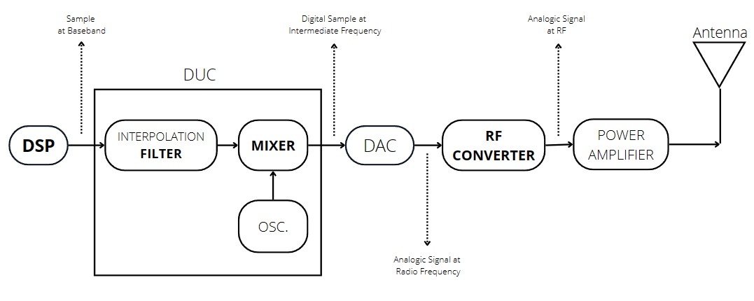

Fig 5.a Transmitter Block

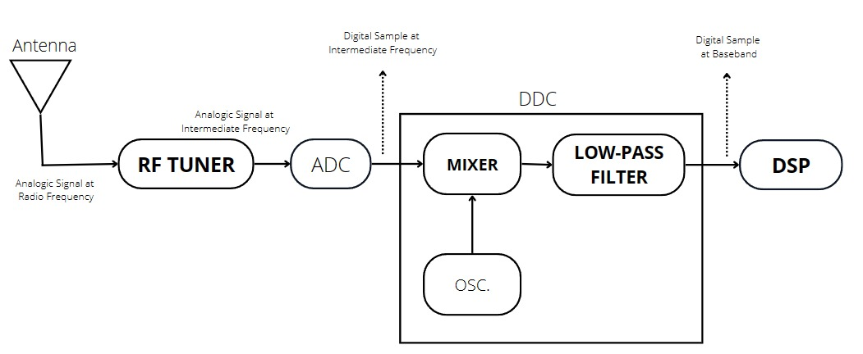

Fig 5.B Receiver Block

**CHAPTER-6**

**METHODOLOGY**

# **CHAPTER-7**

**SOFTWARE & HARDWARE REQUIREMENTS**

1. **Software-Defined Radio**

The Software Defined Radio is a device used to design and prototype communication systems. The platform is used in a variety of research, commercial, and military projects for prototyping and developing software radio applications

The concept of SDR takes us back to the early 1900s, when scientists and engineers first began exploring the use of software to control and manipulate radio signals. However, in the latter half of the 20th century, the development of SDR began to take off. This was driven by advances in computer technology and the increasing demand for flexible and adaptable radio systems.

One of the earliest and most influential developments in SDR was the development of the Universal Software Radio Peripheral (USRP), a device that allows users to experiment with SDR and build their own radio systems. The USRP, developed by Matt Ettus and a team at the University of California, Berkeley, was introduced in 2003. It has since become a widely used platform for SDR research and development.

Since the introduction of the USRP, there have been numerous advancements and innovations in SDR technology. These involve the development of new software libraries and frameworks for SDR, such as GNU Radio and Pothos. In addition, the introduction of brand-new hardware platforms, such as LimeSDR and HackRF. These tools and platforms have made it easier for researchers and developers to experiment with and build their own SDR systems. They have helped to drive the continued advancement of SDR technology.

In addition to these technical advancements, SDR has also seen increasing adoption in a wide range of applications, including military communications, cellular networks, and the wireless internet. SDR has proven to be particularly useful in military applications, where the ability to quickly and easily adapt to changing circumstances and environments is crucial. SDR has also become a key component of many emerging technologies, such as 5G and the Internet of Things (IoT), which rely on the flexibility and adaptability of SDR to support a wide range of devices and applications.

Overall, the history of SDR has been one of continuous development and innovation. This is due to ongoing advances in hardware and software helping to push the boundaries of what is possible with radio communication. This enables the development of creative and exciting applications. While SDR technology has come a long way since its inception, there is still much room for further advancement and innovation. It is likely that SDR will continue to play a major role in the future of radio communication.

**Advantages of SDR Systems**

**Flexibility and adaptability:** SDR systems are highly flexible and adaptable, as the physical layer functions are implemented in software rather than hardware. This allows for easy modification and updates to meet changing requirements or to add new capabilities.

**Cost savings:** SDR systems can be more cost-effective than traditional radio systems, as the use of software rather than hardware can reduce the cost of development and maintenance.

**Rapid prototyping:** SDR systems can be quickly and easily prototyped using software tools and platforms, which can speed up the development process and reduce the time to market.

**Interoperability:** SDR systems can be designed to be interoperable with a wide range of communication standards and protocols, which can facilitate the integration of different systems and devices.

**Reusability:** SDR systems can be easily reused and repurposed for different applications, as the software can be easily modified to meet different requirements.

**Applications Of SDR Systems:**

In areas like mobile communications, software defined radios are extremely useful. By updating the program, it is possible to make adjustments to any specifications and even incorporate new waveforms without having to upgrade the hardware. This can also be achieved remotely, resulting in significant cost savings.

**Military communications:** SDR systems are used in military communications to provide flexible and adaptable communication capabilities for different scenarios and environments.

**Cellular networks:** SDR systems are used in cellular networks to support the growing demand for mobile communication and data services.

**Wireless internet:** SDR systems are used in wireless internet networks to provide broadband connectivity to a wide range of devices and users.

**Radio broadcasting:** SDR systems are used in radio broadcasting to transmit and receive audio and data signals over the airwaves.

**Industrial automation:** SDR systems are used in industrial automation to support the integration of different devices and systems, such as sensors and actuators.

**Internet of Things (IoT):** SDR systems are used in the IoT to support the integration of a wide range of devices and systems, such as sensors, actuators, and processors, and to facilitate communication and data exchange between these devices.

**Disadvantages:**

**Complexity:** SDR systems can be complex to design, implement, and maintain, as they rely on software and digital signal processing techniques that require specialized knowledge and skills.

**Performance:** SDR systems may not perform as well as hardware-based radio systems in some scenarios, particularly in environments with extreme temperature or radiation conditions.

**Dependency on software:** SDR systems rely on software to implement the physical layer functions, which can be vulnerable to bugs, errors, and security threats.

**Limited hardware customization:** SDR systems are limited in their ability to customize the hardware to meet specific requirements or to add new capabilities, as the hardware is typically generic and off-the-shelf.

**Compatibility issues:** SDR systems may not be compatible with all types of hardware or software platforms, which can limit their use and flexibility.

**Cost:** While SDR systems can be more cost-effective than traditional radio systems in some cases, they may also have higher upfront costs due to the need for specialized hardware and software. Significant Applications of Software Defined Radios.

**Generations of SDR**

The term "generations" is often used to describe the evolution and development of technology, and this is also true for software-defined radio (SDR). The following are some of the key "generations" of SDR that have emerged over the years:

**First generation (1G):** This refers to the earliest forms of SDR, which emerged in the 1900s and were primarily used for experimental and research purposes. These early SDR systems were limited in their capabilities and were not widely used.

**Second generation (2G):** This refers to the development of more sophisticated SDR systems in the 1980s and 1990s, which were used in a variety of applications, including military communications and cellular networks.

**Third generation (3G):** This refers to the development of SDR systems in the 2000s, which were designed to support the growing demand for wireless internet and other broadband applications.

**Fourth generation (4G):** This refers to the development of SDR systems in the 2010s, which were designed to support the increasing demand for high-speed data transmission and the proliferation of mobile devices.

**Fifth generation (5G):** This refers to the development of SDR systems in the 2020s and beyond, which are designed to support the growing demand for high-speed, low-latency communication and the proliferation of the Internet of Things (IoT).

HARDWARE COMPARISON OF DIFFERENT GENERATIONS

|  |  |  |  |  |
| --- | --- | --- | --- | --- |
| **1G** | **2G** | **3G** | **4G** | **5G** |
| ADC | ADC | ADC | ADC | ADC |
| DAC | DAC | DAC | DAC | DAC |
| MICROPROCESSORS | MICROPROCESSORS | MICROPROCESSORS | MICROPROCESSORS | MICROPROCESSORS |
| - | DSP PROCESSORS | DSP PROCESSORS | DSP PROCESSORS | DSP PROCESSORS |
| - | FPGA’S | FPGA’S | FPGA’S | FPGA’S |
| - | - | ASIC’S | ASIC’S | ASIC’S |

1. **GNU Radio:**

GNU Radio is a free software development toolkit that provides signal processing blocks to implement Software defined radio and signal processing m systems. It can be used with external RF hardware to create software-defined radios, or without hardware in a simulation-like environment. It is widely used in hobbyist, academic, and commercial environments to support both wireless communications research and real-world radio systems.

**History of GNU radio:**

GNU Radio is a free and open-source software development toolkit that is widely used for designing, implementing, and testing software-defined radio (SDR) systems. It was first developed in the late 1990s by Eric Blossom, a software engineer and amateur radio operator.

Blossom was inspired to create GNU Radio as a way to explore the possibilities of SDR and to make it more accessible to a wider community of users. He believed that SDR had the potential to revolutionize the way that radio communication systems were designed and used, and he wanted to make it easy for people to experiment with and learn about SDR.

To achieve this goal, Blossom developed GNU Radio as a collection of software libraries and tools that could be used to design and implement SDR systems using a variety of hardware platforms. He also created a community website and forums to encourage collaboration and sharing of ideas among users.

Over the years, GNU Radio has grown in popularity and has become a key tool for many researchers and developers working in the field of SDR. It is now used by a wide range of organizations and individuals, including government agencies, military organizations, universities, and private companies, to design and implement SDR systems for a variety of applications.

Overall, GNU Radio has played a significant role in the development and advancement of SDR technology, and it continues to be a valuable resource for anyone interested in exploring the possibilities of SDR.

**Software Description**

**Operating systems:** GNU Radio is supported on a variety of operating systems, including Linux, macOS, and Windows.

**Hardware platforms:** GNU Radio can be used with a wide range of hardware platforms, including general-purpose computers, embedded systems, and specialized SDR hardware.

**Communication standards:** GNU Radio supports a wide range of communication standards and protocols, including analog and digital radio, cellular, and wireless networking.

**Signal processing:** GNU Radio provides a range of signal processing algorithms and features, including filters, modulation and demodulation, encoding and decoding, and error correction.

**Graphical user interface:** GNU Radio includes a graphical user interface (GUI) that allows users to design and implement SDR systems using a visual programming approach.

**Software libraries:** GNU Radio consists of a collection of software libraries that can be used to develop custom SDR applications and to interface with hardware devices.

# **CHAPTER-8**

**CURRENT PROGRESS**

As a part of our final project, we are successfully implemented the basic receiver and transmitter blocks involving basic modulation and multiplexing blocks using GNU radio platform and

# **CHAPTER-9**

**EXPECTED RESULTS**

* System would be an efficient and reliable communication system that can be used for various applications.
* The system should be able to transmit and receive data reliably and accurately, with minimal interference from other signals.

# **CHAPTER-10**

## **APPLICATIONS**

* **Wireless communication** : OFDM can be widely as wireless communication systems such as Wi-Fi, WiMAX, LTE, and 5G
* **Broadcasting:** OFDM can be used in digital television and radio broadcasting, such as DVB-T, ATSC, and ISDB-T.
* **Radar:** OFDM can be used for radar applications, such as Synthetic Aperture Radar (SAR).
* **Vehicular Communications:** OFDM can be used in vehicular communication systems, such as Dedicated Short Range Communications (DSRC).

# **CHAPTER-11**

**REFERENCES**

1. A. Singal, D. Kedia, N. Jaglan and S. D. Gupta, "Performance analysis of MIMO-OFDM system with transceiver hardware impairments," 2017 4th International Conference on Signal Processing, Computing and Control (ISPCC), 2017, pp. 102-105, doi: 10.1109/ISPCC.2017.8269658.: 10.1109/ICVEE50212.2020.9243264.
2. T. Ota, M. Nakamura and H. Otsuka, "Performance evaluation of OFDM-based 256- and 1024-QAM in multipath fading propagation conditions," 2017 Ninth International Conference on Ubiquitous and Future Networks (ICUFN), 2017, pp. 554-556, doi: 10.1109/ICUFN.2017.7993849.
3. M. H. Mahmud, M. M. Hossain, A. A. Khan, S. Ahmed, M. A. Mahmud and M. H. Islam, "Performance Analysis of OFDM, W-OFDM and F-OFDM Under Rayleigh Fading Channel for 5G Wireless Communication," 2020 3rd International Conference on Intelligent Sustainable Systems (ICISS), 2020, pp. 1172-1177, doi: 10.1109/ICISS49785.2020.9316134.
4. A. L, A. K, P. Savarinathan and A. Jayapalan, "Data Transfer through OFDM transceiver with the aid of GNU Radio," 2021 International Conference on Computer Communication and Informatics (ICCCI), 2021, pp. 1-5, doi: 10.1109/ICCCI50826.2021.9402541.