**Name: Harshavardhana K**

**USN: 1BM18CS035**

**Program Number :**

**Program Title : Temperature detection**

**AIM: To display the temperature in Celsius to Fahrenheit.**

**Hardware Required:**

* **Arduino Board**
* **Temperature sensor**

**Circuit Diagram:**

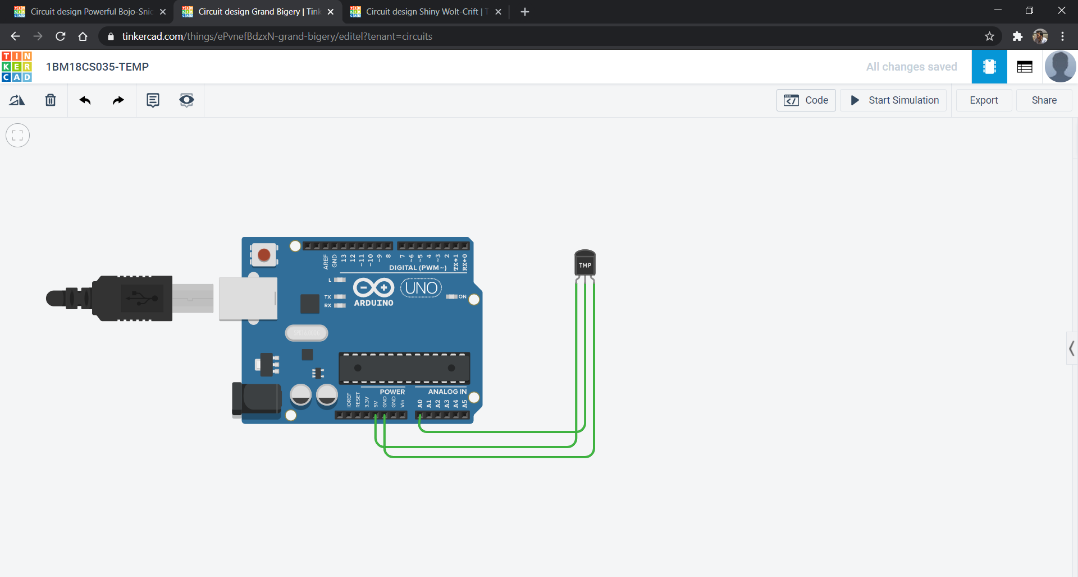

**Circuit diagram along with code:**

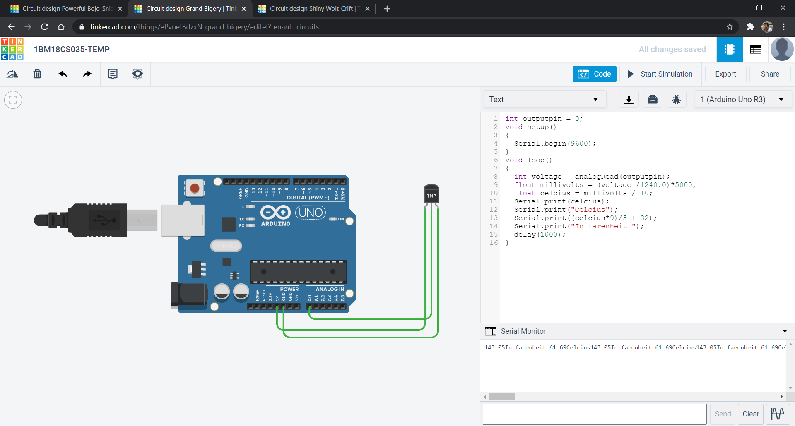

**Simulation:**

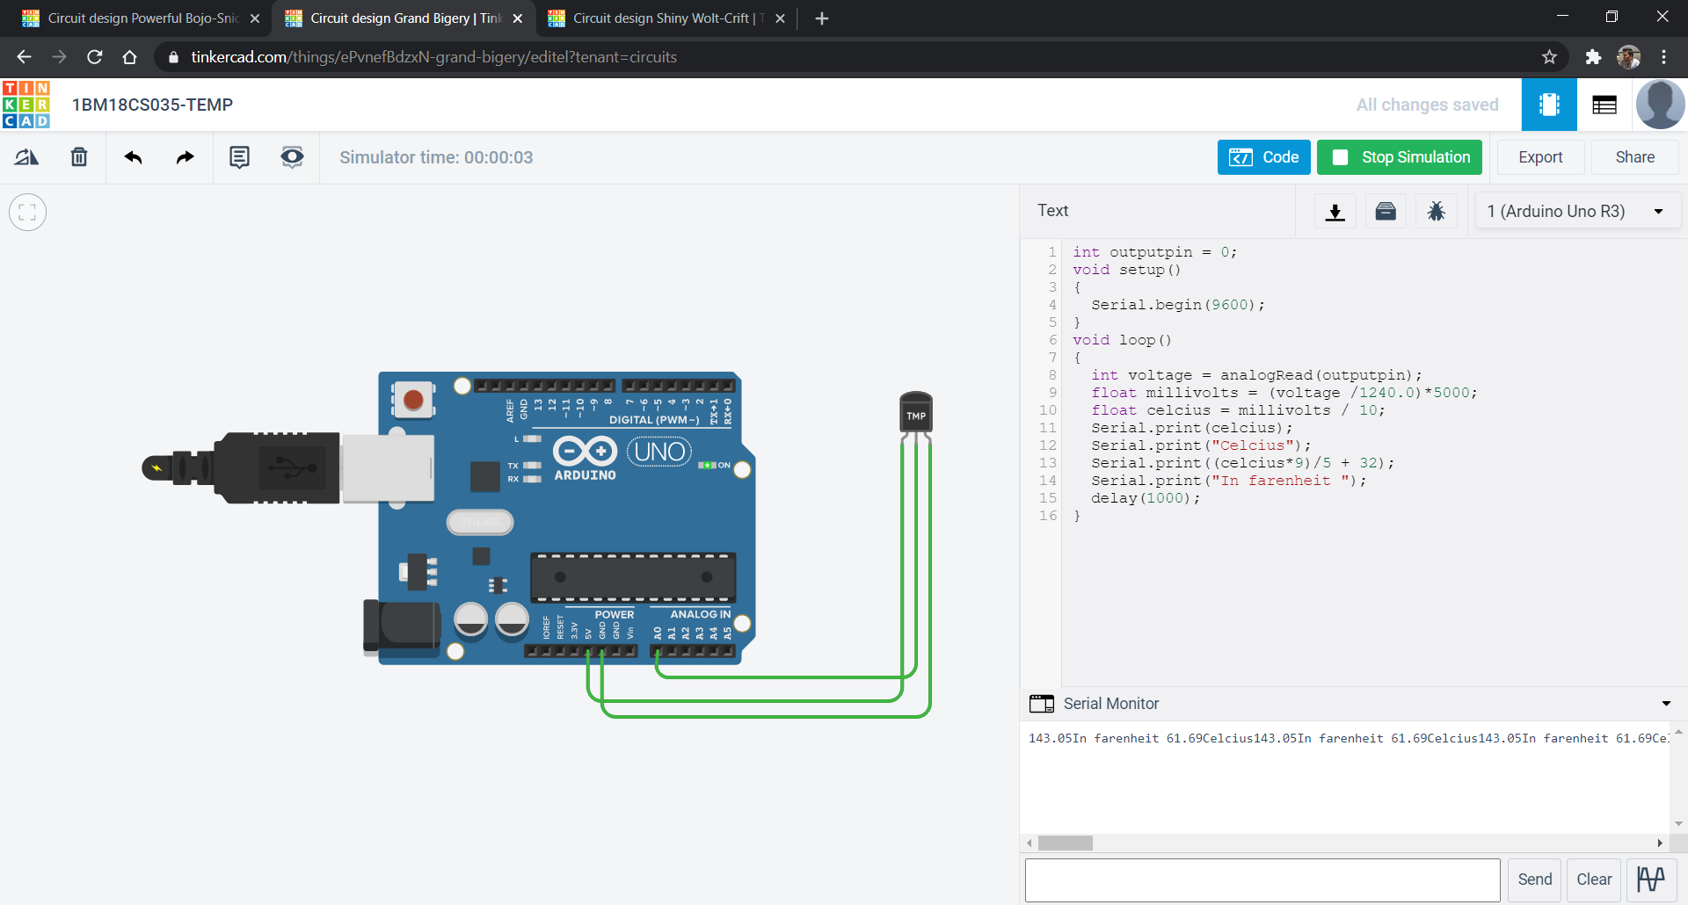

**Code:**

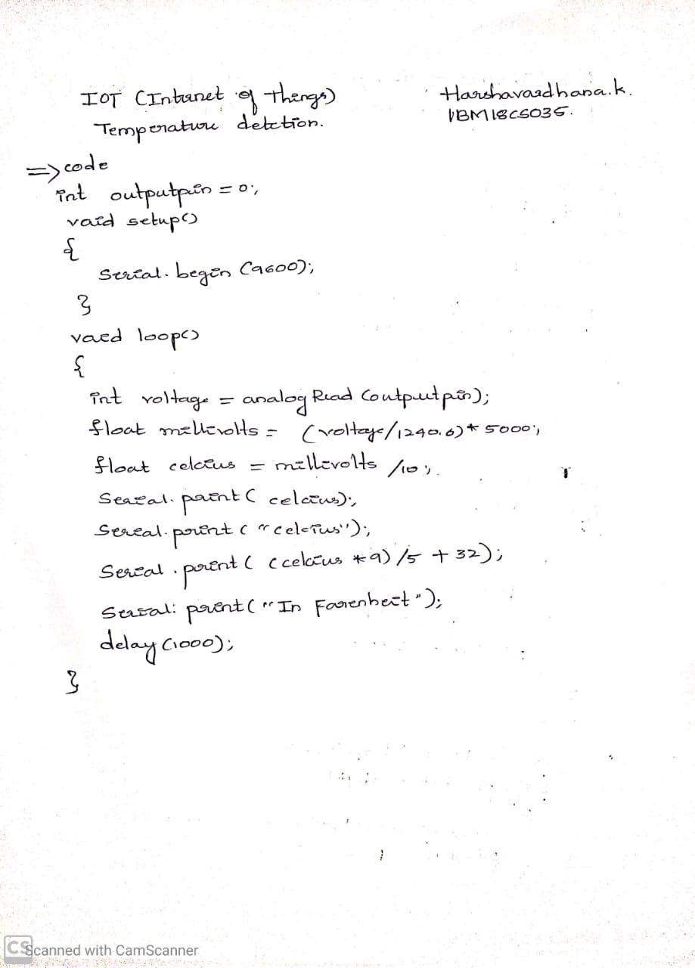

**Observation/output:**

Temperature was displayed in Celsius and fahrenheit.