**Name: Harshavardhana K**

**USN: 1BM18CS035**

**Program Number :**

**Program Title : Tilt Sensor**

**AIM: LED glows whenever there is a rise in mercury level.**

**Hardware Required:**

* **Arduino Board**
* **LED**
* **Tilt sensor**
* **Resistor**

**Circuit Diagram:**

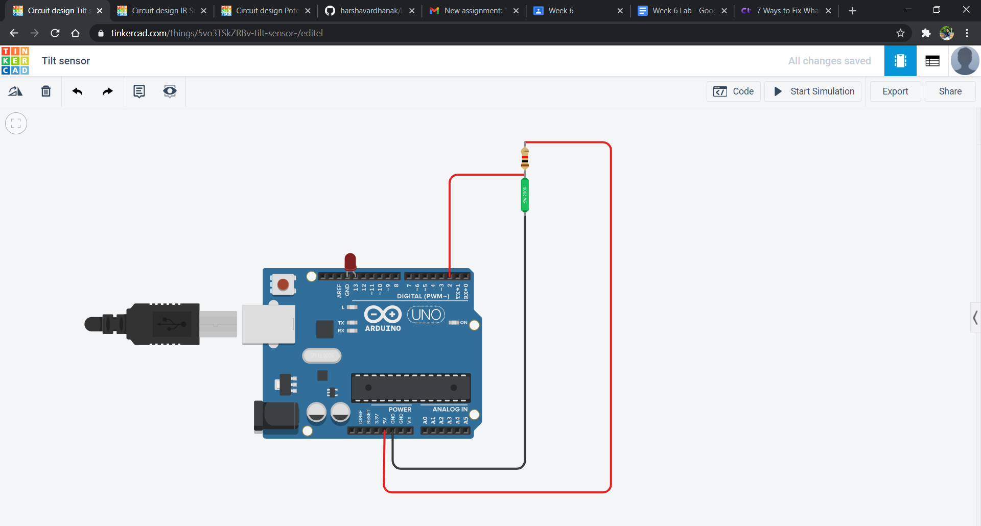

**Circuit diagram along with code:**

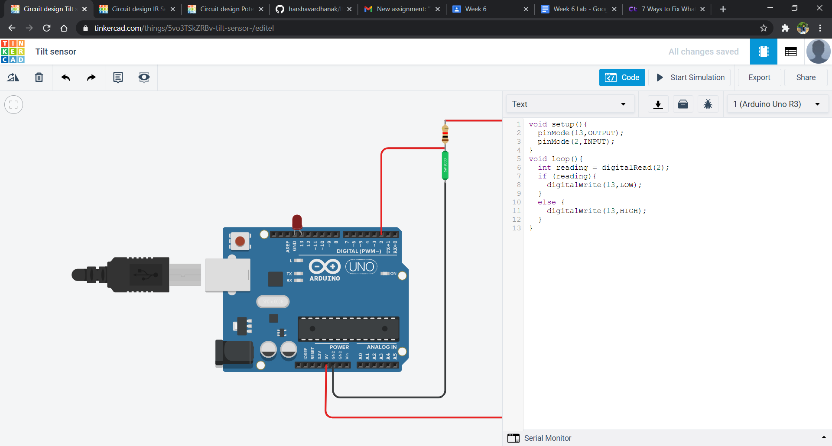

**Simulation:**

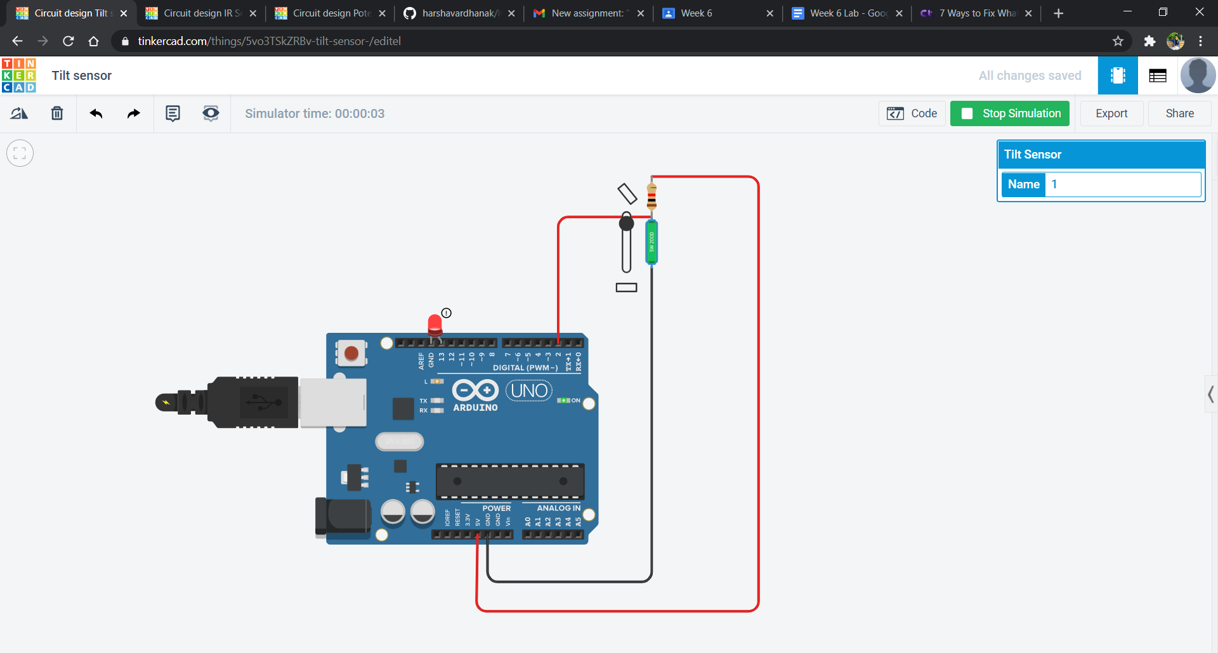

**Code:**

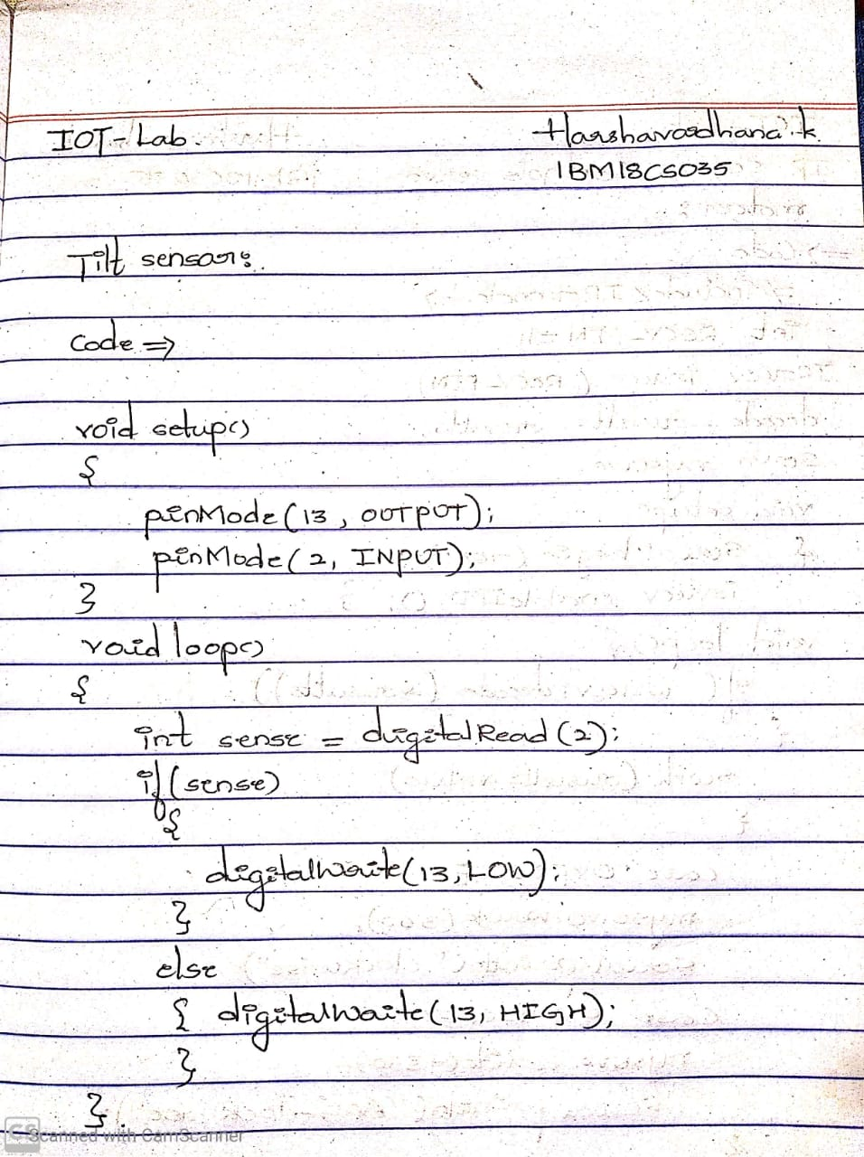

**Observation/output:**

LED glows whenever there is a rise in mercury level.