Overview: This project evaluates vendor performance and retail inventory dynamics to drive strategic insights for purchasing, pricing and inventory optimization. A complete data pipeline was built using SQL for ETL, Python for analysis and hypothesis testing, and Power BI for data visualization.
Business problem: Effective inventory and sales management are critical for optimizing profitability in the retail and wholesale industry. Companies need to ensure that they are not incurring losses due to inefficient pricing, poor inventory turnover, or vendor dependency. The goal of this analysis is to:
- Identify underperforming brands that require promotional or pricing adjustments.
- Determine top vendors contributing to sales and gross profit.
- Analyze the impact of bulk purchasing on unit costs.
- Assess inventory turnover to reduce holding costs and improve efficiency.
- Investigate the profitability variance between high-performing and low-performing vendors.

Exploratory Data Analysis insights:
Summary statistics
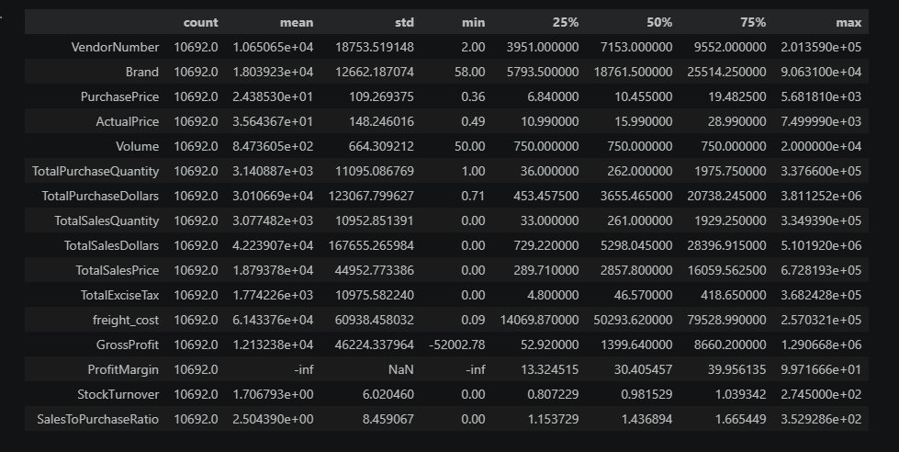

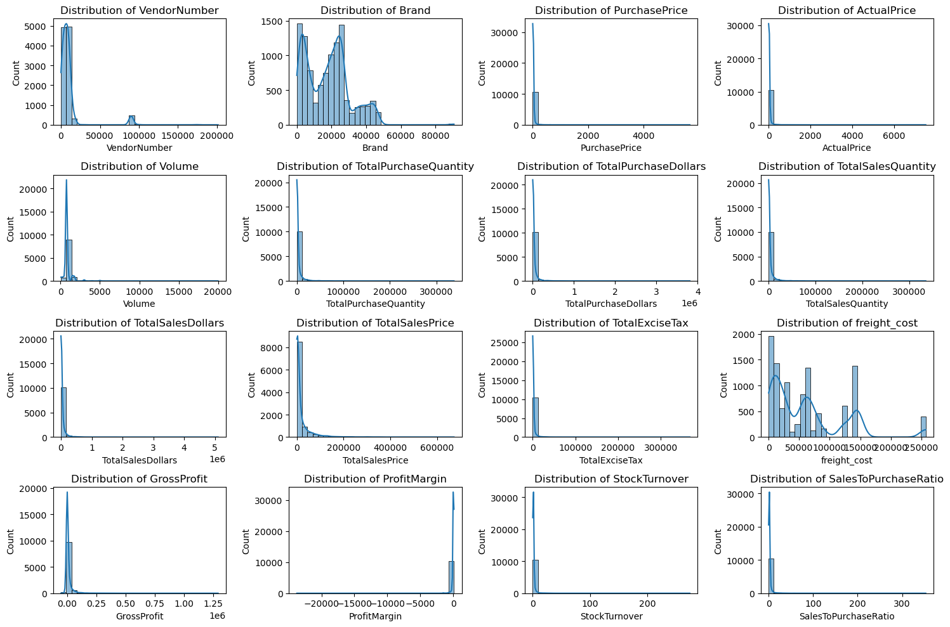

Negative &Zero values
Gross profit: Minimum of -52002.28 indicates potential losses due to high costs or heavy discount.
Profit margin: It has a minimum of -infinity which suggests instance where revenue is zero or even lower than the total cost leading to the extreme -ve profit margins.
Total sales quantity & sales dollars: Some products show zero sales indicating they were purchased but never sold. This may be slow moving stocks leading to stock inefficiency.
Outliers detected by high standard deviation for:
Purchase & actual prices- The maximum values go upto (5681 & 7500) are significantly higher than the mean (24.4 & 35.64) indicates premium products.
Freight cost: Extreme variation from 0.09 to 257032 suggests logistics efficiency bulk shipments or erratic shipping costs across different products.
Stock Turnover: It ranges from 0 to 274.5 suggesting some products sell rapidly while others remain unsold for a product exceed the purchased quantity due to older stock fulfilling orders.

Data filtering:
To enhance the reliability of the insights, we removed inconsistency data points where:
- Gross profit < 0
- Profit margin< 0
- Total sales quantity =0

Correlation Insights:
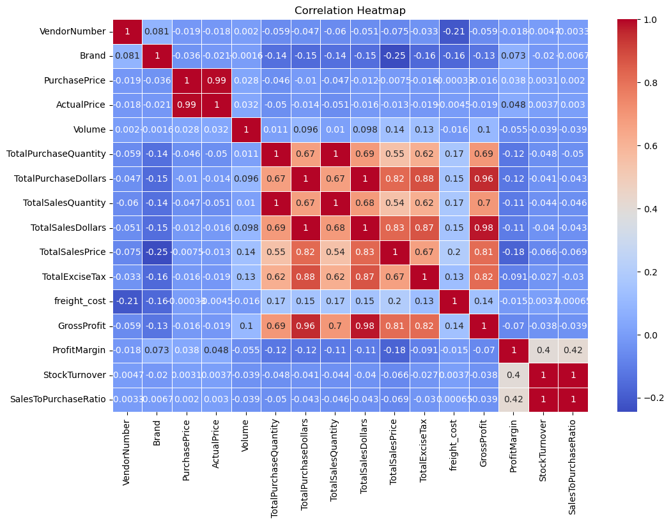
1)Purchase price has weak correlation with Total sales dollars (-0.012) and Gross profit (-0.016) suggesting that price variations don't significantly impact sales revenue and profit.
2)Strong correlation between total purchase quantity and total sales quantity (0.99).
3)Negative correlation between profit margin and total sales price (-0.18) which has weak inverse relationship between each other.
4)There is strong relation between the total sales dollars and total purchase dollars with the gross profit.

Research questions and key findings:
1.Brands for promotional and pricing adjustments
This is the brands which has lower sales which is less than $10000 but higher profit margin. There are 198 brands which fulfill the criteria which will benefit from target marketing , promotion or price optimization to increase volume without compromising profitability.
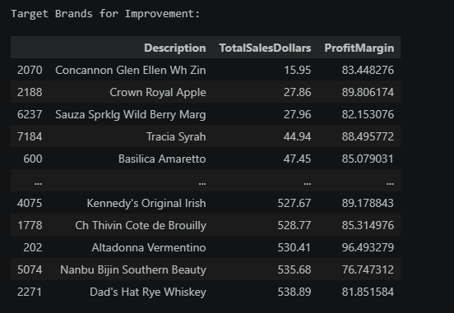

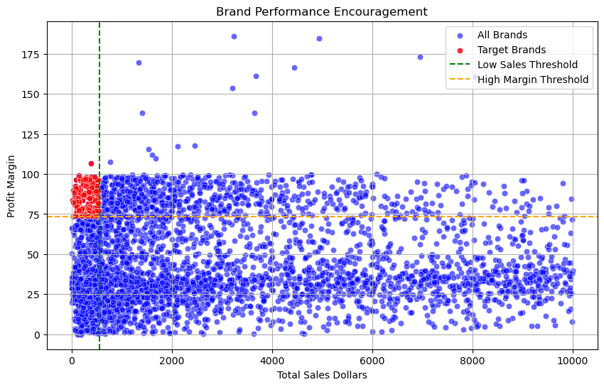
2.Top vendors by sales and purchase contribution
The top 10 vendors contribute 65.69% of total purchases so over reliance on a few vendors may introduce risks such as supply chain disruption so there is need for diversification.
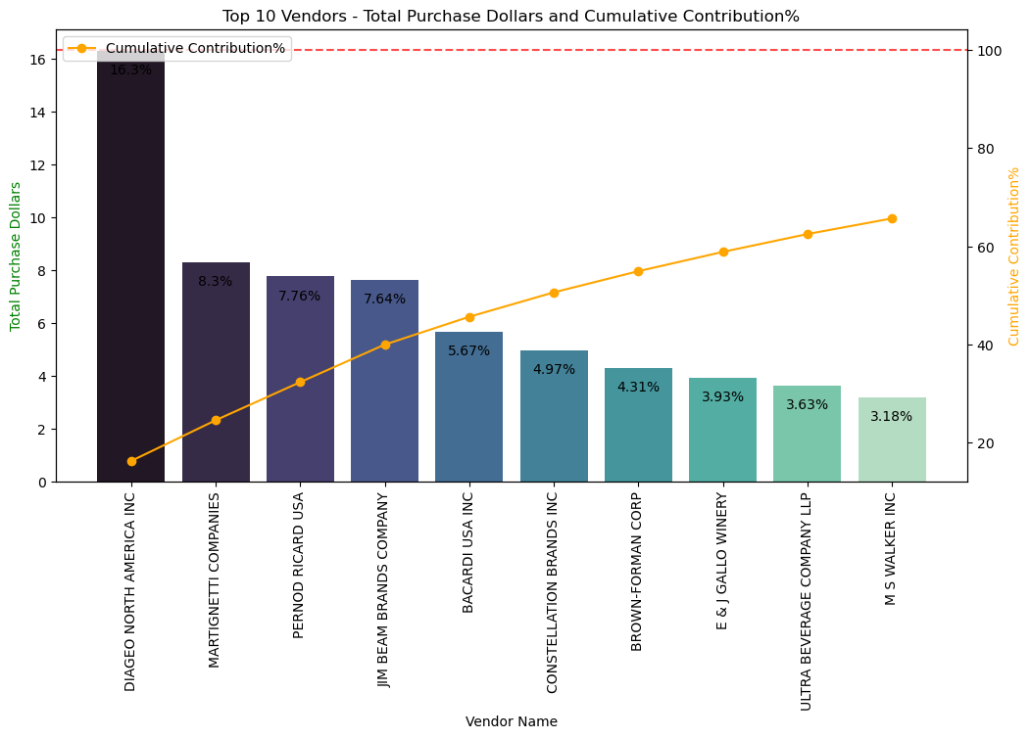

After purchase we have top vendors and brands who perform well in sales so getting know about them will help us the effective vendors and brands for market expansion by focusing on them.
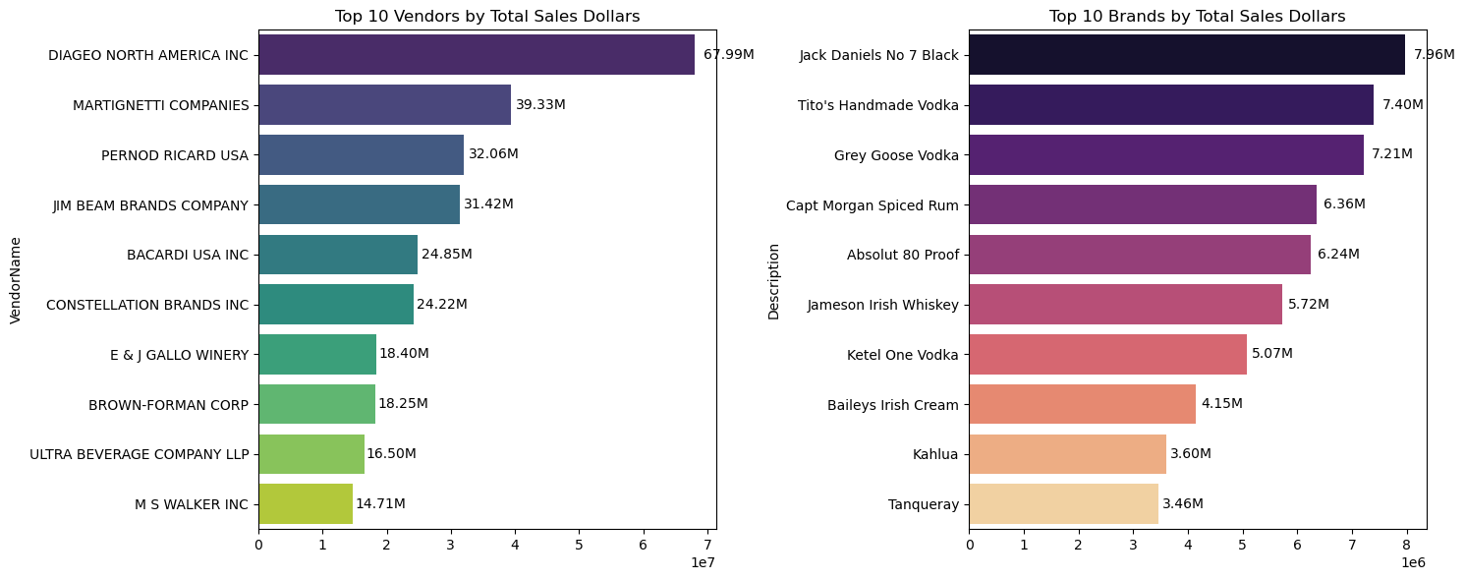

3.Poor performing vendors and brands
To know it we take total sales less than $10000 and profit margin less than 15% so it results to 512 brands and 5 vendors. It will help to give them management, financial and marketing support for such vendors and brands.
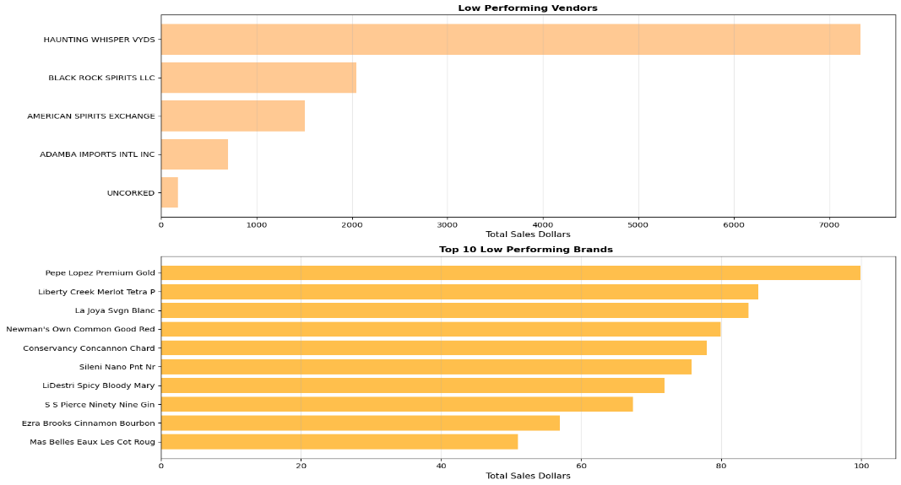

4.Identifying vendors with low inventory turnover
Total unsold inventory capital: $2.7M
Slow-moving inventory increases storage costs, reduces cash flow efficiency and affects overall profitability.
Identify vendor with low inventory turnover enhances better stock management, minimum financial strain.
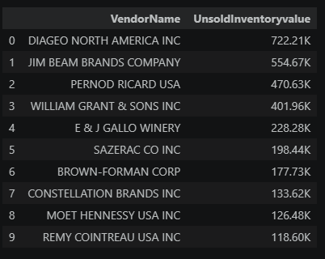

5.Profit margin comparison: High vs low performing vendors
Top Vendors Profit Margin: Mean=31.18%, CI = (30.74%, 31.61%)
Low Vendors Profit Margin: Mean=41.57%, CI = (40.50%, 42.64%)
Low performing vendors maintain higher margins but struggle with sales volume indicating potential pricing inefficiency or market reach issues.
- Top performing vendors must optimize profitability by adjusting pricing, reducing operational costs or offering bundled promotions.
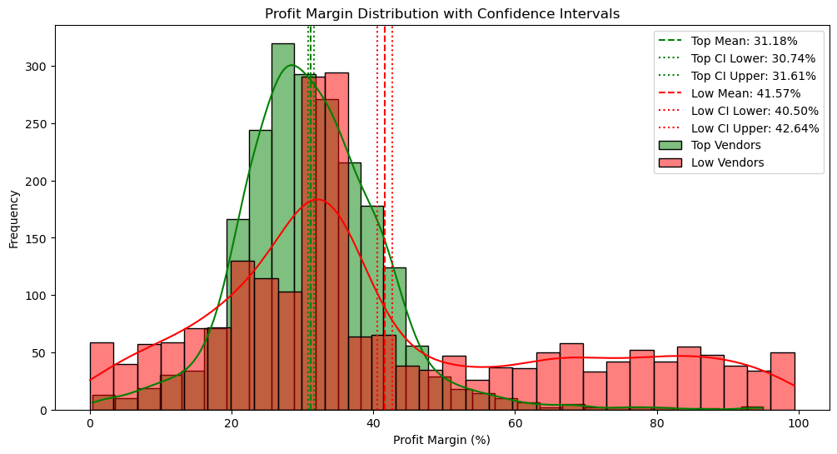
- Low performing vendors must improve marketing efforts, optimize pricing strategies and enhance distribution networks.

6.Statistical validation of profit margin differences
Hypothesis testing:
Null hypothesis (Ho): No significant differences in profit margin between top and low-performing vendors.
Alternative hypothesis(H1): A significant difference exists in profit margins between two vendor groups.
Result: The null hypothesis is rejected confirming that two groups operate under distinctly different profitability models.
Implication: High margin vendors may benefit from better pricing strategies while top selling vendors could focus on cost efficiency.

Final recommendations:
- Revaluate pricing for low-sales, high margin brands to boost sales volume without sacrificing profitability.
- Diversify vendor partnerships to reduce dependency on few suppliers and mitigate supply chain risks.
- Leverage bulk purchasing advantages to maintain competitive pricing while optimizing inventory management.
- Optimize slow-moving inventory by adjusting purchase quantities, launching clearance sales or revising storage strategies.
- Enhance marketing & distribution strategies for low -performing vendors to drive higher sales volume without compromising profit margins.
- By implementing these recommendations, the company can achieve sustainable profitability, mitigate risks and enhance overall operational efficiency.

