FULL STACK APPLICATION DEVELOPMENT
NAME | M,HARSHAVARDHAN REDDY
ID | 2400090136
SECTION | S-56
COURSE | FSAD

SKILL – 6: Spring MVC Web Request Handling Demo

Aim
To demonstrate different types of web request handling in Spring MVC using @RestController, @GetMapping, @PostMapping, @PathVariable and @RequestParam.

Prerequisites
• Basic understanding of Spring Boot
• Knowledge of Spring MVC
• Understanding of HTTP methods (GET and POST)

Software Requirements
• Java 17
• Spring Boot
• Maven
• Spring Tool Suite / Eclipse / IntelliJ

Tasks Implementationask 1: Create a controller class named LibraryController.
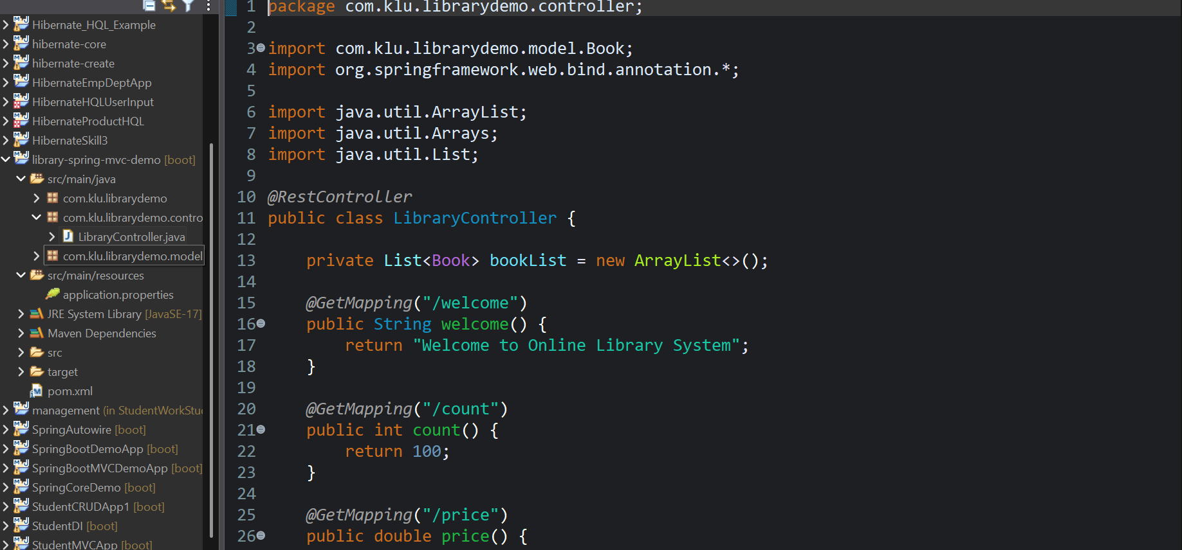

Task 2: Create a method mapped to /welcome that returns a welcome message.
Output:
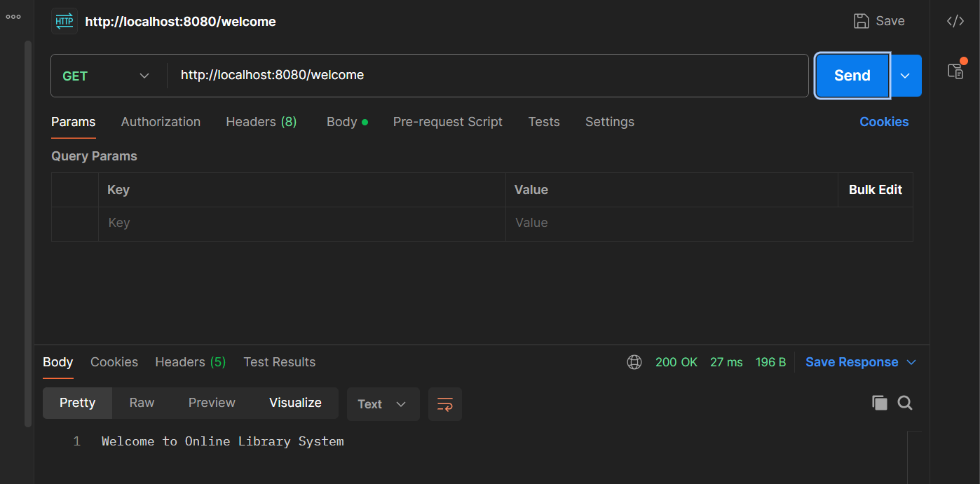

Task 3: Create a method mapped to /count that returns total number of books.
Output:
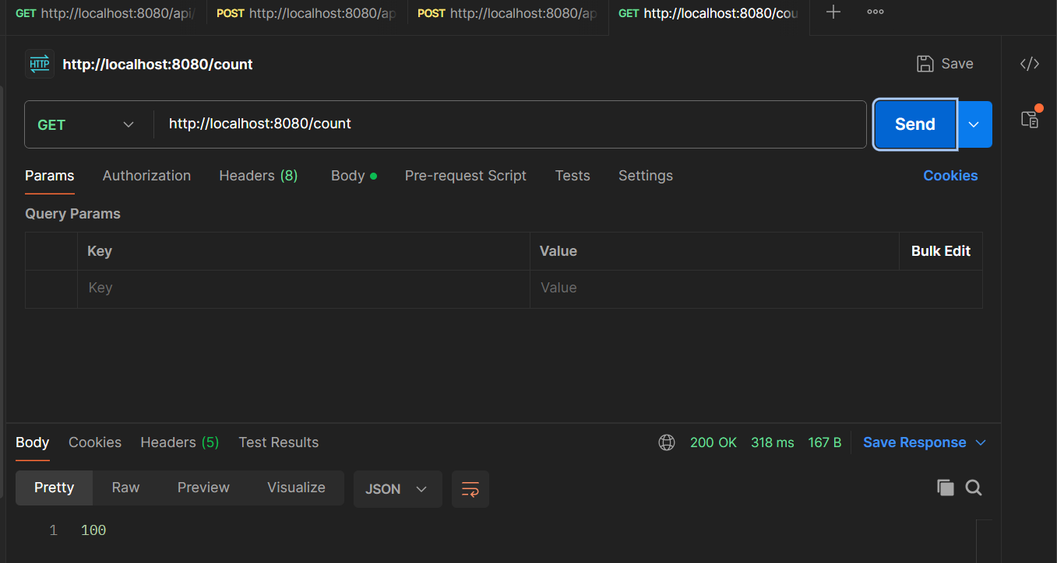
Task 4: Create a method mapped to /price that returns a sample book price.
Output:
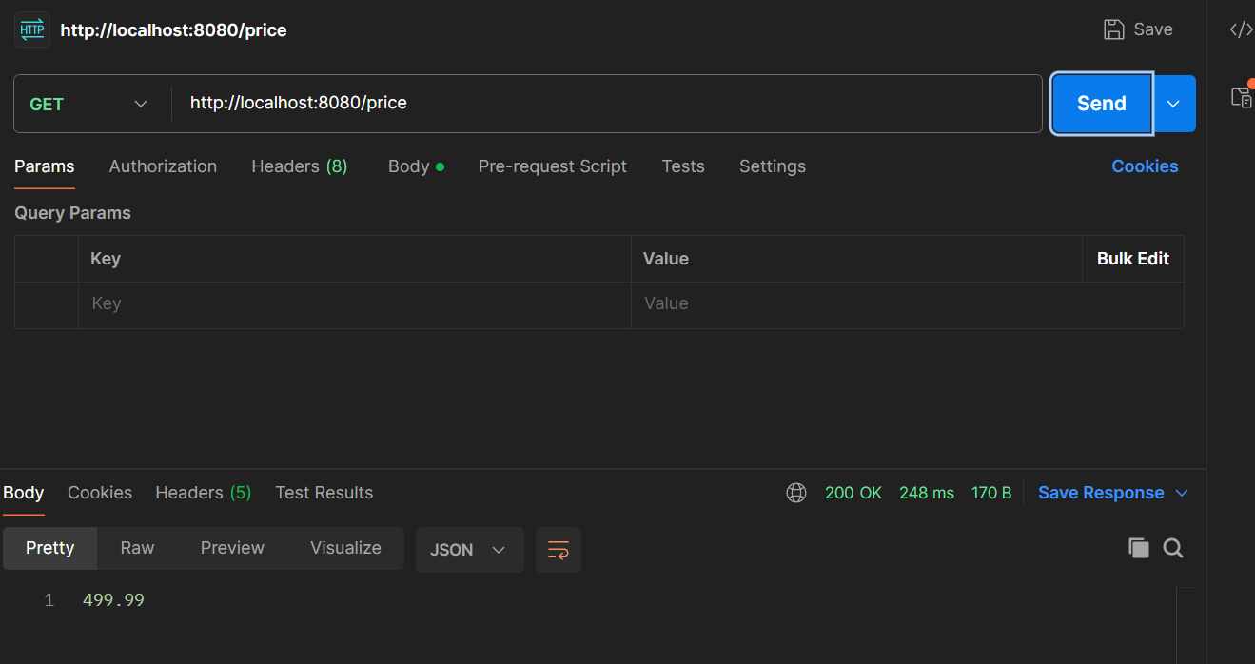

Task 5: Create a method mapped to /books using @GetMapping that returns a list of books.
Output:
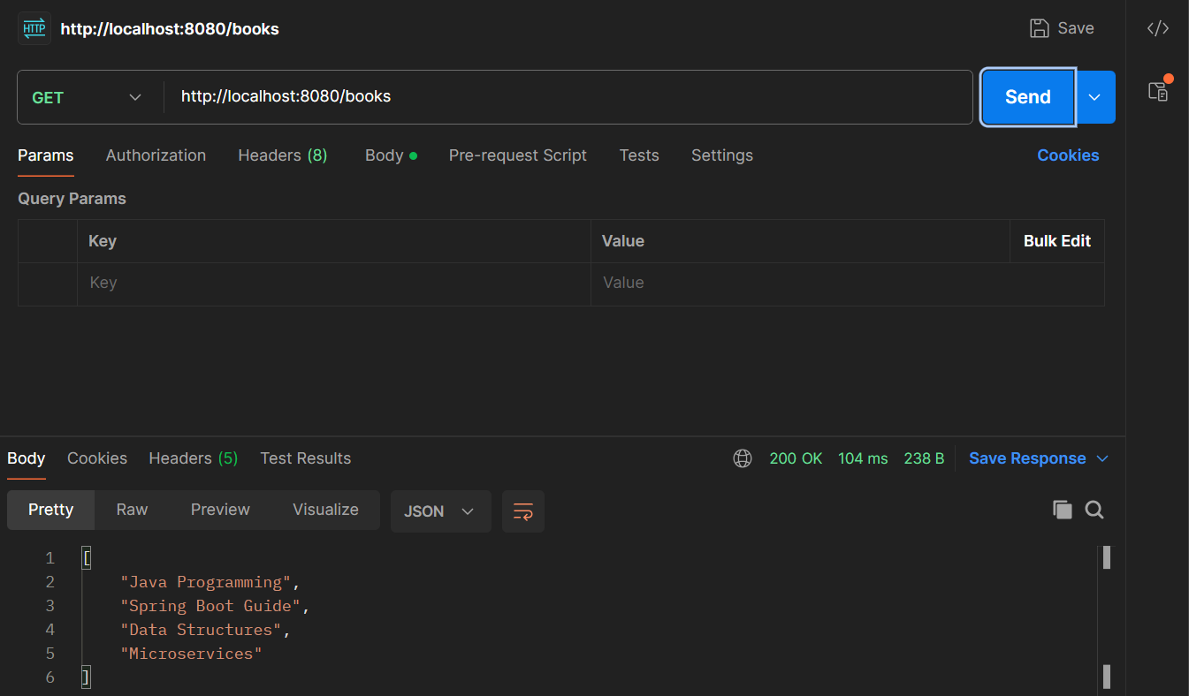
Task 6: Create a method mapped to /books/{id} using @PathVariable.
Output:
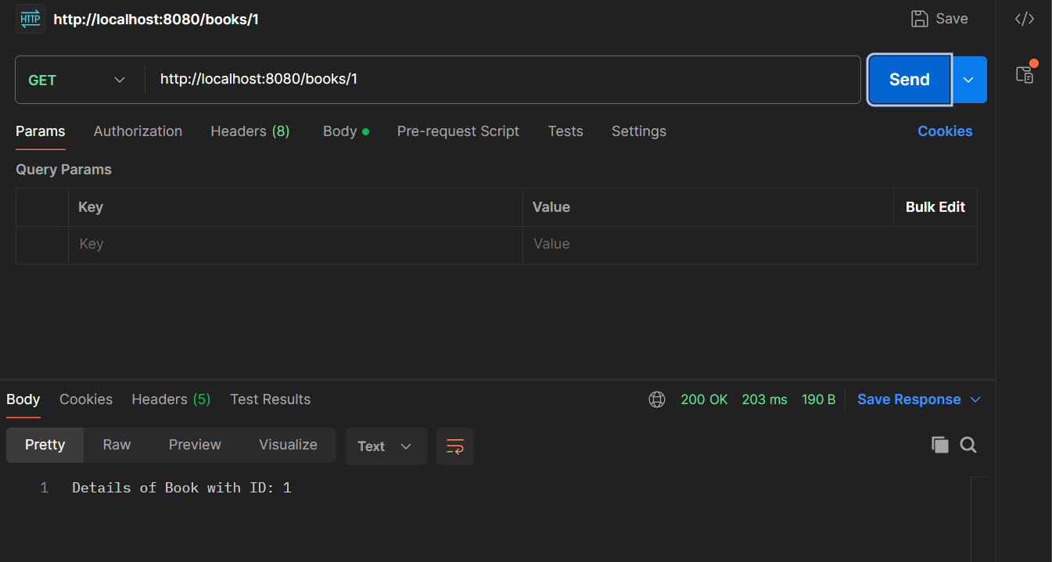
Task 7: Create a method mapped to /search using @RequestParam.
Output:
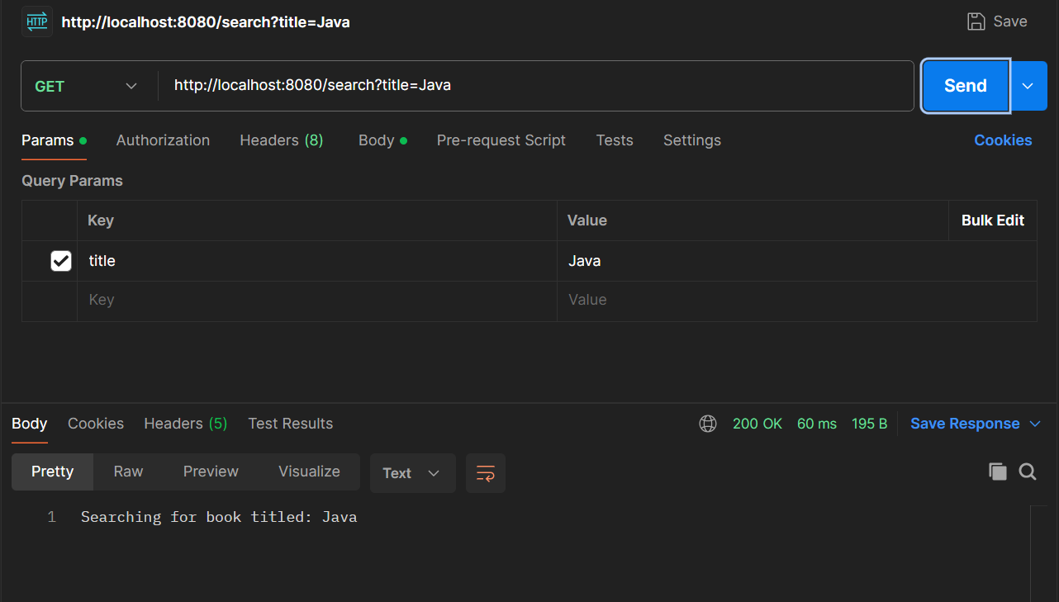
Task 8: Create a method mapped to /author/{name}.
Output:
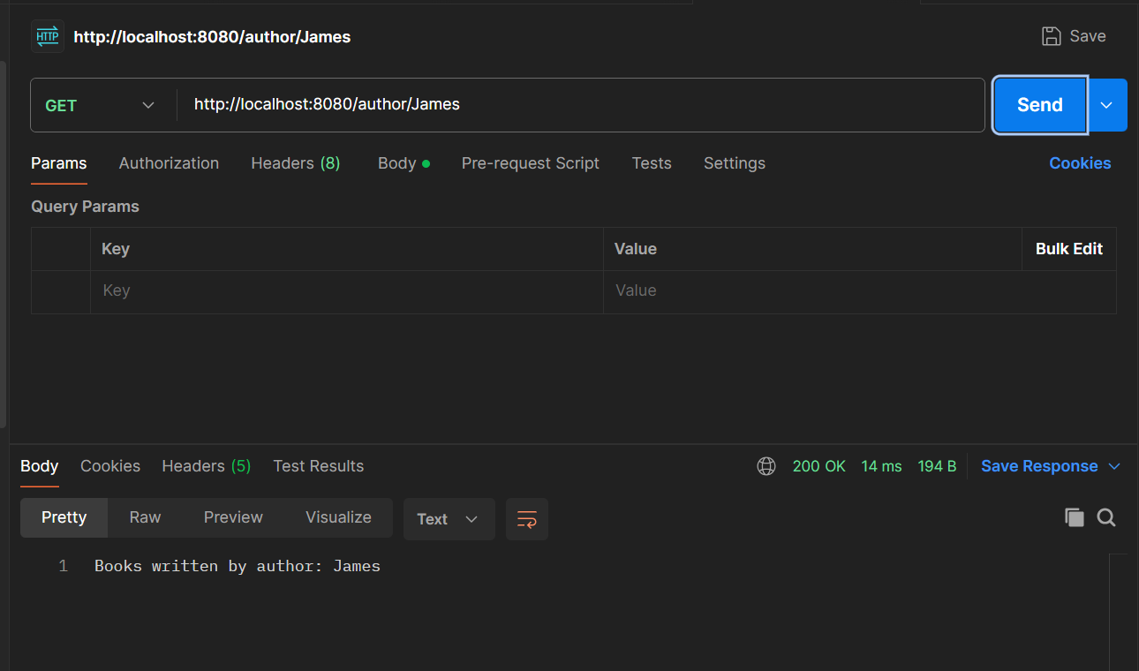
Task 9: Push the project to GitHub.
Output:
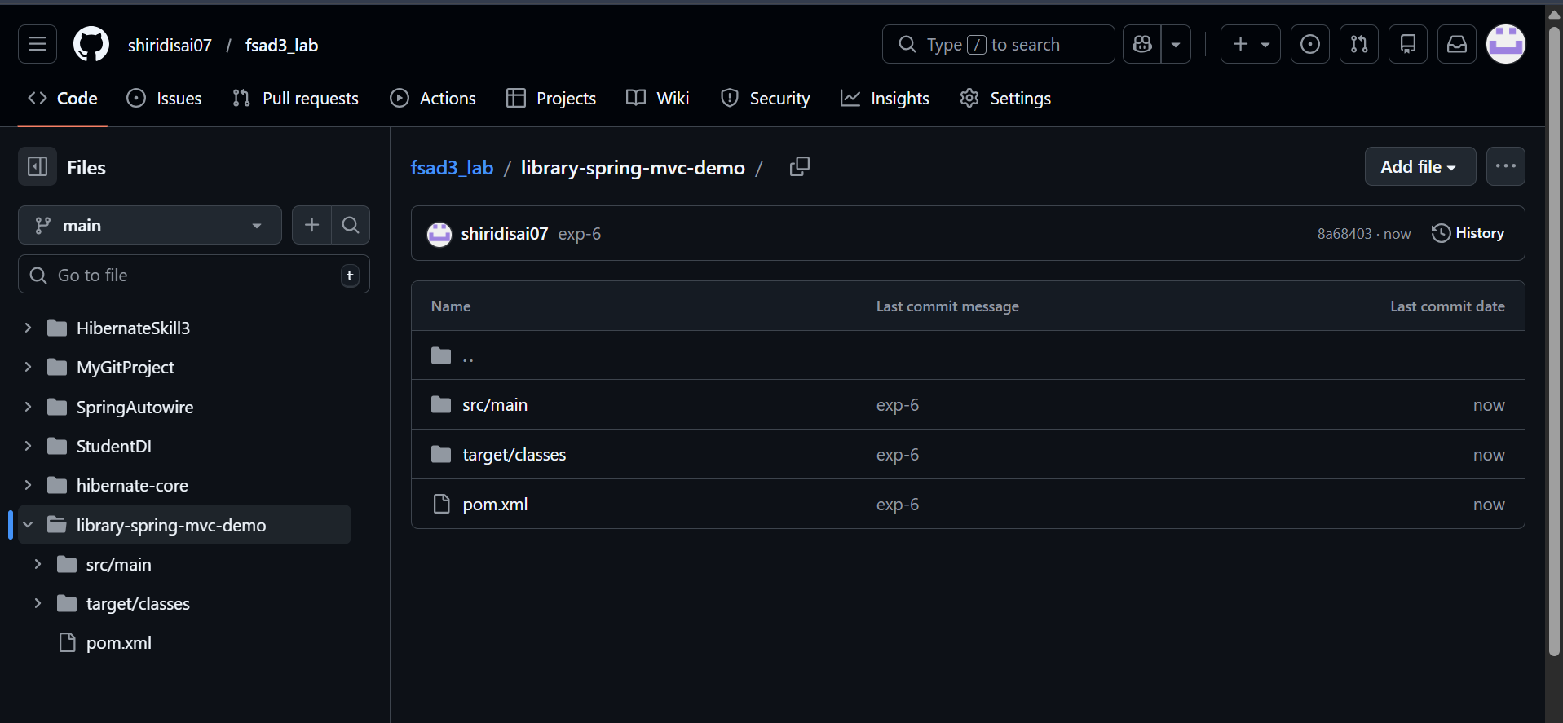
Github link:
https://github.com/shiridisai07/fsad3_lab/tree/main/SpringAutowire

Controller Code (LibraryController.java)
@RestController
public class LibraryController {
private List<Book> bookList = new ArrayList<>();
@GetMapping("/welcome")
public String welcome(){
return "Welcome to Online Library System";
}
@GetMapping("/count")
public int count(){
return 100;
}
@GetMapping("/price")
public double price(){
return 499.99;
}
@GetMapping("/books")
public List<String> books(){
return Arrays.asList("Java","Spring Boot","Microservices");
}
@GetMapping("/books/{id}")
public String bookById(@PathVariable int id){
return "Book ID: " + id;
}
@GetMapping("/search")
public String search(@RequestParam String title){
return "Searching book: " + title;
}
@GetMapping("/author/{name}")
public String author(@PathVariable String name){
return "Books written by: " + name;
}
@PostMapping("/addbook")
public String addBook(@RequestBody Book book){
bookList.add(book);
return "Book added successfully";
}
@GetMapping("/viewbooks")
public List<Book> viewBooks(){
return bookList;
}
}
librarydemo;
package com.klu.librarydemo;

import org.springframework.boot.SpringApplication;
import org.springframework.boot.autoconfigure.SpringBootApplication;

@SpringBootApplication
public class LibraryDemoApplication {

public static void main(String[] args) {
SpringApplication.run(LibraryDemoApplication.class, args);
}
}
Book.java
package com.klu.librarydemo.model;
public class Book {
private int id;
private String title;
private String author;
private double price;
public Book() {}
public Book(int id, String title, String author, double price) {
this.id = id;
this.title = title;
this.author = author;
this.price = price;
}
public int getId() {
return id;
}
public void setId(int id) {
this.id = id;
}
public String getTitle() {
return title;
}
public void setTitle(String title) {
this.title = title;
}

public String getAuthor() {
return author;
}

public void setAuthor(String author) {
this.author = author;
}
public double getPrice() {
return price;
}

public void setPrice(double price) {
this.price = price;
}
}

Result
All Spring MVC request handling operations were successfully implemented using different annotations such as @GetMapping, @PostMapping, @PathVariable and @RequestParam.

Viva Questions
- What is the role of @RestController in Spring MVC?
Answer: @RestController is used to create RESTful web services in Spring MVC. It returns data such as JSON or text directly to the client instead of returning a view page.
- What is the difference between @GetMapping and @PostMapping?
Answer: @GetMapping is used to handle HTTP GET requests and retrieve data from the server, while @PostMapping is used to handle HTTP POST requests and send or store data in the server.
- How does @PathVariable help in handling dynamic URLs?
Answer: @PathVariable is used to extract values from the URL path and pass them as parameters to a method, allowing handling of dynamic URLs like /books/{id}.
- When do we use @RequestParam?
Answer: @RequestParam is used to read query parameters from the URL, usually in the format ?key=value, such as /search?title=Java.
- Can one controller contain multiple request-mapped methods?
Answer: Yes, a single controller can contain multiple request-mapped methods to handle different URLs and HTTP requests within the same controller class.

