
NAME: | MADDA HARSHAVARDHAN REDDY
ID: | 2400090136
SECTION: | S-56
SUBJECT: | FULL STACK APPLICATION  DEVELOPMENT

#SKILL – 2 Hibernate CRUD Operations

Tasks:

Create a Product entity with fields: id (primary key), name, description, price, quantity.
Output:-
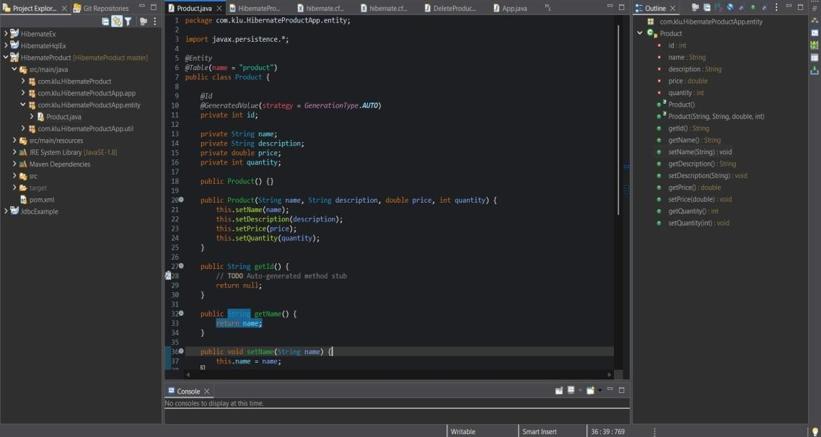
- Configure Hibernate and map the Product entity to a table using JPA annotation

Output:-
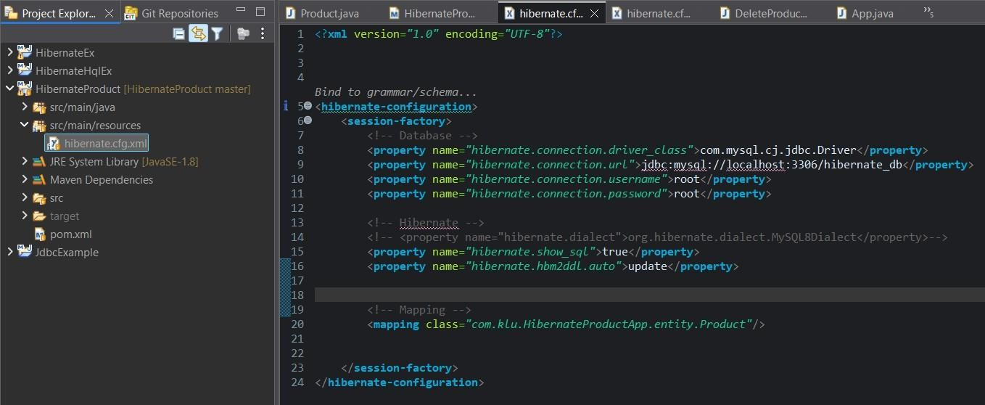

- Insert multiple Product records into the database.

Output:-
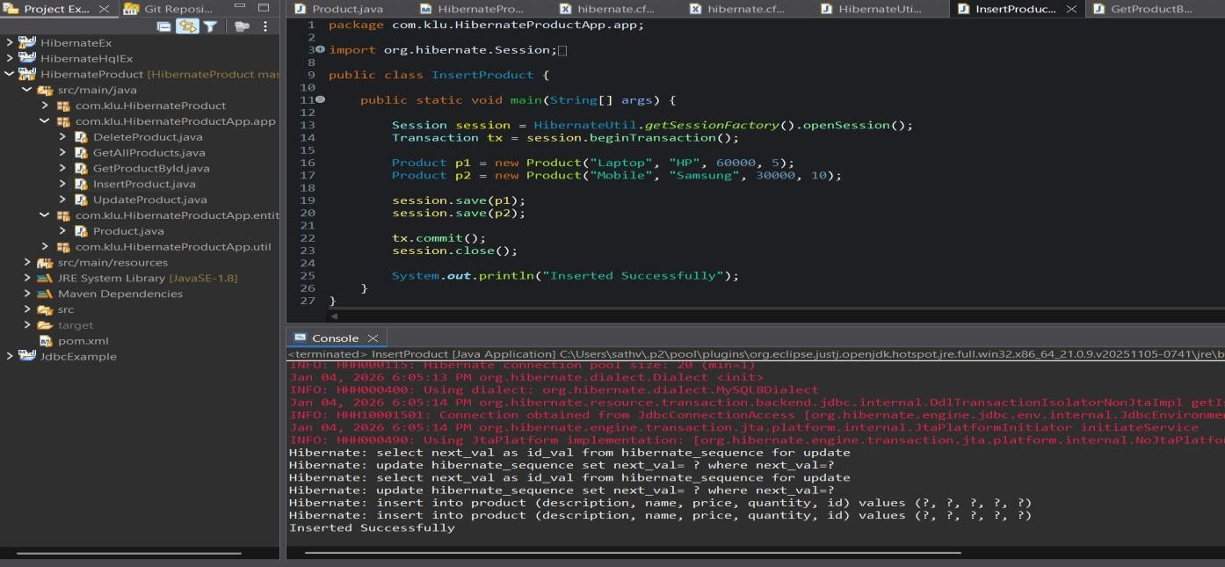
- Retrieve a product using its id.

Output:-
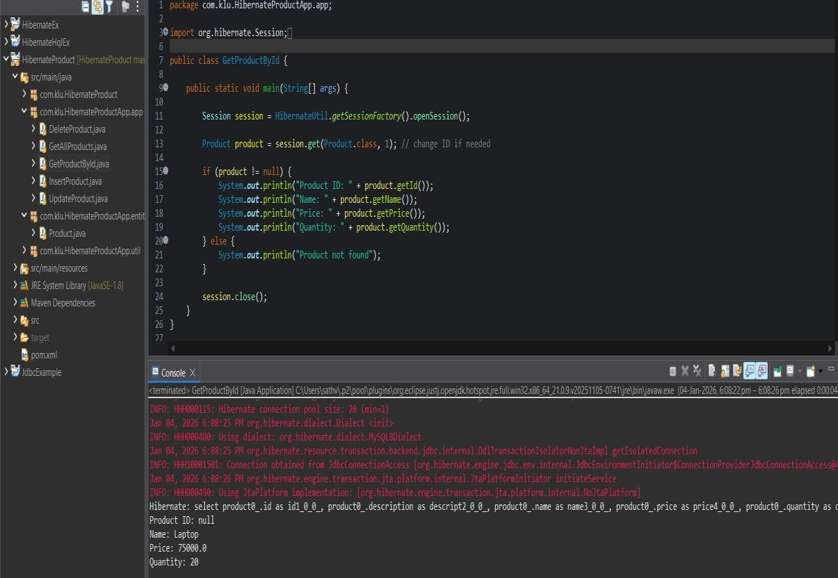

- Update the price or quantity of any selected product.
Output:-
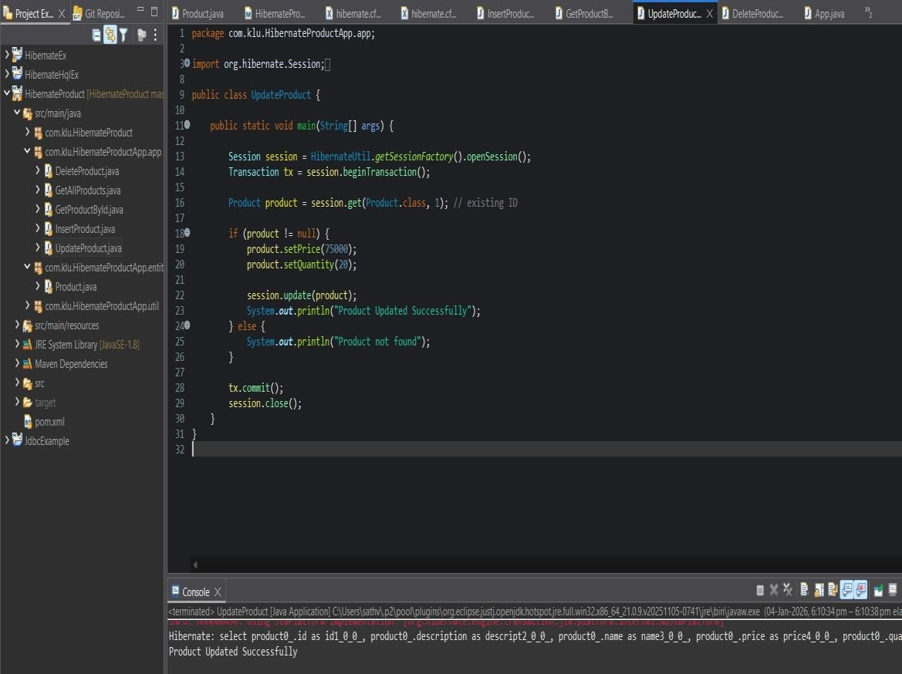

- Delete a product record by id if it is discontinued Output:-
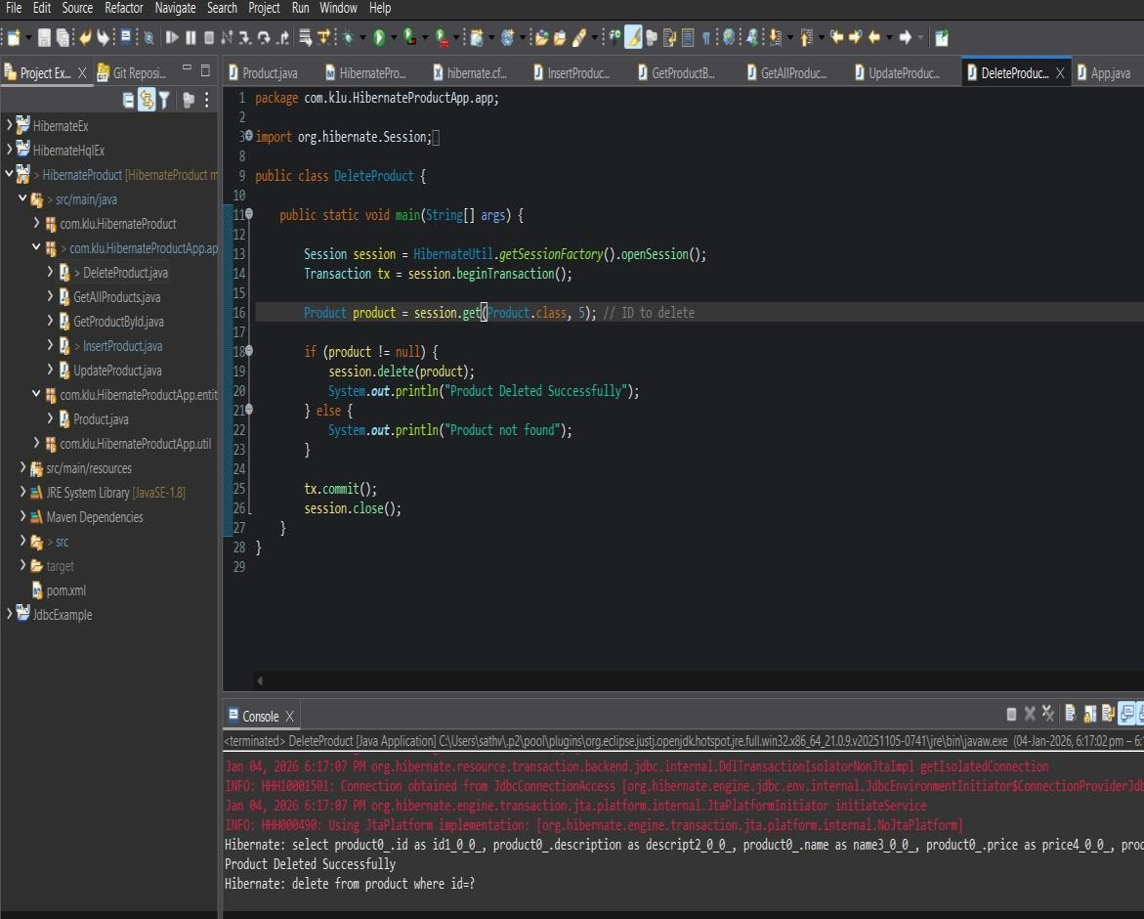

- a. Implement Hibernate ID generation strategies (AUTO, IDENTITY, SEQUENCE) inside the entity to observe how primary key values differ.
Output:-
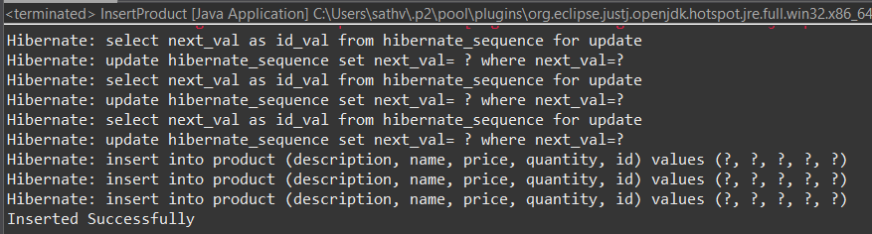
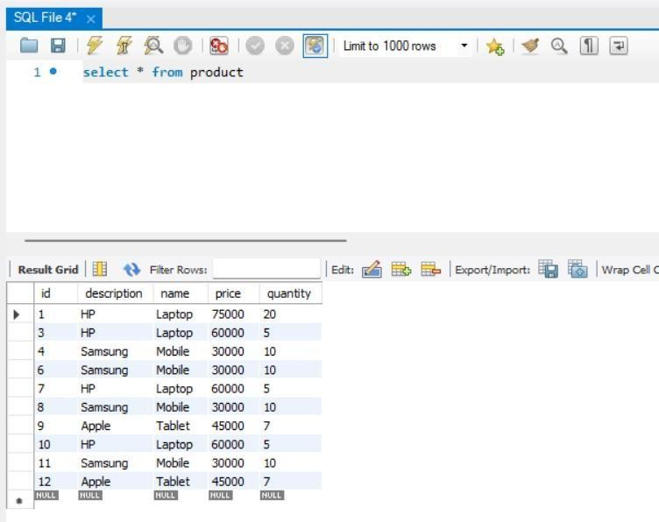

b. The ID can be manual or auto generated, based on your chosen strategy.

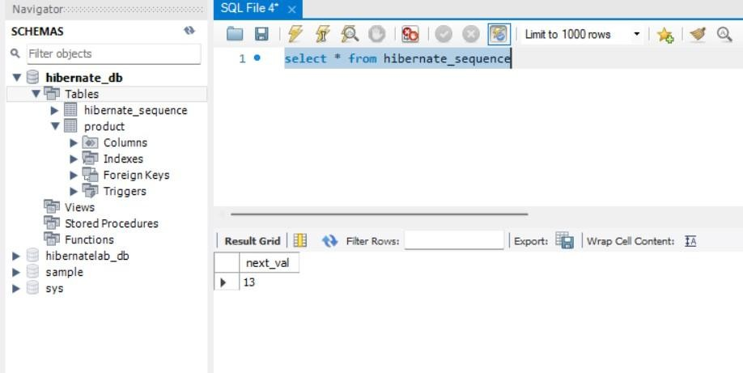

- Push the Hibernate project into a single GitHub repository
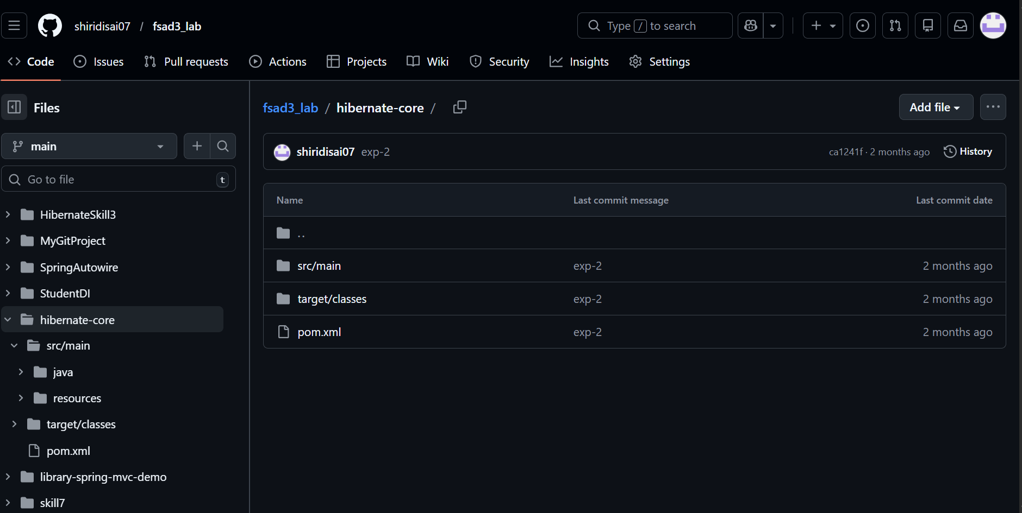

Conclusion
This experiment successfully demonstrated the implementation of complete CRUD operations using Hibernate with JPA annotations for a retail inventory system. By mapping the Product entity to a database table and performing create, read, update, and delete operations, we validated how Hibernate simplifies database interaction through ORM. The use of different ID generation strategies (AUTO, IDENTITY, SEQUENCE) helped in understanding primary key management in real-world applications. Overall, this exercise strengthened practical knowledge of Hibernate configuration, entity mapping, and database operations, which are essential for building scalable Java-based enterprise applications.

GITHUB REPO LINK :- https://github.com/shiridisai07/fsad3_lab/tree/main/hibernate-core

VIVA :

1. What is ORM and why is it used in application development?
ORM (Object Relational Mapping) is a technique used to map Java objects to database tables. It helps developers interact with the database using objects instead of writing SQL queries, making development easier and faster.
2. Which annotation is used to mark a class as a JPA entity?
The @Entity annotation is used to mark a class as a JPA entity. It indicates that the class is mapped to a database table.
3. Why must every Hibernate entity have a primary key?
Every Hibernate entity must have a primary key because it uniquely identifies each record in the database table and helps Hibernate track and manage objects properly.
4. How do you update an existing record using Hibernate?
An existing record can be updated using the update() method of the Hibernate session after modifying the entity object.
5. What is the difference between get() and load() in Hibernate?
- get() immediately retrieves the object from the database and returns null if the record does not exist.
- load() returns a proxy object and throws an exception if the record does not exist.

