FULL STACK APPLICATION DEVELOPMENT
SKILL – 3: Working with HQL - Sorting, Pagination & Aggregates
Name | M.HARSHAVARDHAN REDDY
ID | 2400090136
Section | S-56
Subject | FSAD

Aim
To perform advanced data retrieval operations using Hibernate Query Language (HQL) such as sorting, pagination, filtering, grouping, and aggregate functions.

Prerequisites
• Basic knowledge of Hibernate
• Basic idea of HQL syntax

Software Requirements
• Java 8
• MySQL
• Eclipse IDE
• Hibernate 5.6
• Maven

Task 1: Insert 5–8 Product Records
HQL / Hibernate Code:
session.save(product);
Output Screenshot: 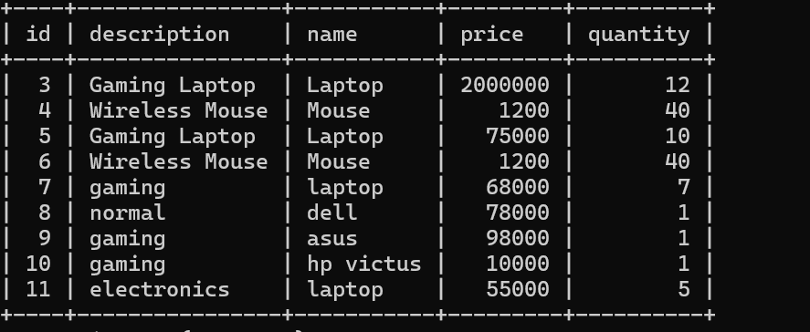

Task 2: Sort Products by Price (Ascending)
from Product order by price asc
Output Screenshot:

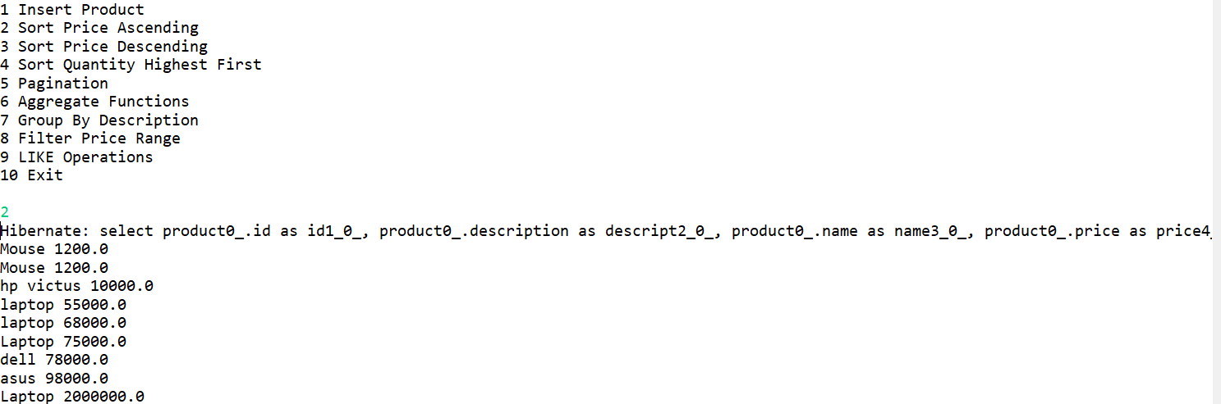

Task 3: Sort Products by Price (Descending)
from Product order by price desc
Output Screenshot: 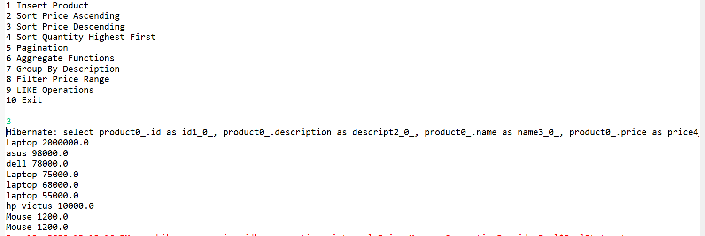

Task 4: Sort by Quantity (Highest First)
from Product order by quantity desc
Output Screenshot:
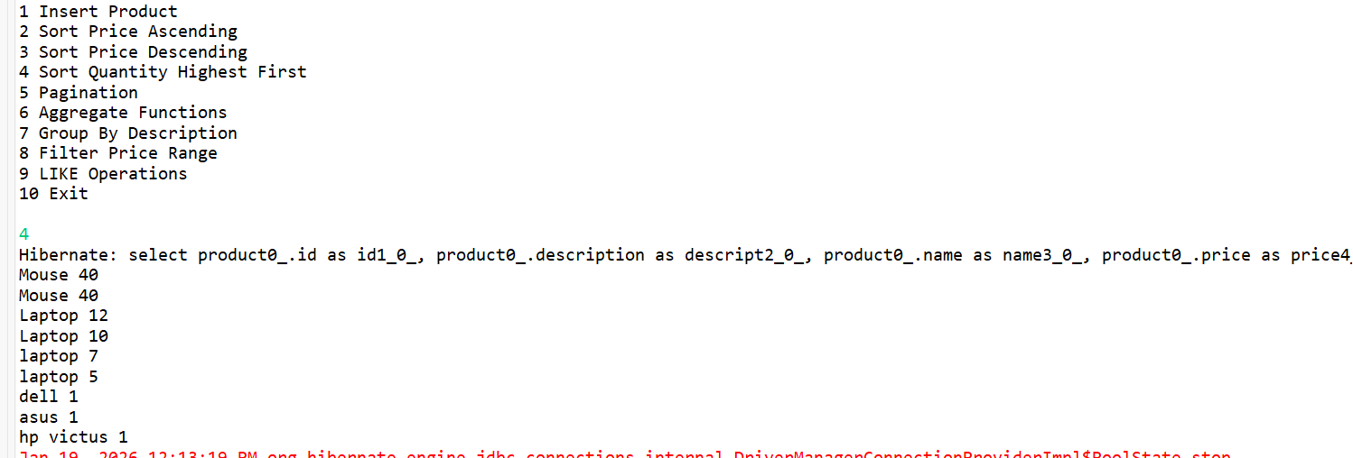

Task 5: Pagination
Query q = session.createQuery("from Product");
q.setFirstResult(0);
q.setMaxResults(3);
Output Screenshot:
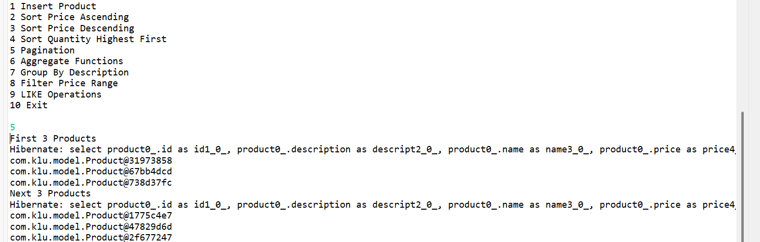

Task 6: Aggregate Functions
select count(*) from Product
select min(price) from Product
select max(price) from Product
Output Screenshot:
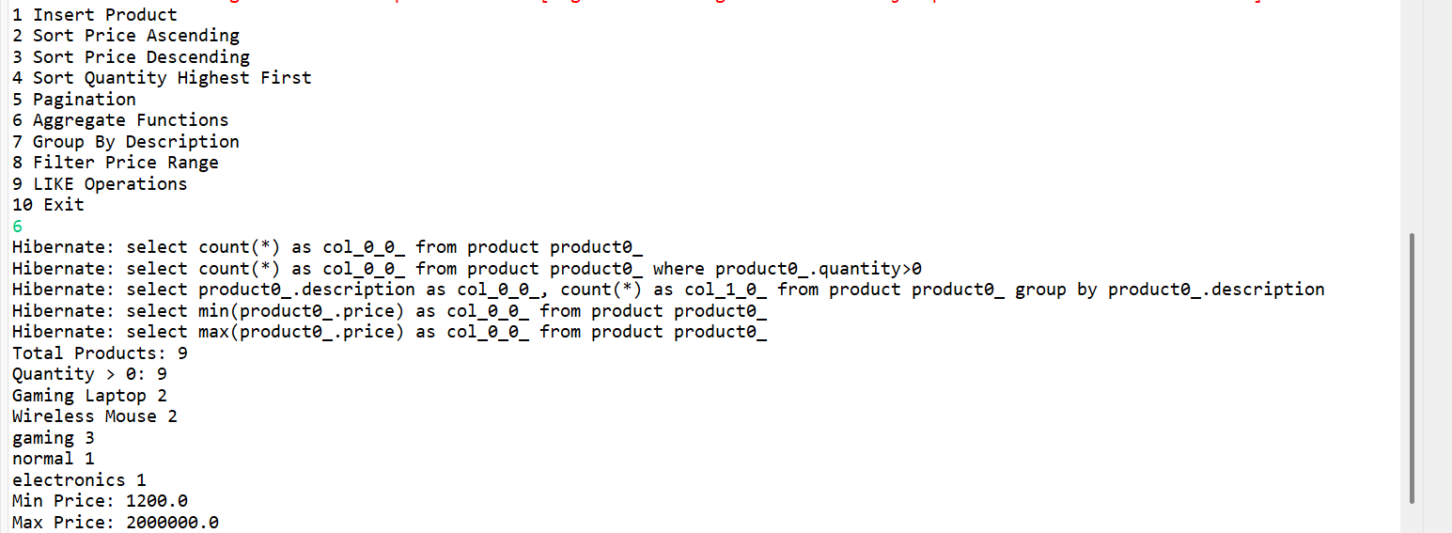

Task 7: Group By Description
select description, count(*) from Product group by description
Output Screenshot:
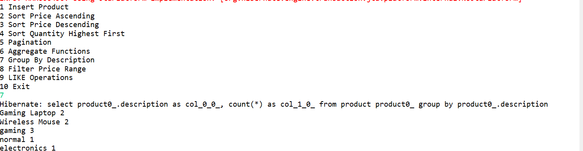

Task 8: Filter Products Using WHERE
from Product where price between :min and :max
Output Screenshot:
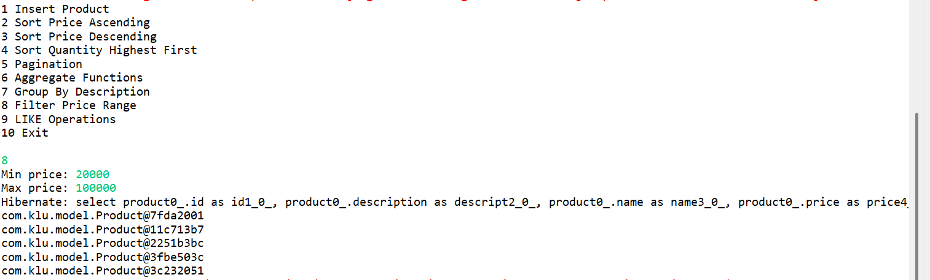

Task 9: LIKE Operations
name like 'A%'
name like '%p'
name like '%ou%'
length(name)=5
Output Screenshot:
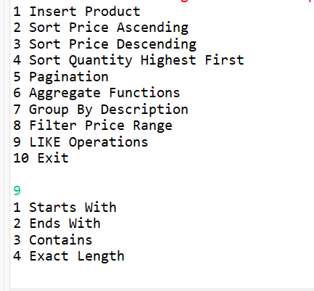

Task 10: GitHub Repository
Project successfully pushed to GitHub.

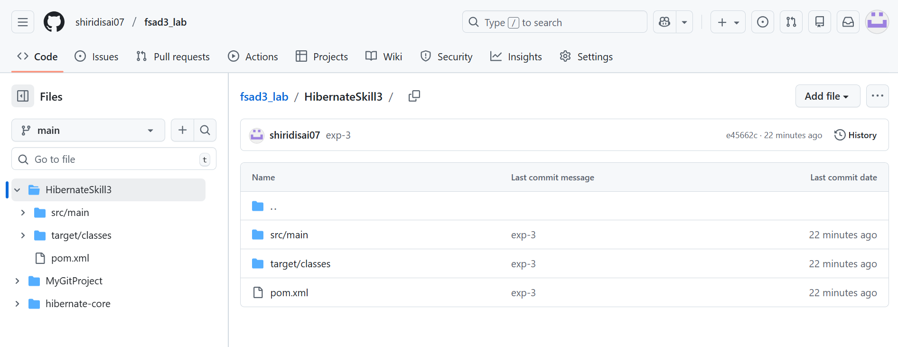Result
All HQL operations including sorting, pagination, filtering, grouping and aggregate functions were successfully implemented using Hibernate.
Codes:
MainApp:
package com.klu.mainapp;

import com.klu.model.Product;
import org.hibernate.*;
import org.hibernate.cfg.Configuration;

import java.util.List;
import java.util.Scanner;

public class MainApp {

public static void main(String[] args) {

Scanner sc = new Scanner(System.in);

SessionFactory sf = new Configuration().configure().buildSessionFactory();
Session session = sf.openSession();
Transaction tx = session.beginTransaction();

System.out.println("1 Insert Product");
System.out.println("2 Sort Price Ascending");
System.out.println("3 Sort Price Descending");
System.out.println("4 Sort Quantity Highest First");
System.out.println("5 Pagination");
System.out.println("6 Aggregate Functions");
System.out.println("7 Group By Description");
System.out.println("8 Filter Price Range");
System.out.println("9 LIKE Operations");
System.out.println("10 Exit");

int ch = sc.nextInt();

switch (ch) {

case 1:
System.out.print("How many products: ");
int n = sc.nextInt();

for (int i = 0; i < n; i++) {
Product p = new Product();

System.out.print("Name: ");
p.setName(sc.next());

System.out.print("Description: ");
p.setDescription(sc.next());

System.out.print("Price: ");
p.setPrice(sc.nextDouble());

System.out.print("Quantity: ");
p.setQuantity(sc.nextInt());

session.save(p);
}
tx.commit();
System.out.println("Products inserted");
break;

case 2:
List<Product> asc =
session.createQuery("from Product order by price asc", Product.class).list();
asc.forEach(p ->
System.out.println(p.getName() + " " + p.getPrice()));
break;

case 3:
List<Product> desc =
session.createQuery("from Product order by price desc", Product.class).list();
desc.forEach(p ->
System.out.println(p.getName() + " " + p.getPrice()));
break;

case 4:
List<Product> qty =
session.createQuery("from Product order by quantity desc", Product.class).list();
qty.forEach(p ->
System.out.println(p.getName() + " " + p.getQuantity()));
break;

case 5:
Query q = session.createQuery("from Product");
q.setFirstResult(0);
q.setMaxResults(3);
System.out.println("First 3 Products");
q.list().forEach(System.out::println);

q.setFirstResult(3);
q.setMaxResults(3);
System.out.println("Next 3 Products");
q.list().forEach(System.out::println);
break;

case 6:
Long total =
(Long) session.createQuery("select count(*) from Product").uniqueResult();

Long available =
(Long) session.createQuery("select count(*) from Product where quantity>0").uniqueResult();

List<Object[]> group =
session.createQuery("select description,count(*) from Product group by description").list();

Double min =
(Double) session.createQuery("select min(price) from Product").uniqueResult();

Double max =
(Double) session.createQuery("select max(price) from Product").uniqueResult();

System.out.println("Total Products: " + total);
System.out.println("Quantity > 0: " + available);
group.forEach(o ->
System.out.println(o[0] + " " + o[1]));
System.out.println("Min Price: " + min);
System.out.println("Max Price: " + max);
break;

case 7:
List<Object[]> grp =
session.createQuery("select description,count(*) from Product group by description").list();
grp.forEach(o ->
System.out.println(o[0] + " " + o[1]));
break;

case 8:
System.out.print("Min price: ");
double minp = sc.nextDouble();
System.out.print("Max price: ");
double maxp = sc.nextDouble();

Query range =
session.createQuery("from Product where price between :a and :b");
range.setParameter("a", minp);
range.setParameter("b", maxp);

range.list().forEach(System.out::println);
break;

case 9:
System.out.println("1 Starts With");
System.out.println("2 Ends With");
System.out.println("3 Contains");
System.out.println("4 Exact Length");

int like = sc.nextInt();

if (like == 1) {
System.out.print("Enter letters: ");
String s = sc.next() + "%";
session.createQuery("from Product where name like :x")
.setParameter("x", s)
.list().forEach(System.out::println);
}

if (like == 2) {
System.out.print("Enter letters: ");
String s = "%" + sc.next();
session.createQuery("from Product where name like :x")
.setParameter("x", s)
.list().forEach(System.out::println);
}

if (like == 3) {
System.out.print("Enter letters: ");
String s = "%" + sc.next() + "%";
session.createQuery("from Product where name like :x")
.setParameter("x", s)
.list().forEach(System.out::println);
}

if (like == 4) {
System.out.print("Enter length: ");
int len = sc.nextInt();
session.createQuery("from Product where length(name)=:l")
.setParameter("l", len)
.list().forEach(System.out::println);
}
break;

case 10:
System.out.println("Program Ended");
break;
}

session.close();
sf.close();
}
}

Product.java:
package com.klu.model;

import javax.persistence.*;

@Entity
@Table(name = "product")
public class Product {

@Id
@GeneratedValue(strategy = GenerationType.IDENTITY)
private int id;

private String name;
private String description;
private double price;
private int quantity;

public int getId() {
return id;
}

public String getName() {
return name;
}

public String getDescription() {
return description;
}

public double getPrice() {
return price;
}

public int getQuantity() {
return quantity;
}

public void setName(String name) {
this.name = name;
}

public void setDescription(String description) {
this.description = description;
}

public void setPrice(double price) {
this.price = price;
}

public void setQuantity(int quantity) {
this.quantity = quantity;
}
}

Hibernate.cfg.xml:
package com.klu.model;
import javax.persistence.*;
@Entity
@Table(name = "product")
public class Product {
@Id
@GeneratedValue(strategy = GenerationType.IDENTITY)
private int id;
private String name;
private String description;
private double price;
private int quantity;

public int getId() {
return id;
}

public String getName() {
return name;
}

public String getDescription() {
return description;
}

public double getPrice() {
return price;
}
public int getQuantity() {
return quantity;
}
public void setName(String name) {
this.name = name;
}
public void setDescription(String description) {
this.description = description;
}
public void setPrice(double price) {
this.price = price;
}
public void setQuantity(int quantity) {
this.quantity = quantity;
}
}

Pom.xml:
<project xmlns="http://maven.apache.org/POM/4.0.0"
xmlns:xsi="http://www.w3.org/2001/XMLSchema-instance"
xsi:schemaLocation="http://maven.apache.org/POM/4.0.0
http://maven.apache.org/xsd/maven-4.0.0.xsd">
<modelVersion>4.0.0</modelVersion>
<groupId>com.klu</groupId>
<artifactId>HibernateSkill3</artifactId>
<version>1.0</version>
<properties>
<maven.compiler.source>1.8</maven.compiler.source>
<maven.compiler.target>1.8</maven.compiler.target>
</properties>
<dependencies>
<dependency>
<groupId>org.hibernate</groupId>
<artifactId>hibernate-core</artifactId>
<version>5.6.15.Final</version>
</dependency>
<dependency>
<groupId>javax.persistence</groupId>
<artifactId>javax.persistence-api</artifactId>
<version>2.2</version>
</dependency>
<dependency>
<groupId>mysql</groupId>
<artifactId>mysql-connector-java</artifactId>
<version>8.0.33</version>
</dependency>
<dependency>
<groupId>org.slf4j</groupId>
<artifactId>slf4j-simple</artifactId>
<version>1.7.36</version>
</dependency>
</dependencies>
</project>
GITHUB :
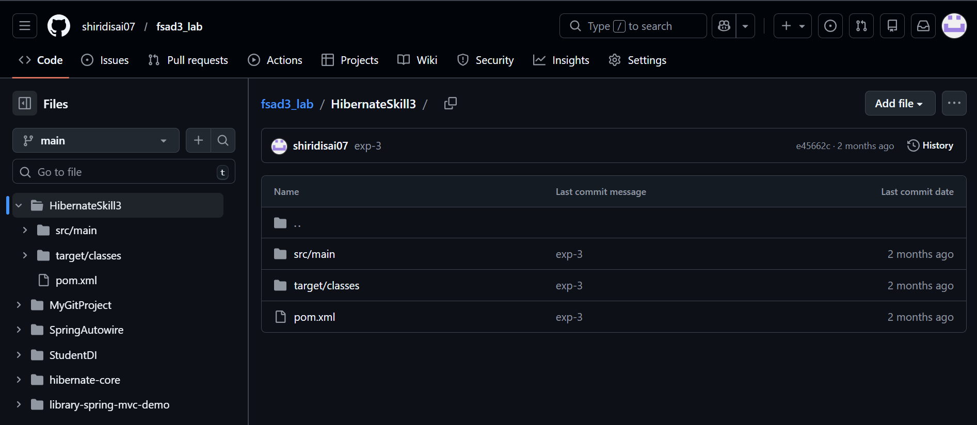
Github url: https://github.com/shiridisai07/fsad3_lab/tree/main/HibernateSkill3
- What is HQL and how does it differ from SQL?
A.)HQL (Hibernate Query Language) is a query language used in Hibernate to perform database operations using Java objects. Unlike SQL, which works with tables and columns, HQL works with Java classes and their properties.
2. Why do we use sorting in HQL?
A.)Sorting in HQL is used to arrange the query results in a specific order, either ascending or descending, using the ORDER BY clause.
3. What is pagination and where is it used?
A. Pagination is the process of dividing large sets of data into smaller pages. It is commonly used in applications to display limited records per page, such as in search results or product listings.
4. Name any three aggregate functions supported in HQL.
A.
Three aggregate functions supported in HQL are:
- COUNT()
- SUM()
- AVG()
5. What is the difference between HQL and HCQL (Hibernate Criteria Query Language)?
A.
- HQL is a query language written similar to SQL but works with objects and their properties.
- HCQL (Criteria Query Language) is a programmatic, object-oriented way of creating queries using Hibernate API instead of writing query strings.

