EXPERIMENT – 4

NAME | M.HARSHAVARDHAN REDDY
ID | 2400090136
SECTION | S-56
COURSE | FSAD

Spring Dependency Injection – Constructor & Setter Injection

Aim
To demonstrate Dependency Injection in Spring using Constructor Injection and Setter Injection with both XML-based and Annotation-based configurations.

Software Requirements
- Java 8 or above
- Spring Framework (Core)
- Eclipse IDE
- Maven

Theory
Dependency Injection (DI) is a design pattern used in Spring Framework where objects are provided with their dependencies by the Spring IoC container rather than creating them manually.

Task 1: Create Student POJO Class
Student.java
package com.klu.model;
public class Student {
private int studentId;
private String name;
private String course;
private int year;
public Student(int studentId, String name, String course, int year) {
this.studentId = studentId;
this.name = name;
this.course = course;
this.year = year;
}
public void setCourse(String course) {
this.course = course;
}
public void setYear(int year) {
this.year = year;
}
public void display() {
System.out.println("Student ID: " + studentId);
System.out.println("Name: " + name);
System.out.println("Course: " + course);
System.out.println("Year: " + year);
}
}
output:

Task 2: XML Configuration (Constructor Injection)
spring.xml
<beans xmlns="http://www.springframework.org/schema/beans">
<bean id="student" class="com.klu.model.Student">
<constructor-arg value="101"/>
<constructor-arg value="Sai"/>
<constructor-arg value="FSAD"/>
<constructor-arg value="2025"/>
</bean>
</beans>

Task 3: Main Class (XML Configuration)
MainApp.java
package com.klu.main;
import org.springframework.context.ApplicationContext;
import org.springframework.context.support.ClassPathXmlApplicationContext;
import com.klu.model.Student;
public class MainApp {
public static void main(String[] args) {
ApplicationContext context =
new ClassPathXmlApplicationContext("spring.xml");
Student student = (Student) context.getBean("student");
student.display();
}
}

Output for XML Configuration
Student ID: 101
Name: Sai
Course: FSAD
Year: 2025

Task 4: Annotation-Based Configuration
Student.java (Updated with Annotations)
package com.klu.model;
import org.springframework.stereotype.Component;
@Component
public class Student {
private int studentId = 102;
private String name = "Sai";
private String course = "Spring";
private int year = 2025;
public void display() {
System.out.println(studentId + " " + name + " " + course + " " + year);
}
}

Task 5: Java Config Class
AppConfig.java
package com.klu.config;
import org.springframework.context.annotation.ComponentScan;
import org.springframework.context.annotation.Configuration;
@Configuration
@ComponentScan("com.klu.model")
public class AppConfig {
}

Task 6: Main Class (Annotation Configuration)
MainApp.java
package com.klu.main;
import org.springframework.context.ApplicationContext;
import org.springframework.context.annotation.AnnotationConfigApplicationContext;
import com.klu.config.AppConfig;
import com.klu.model.Student;
public class MainApp {
public static void main(String[] args) {
ApplicationContext context =
new AnnotationConfigApplicationContext(AppConfig.class);
Student student = context.getBean(Student.class);
student.display();
}
}

Output for Annotation Configuration
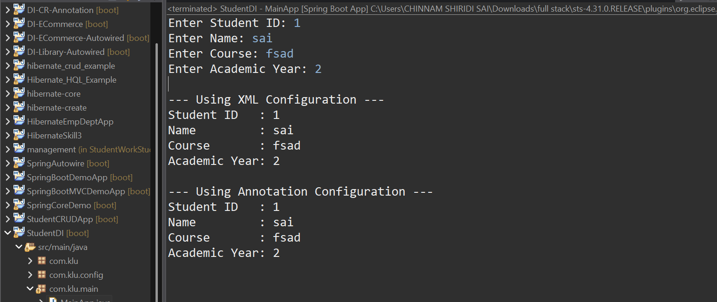
Github ScreenShot:
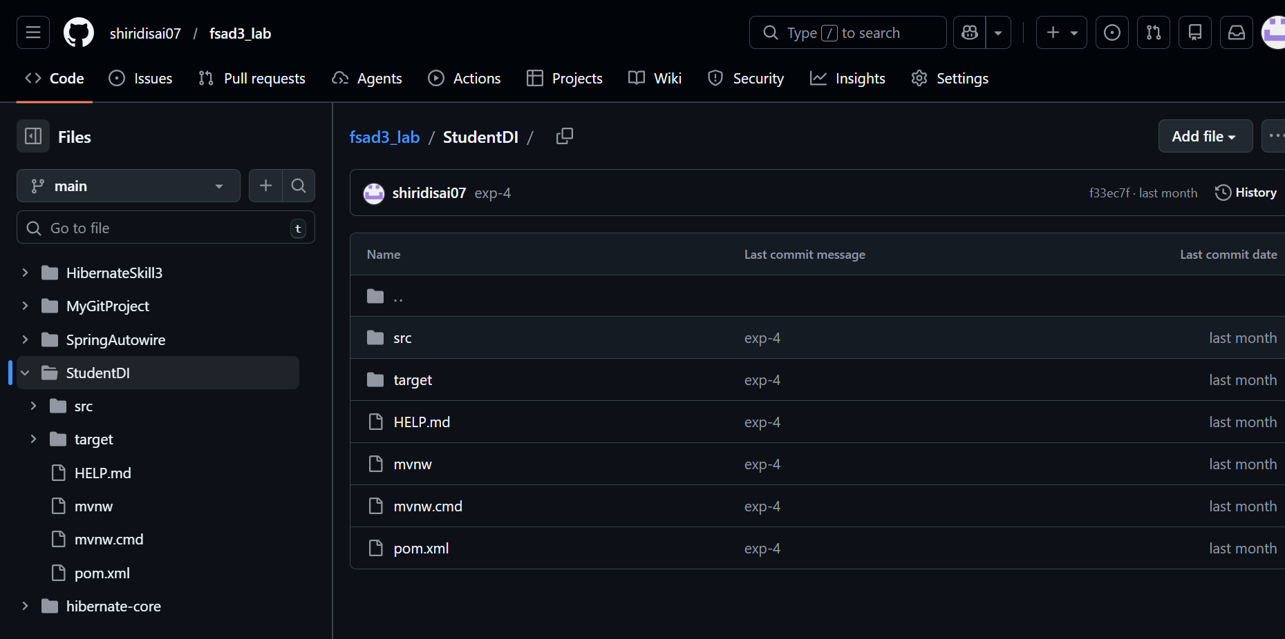
Githublink:
https://github.com/shiridisai07/fsad3_lab/tree/main/StudentDI

Result
All tasks of Experiment 4 were successfully executed. Constructor Injection and Setter Injection were implemented using XML-based and Annotation-based Spring configurations.

VIVA:
1. What is Dependency Injection (DI) in Spring?
Answer:
Dependency Injection is a Spring mechanism where the IoC container provides required objects (dependencies) to a class instead of the class creating them using the new keyword.

2. What is the difference between Constructor DI and Setter DI?
Answer:
- Constructor DI injects dependencies through the constructor at object creation.
- Setter DI injects dependencies using setter methods after the object is created.
Constructor DI is used for mandatory dependencies, while Setter DI is used for optional dependencies.

3. What is the purpose of the IoC container?
Answer:
The IoC container is responsible for creating, managing, and injecting beans, and controlling their lifecycle in a Spring application.

4. Why is DI preferred over manual object creation?
Answer:
DI is preferred because it:
- Reduces tight coupling
- Improves code reusability
- Makes applications easier to test and maintain

5. Can Constructor Injection and Setter Injection be used together?
Answer:
Yes, Constructor Injection and Setter Injection can be used together in the same class in Spring.

(For Evaluator’s use only)
Comment of the Evaluator (if Any)

Evaluator’s Observation
Marks Secured: out of
EMP ID & Full Name of the Evaluator:

Signature of the Evaluator Date of Evaluation

Date of the Session: / / Time of The Session: to

