EXPERIMENT – 5
NAME | M.HARSHAVARDHAN REDDY
ID | 2400090136
SECTION | S-56
COURSE | FSAD

Spring Autowiring Demo using @Autowired

Aim
To demonstrate Spring Autowiring using the @Autowired annotation to automatically inject dependent objects into a Spring bean.

Software Requirements
• Java 8 or above
• Spring Framework (Core)
• Eclipse IDE
• Maven

Theory
Autowiring is a feature of Spring Framework that enables automatic injection of dependent objects. Using annotations like @Component and @Autowired, Spring creates and links objects inside the IoC container without using the new keyword.

Task 1: Create Certification Class
Certification.java
package com.klu.model;
import org.springframework.stereotype.Component;
@Component
public class Certification {
private int id = 501;
private String name = "Java Full Stack";
private String dateOfCompletion = "2025-01-10";
@Override
public String toString() {
return id + " " + name + " " + dateOfCompletion;
}
}

Task 2: Create Student Class and Autowire Certification
Student.java
package com.klu.model;
import org.springframework.beans.factory.annotation.Autowired;
import org.springframework.stereotype.Component;
@Component
public class Student {
private int id = 101;
private String name = "Sai";
private String gender = "Male";
@Autowired
private Certification certification;
public void display() {
System.out.println("Student ID: " + id);
System.out.println("Name: " + name);
System.out.println("Gender: " + gender);
System.out.println("Certification: " + certification);
}
}

Task 3: Enable Component Scanning
AppConfig.java
package com.klu.config;
import org.springframework.context.annotation.ComponentScan;
import org.springframework.context.annotation.Configuration;
@Configuration
@ComponentScan("com.klu.model")
public class AppConfig {
}

Task 4: Load Spring IoC Container
MainApp.java
package com.klu.main;
import org.springframework.context.ApplicationContext;
import org.springframework.context.annotation.AnnotationConfigApplicationContext;
import com.klu.config.AppConfig;
import com.klu.model.Student;
public class MainApp {
public static void main(String[] args) {
ApplicationContext context =
new AnnotationConfigApplicationContext(AppConfig.class);
Student student = context.getBean(Student.class);
student.display();
}
}

Output
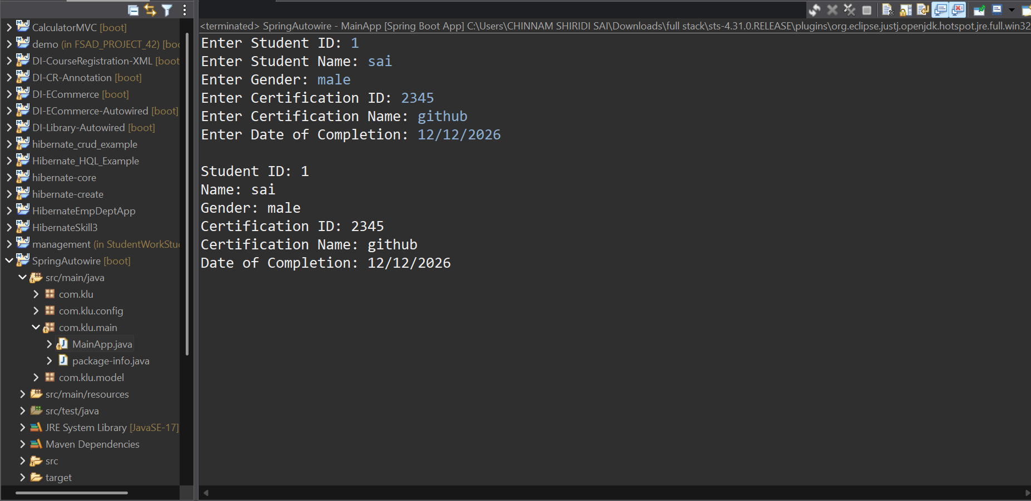
Github Screen shot:
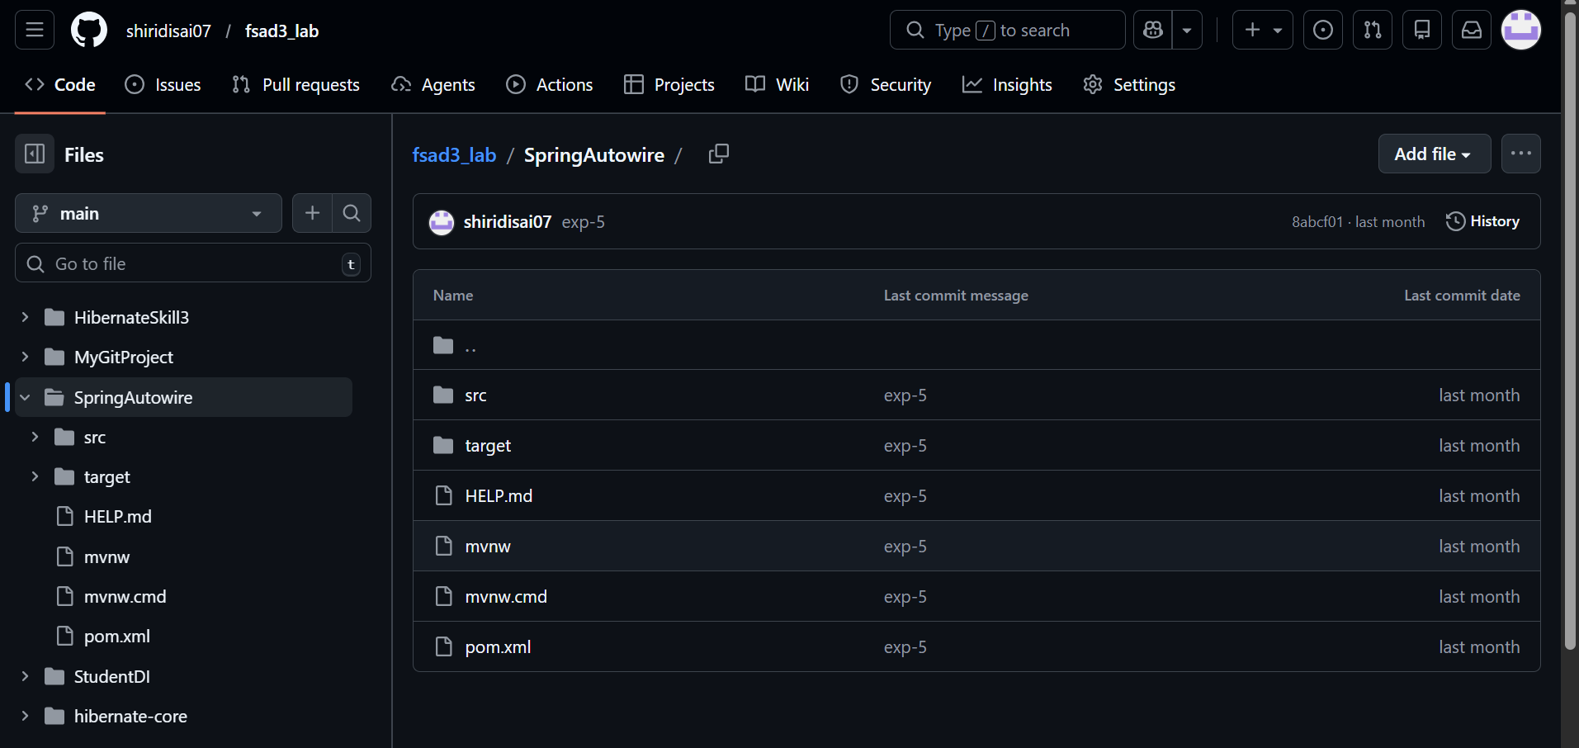
Github link:
https://github.com/shiridisai07/fsad3_lab/tree/main/SpringAutowire

Result
All tasks of Experiment–5 were successfully executed. Spring Autowiring using the @Autowired annotation was implemented and the Certification object was automatically injected into the Student object.

VIVA:
1. What is autowiring in Spring?
Answer:
Autowiring is a feature of Spring where the IoC container automatically injects required dependencies into a bean without manual configuration.

2. What is the purpose of the @Autowired annotation?
Answer:
@Autowired is used to automatically inject a dependent bean into another bean by Spring based on type.

3. How does Spring choose which bean to inject?
Answer:
Spring selects a bean by type first.
If multiple beans exist, it uses:
- @Primary
- @Qualifier
- Bean name
to decide which bean to inject.

4. What is component scanning in Spring?
Answer:
Component scanning allows Spring to automatically detect and register beans annotated with @Component, @Service, @Repository, and @Controller.

5. What happens if more than one bean matches the dependency type?
Answer:
Spring throws a NoUniqueBeanDefinitionException unless:
- @Primary is used
- @Qualifier is specified

- (For Evaluator’s use only)
Comment of the Evaluator (if Any)

Evaluator’s Observation
Marks Secured: out of
EMP ID & Full Name of the Evaluator:

Signature of the Evaluator Date of Evaluation

- Date of the Session: / / Time of The Session: to

