
NAME: | M.HARSHAVARDHAN REDDY
ID: | 2400090136
SECTION: | S-56
SUBJECT: | FULL STACK APPLICATION  DEVELOPMENT

#SKILL - 8 Spring Boot – JPQL & Query Methods Module

Tasks:

1. Create a Product entity with the following fields:
a. id
b. name
c. category
d. price
Output:-

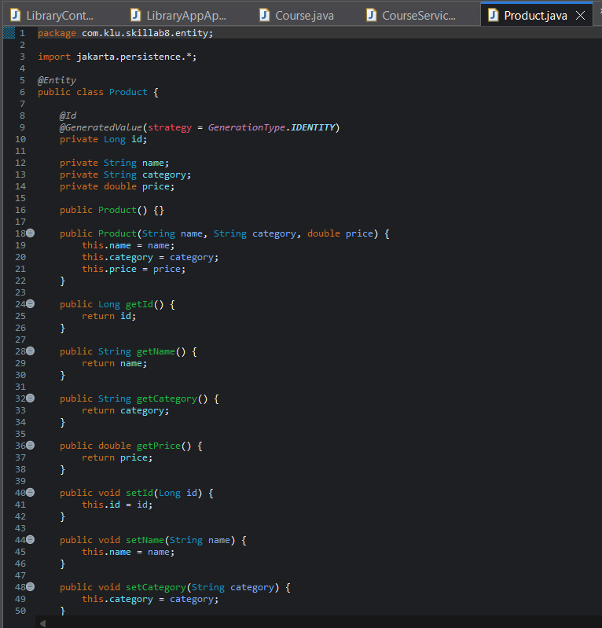

2. Create a ProductRepository and add derived query methods:
a. findByCategory(String category)
b. findByPriceBetween(double min, double max)

Output:-

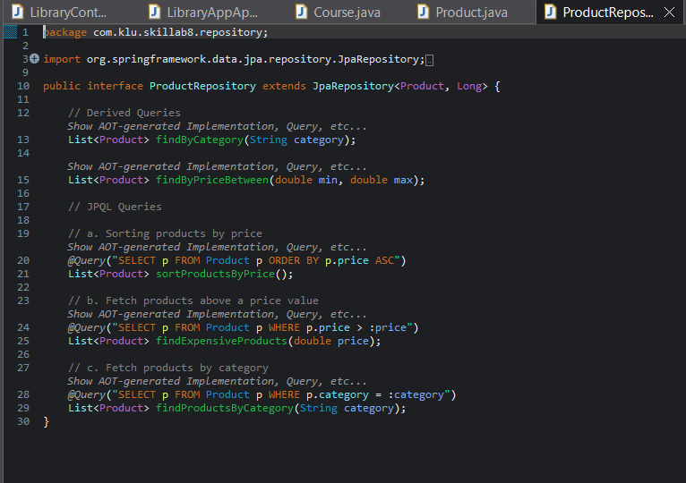

3. Write JPQL queries using @Query for:

a. Sorting products by price

b. Fetching products above a price value

c. Fetching products by category Output:-
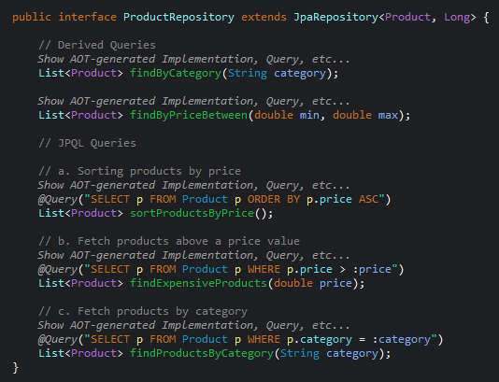

4. Create REST controller endpoints to test query methods:
a. /products/category/{category}
b. /products/filter?min=&max=
c. /products/sorted d. /products/expensive/{price}

Output:-

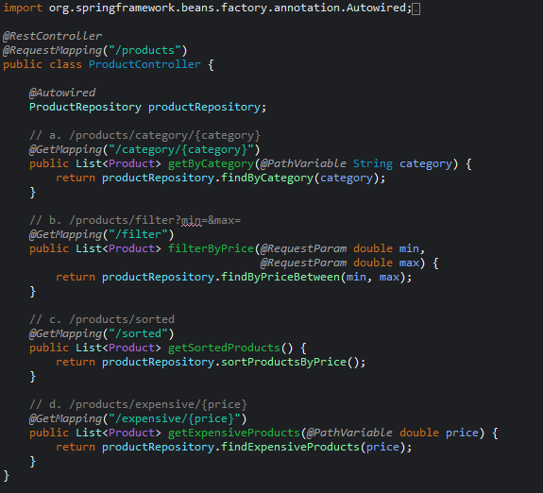

5. Insert sample product records and test using Postman.
Output:-

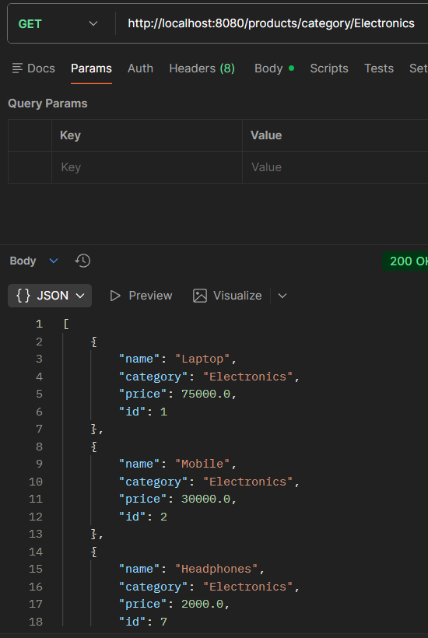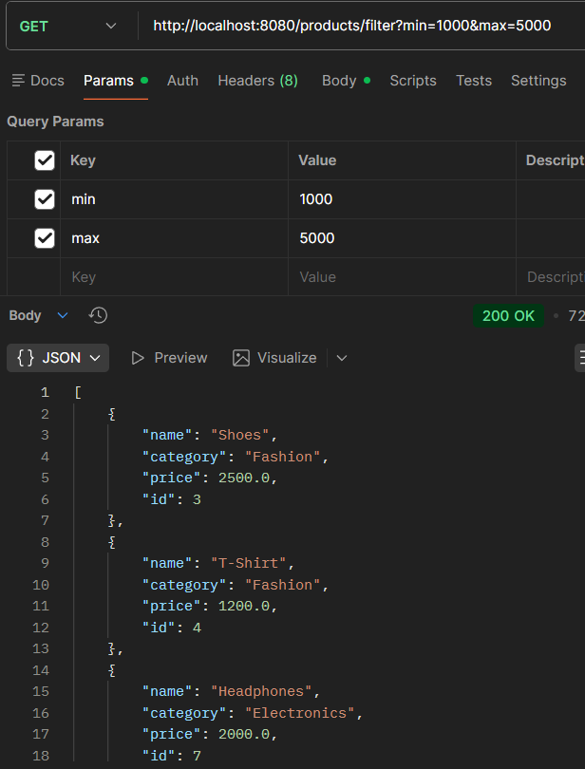

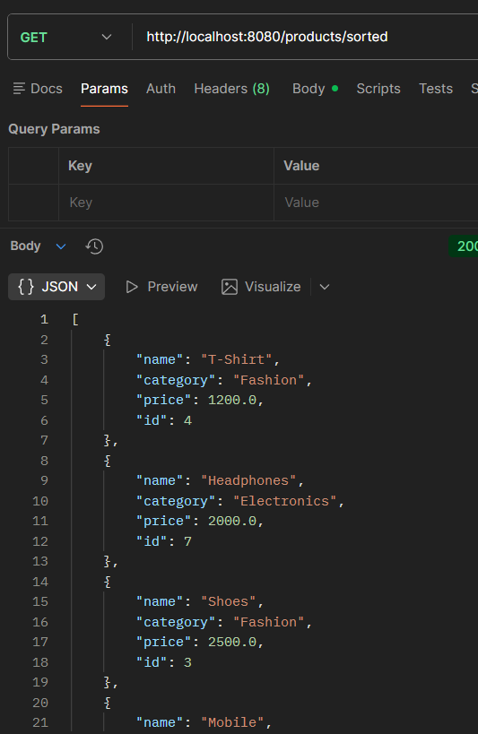

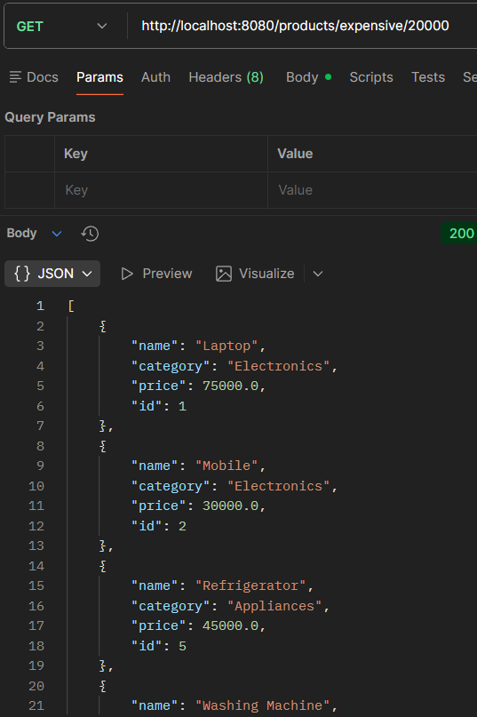

7. Push the Spring Boot project to GitHub.

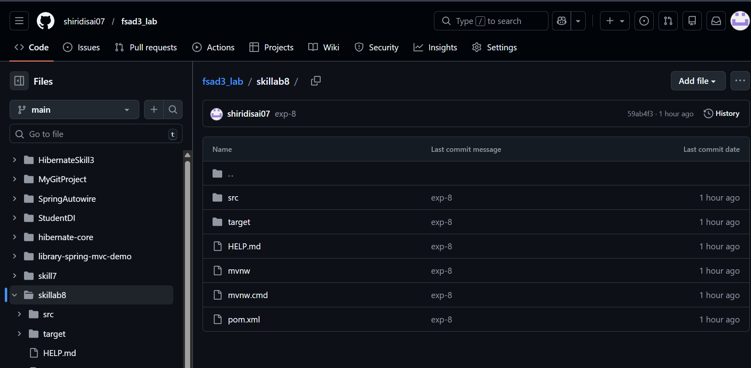

GITHUB REPO LINK :- https://github.com/shiridisai07/fsad3_lab/tree/main/skillab8

VIVA:
1. What is JPQL and how is it different from SQL?
Answer:
JPQL (Java Persistence Query Language) is used to query entities in JPA using entity class names and attributes. SQL queries database tables directly, while JPQL works with Java objects.

2. What are derived query methods in Spring Data JPA?
Answer:
Derived query methods are query methods automatically generated by Spring Data JPA based on method names like findByName() or findByEmail().

3. Why is method naming important in Spring Data JPA?
Answer:
Method naming is important because Spring Data JPA automatically creates queries by analyzing the method name. The name must follow specific conventions like findBy, deleteBy, or countBy.

4. Can JPQL return custom objects in a query?
Answer:
Yes, JPQL can return custom objects using constructor expressions such as SELECT new com.example.DTO(...).

5. When should we choose derived queries instead of JPQL?
Answer:
Derived queries should be used for simple queries because they are easy to write and reduce boilerplate code compared to writing JPQL manually.

