
NAME: | M.HARSHAVARDHAN REDDY
ID: | 2400090136
SECTION: | S-56
SUBJECT: | FULL STACK APPLICATION DEVELOPMENT

#SKILL - 9 Global Exception Handling using @ControllerAdviceTasks:

Create a custom exception class named StudentNotFoundException.

Output:-
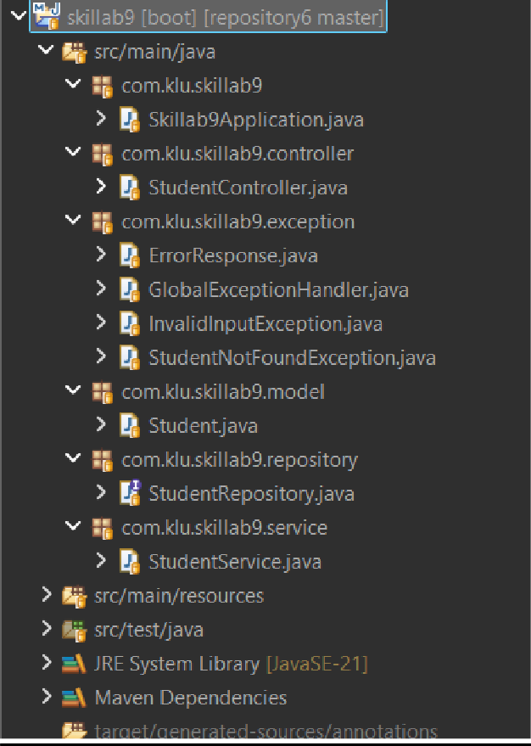

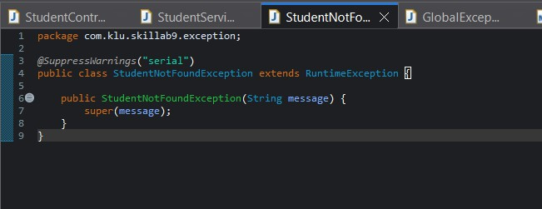

- Create a REST endpoint /student/{id} that retrieves student information and throws the custom exception when the given student ID is invalid.

Output:-
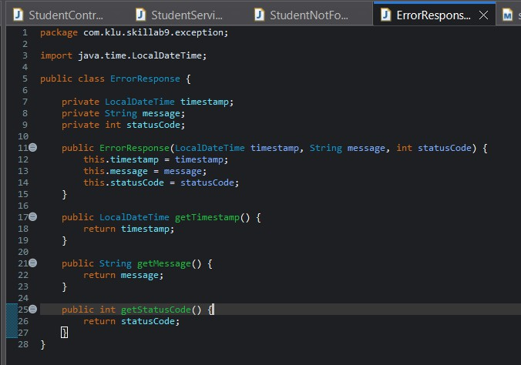
- Create a GlobalExceptionHandler class using @ControllerAdvice to handle exceptions across the entire application.

Output:-
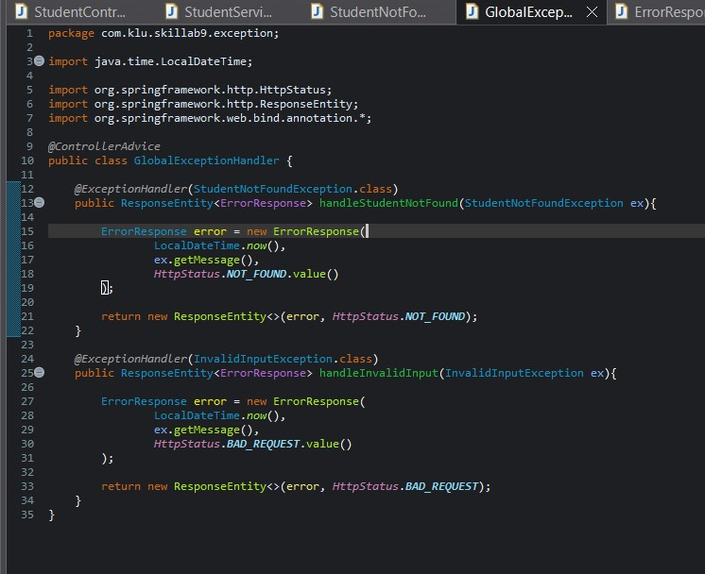

- Add a method with @ExceptionHandler(StudentNotFoundException.class) to return a meaningful error response along with an appropriate HTTP status code.

Output:-
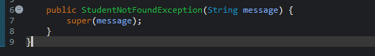

- Add a second custom exception, such as InvalidInputException, and handle it inside the same @ControllerAdvice class.

Output:-
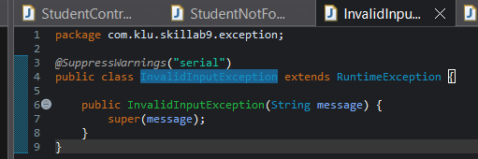

- Return a structured JSON response (fields like timestamp, message, statusCode) from the exception handler to make the error readable and consistent.

Output:-
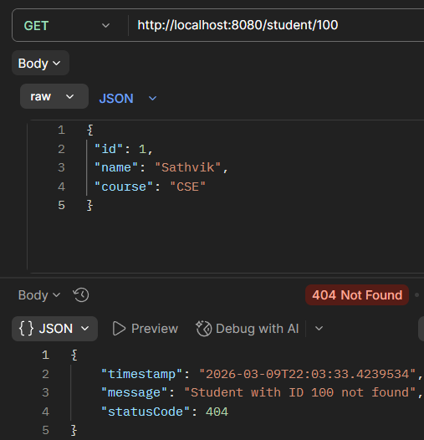

- Test the API with valid and invalid student IDs and observe the difference in responses.

Output:-
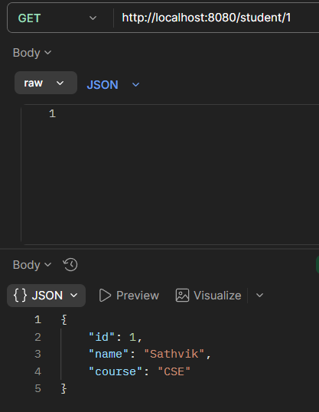
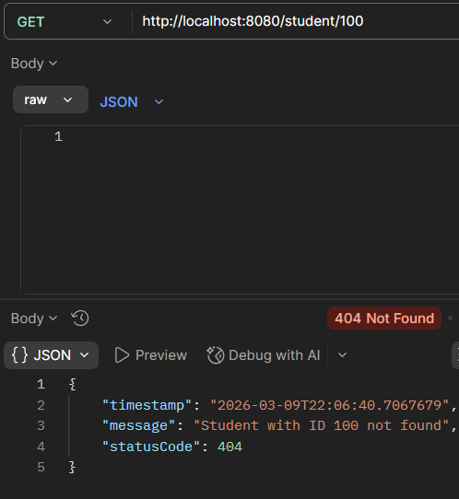

- Test an endpoint with invalid input format (e.g., sending text instead of a number) to trigger the second custom exception using Postman.

Output:-
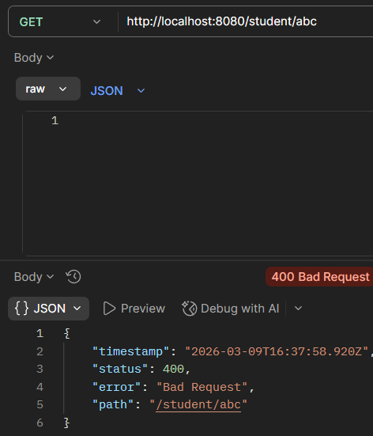

- Push the Spring Boot project to GitHub.

Output:-
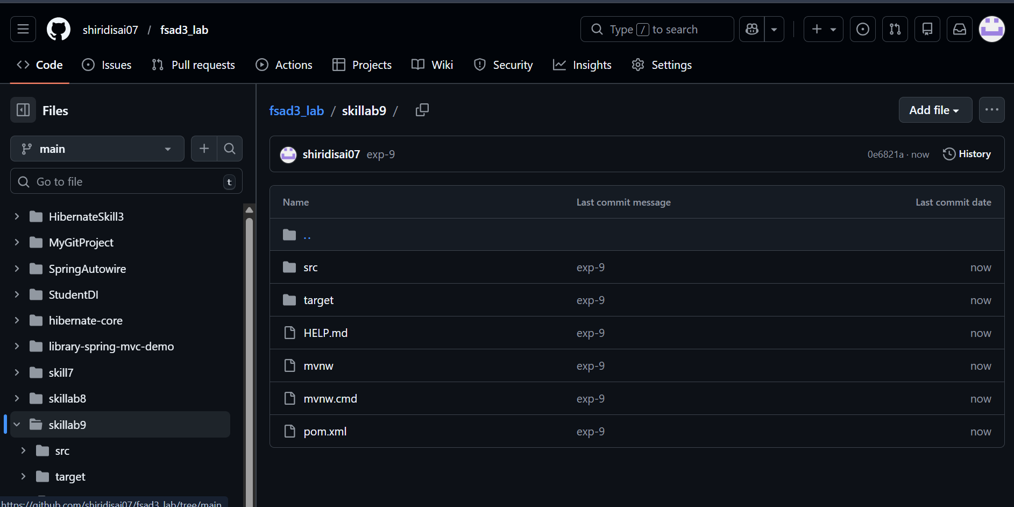

GITHUB REPO LINK :- https://github.com/shiridisai07/fsad3_lab/tree/main/skillab9

VIVA:
1. What is the purpose of @ControllerAdvice in Spring?
Answer:
@ControllerAdvice is used to handle exceptions globally across the whole Spring application. It allows developers to write centralized exception handling logic so that all controllers can share the same error handling methods.

2. How does @ExceptionHandler work inside a global handler?
Answer:
@ExceptionHandler is used to define methods that handle specific exceptions. When an exception occurs in any controller, Spring automatically calls the method annotated with @ExceptionHandler in the @ControllerAdvice class that matches that exception type.

3. Why do applications use global exception handling?
Answer:
Applications use global exception handling to avoid repeating exception handling code in multiple controllers. It improves code readability, maintainability, and provides consistent error responses across the application.

4. What is the difference between custom exceptions and default exceptions?
Answer:
- Default Exceptions: Built-in exceptions provided by Java or Spring (e.g., NullPointerException, IOException).
- Custom Exceptions: User-defined exceptions created by developers to represent specific application errors.

5. Can a single @ControllerAdvice class handle multiple exceptions?
Answer:
Yes, a single @ControllerAdvice class can handle multiple exceptions. Multiple methods can be defined using @ExceptionHandler to handle different types of exceptions within the same class.

