
NAME: | M.HARSHAVARDHAN REDDY
ID: | 2400090136
SECTION: | S-56
SUBJECT: | FULL STACK APPLICATION  DEVELOPMENT

#SKILL - 10 React State Management using useState Object

Tasks:

Create a new React component named StudentManager. Output:-
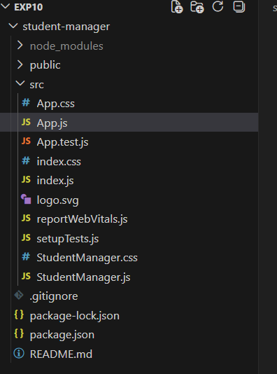

- Inside the component, create an initial students array with at least 5 objects containing:
  - id
  - name
  - course

Output:-
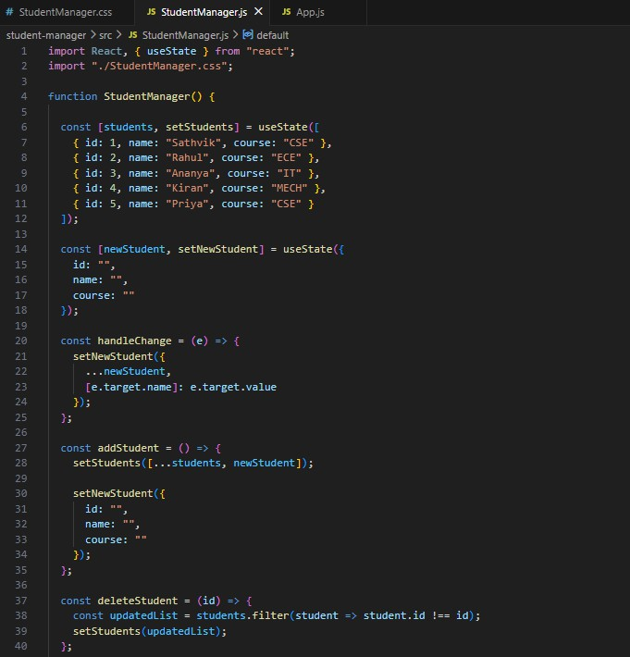

- Use useState to store:
  - students (array of student objects)
  - newStudent (object with fields like id, name, course) Output:-
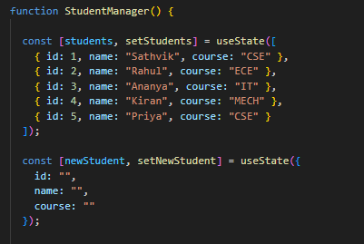

- Create input boxes to accept id, name, and course.
i. Update the newStudent object using onChange events.
Output:-
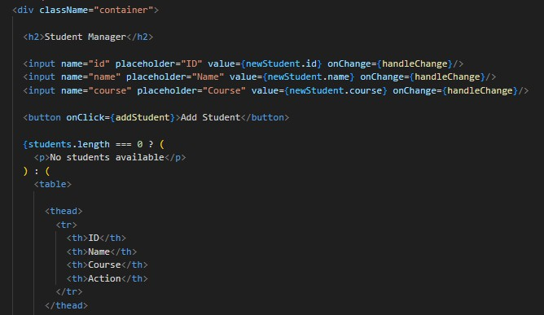

- Create an Add Student button.
- On click, add the newStudent object to the students array.
- After adding, clear the input fields.
Output:-
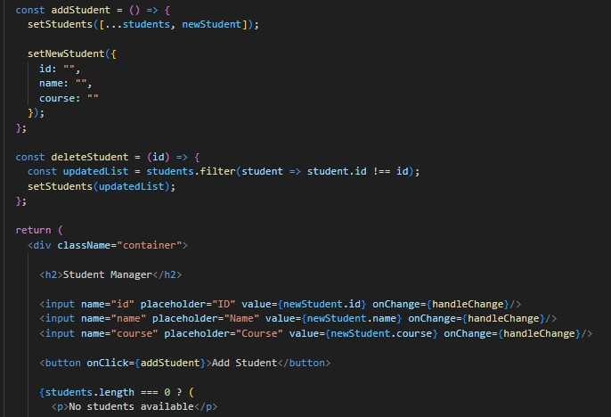

- Display the list of students below using the students state.

Output:-
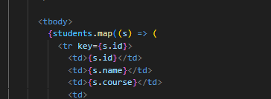
- Each student row should have a Delete button.
- On clicking delete, remove the record from the students array.
- The UI should update immediately using setStudents.

Output:-
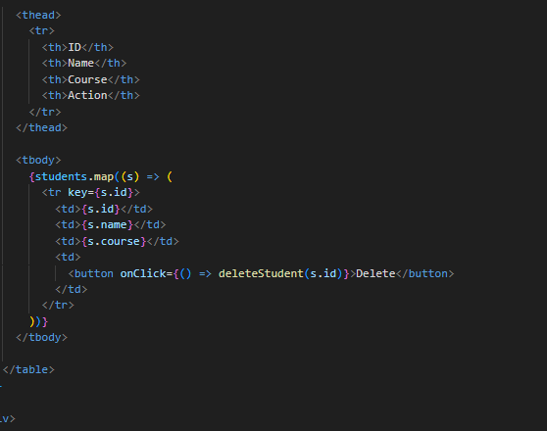

- If the list becomes empty, display the message: "No students available" Output:-
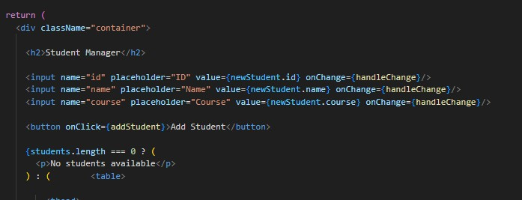

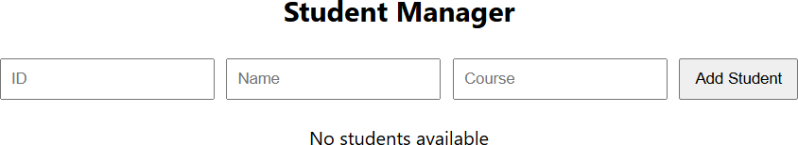

- Add basic CSS styling for a clean UI (margin, padding, table style, buttons).

Output:-

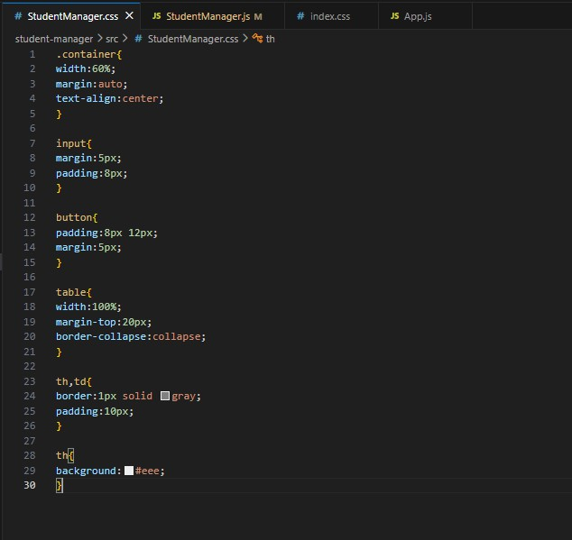

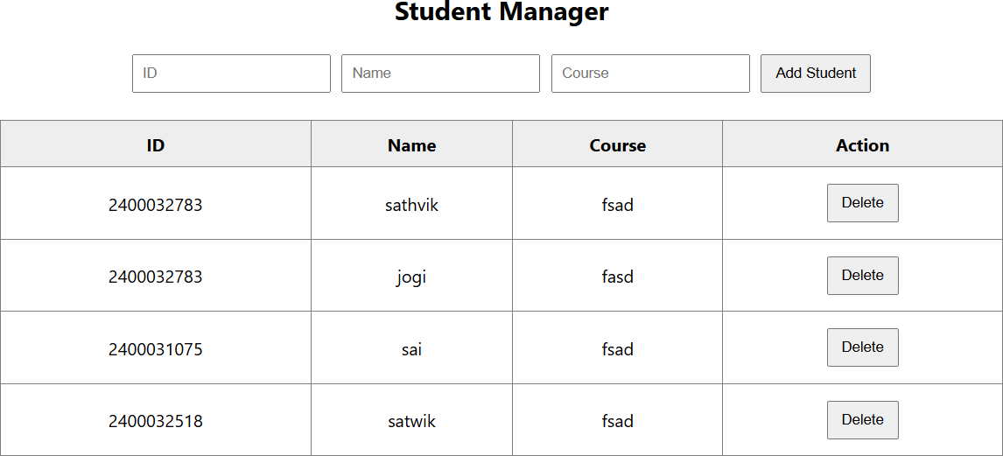

Github pushed Screenshot:
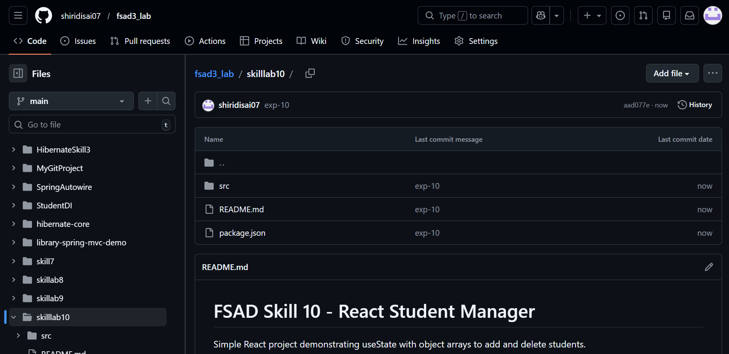

Github link;
https://github.com/shiridisai07/fsad3_lab/tree/main/skilllab10

VIVA:

1. What is the purpose of the useState hook in React?
Answer:
The useState hook is used to create and manage state in functional components. It allows components to store data and update the UI whenever the state changes.

2. How does React update the UI when state changes?
Answer:
When the state is updated using the state setter function (like setState or setStudents), React automatically re-renders the component and updates the UI to reflect the new state.

3. Why do we store form inputs in state for controlled components?
Answer:
Form inputs are stored in state to make them controlled components. This allows React to control the input values and handle changes using event handlers like onChange.

4. What is the importance of using keys when rendering lists?
Answer:
Keys help React identify which items in a list have changed, been added, or removed. This improves performance and ensures efficient UI updates.

5. Can one component use multiple useState variables? Why?
Answer:
Yes, a component can use multiple useState variables. This helps manage different pieces of state separately, making the code cleaner and easier to maintain.

