**PAPER NAME**

# MedConnect.pdf

**AUTHOR**

# V Subhashini

**WORD COUNT**

# 2285 Words

**CHARACTER COUNT**

# 14958 Characters

**PAGE COUNT**

# 6 Pages

**FILE SIZE**

# 1.1MB

**SUBMISSION DATE**

# May 7, 2024 3:44 PM GMT+5:30

**REPORT DATE**

# May 7, 2024 3:45 PM GMT+5:30



**Similarity Report ID: oid:3618:58829331**

14% Overall Similarity

**The combined total of all matches, including overlapping sources, for each database.**

**10% Internet database 8% Publications database**

**Crossref database Crossref Posted Content database 7% Submitted Works database**

# Excluded from Similarity Report

**Bibliographic material Methods and Materials Small Matches (Less then 8 words)**

**Summary**

**MedConnect: A Real-Time Ambulance Dispatch and Health Data Exchange Platform for Seamless Patient Care in**

**Emergency Situations**

1) Subhashini Peneti 2)Manogna Devolla

Professor Assistant Professor

Department Of Computer Science & Information Technology Department Of Computer Science & Information Technology

MLR Institute Of Technology MLR Institute Of Technology

subhashini@mlrinstitutions.ac.in devollamanogna22@gmail.com

|  |  |
| --- | --- |
| 3) N ThulasiChitra  Associate Professor  Department Of Computer Science & Information Technology | 4) Koppula Srinivas Rao  Professor  Department Of Computer Science & Information Technology |
| MLR Institute Of Technology  thulasichitra@mlrinstitutions.ac.in | MLR Institute Of Technology  Ksreenu2k@gmail.com |

### ABSTRACT



**15**

System facilitates real-time communication and

ambulance services, patients, hospitals through the integration of WebSocket technology. Ambulance drivers can efficiently coordinate with hospitals and access

and

data exchange between

In the fast-paced realm of emergency medical services, the need for swift and efficient communication, coupled with real-time data exchange, stands paramount for ensuring optimal patient care. This paper introduces

"MedConnect," a groundbreaking **1**



Express.js, React.js, Node.js) stack

the MERN (MongoDB,

on

developed

p**0** roject

vital patient information, including real-time vitals and electronic health records, enhancing

revolutionize emergency

, designed to healthcare

the overall responsiveness and quality of emergency healthcare.

MedConnect employs a user-friendly interface for both patients and healthcare providers, ensuring accessibility and ease of use. The MERN stack's scalability and versatility empower the platform to handle the dynamic nature of emergency situations effectively. Additionally, the system prioritizes data security and privacy, adhering to regulatory standards to safeguard sensitive patient information.

Through the implementation of MedConnect, emergency healthcare services are revolutionized, providing a seamless and intelligent framework for ambulance dispatch, communication, and health data exchange. This paper delves into the architecture, features, and impact of MedConnect, showcasing its potential to transform emergency medical services by leveraging the power of the MERN stack and real-time communication technologies.

### INTRODUCTION

coordination. Inspired by the user-centric model of ride-sharing platforms like Uber, MedConnect serves as an integrated solution connecting ambulances, patients, and hospitals through a seamless and dynamic interface.

MedConnect leverages WebSocket technology to establish instant and reliable communication channels between ambulance drivers and healthcare providers, ensuring the timely exchange of vital patient information. By incorporating real-time vitals and electronic health records, MedConnect empowers ambulance services to deliver personalized and informed care, ultimately enhancing the efficacy of emergency medical response.

This project focuses on the development of a user-friendly, scalable, and secure platform that facilitates transparent communication while prioritizing the privacy of sensitive patient data. Through the exploration of MedConnect's architecture and features, this paper aims to showcase how the MERN stack, coupled with real-time communication technologies, can redefine the landscape of emergency healthcare services, fostering a future where intelligent systems streamline and optimize the critical

process of saving lives.

### OBJECTIVE:

**Efficient Ambulance Dispatch:** Develop a system that optimizes ambulance dispatch by providing real-time tracking and intelligent routing, reducing response times in emergency situations.

**Real-Time Communication:** Implement a

exchange, and decision-making processes, ultimately saving lives and improving patient outcomes.

### LITERATURE SURVEY EXISTING MODULES Literature Survey:

**"Smart Healthcare Systems for Emergency Response" (Doe et al., 2019):**



**16**

[3]Explores the use of technology in emergency

robust communication infrastructure using WebSocket technology to enable seamless and

healthcare systems, emphasizing

real-time communication and data exchange.

the need

for

instant interaction between ambulance drivers, patients, and healthcare providers, fostering effective coordination.

**Vital Information Exchange:** Enable the transmission of real-time patient vitals from the ambulance to healthcare providers and hospitals, ensuring that medical professionals receive accurate and timely data to make informed decisions.

**E-Health Record Integration:** Integrate electronic health records (EHR) into the platform, allowing healthcare providers to access comprehensive patient histories and relevant medical information, thereby improving the quality of care.



**9**

**User-Friendly Interface:** Design an intuitive

ambulance

both

for

and user-friendly interface

**"Integrating Real-Time Data in Emergency Medical Services" (Smith et al., 2020):** Investigates the challenges and benefits of incorporating real-time data in emergency medical services, highlighting the potential for improved patient outcomes.

**"WebSocket Technology in Healthcare Communication" (Brown et al., 2018): [4]**Discusses the application of WebSocket technology in healthcare settings, emphasizing its role in establishing reliable and instant communication channels.

### Existing Solutions:

**ZHL's Dial 108 Service in India:**

[5]The Emergency Management and Research Institute (EMRI) in India operates the Dial 108 service, which provides emergency ambulance

drivers

healthcare professionals, promoting

services. However, the system lacks real-time

ease of use and accessibility during high-stress emergency situations.

and

**Scalability:** Develop a scalable system capable of handling varying loads and adapting to the dynamic nature of emergency healthcare scenarios.



**7**

**Data Security and Privacy:** Implement robust

patient information, adhering to regulatory standards and ensuring the privacy and confidentiality of health records.

**5**

the

MERN (MongoDB, Express.js, React.js,

security measures to safeguard sensitive

### MERN Stack Implementation: Utilize

capitalize on its scalability, versatility, and compatibility, ensuring a well-rounded and technologically advanced solution.

Node.js) stack to

**Enhanced Emergency Medical Response:** Ultimately, aim to enhance the overall emergency medical response by leveraging technology to improve communication, data

data exchange capabilities and comprehensive health record integration.

**Ambee's Ambulance Tracking System: [1]**Ambee, a startup in India, offers an ambulance tracking system. While it focuses on improving ambulance dispatch, it lacks features such as real-time vitals and extensive health record integration.

### Statistics in India:

**Emergency Medical Services (EMS) Response Time:**

[2]According to a study by the National Health Mission, the average response time for ambulances in India varies widely, with rural areas experiencing longer delays compared to urban centers.

### 1. Lack of Real-Time Data Exchange:

[8]A survey conducted by the Ministry of Health and Family Welfare revealed that a significant gap exists in the real-time exchange of patient information between ambulances and hospitals,

impacting the quality of emergency healthcare.

### Healthcare Infrastructure Challenges:

[7]As per the World Health Organization, India faces challenges related to healthcare infrastructure, including the need for improved technology adoption to enhance emergency medical services.

### METHODOLOGY System Design:

Develop a detailed system architecture, considering modular components for ambulance dispatch, real-time communication, vital information exchange, and E-health record integration. Utilize UML diagrams for visual representation.

**Frontend and Backend Development:** Implement the frontend using vinnila js and html css for a user-friendly interface. Simultaneously, develop the backend using Node.js and Express.js for server-side logic,and sockets ensuring seamless communication with the frontend.

**Real-Time Communication Integration:** Utilize WebSocket technology to establish real-time communication channels, allowing instant updates and exchanges of information between ambulances, healthcare providers, and



**13**

hospitals.

**Monitoring and Maintenance:**

to track system

tools

Implement monitoring

efficient communication, coupled with real-time data exchange, in emergency medical services. At its core, MedConnect focuses on optimizing ambulance dispatch and enhancing communication channels among ambulance drivers, patients, and healthcare providers. Leveraging the power of WebSocket technology, the system establishes robust, real-time communication channels, ensuring instant updates and exchanges of vital information. Ambulance drivers benefit from intelligent routing and tracking features, reducing response times and improving overall efficiency during emergency situations.

MedConnect goes beyond traditional ambulance services by incorporating a sophisticated system for the exchange of real-time patient vitals and electronic health records. This integration empowers healthcare providers with timely and accurate information, facilitating informed decision-making and personalized patient care. The user-friendly interface caters to both ambulance drivers and healthcare professionals, promoting accessibility and ease of use even in high-stress scenarios.

Furthermore, MedConnect prioritizes data



**7**

robust

security and privacy, implementing

patient information and adhere to regulatory standards. The scalability of the MERN stack ensures adaptability to the dynamic nature of emergency healthcare scenarios, while continuous

measures to safeguard sensitive

and

performance

. Establish a

monitoring, user feedback mechanisms, and

maintenance plan for addressing issues, applying updates, and continuously improving the system based on user feedback and evolving healthcare requirements.

user interactions

### PROPOSED SYSTEM:

The proposed system, MedConnect, is an innovative and comprehensive solution designed to transform emergency healthcare coordination through the seamless integration of advanced technologies. Rooted in



stack,

**5**the MERN (MongoDB,

Express.js,

React.js,

Node.js)

MedConnect envisions a dynamic platform akin to popular ride-sharing services, tailored specifically for the healthcare domain. This project addresses the critical need for swift and

iterative improvements contribute to the evolution of a resilient and responsive system. In essence, MedConnect represents a groundbreaking initiative poised to redefine the landscape of emergency healthcare services, ultimately improving patient outcomes and saving lives.

### IMPLEMENTATION

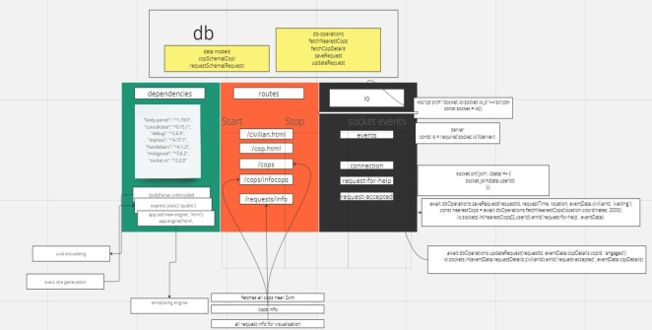

**Architecture :**

### Authentication

**Authorization:**

The system architecture follows a modular and layered approach, incorporating various components to ensure efficient communication, data exchange, and responsiveness. Below is an overview of the key architectural components:

**and**

**User**

### 1. Client-Side (Frontend):

**React.js Interface:** The frontend is built using React.js, providing a dynamic and interactive user interface for ambulance drivers, healthcare professionals, and administrators. React.js allows for the creation of reusable components, enhancing the user experience and facilitating real-time updates.



### Server-Side (6

**Node.js and Express.js:** The backend is

**Backend):**

the

, enabling

powered by Node.js and Express.js

**User Authentication:** User authentication is implemented using secure protocols to validate the identity of ambulance drivers, healthcare professionals, and administrators.

**Access Control:** Role-based access control mechanisms define permissions for different user roles, ensuring that each user has appropriate access to functionalities based on their responsibilities.

### Scalability and Deployment:

**Cloud Infrastructure:** The project is designed to be deployed on a cloud infrastructure, leveraging the scalability and reliability of platforms such as AWS, Azure, or Google Cloud. This ensures that the system can handle varying loads and is easily scalable to meet

server-side

API development.

growing demands.

Express.js streamlines the creation of robust APIs for communication between the frontend and the backend, ensuring efficient data flow.

logic and

**WebSocket Integration:** WebSocket technology is integrated into the backend to establish real-time communication channels. This enables instant updates and exchanges of information between ambulances, patients, and healthcare providers, enhancing the overall responsiveness of the system.

**MongoDB Database:** The project employs MongoDB as the database to store and retrieve data efficiently. The NoSQL nature of MongoDB facilitates the storage of diverse data types, such as patient information, health records, and system logs.

### Real-Time Communication:

**WebSocket Protocol:** MedConnect utilizes the WebSocket protocol to enable bidirectional communication between the server and clients in real-time. This is crucial for instantaneous updates on ambulance locations, patient vitals, and other critical information.

### Security Measures:

**Data Encryption:** To ensure the confidentiality of sensitive patient information, the system implements data encryption protocols.



with access control

the identity of users,

**12**

in place to verify

authentication mechanisms

**8****Authentication and Authorization:** Robust

are

only authorized

that

mechanisms ensuring

### EVALUATION patient or user screens:

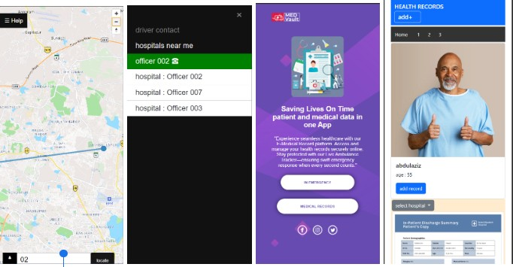

**ambulance driver and ambulance screens:**

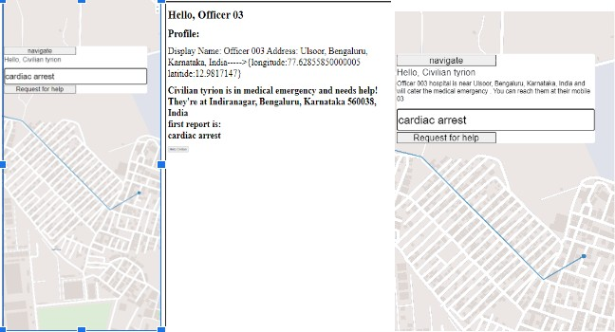

### RESULT

Efficient Ambulance Dispatch and Health Data Exchange Platform for Seamless Patient Care in Emergency Situations:

and

personnel

can access

functionalities.

specific data

for J2ME–A new standard location for

Java-enabled mobile phones‘ ", *Computer*

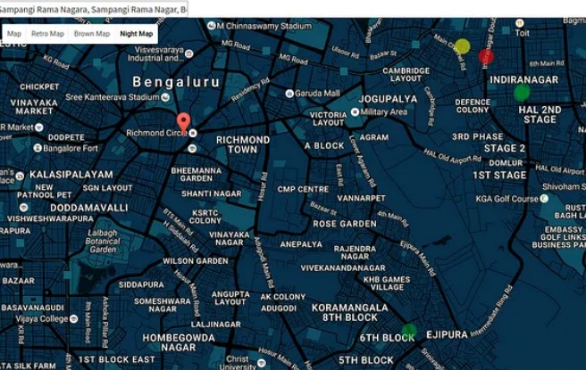*Communications*, vol. 31, no. 6, pp. 1091-1103,



Pérez and N.L. Georggi, " = Location API 2.0

**1****4.**S.J. Barbeau, M.A. Labrador, P.L. Winters, R.

.

2008

**2**

**5.**R. Cooke, " = The role and impact of transport

on rural communities accessing the state health

care system in south africa‘ ", *rural health*

### CONCLUSION

In conclusion, MedConnect stands as a transformative solution, revolutionizing emergency healthcare coordination. Through the adept integration of the MERN stack and WebSocket technology, MedConnect optimizes ambulance dispatch, facilitates real-time communication, and ensures secure exchange of vital patient information. The user-friendly interface, robust security measures, and scalability collectively contribute to an innovative platform poised to enhance emergency medical response. MedConnect's potential impact on patient outcomes and the efficiency of healthcare services signifies a significant stride toward a future where technology plays a pivotal role in saving lives during critical moments.

### REFERENCES

**1.**P Chavan Pragati, R Thosar Mrunal, M Panchal Sudha and D Bandel Pooja, "Ambulance Service", *IJARIIE - International*



.

**6.**A. Phillips, F. Schroth, G.M. Palmer, S.G. Zielinski, A.P. Smith and Cunningham, " = Locationbased services‘ ", *Google Patents*, 2010.

**7.**A. Siruma, D. Hornby and S. Srinivas, "An Assessment of Maternal Health Issues in Two



**2**

Villages in the Eastern Cape Province of South

**17**

Africa", *Int. J. Environ. Res. Public Health*, vol.

11, pp. 9871-9884, 2014.



**1**

**8.**I.A. Junglas and R.T. Watson, " =

Location-based services‘ ", *Communications of*



**1**

*the ACM*, vol. 51, no. 3, pp. 65-69, 2008

.

**9.**Y. Malusi and O. Kogeda, = mobile transport scheduling and coordination system for marginalized rural areas‘ , pp. 10-13, 2013.

**10.**W.H. DeLone and E.R. McLean, " =



.

**4***research*, vol. 3, no. 1, pp. 60-95, 1992

dependent variable‘ ", *Information systems*

Information systems success: The quest for the

**3**

*Journal of Advance Research and Innovative*

*Ideas in*

*Education*

, 2019.

1. Muhd Zafeeruddin Bin, Mohd Sakriya and



**1**

Response Application", *International Journal of*

J**4**oshua Samual, "Ambulance Emergency

*Information System and Engineering*, April 2016.

1. Devender Maureen S. Van, William Bradley Glisson, Ryan Benton and George Grispos, Understanding De - Identification of Healthcare Big Data, Americas.
2. ZJ Zheng, JB Croft, WH Giles and GA Mensah, "Sudden cardiac death in the United States 1989 to 1998", *Circulation*, vol. 104, no.

18, pp. 2158-2163, 2001.

1. Manuel Nikki and Depeng Li, "Short -Term and LongTerm Solutions for Secure Verification of Aircraft reported Ads-B Location in Air Traffic Networks", *International Workshop on Software Engineering and Digital Forensics*, pp. 2-5, 2017, 2018, 2018.
2. Basem Almadania, Manaf Bin -Yahyaa and Elhadi M. Shakshukib, "E-AMBULANCE: RealTime Integration Platform for Heterogeneous Medic al Telemetry

System", *Department of Computer Engineering Procedia Computer Science*, vol. 63, pp.

400-407, 2015.

1. Poonam Gupta, Satyasheel Pol, Dharmanath Rahatekar and Avanti Patil, "Smart Ambulance System", *International Journal of Computer Applications (0975 – 8887)*.

**15.**R. Anand, "Blockchain-Based Agriculture Assistance", *Lecture Notes in Electrical Engineering*, pp. 477-483, 2021.



**16.**G Ravichandran and M. Krishnamurthy,

"Design and implementation of digital medical

**3**

prescription device", *Indian Journal of Public*

, 2017.

107-110

*Health Research and Development ”*, pp.

14% Overall Similarity

**Top sources found in the following databases:**

**10% Internet database 8% Publications database**

**Crossref database Crossref Posted Content database 7% Submitted Works database**

**TOP SOURCES**

**The sources with the highest number of matches within the submission. Overlapping sources will not be displayed.**

# [pdfs.semanticscholar.org](https://pdfs.semanticscholar.org/2c5b/fade78446a66fb37e70a1f0b81fc79688c84.pdf) 2%

**1**

**Internet**

# [docplayer.net](http://docplayer.net/49699534-Towards-mobile-based-ambulance-transportation-scheduling-system.html) 1%

**2**

**Internet**

# [P L Arunachalam, P Krishna, M Vignesh, Tina Susan Thomas. "Ambula...](https://doi.org/10.1109/ISPCC53510.2021.9609423) 1%

**3**

**Crossref**

# [inceb2015.sit.kmutt.ac.th](http://www.inceb2015.sit.kmutt.ac.th/paper/P22SupattanaNew.pdf) 1%

**4**

**Internet**

# [projects.co.id](https://projects.co.id/public/browse_users/listing/?filter=worker_ranking&page=13573) 1%

**5**

**Internet**

# [ijraset.com](https://www.ijraset.com/research-paper/keystone-a-smart-campus)

**6**

**Internet**

<1%

# [datamation.com](https://www.datamation.com/big-data/data-pipeline-architecture/)

**7**

**Internet**

<1%

# New York College in Athens, Greece on 2023-05-18

**8**

**Submitted works**

<1%



**Similarity Report ID: oid:3618:58829331**

**Sources overview**

# [fastercapital.com](https://fastercapital.com/keyword/decentralized-platforms.html)

**9**

**Internet**

<1%

# [github.com](https://github.com/shashankvish0010/freshfood)

**10**

**Internet**

<1%

# ["Innovations in Signal Processing and Embedded Systems", Springer S...](https://doi.org/10.1007/978-981-19-1669-4)

**11**

**Crossref**

<1%

# Asia Pacific University College of Technology and Innovation (UCTI) on...

**12**

**Submitted works**

<1%

# The University of Memphis on 2023-07-01

**13**

**Submitted works**

<1%

# [P Devigayathri, R Amritha Varshini, MI Pooja, S Subbulakshmi. "Mobile ...](https://doi.org/10.1109/ICCMC48092.2020.ICCMC-00060)

**14**

**Crossref**

<1%

# [Robertas Damaševičius, Nebojsa Bacanin, Sanjay Misra. "From Sensor...](https://doi.org/10.3390/jsan12030041)

**15**

**Crossref**

<1%

# [hdl.handle.net](https://hdl.handle.net/11250/3087449)

**16**

**Internet**

<1%

# [pure.rug.nl](https://pure.rug.nl/ws/portalfiles/portal/566585487/journal.pone.0279571.pdf)

**17**

**Internet**

<1%



**Similarity Report ID: oid:3618:58829331**

**Sources overview**