2DES (Double DES)
Aim
To implement the Double DES (2DES) encryption algorithm in C using two different keys to perform encryption twice and decryption twice.

Algorithm
- Start the program.
- Read the plaintext and two secret keys (Key1 and Key2).
- Perform the first DES encryption using Key1.
- Obtain the intermediate ciphertext.
- Perform the second DES encryption on the intermediate ciphertext using Key2.
- Display the final encrypted ciphertext.
- For decryption:
  - Apply DES decryption using Key2.
  - Apply DES decryption using Key1.
- Display the original plaintext.
- Stop the program.

C Program (2DES Demonstration)
#include <stdio.h>
#include <string.h>

void encrypt(char text[], int key)
{
int i;

for(i = 0; text[i] != '\0'; i++)
{
text[i] = text[i] ^ key;
}
}

void decrypt(char text[], int key)
{
int i;

for(i = 0; text[i] != '\0'; i++)
{
text[i] = text[i] ^ key;
}
}

int main()
{
char plaintext[100];
int key1, key2;

printf("2DES Encryption Demonstration\n");

printf("Enter Plaintext: ");
scanf("%s", plaintext);

printf("Enter First Key: ");
scanf("%d", &key1);

printf("Enter Second Key: ");
scanf("%d", &key2);

// First DES Encryption
encrypt(plaintext, key1);

// Second DES Encryption
encrypt(plaintext, key2);

printf("\nEncrypted Cipher Text: %s\n", plaintext);

// Second DES Decryption
decrypt(plaintext, key2);

// First DES Decryption
decrypt(plaintext, key1);

printf("Decrypted Plain Text: %s\n", plaintext);

return 0;
}

Sample Output
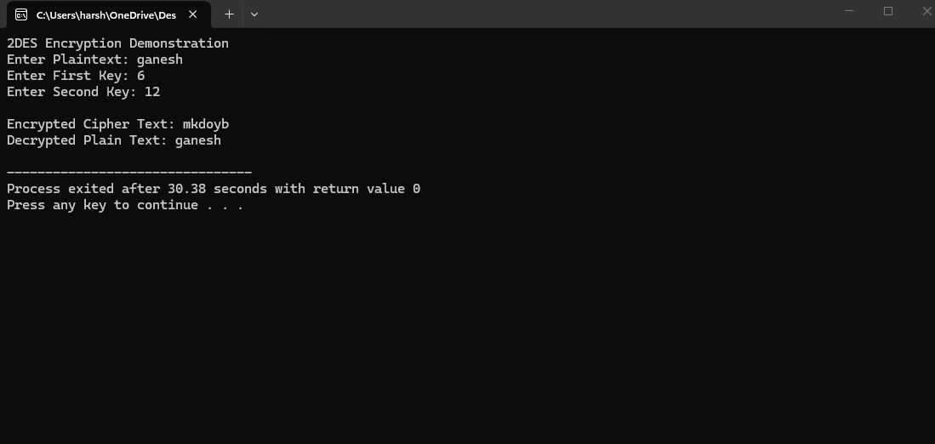
Result
Thus, the Double DES (2DES) encryption and decryption algorithm was implemented successfully in C using two keys.

2DES Information
- Type: Symmetric Key Encryption
- Number of DES Operations: 2
- Keys Used: Key1 and Key2
- Encryption:
Cipher Text = DES(Key2, DES(Key1, Plaintext))
- Decryption:
Plaintext = DES⁻¹(Key1, DES⁻¹(Key2, Ciphertext))

