3DES (Triple DES)
Aim
To implement the Triple DES (3DES) encryption and decryption algorithm in C using three different keys to provide enhanced security over DES.

Algorithm
- Start the program.
- Read the plaintext and three secret keys:
  - Key1
  - Key2
  - Key3
- Perform the first DES encryption using Key1.
- Perform DES decryption using Key2.
- Perform the third DES encryption using Key3.
- Display the final encrypted ciphertext.
- For decryption:
  - Apply DES decryption using Key3.
  - Apply DES encryption using Key2.
  - Apply DES decryption using Key1.
- Display the original plaintext.
- Stop the program.

C Program (3DES Demonstration)
#include <stdio.h>
#include <string.h>

void encrypt(char text[], int key)
{
int i;

for(i = 0; text[i] != '\0'; i++)
{
text[i] = text[i] ^ key;
}
}

void decrypt(char text[], int key)
{
int i;

for(i = 0; text[i] != '\0'; i++)
{
text[i] = text[i] ^ key;
}
}

int main()
{
char plaintext[100];
int key1, key2, key3;

printf("3DES Encryption Demonstration\n");

printf("Enter Plaintext: ");
scanf("%s", plaintext);

printf("Enter Key 1: ");
scanf("%d", &key1);

printf("Enter Key 2: ");
scanf("%d", &key2);

printf("Enter Key 3: ");
scanf("%d", &key3);

// Encryption: DES(K1) -> DES(K2) -> DES(K3)

encrypt(plaintext, key1);

decrypt(plaintext, key2);

encrypt(plaintext, key3);

printf("\nEncrypted Cipher Text: %s\n", plaintext);

// Decryption: DES^-1(K3) -> DES(K2) -> DES^-1(K1)

decrypt(plaintext, key3);

encrypt(plaintext, key2);

decrypt(plaintext, key1);

printf("Decrypted Plain Text: %s\n", plaintext);

return 0;
}

Sample Output
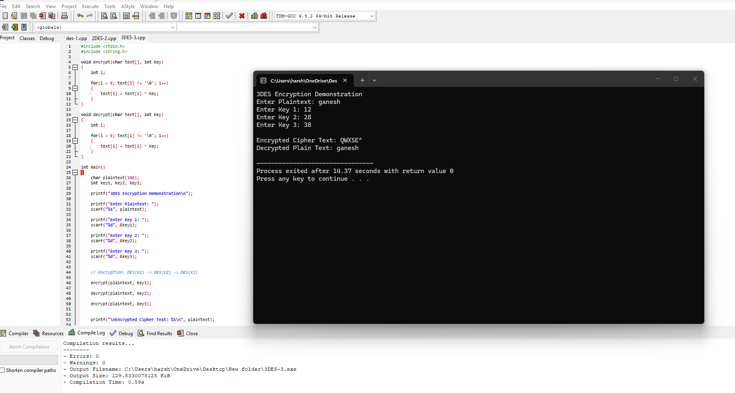
Result
Thus, the Triple DES (3DES) encryption and decryption algorithm was implemented successfully in C using three keys.

3DES Information
- Type: Symmetric Key Encryption
- Block Size: 64 bits
- Key Size:
  - 112 bits (2-key 3DES)
  - 168 bits (3-key 3DES)
- Number of DES Operations: 3
- Encryption Process:
[
Cipher = E(K3,D(K2,E(K1,Plaintext)))
]
- Decryption Process:
[
Plaintext = D(K1,E(K2,D(K3,Cipher)))
]

