6. Diffie–Hellman Key Exchange Algorithm
Aim
To implement the Diffie–Hellman key exchange algorithm in C to generate a shared secret key between two parties securely.

Algorithm
- Start the program.
- Choose a large prime number P and primitive root G.
- Select private keys:
  - Alice's private key = a
  - Bob's private key = b
- Calculate public keys:
Alice:
[
A = G^a \mod P
]
Bob:
[
B = G^b \mod P
]
- Exchange public keys.
- Calculate shared secret key:
Alice:
[
K = B^a \mod P
]
Bob:
[
K = A^b \mod P
]
- Display the shared secret key.
- Stop.

C Program for Diffie-Hellman
#include <stdio.h>

long long power(long long a, long long b, long long p)
{
long long result = 1;

while(b > 0)
{
result = (result * a) % p;
b--;
}

return result;
}

int main()
{
long long P, G;
long long a, b;
long long A, B;
long long key1, key2;

printf("Diffie-Hellman Key Exchange\n");

printf("Enter Prime Number P: ");
scanf("%lld",&P);

printf("Enter Primitive Root G: ");
scanf("%lld",&G);

printf("Enter Alice Private Key: ");
scanf("%lld",&a);

printf("Enter Bob Private Key: ");
scanf("%lld",&b);

// Public Keys

A = power(G,a,P);

B = power(G,b,P);

printf("\nAlice Public Key: %lld",A);

printf("\nBob Public Key: %lld",B);

// Shared Secret Keys

key1 = power(B,a,P);

key2 = power(A,b,P);

printf("\n\nAlice Shared Key: %lld",key1);

printf("\nBob Shared Key: %lld",key2);

return 0;
}

Sample Output
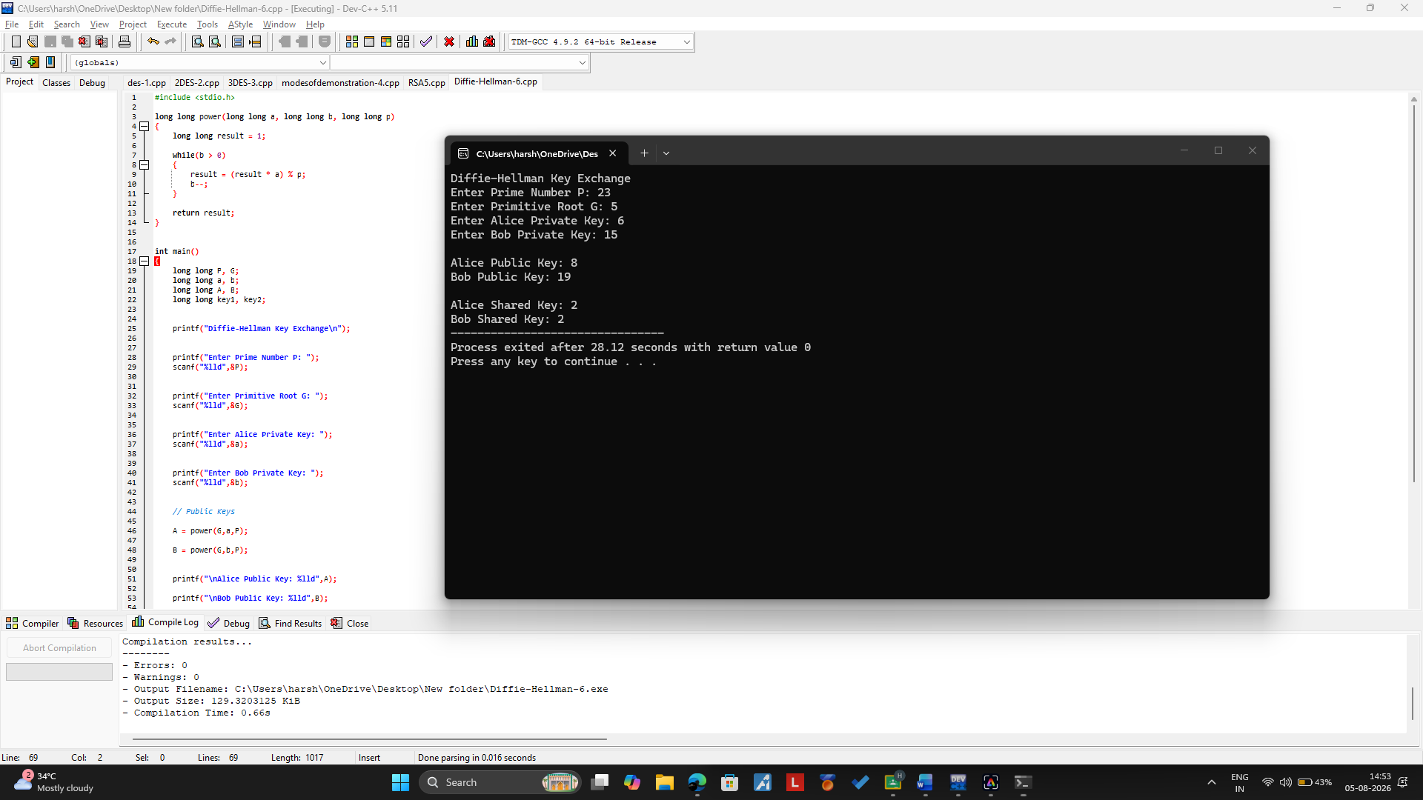Result
Thus, the Diffie–Hellman key exchange algorithm was implemented successfully in C and a shared secret key was generated.

