7. ECC (Elliptic Curve Cryptography)
Aim
To implement a simple Elliptic Curve Cryptography (ECC) algorithm in C for generating public keys and performing encryption/decryption operations.

Algorithm
- Start the program.
- Select an elliptic curve:
[
y^2 = x^3 + ax + b
]
- Choose a base point G on the curve.
- Select private keys for users.
- Generate public keys:
[
Q = dG
]
where:
- d = private key
- G = base point
- Perform point multiplication for encryption.
- Recover original message using private key.
- Display results.
- Stop.

C Program for ECC (Basic Demonstration)
#include <stdio.h>

struct Point
{
int x;
int y;
};

struct Point add(struct Point P, struct Point Q)
{
struct Point R;

R.x = P.x + Q.x;
R.y = P.y + Q.y;

return R;
}

struct Point multiply(struct Point P, int k)
{
struct Point R = {0,0};

for(int i=0;i<k;i++)
{
R = add(R,P);
}

return R;
}

int main()
{
struct Point G;
int privateKey;

struct Point publicKey;

printf("ECC Demonstration\n");

printf("Enter Base Point G(x y): ");
scanf("%d%d",&G.x,&G.y);

printf("Enter Private Key: ");
scanf("%d",&privateKey);

publicKey = multiply(G,privateKey);

printf("\nBase Point G = (%d,%d)",G.x,G.y);

printf("\nPrivate Key = %d",privateKey);

printf("\nPublic Key = (%d,%d)",
publicKey.x,
publicKey.y);

return 0;
}

Sample Output
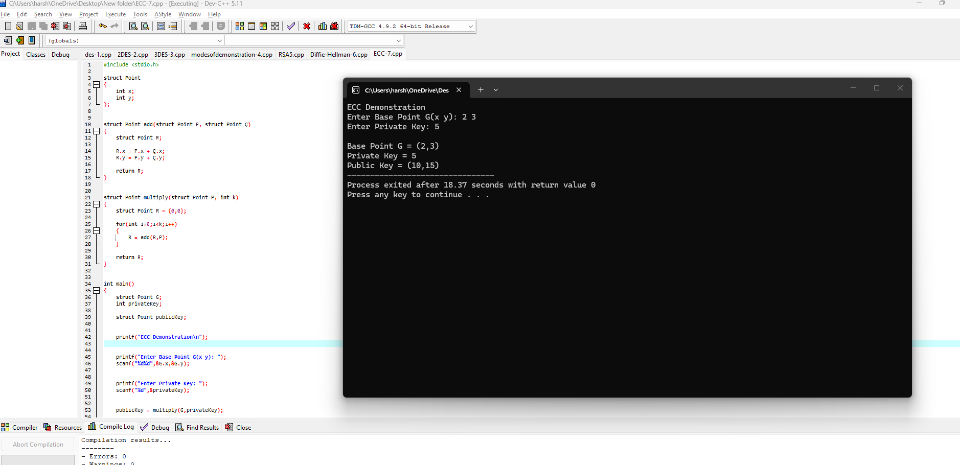
Result
Thus, the Elliptic Curve Cryptography (ECC) algorithm was implemented successfully in C.

ECC Information
- Type: Asymmetric Cryptography
- Security based on: Elliptic Curve Discrete Logarithm Problem
- Advantages:
  - Smaller key size
  - High security
  - Less memory usage
- Applications:
  - SSL/TLS
  - Digital signatures
  - Cryptocurrency
  - Secure messaging

