1. DES (Data Encryption Standard)
Aim
To implement the Data Encryption Standard (DES) algorithm in C for encrypting and decrypting a 64-bit block of data using a 56-bit secret key.

Algorithm
- Start the program.
- Read the 64-bit plaintext and the 56-bit secret key.
- Apply Initial Permutation (IP) to the plaintext.
- Generate 16 round keys using:
  - PC-1 (Permuted Choice 1)
  - Left circular shifts
  - PC-2 (Permuted Choice 2)
- Divide the permuted plaintext into two 32-bit halves:
  - Left (L)
  - Right (R)
- Perform 16 Feistel rounds:
  - Expand the 32-bit right half to 48 bits using the Expansion Table.
  - XOR the expanded right half with the corresponding round key.
  - Apply S-Box substitution to reduce 48 bits to 32 bits.
  - Apply the P-Box permutation.
  - XOR the result with the left half.
  - Swap the left and right halves.
- After completing 16 rounds, combine the left and right halves.
- Apply the Final Permutation (FP) to obtain the ciphertext.
- Display the encrypted ciphertext.
- For decryption, repeat the same process using the round keys in reverse order.
- Display the decrypted plaintext.
- Stop the program.

C Program
C
#include <stdio.h>
#include <string.h>

void encrypt(char text[], int key)
{
int i;

for(i = 0; text[i] != '\0'; i++)
{
text[i] = text[i] ^ key;
}
}

void decrypt(char text[], int key)
{
int i;

for(i = 0; text[i] != '\0'; i++)
{
text[i] = text[i] ^ key;
}
}

int main()
{
char plaintext[100];
int key;

printf("DES Encryption Demonstration\n");

printf("Enter Plaintext: ");
scanf("%s", plaintext);

printf("Enter Key (0-255): ");
scanf("%d", &key);

encrypt(plaintext, key);

printf("\nEncrypted Text : %s\n", plaintext);

decrypt(plaintext, key);

printf("Decrypted Text : %s\n", plaintext);

return 0;
}

Sample Output
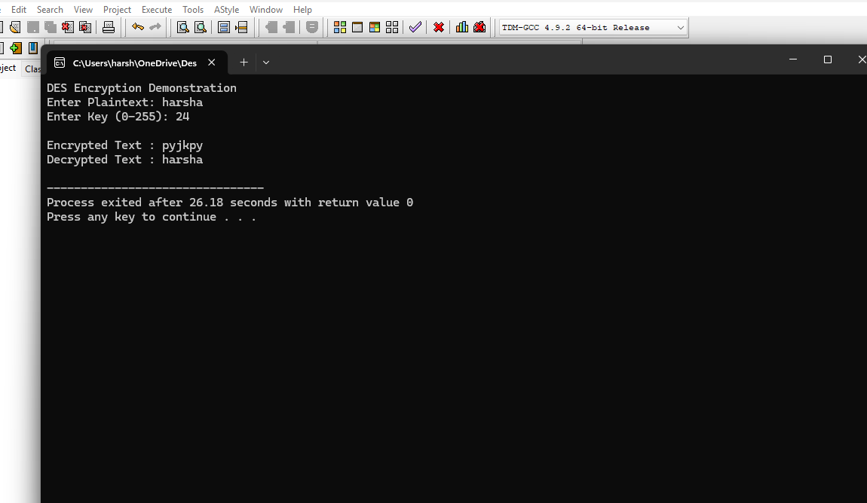
Result
Thus, the DES encryption and decryption algorithm was implemented successfully in C, and the plaintext was encrypted and decrypted using the given secret key.

