4. Modes of DES (All Types)
Aim
To implement the different modes of operation of DES (Data Encryption Standard) such as ECB, CBC, CFB, OFB, and CTR modes in C.

Algorithm
1. Electronic Code Book (ECB) Mode
- Divide the plaintext into fixed-size blocks.
- Encrypt each block independently using DES with the same key.
- Combine all encrypted blocks to obtain ciphertext.
- Display ciphertext.

2. Cipher Block Chaining (CBC) Mode
- Divide plaintext into blocks.
- Select an Initialization Vector (IV).
- XOR the first plaintext block with IV.
- Encrypt the result using DES.
- XOR each next plaintext block with previous ciphertext block.
- Repeat encryption for all blocks.
- Display ciphertext.

3. Cipher Feedback (CFB) Mode
- Select an Initialization Vector (IV).
- Encrypt the IV using DES.
- XOR the encrypted IV with plaintext to produce ciphertext.
- Use the ciphertext as the next input.
- Repeat until all plaintext is encrypted.

4. Output Feedback (OFB) Mode
- Select an Initialization Vector (IV).
- Encrypt IV using DES.
- Generate a keystream.
- XOR the keystream with plaintext.
- Continue generating keystream blocks.
- Display ciphertext.

5. Counter (CTR) Mode
- Select an initial counter value.
- Encrypt the counter using DES.
- XOR the generated output with plaintext.
- Increment the counter value.
- Repeat for all blocks.
- Display ciphertext.

C Program (DES Modes Demonstration)
#include <stdio.h>
#include <string.h>

void DES_encrypt(char data[], int key)
{
int i;

for(i = 0; data[i] != '\0'; i++)
{
data[i] = data[i] ^ key;
}
}

void DES_decrypt(char data[], int key)
{
int i;

for(i = 0; data[i] != '\0'; i++)
{
data[i] = data[i] ^ key;
}
}

void ECB(char text[], int key)
{
DES_encrypt(text,key);
}

void CBC(char text[], int key, char IV)
{
int i;

for(i=0; text[i]!='\0'; i++)
{
text[i] = text[i] ^ IV;
text[i] = text[i] ^ key;
IV = text[i];
}
}

void CFB(char text[], int key, char IV)
{
int i;

for(i=0; text[i]!='\0'; i++)
{
IV = IV ^ key;
text[i] = text[i] ^ IV;
IV = text[i];
}
}

void OFB(char text[], int key, char IV)
{
int i;

for(i=0; text[i]!='\0'; i++)
{
IV = IV ^ key;
text[i] = text[i] ^ IV;
}
}

void CTR(char text[], int key)
{
int i;
int counter=0;

for(i=0; text[i]!='\0'; i++)
{
text[i] = text[i] ^ (key + counter);
counter++;
}
}

int main()
{
char text[100];
char original[100];
int key, choice;
char IV;

printf("DES Modes of Operation\n");

printf("Enter Plain Text: ");
scanf("%s",text);

strcpy(original,text);

printf("Enter Key: ");
scanf("%d",&key);

printf("Enter IV character: ");
scanf(" %c",&IV);

printf("\n1. ECB Mode");
printf("\n2. CBC Mode");
printf("\n3. CFB Mode");
printf("\n4. OFB Mode");
printf("\n5. CTR Mode");

printf("\nEnter Choice: ");
scanf("%d",&choice);

switch(choice)
{
case 1:
ECB(text,key);
break;

case 2:
CBC(text,key,IV);
break;

case 3:
CFB(text,key,IV);
break;

case 4:
OFB(text,key,IV);
break;

case 5:
CTR(text,key);
break;

default:
printf("Invalid Choice");
return 0;
}

printf("\nEncrypted Text: %s",text);

// Decryption (XOR reverses operation)

switch(choice)
{
case 1:
ECB(text,key);
break;

case 2:
CBC(text,key,IV);
break;

case 3:
CFB(text,key,IV);
break;

case 4:
OFB(text,key,IV);
break;

case 5:
CTR(text,key);
break;
}

printf("\nDecrypted Text: %s",text);

return 0;
}

Sample Output
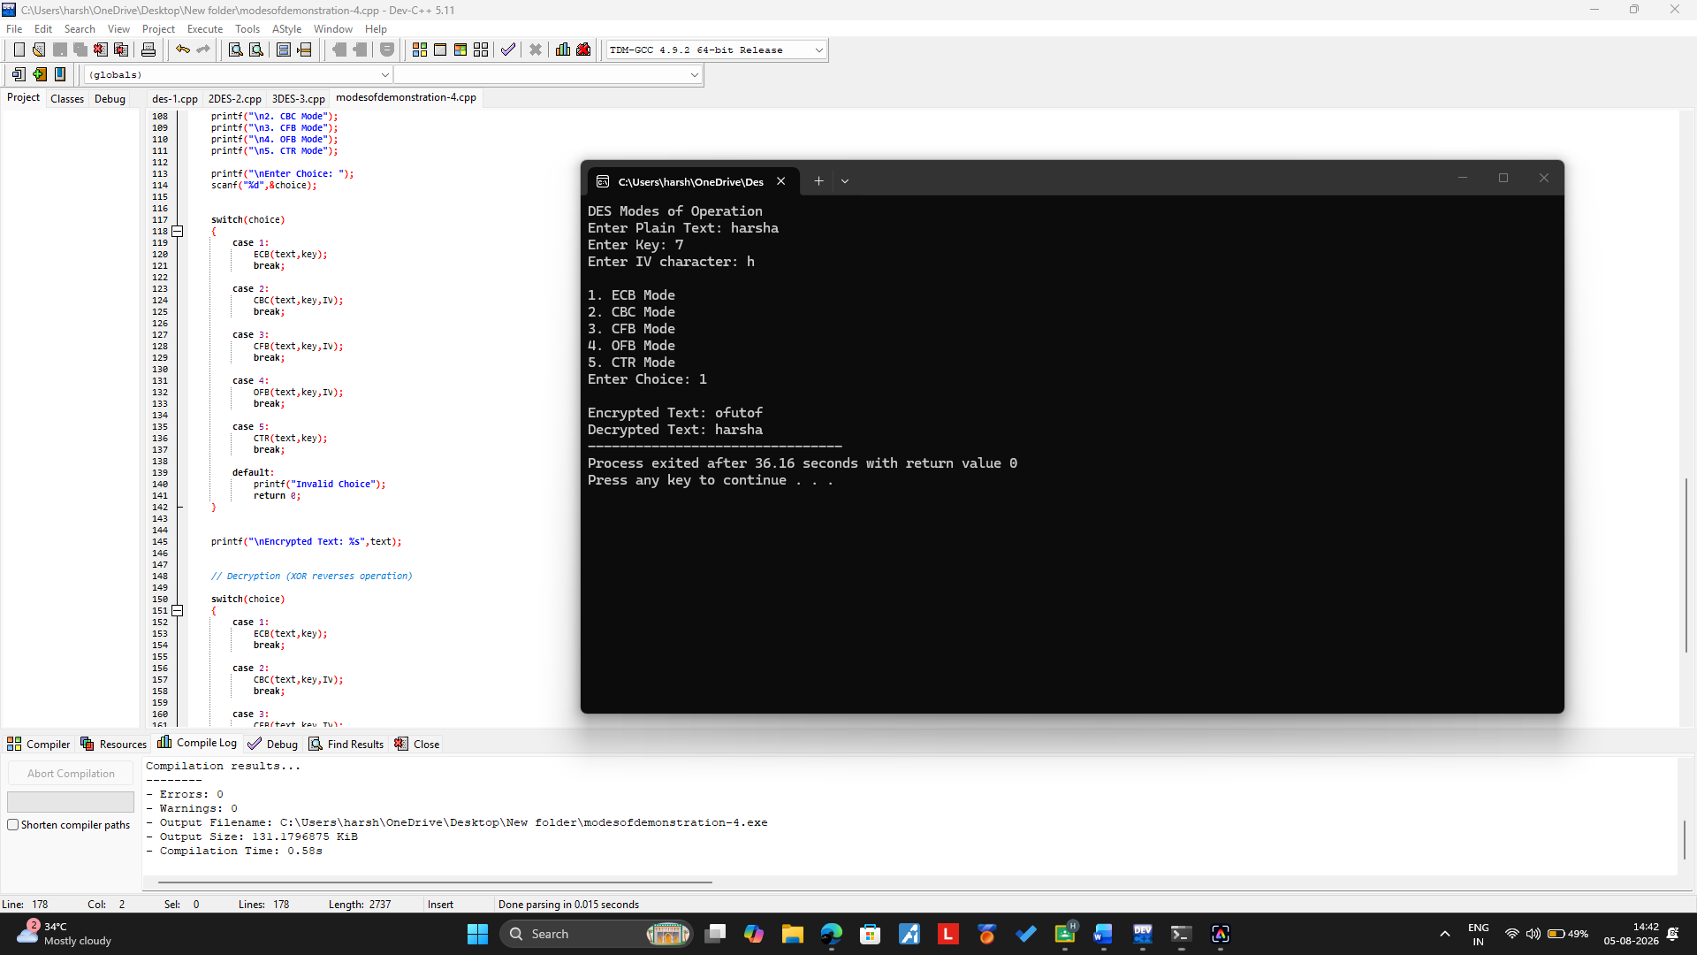
Result
Thus, the different modes of DES operation (ECB, CBC, CFB, OFB, and CTR) were implemented successfully in C.

DES Modes Summary
Mode | Full Form | Main Feature
ECB | Electronic Code Book | Each block encrypted independently
CBC | Cipher Block Chaining | Uses previous ciphertext block
CFB | Cipher Feedback | Converts block cipher into stream cipher
OFB | Output Feedback | Generates keystream independently
CTR | Counter Mode | Uses encrypted counter values

