5. RSA (Rivest–Shamir–Adleman)
Aim
To implement the RSA public key encryption and decryption algorithm in C for securing data using public and private keys.

Algorithm
Key Generation
- Select two prime numbers p and q.
- Calculate:
[
n = p \times q
]
- Calculate Euler's Totient:
[
\phi(n) = (p-1)(q-1)
]
- Select a public key e such that:
  - 1 < e < φ(n)
  - gcd(e, φ(n)) = 1
- Calculate private key d:
[
d \times e \equiv 1 \pmod{\phi(n)}
]

Encryption
- Read plaintext message.
- Convert message into numerical form.
- Calculate ciphertext:
[
C = M^e \bmod n
]
- Display encrypted message.

Decryption
- Use private key d.
- Calculate plaintext:
[
M = C^d \bmod n
]
- Display decrypted message.
- Stop.

C Program for RSA Algorithm
#include <stdio.h>
#include <math.h>

int gcd(int a, int b)
{
while(b != 0)
{
int temp = b;
b = a % b;
a = temp;
}

return a;
}

long long powerMod(long long base, long long exp, long long mod)
{
long long result = 1;

while(exp > 0)
{
result = (result * base) % mod;
exp--;
}

return result;
}

int main()
{
int p, q;
int n, phi;
int e, d;
int message;
int cipher, plain;

printf("RSA Encryption Algorithm\n");

printf("Enter prime number p: ");
scanf("%d",&p);

printf("Enter prime number q: ");
scanf("%d",&q);

n = p * q;

phi = (p-1)*(q-1);

printf("Enter public key e: ");
scanf("%d",&e);

if(gcd(e,phi)!=1)
{
printf("Invalid public key");
return 0;
}

// Calculate private key

for(d=1; d<phi; d++)
{
if((d*e)%phi==1)
break;
}

printf("\nPublic Key : (%d,%d)",e,n);
printf("\nPrivate Key : (%d,%d)",d,n);

printf("\n\nEnter message (number): ");
scanf("%d",&message);

// Encryption

cipher = powerMod(message,e,n);

printf("\nEncrypted Message : %d",cipher);

// Decryption

plain = powerMod(cipher,d,n);

printf("\nDecrypted Message : %d",plain);

return 0;
}

Sample Output
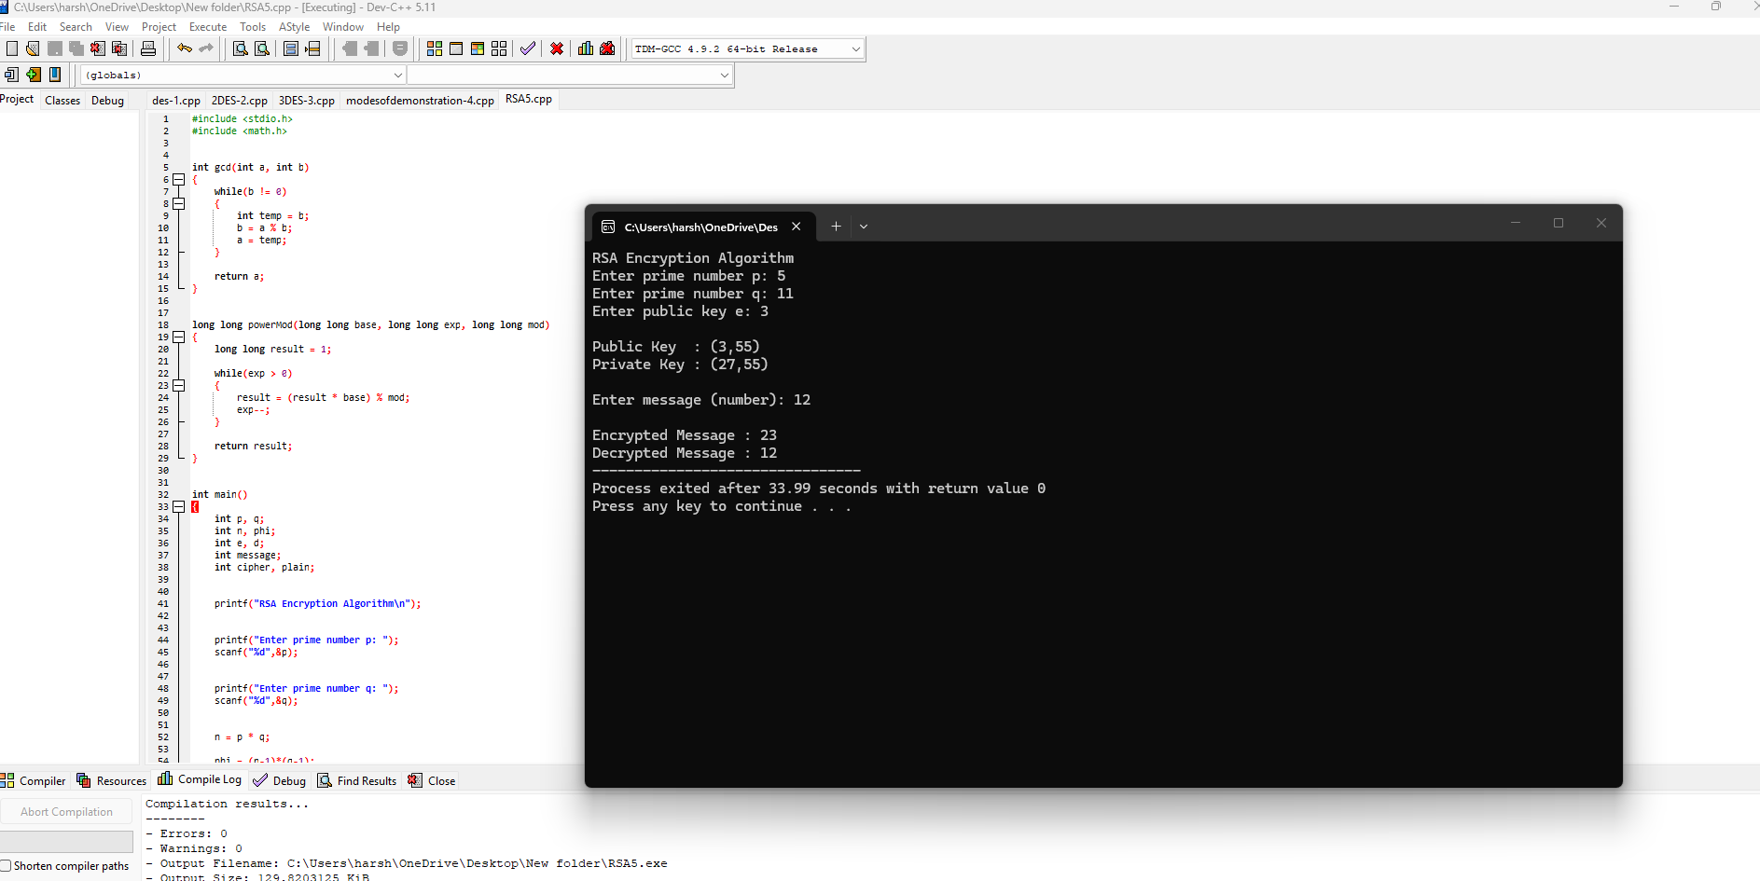

Result
Thus, the RSA encryption and decryption algorithm was implemented successfully in C using public and private keys.

RSA Information
- Type: Asymmetric Key Cryptography
- Developed by: Rivest, Shamir, Adleman
- Public Key: (e, n)
- Private Key: (d, n)
- Security based on: Integer Factorization Problem
- Applications:
  - Secure communication
  - Digital signatures
  - SSL/TLS certificates
  - Authentication

