5. Playfair Cipher
Aim
To implement the Playfair Cipher algorithm for encrypting and decrypting plaintext using a 5×5 key matrix, thereby providing secure digraph (pair of letters) substitution.
Algorithm
- Read the plaintext and secret key.
- Remove duplicate letters from the key.
- Construct a 5×5 key matrix using the key followed by the remaining alphabet letters (combine I and J).
- Divide the plaintext into pairs of letters (digraphs).
- If a pair contains identical letters, insert X between them.
- If the plaintext length is odd, append X at the end.
- Encrypt each pair:
  - Same row → Replace each letter with the letter to its right.
  - Same column → Replace each letter with the letter below it.
  - Different row and column → Replace each letter with the one in the same row but the other letter's column.
- Display the ciphertext.
- For decryption, apply the reverse rules.
Program
#include <stdio.h>
#include <string.h>
#include <ctype.h>

#define SIZE 5

void UPPERCASE(char src[], char dst[]) {
int i, j = 0;
for (i = 0; src[i] != '\0'; i++) {
if (isalpha(src[i])) {
dst[j++] = toupper(src[i] == 'J' ? 'I' : src[i]);
}
}
dst[j] = '\0';
}

void createMatrix(char key[], char matrix[SIZE][SIZE]) {
int map[26] = {0};
map['J' - 'A'] = 1; // Treat J as I

int r = 0, c = 0;

// Insert key into matrix
for (int i = 0; key[i] != '\0'; i++) {
if (!map[key[i] - 'A']) {
matrix[r][c] = key[i];
map[key[i] - 'A'] = 1;
c++;
if (c == SIZE) { r++; c = 0; }
}
}

// Fill remaining alphabet
for (int i = 0; i < 26; i++) {
if (!map[i]) {
matrix[r][c] = (char)(i + 'A');
c++;
if (c == SIZE) { r++; c = 0; }
}
}
}

void getPosition(char matrix[SIZE][SIZE], char ch, int *row, int *col) {
for (int i = 0; i < SIZE; i++) {
for (int j = 0; j < SIZE; j++) {
if (matrix[i][j] == ch) {
*row = i;
*col = j;
return;
}
}
}
}

void formatPlaintext(char src[], char dst[]) {
int i = 0, j = 0;
while (src[i] != '\0') {
dst[j++] = src[i];
if (src[i + 1] == '\0') {
dst[j++] = 'X';
break;
} else if (src[i] == src[i + 1]) {
dst[j++] = 'X';
i++;
} else {
dst[j++] = src[i + 1];
i += 2;
}
}
dst[j] = '\0';
}

void encryptPlayfair(char matrix[SIZE][SIZE], char text[], char cipher[]) {
int r1, c1, r2, c2;
int len = strlen(text);

for (int i = 0; i < len; i += 2) {
getPosition(matrix, text[i], &r1, &c1);
getPosition(matrix, text[i + 1], &r2, &c2);

if (r1 == r2) { // Same row
cipher[i] = matrix[r1][(c1 + 1) % SIZE];
cipher[i + 1] = matrix[r2][(c2 + 1) % SIZE];
} else if (c1 == c2) { // Same column
cipher[i] = matrix[(r1 + 1) % SIZE][c1];
cipher[i + 1] = matrix[(r2 + 1) % SIZE][c2];
} else { // Rectangle swap
cipher[i] = matrix[r1][c2];
cipher[i + 1] = matrix[r2][c1];
}
}
cipher[len] = '\0';
}

int main() {
char rawKey[100], rawText[100];
char key[100], text[200], formattedText[200], cipher[200];
char matrix[SIZE][SIZE];

printf("Enter keyword: ");
fgets(rawKey, sizeof(rawKey), stdin);
printf("Enter plaintext: ");
fgets(rawText, sizeof(rawText), stdin);

UPPERCASE(rawKey, key);
UPPERCASE(rawText, text);

createMatrix(key, matrix);
formatPlaintext(text, formattedText);
encryptPlayfair(matrix, formattedText, cipher);

printf("\n--- PLAYFAIR CIPHER ---");
printf("\nKey Matrix:\n");
for (int i = 0; i < SIZE; i++) {
for (int j = 0; j < SIZE; j++) {
printf("%c ", matrix[i][j]);
}
printf("\n");
}
printf("\nFormatted Plaintext: %s", formattedText);
printf("\nEncrypted Ciphertext: %s\n", cipher);
return 0;
}
Output
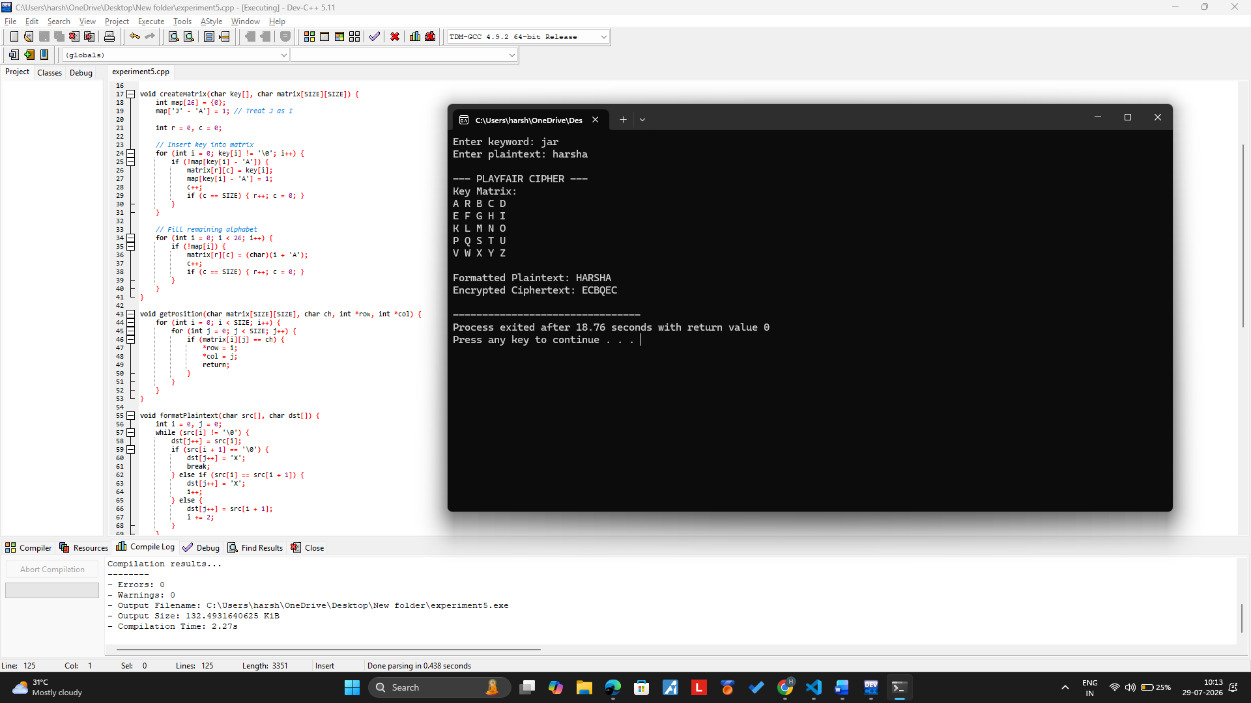
Result
Thus the Playfair cipher substitution technique had been implemented successfully.

