6. Rail Fence Cipher
Aim
To implement the Rail Fence Cipher algorithm for encrypting and decrypting a message using a zigzag pattern.
Algorithm
- Read the plaintext and the number of rails.
- Create a matrix with the specified number of rails.
- Write the plaintext in a zigzag pattern across the rails.
- Read the characters row by row to generate the ciphertext.
- Display the ciphertext.
- For decryption:
  - Mark the zigzag positions.
  - Fill the marked positions row by row with the ciphertext.
  - Read the matrix in the zigzag order to obtain the original plaintext.
Program
#include <stdio.h>
#include <string.h>
#include <ctype.h>

void encryptRailFence(char text[], int key, char cipher[]) {
int len = strlen(text);
char rail[key][len];

// Initialize matrix with markers
for (int i = 0; i < key; i++) {
for (int j = 0; j < len; j++) {
rail[i][j] = '\n';
}
}

int row = 0, col = 0;
int direction_down = 0; // 0 for up, 1 for down

// Place characters diagonally on rails
for (int i = 0; i < len; i++) {
if (row == 0 || row == key - 1) {
direction_down = !direction_down;
}

rail[row][col++] = text[i];

if (direction_down) {
row++;
} else {
row--;
}
}

// Read matrix row by row to construct ciphertext
int k = 0;
for (int i = 0; i < key; i++) {
for (int j = 0; j < len; j++) {
if (rail[i][j] != '\n') {
cipher[k++] = rail[i][j];
}
}
}
cipher[k] = '\0';
}

int main() {
char rawText[200], text[200], cipher[200];
int key;

printf("Enter plaintext: ");
fgets(rawText, sizeof(rawText), stdin);
printf("Enter number of rails (key): ");
scanf("%d", &key);

// Clean string input (remove spaces/newlines and convert to uppercase)
int j = 0;
for (int i = 0; rawText[i] != '\0'; i++) {
if (isalpha(rawText[i])) {
text[j++] = toupper(rawText[i]);
}
}
text[j] = '\0';

if (key <= 1) {
printf("Key must be greater than 1.\n");
return 1;
}

encryptRailFence(text, key, cipher);

printf("\n--- RAIL FENCE CIPHER ---");
printf("\nCleaned Plaintext: %s", text);
printf("\nEncrypted Ciphertext: %s\n", cipher);

return 0;
}

Output
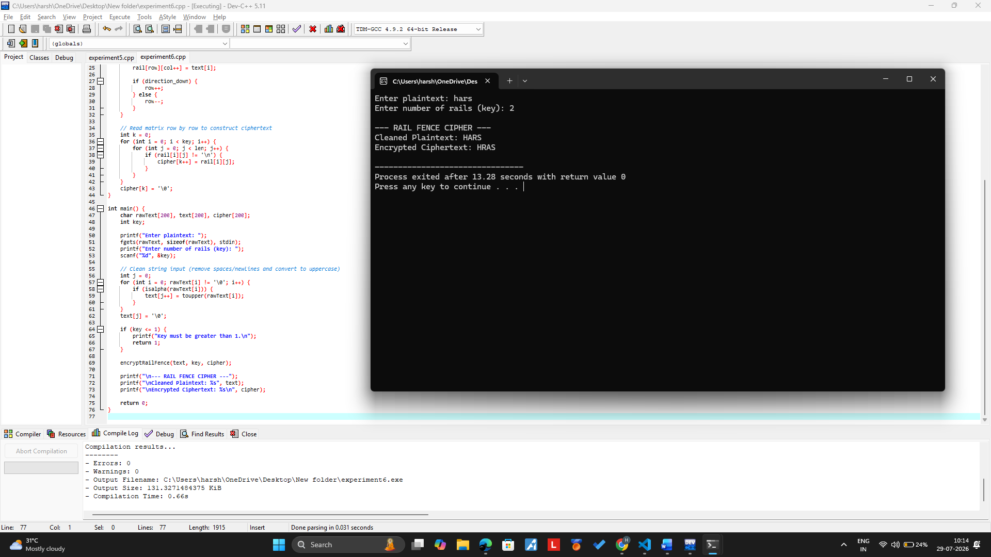

Result
Thus the rail fence algorithm had been executed successfully.

