9. RC5
Aim
To implement the RC5 encryption and decryption algorithm using C programming.
Algorithm
- Start the program.
- Read the plaintext and secret key.
- Initialize the RC5 key schedule.
- Generate the expanded key array.
- Split the plaintext into two words, A and B.
- Perform the RC5 pre-whitening operation.
- Perform the specified number of encryption rounds using:
  - Addition
  - XOR
  - Circular left rotation
- Display the ciphertext.
- Reverse the operations to decrypt the ciphertext.
- Display the original plaintext.
- Stop the program.
C Program
C
#include <stdio.h>
#include <stdint.h>

#define R 12
#define S_SIZE (2 * R + 2)

uint32_t S[S_SIZE];

uint32_t ROTL(uint32_t x, uint32_t y)
{
y = y & 31;
return (x << y) | (x >> (32 - y));
}

uint32_t ROTR(uint32_t x, uint32_t y)
{
y = y & 31;
return (x >> y) | (x << (32 - y));
}

void key_schedule(uint32_t key)
{
int i;

S[0] = 0xB7E15163;

for (i = 1; i < S_SIZE; i++)
S[i] = S[i - 1] + 0x9E3779B9;

/* Simple key mixing */
for (i = 0; i < S_SIZE; i++)
S[i] ^= ROTL(key, i);
}

void encrypt(uint32_t *A, uint32_t *B)
{
int i;

*A += S[0];
*B += S[1];

for (i = 1; i <= R; i++)
{
*A = ROTL(*A ^ *B, *B) + S[2 * i];
*B = ROTL(*B ^ *A, *A) + S[2 * i + 1];
}
}

void decrypt(uint32_t *A, uint32_t *B)
{
int i;

for (i = R; i >= 1; i--)
{
*B = ROTR(*B - S[2 * i + 1], *A) ^ *A;
*A = ROTR(*A - S[2 * i], *B) ^ *B;
}

*B -= S[1];
*A -= S[0];
}

int main()
{
uint32_t A, B;
uint32_t key;

printf("Enter first 32-bit plaintext value: ");
scanf("%u", &A);

printf("Enter second 32-bit plaintext value: ");
scanf("%u", &B);

printf("Enter numeric key: ");
scanf("%u", &key);

key_schedule(key);

printf("\nOriginal Plaintext:\n");
printf("A = %u\n", A);
printf("B = %u\n", B);

encrypt(&A, &B);

printf("\nEncrypted Ciphertext:\n");
printf("A = %u\n", A);
printf("B = %u\n", B);

decrypt(&A, &B);

printf("\nDecrypted Plaintext:\n");
printf("A = %u\n", A);
printf("B = %u\n", B);

return 0;
}

Output
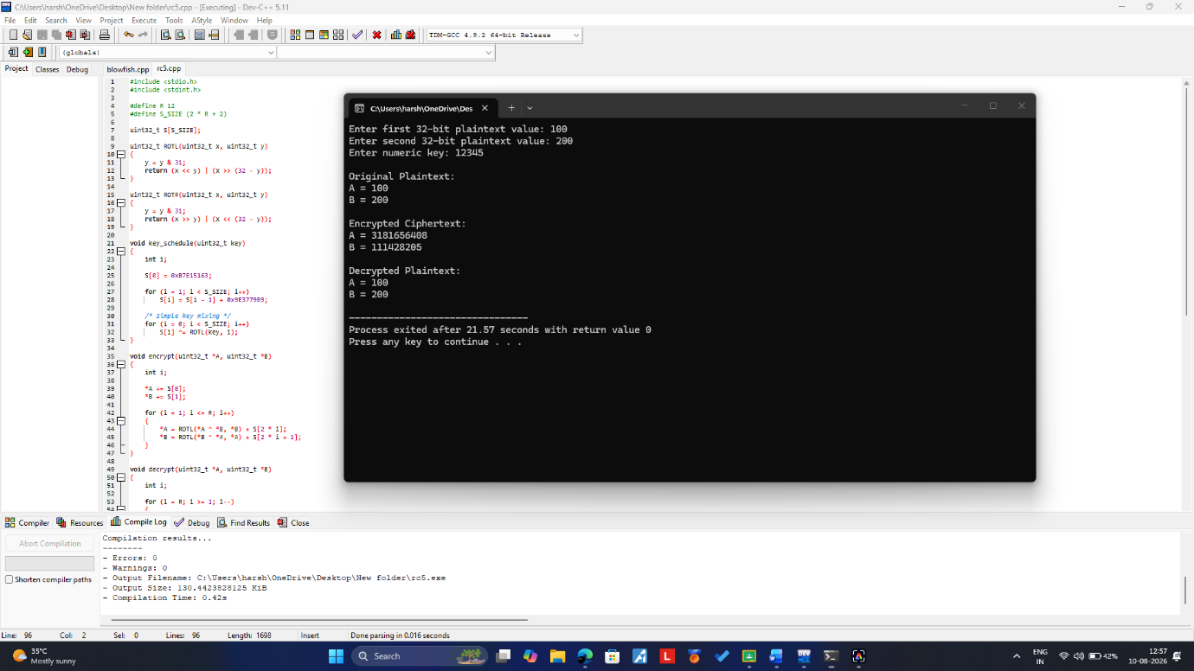Result
Thus, the RC5 encryption and decryption algorithm was implemented successfully, and the original plaintext was obtained after decryption.

