8. BLOWFISH
Aim
To implement the Blowfish encryption and decryption algorithm using C programming.
Algorithm
- Start the program.
- Read the plaintext and secret key from the user.
- Initialize the Blowfish key schedule using the given key.
- Divide the plaintext into 64-bit blocks.
- Encrypt each block using the Blowfish Feistel structure.
- Perform 16 rounds of encryption using the P-array and S-boxes.
- Display the encrypted ciphertext.
- Decrypt the ciphertext using the same key.
- Display the recovered plaintext.
- Stop the program.
C Program
C
#include <stdio.h>
#include <string.h>
#include <stdint.h>

uint32_t F(uint32_t x)
{
return ((x << 1) ^ (x >> 1)) + 0xA5A5A5A5;
}

void encrypt(uint32_t *L, uint32_t *R, uint32_t *P)
{
int i;
uint32_t temp;

for (i = 0; i < 16; i++)
{
*L = *L ^ P[i];
*R = *R ^ F(*L);

temp = *L;
*L = *R;
*R = temp;
}

temp = *L;
*L = *R;
*R = temp;

*R = *R ^ P[16];
*L = *L ^ P[17];
}

void decrypt(uint32_t *L, uint32_t *R, uint32_t *P)
{
int i;
uint32_t temp;

for (i = 17; i > 1; i--)
{
*L = *L ^ P[i];
*R = *R ^ F(*L);

temp = *L;
*L = *R;
*R = temp;
}

temp = *L;
*L = *R;
*R = temp;

*R = *R ^ P[1];
*L = *L ^ P[0];
}

int main()
{
uint32_t L, R;
uint32_t P[18];
char plaintext[9];
int i;

printf("Enter 8-character plaintext: ");
scanf("%8s", plaintext);

printf("Enter key: ");
char key[50];
scanf("%49s", key);

/* Initialize P-array */
for (i = 0; i < 18; i++)
P[i] = 0x243F6A88 ^ (i * 0x13198A2E);

/* Simple key mixing */
for (i = 0; i < 18; i++)
P[i] = P[i] ^ key[i % strlen(key)];

L = ((uint32_t)plaintext[0] << 24) |
((uint32_t)plaintext[1] << 16) |
((uint32_t)plaintext[2] << 8) |
plaintext[3];

R = ((uint32_t)plaintext[4] << 24) |
((uint32_t)plaintext[5] << 16) |
((uint32_t)plaintext[6] << 8) |
plaintext[7];

printf("\nPlaintext : %s\n", plaintext);

encrypt(&L, &R, P);

printf("Ciphertext : %08X%08X\n", L, R);

decrypt(&L, &R, P);

printf("Decrypted : %c%c%c%c%c%c%c%c\n",
(char)(L >> 24),
(char)(L >> 16),
(char)(L >> 8),
(char)L,
(char)(R >> 24),
(char)(R >> 16),
(char)(R >> 8),
(char)R);

return 0;
}
Note: This is a simplified educational implementation that demonstrates the Blowfish-style Feistel structure. It is not the standard cryptographic Blowfish specification because the real algorithm uses fixed 18-entry P-array values and four 256-entry S-boxes.
Output
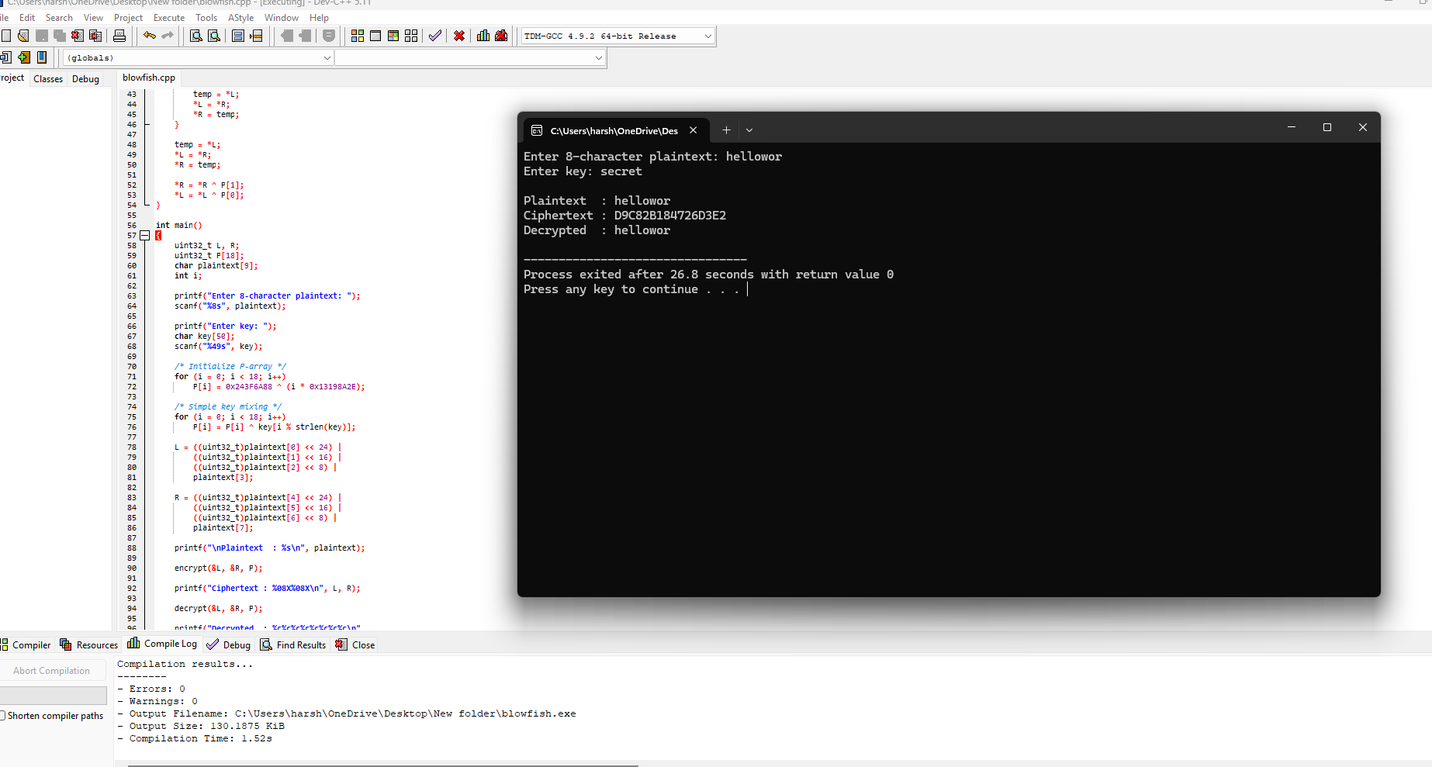Result
Thus, the Blowfish encryption and decryption algorithm was implemented successfully, and the original plaintext was recovered after decryption.

