

**Title : AgriMarket Insights Dashboard**

**Course : Int 217**

**Name : HARSHA VARDHINI**

**Section : K23GP**

**Reg No : 12320799**

**Roll No : 02**

**Submitted To : ASHU MA’AM**

**Student Declaration**

I, HARSHA VARDHINI hereby declare that the work done and presented in this report is solely completed by me.

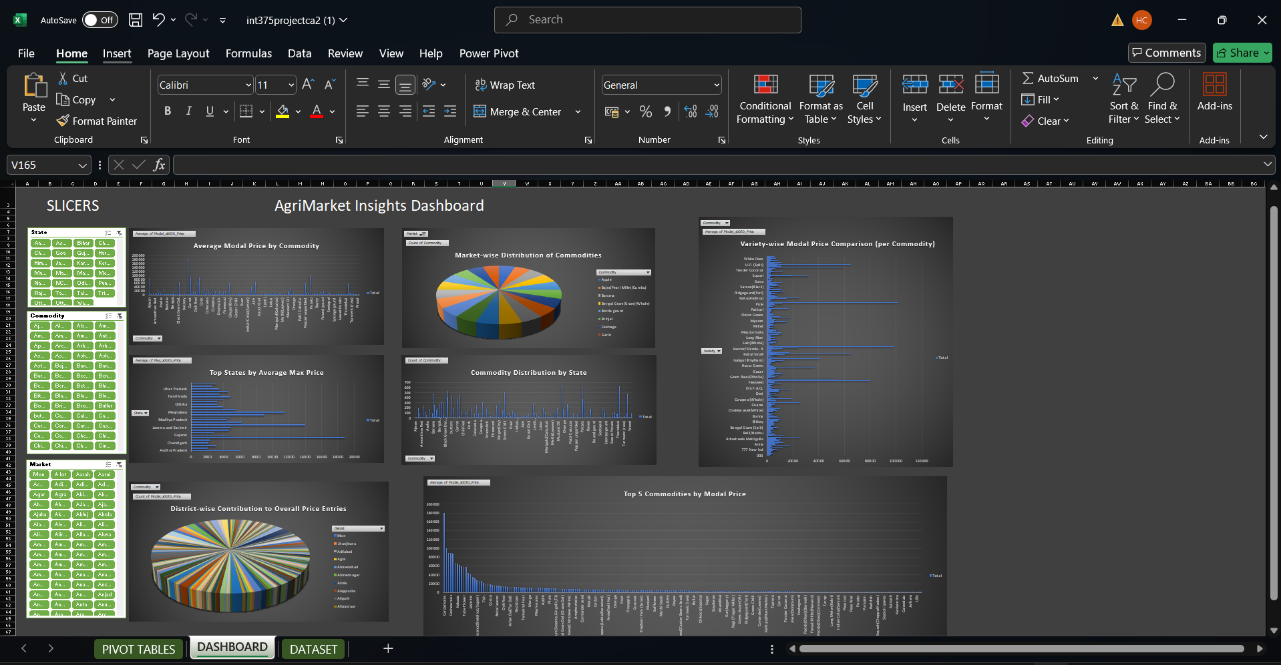

**Introduction to the** AgriMarket Insights Dashboard

Agricultural markets play a vital role in the Indian economy, impacting the livelihoods of millions of farmers and influencing national food security. However, due to the vastness and complexity of agricultural data, it can be difficult to understand market behavior and price trends across different states, districts, and commodities. This project aims to bridge that gap by creating an interactive Excel dashboard that visually represents agricultural price data in a simplified and insightful way.

Using a dataset that includes key details such as **state**, **district**, **market**, **commodity**, **variety**, and **grade**, along with **minimum**, **maximum**, and **modal prices** for each arrival date, the dashboard enables users to explore and analyze market data efficiently. The use of Pivot Tables and Charts allows for dynamic filtering and comparison of commodities, price trends, and regional variations.

The dashboard includes key visualizations such as average price comparisons by commodity and state, top and bottom price performers, price fluctuation over time, and commodity distribution across markets. These insights help users identify market opportunities, monitor seasonal trends, and assess price volatility, which is especially valuable for farmers, market analysts, traders, and agricultural policymakers.

Overall, the dashboard turns raw agricultural data into a powerful decision-making tool. It promotes transparency, supports strategic planning, and encourages data-driven decisions in the agricultural sector.

AVERAGE MODEL PRICE BY COMMODITIES



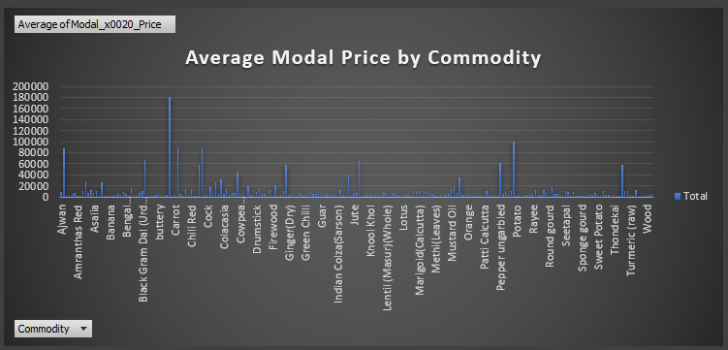

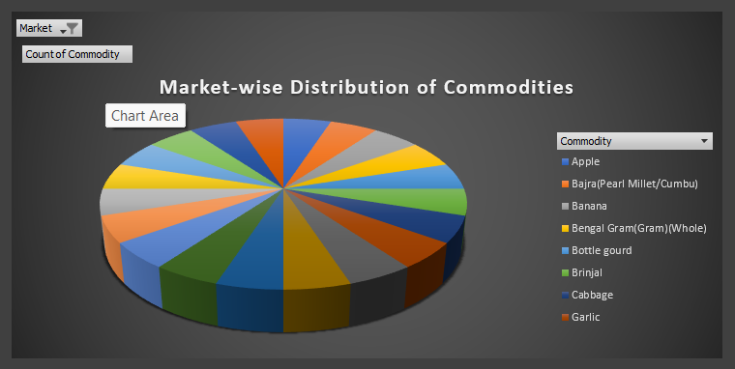

**2.** **MARKET WISE DISTRIBUTION OF COMMODITIES**

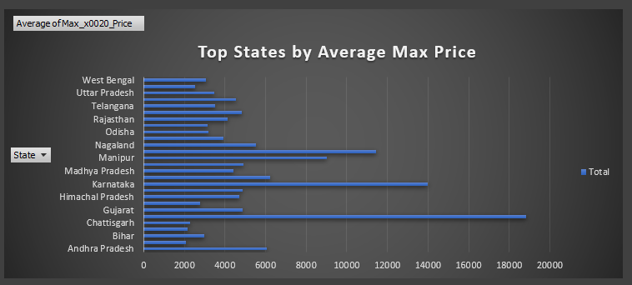

**3.** **TOP STATES BY AVERAGE MAX PRICE**

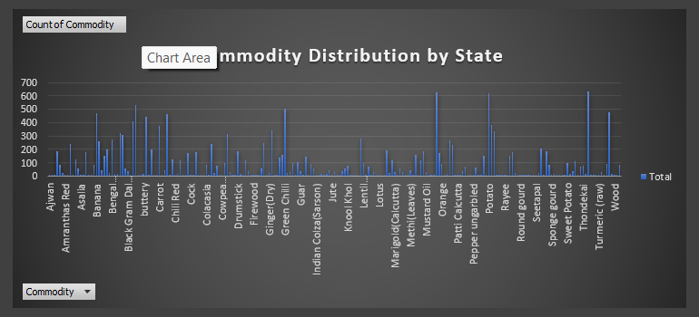

**4.** **DISTIBUTION BY STATE**

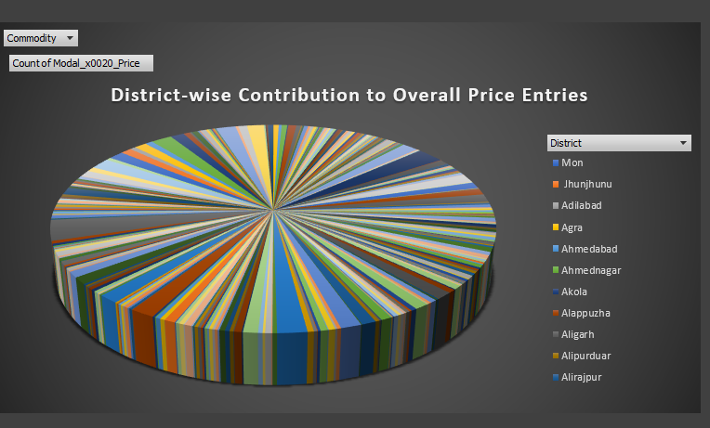

**5.** **DISTRICT WISE PRICE DISTRIBUTION**

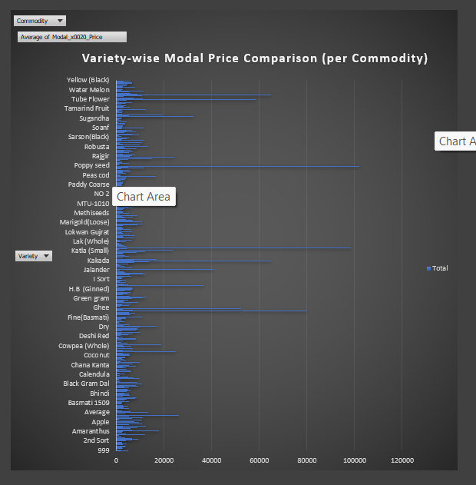

**6. PRICE COMPARISON**

CONCLUSION :

This project demonstrates the power of data visualization in understanding complex agricultural market data. By transforming raw datasets into a dynamic and interactive Excel dashboard, we are able to uncover key insights into commodity pricing trends, regional market variations, and seasonal fluctuations.

The use of Pivot Tables and Charts has enabled the creation of a flexible tool that allows users to filter, compare, and analyze agricultural data from multiple perspectives—whether by state, district, market, or commodity. This makes the dashboard not only informative but also practical for various stakeholders including farmers, traders, policymakers, and researchers.

Through this dashboard, users can make more informed decisions, track price movements, and identify opportunities in the agricultural supply chain. It also serves as a foundation for further improvements, such as incorporating real-time data updates, forecasting models, or integration with geographic visuals for better spatial analysis.

In conclusion, this project highlights how effective data presentation can simplify complex information and support smart, data-driven decision-making in the agriculture sector. It emphasizes the importance of transparency and accessibility in agricultural market information, contributing to a more efficient and informed agricultural ecosystem.