

**(23CSE111) OBJECT ORIENTED PROGRAMMING**

**LAB MANUAL**

**CSE-1st YEAR II SEMESTER (2024-2025)**

|  |  |  |  |
| --- | --- | --- | --- |
| **Submitted by** | | **Submitted to** | |
| **NAME:** | **Harsha Vardhini. M** | **NAME:** | **RAJ KUMAR BATCHU** |
| **ROLL NO:** | **AV.SC.U4CSE24225** | **DEPARTMENT:** | **CSE** |
| **SECTION:** | **CSE-C** | **DESIGNATION:** |  |

Week -1

***AIM***: 1. To Download and install Java and Execute the First Java Program.

***PROCEDURE***:

1)First,we need to open google chrome and search for java download oracle.

2)Click on the first web site which appears with name JAVA downloads.

3)After entering into web site,we need to scroll down and choose the operating system which we are using Linux(or)Macos(or)Windows

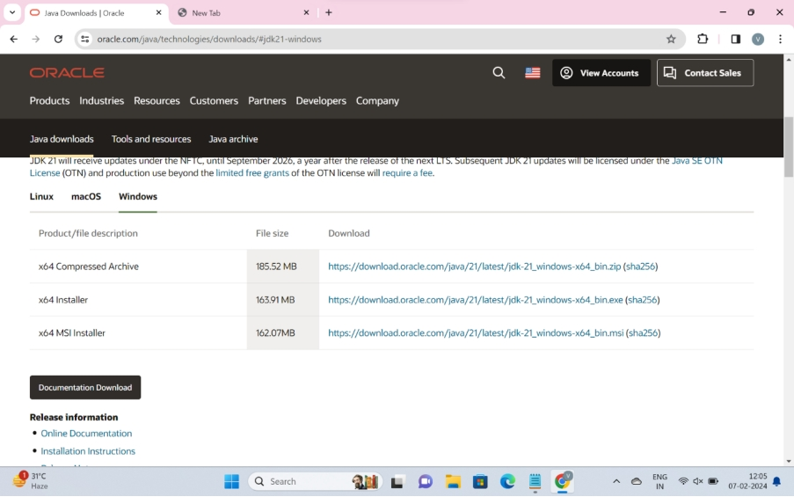

4)According to my lap top, I choose windows and click on **x64** **installer** which results download of java.

5)Then we need to go to downloads of laptop and allow the downloaded application to install in our laptop.

6)All the programming related files were stored in local disk(c) drive until then we changed it.

7)By moving into local disk(c),we need to move into program files.In it we find a file named java.

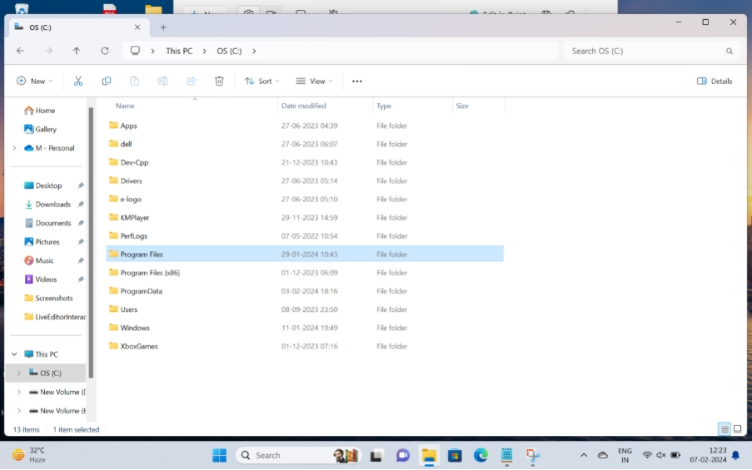

8)After entering into JAVA file. we need to move on to file JDK-21and then into bin.

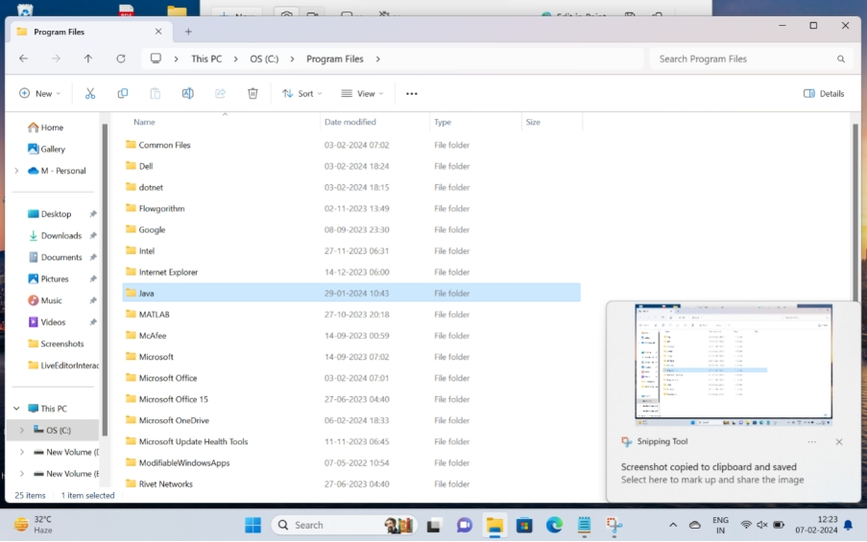

9)Now,By clicking on file address (or) location,we get c:\program files\JAVA\jdk-21\bin which we need to copy.

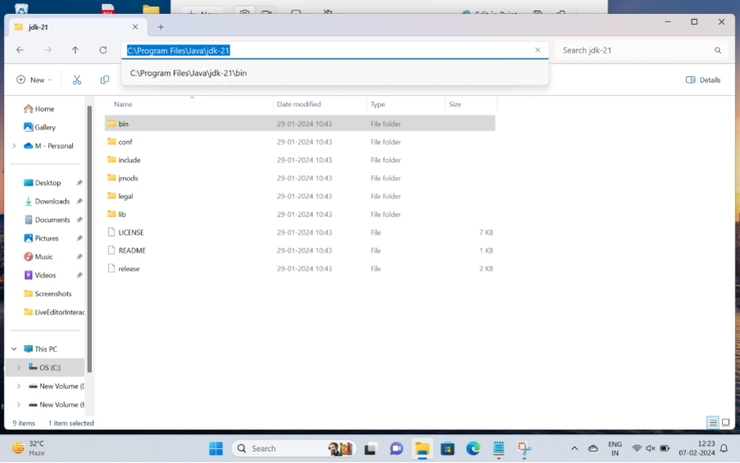

10)Now move on to windows search and search for environmental variables under advanced tab.

11)we need to click on environmental variables which is located in Advanced file.

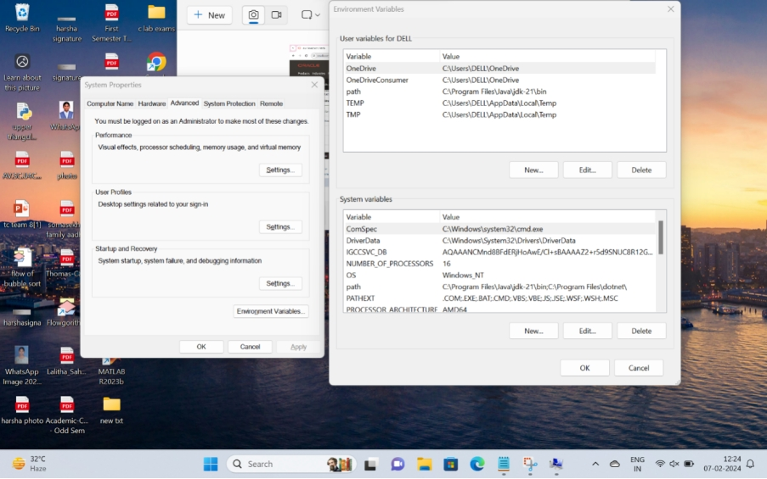

12)Now,we can find user variables and system variables.

13)we need to choose system variables and click on new.

14)It shows variable name and variable value.In which we need to fill as variable name:JAVA_HOME and variable value is to paste the copied content in file address at point(9).

15)By clicking “ok” we completed this process.

16)Now, to write a java program, we need to create a folder named java and a text document in the folder.

17)write the program in text document and save it by adding extension “.java”.

Program 1:

Aim : write a java code to print the message “Hello world”

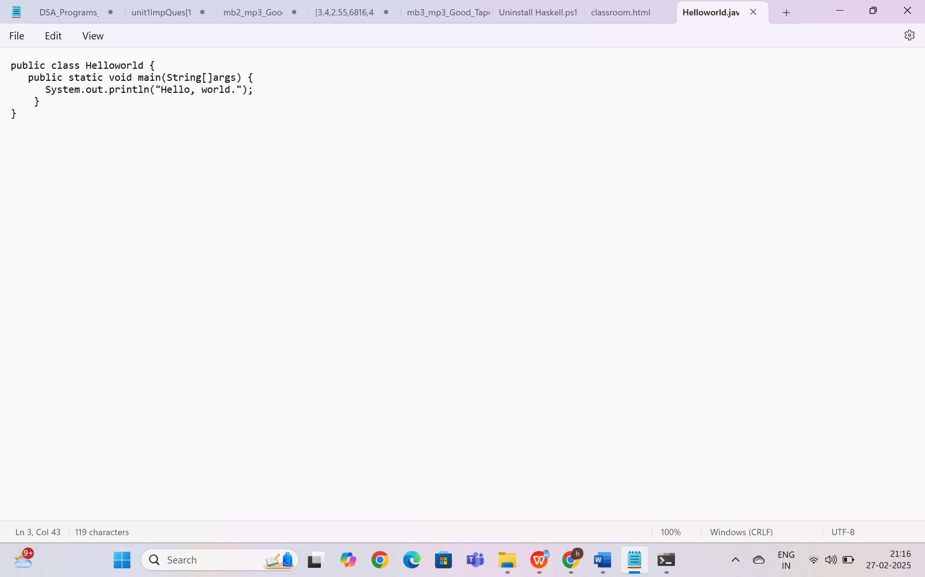

 important things :

* Everything you want to print should be kept inside parentheses ().
* The text to be printed is enclosed within double quotes "".
* Each System.out.println() statement ends with a semicolon ;

Output:

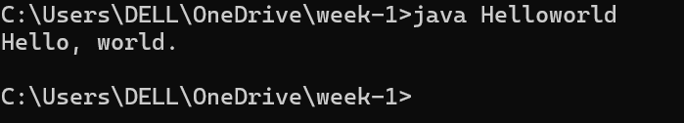

Error table:

|  |  |
| --- | --- |
| Error | rectification |
| Helloworld.java:3: error: ';' expected  System. out. println("Hello, world.")  ^  1 error | Need to keep semicolon after  System. out. println (“Hello, world.”); |

Program : 2

AIM: write a java program to print the student details name, roll no , section of student

Code

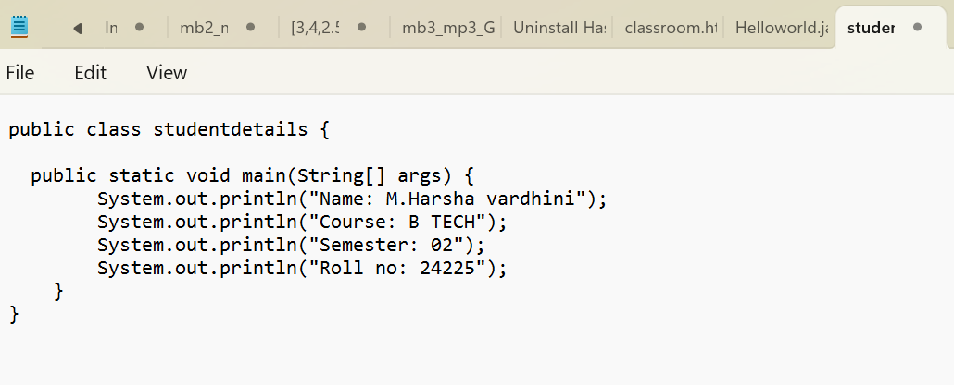

Key points:

1)class definition:

.The program defines a class named studentdetails

2)main method

The main method is the entry point of the program defined as public static void main(String[] args), which means:

* public: The method is accessible from anywhere.
* static: The method can be called without creating an instance of the class.
* void: The method doesn't return anything.
* String[] args: It accepts an array of String arguments, though they are not used in this program.

3) the program prints the the following details using System.out.println()

Output:

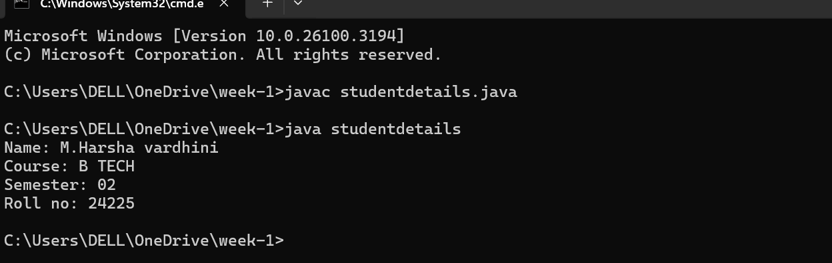

Error table:

|  |  |
| --- | --- |
| error | rectification |
| Writing small “s” in place of  “S” | Code is rectified by keeping capital “S” |

WEEK-2

Program :1

Aim : write a java program to write simple interest where all the inputs are taken from the user

Code :

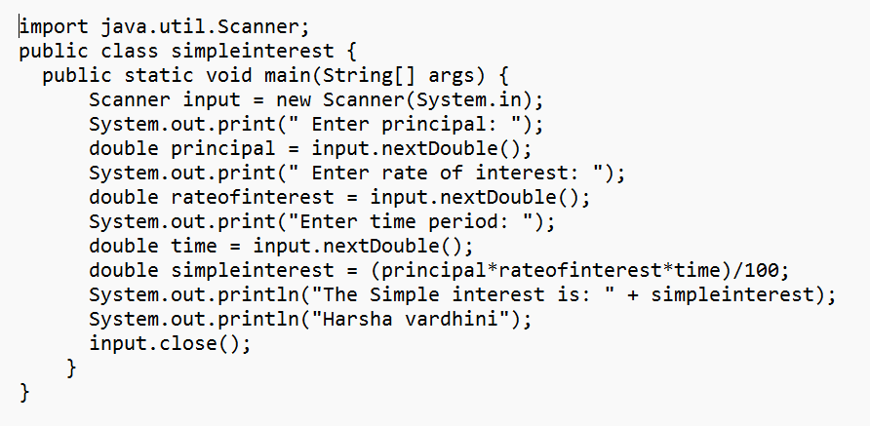

Key points:

JAVA.util package: The java.util package in java is a versatile buit-in package that contains various utility classes and interfaces.it provides basic functionality for commonly ocuuring use cases.it contains Java’s collections framework,date and time utilities,string-tokenizer,event-model utilities,etc

**import keyword**: It allows you to bring external classes or packages into your Java program. In this case, you're importing the Scanner class.

**java.util.Scanner**: This specifies the full path to the class. The Scanner class resides in the java.util package, which is why you need to import it.

The Scanner class is used to take user input in Java.

. The nextDouble() method is used to read double values (for principal, rate of interest, and time period).

. The input.close() line at the end of the program is used to close the Scanner object and free up resources after the input is completed.

* **import java.util.Scanner;** allows your program to use the Scanner class for input.
* Without it, the Scanner class wouldn't be recognized by your program, and you wouldn’t be able to read user input using methods like nextInt(), nextDouble(), etc.

Output: 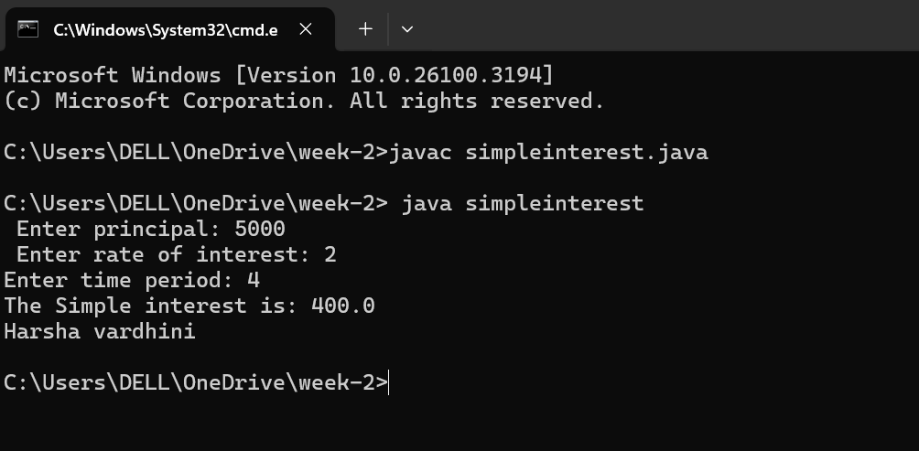

Error table:

|  |  |
| --- | --- |
| Error | rectification |
| 1.Giving space between next  and double | 1. Should not give space between nextDouble |

Program 2 :

Aim: write a java program to find the factorial of a number where alll the inputs are taken from a user.

Code:

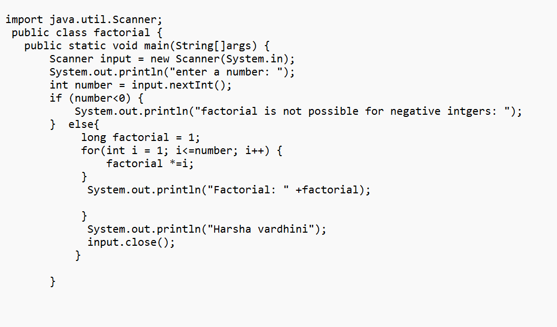

Output:

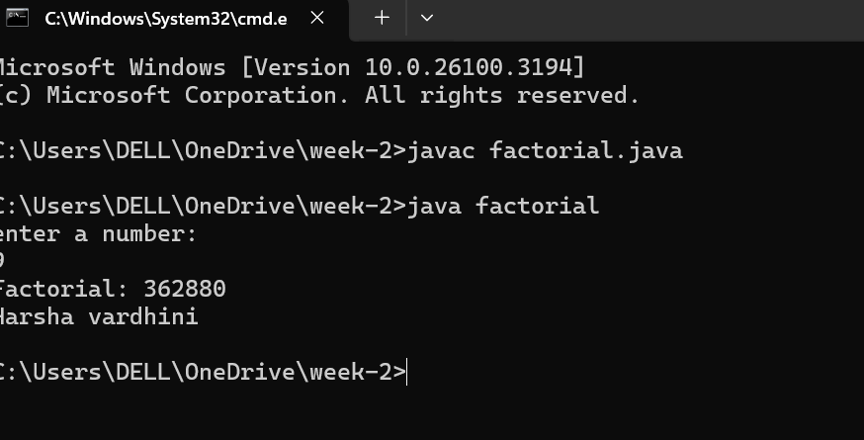

Error table:

|  |  |
| --- | --- |
| Error | Rectification |
| factorial.java:1: error: ';' expected  import java. util. Scanner  ^  factorial.java:17: error: unclosed string literal  System.  out. Println("Harsha vardhini);  ^  2 errors | import java. util. Scanner;  semicolon and quotation should be there  System. out. println(“Harsha vardhini”); |

Program - 3

Aim: write a program to convert the temperature from Celsius to Fahrenheit and Fahrenheit to Celsius

Code: import java.util.Scanner;

class Temperature {

public static void main(String[] args) {

Scanner input = new Scanner(System.in);

System.out.print("Enter Temperature in Fahrenheit: ");

float F = input.nextFloat();

input.close();

float C = (F - 32)*5/9;

System.out.println("Temperature in celsius: " + C);

}

}

**OUTPUT:** 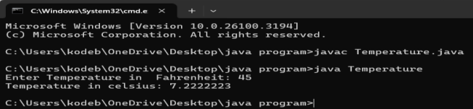

Code: 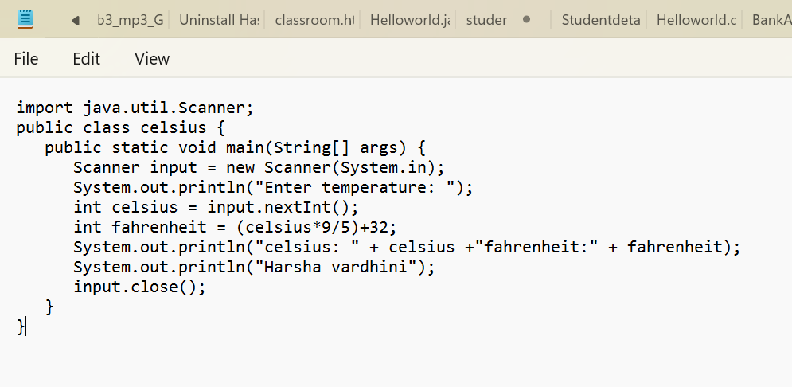

Output:

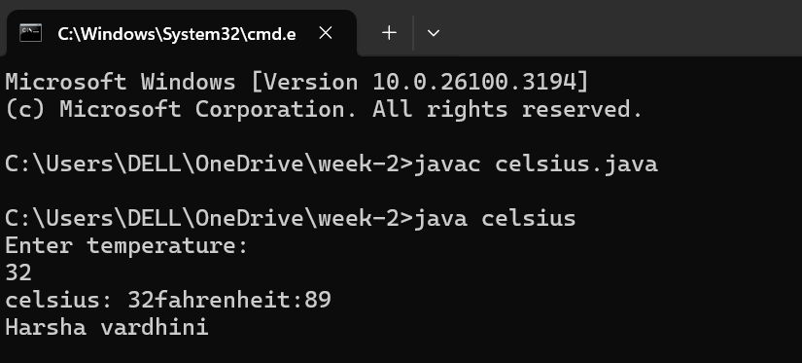

Error table

|  |  |
| --- | --- |
| Error | Rectification |
| Error in line :3  System.out.println | S should be caapital |

Program 4:

Aim: write a java program to find the Fibonacci series of a given number where all the inputs are taken from the user

Code :

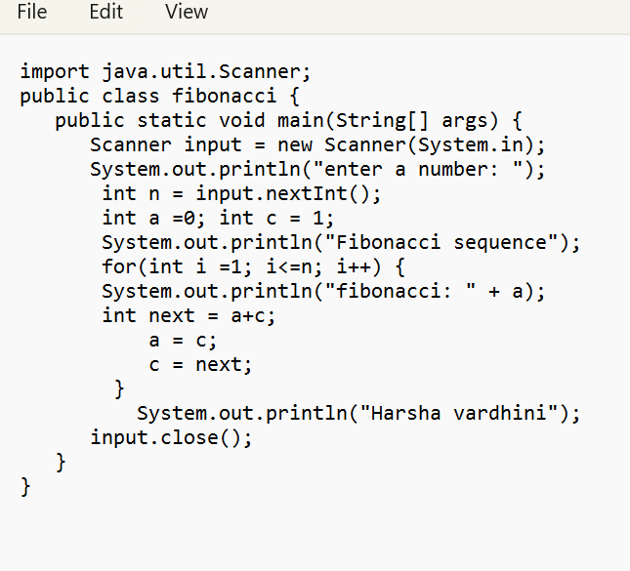

Output:

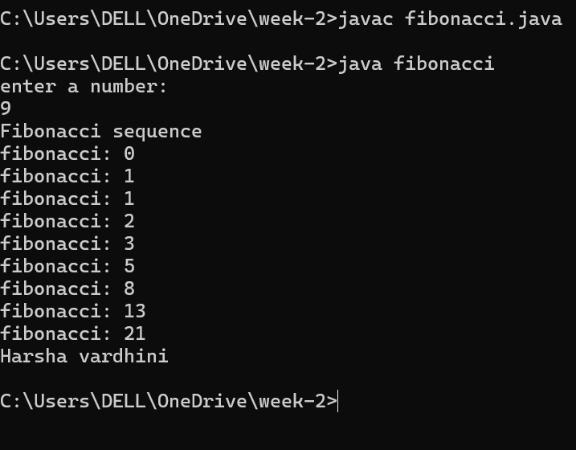

Error table:

|  |  |
| --- | --- |
| Error | rectification |
| fibonacci.java:8: error: ')' or ',' expected  System.out.println("Fibonacci sequence";  ^  1 error | Need to give parentheses |

Program – 5:

AIM : write a java program to find the area of a rectangle, where all the inputs are taken from the user

Code :

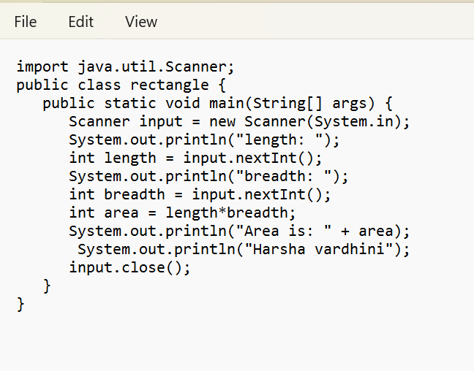

Output:

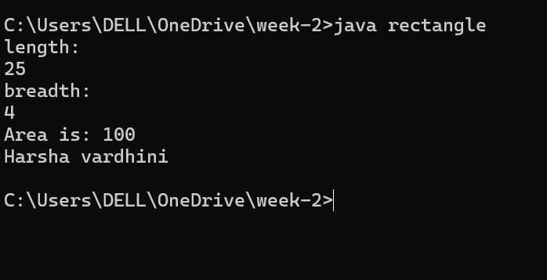

Error table:

|  |  |
| --- | --- |
| Code error | Code rectification |
| While using for iteration, not  Giving the conditions correctly    Declaring the data type as double instead of int | We should give iterative statements correctly  We should give the data type  Type as int for integers |

Program – 6

Aim : write a java program to find the area of the triangle using herons formula where inputs are taken from the user.

Code:

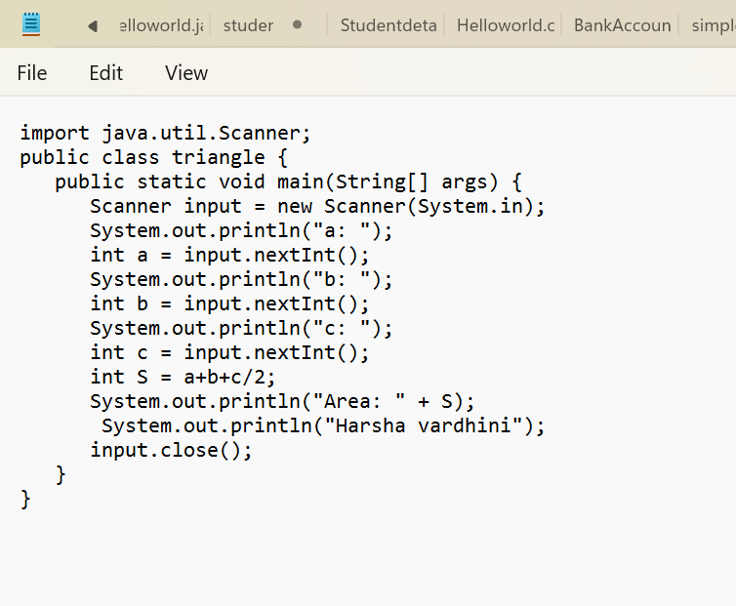

Output:

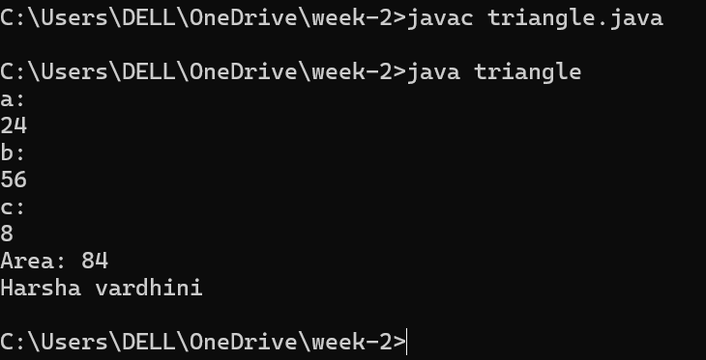

Error table:

|  |  |
| --- | --- |
| Code error | Code rectifiction |
| 1. While prining the variable not giving +sign 2. Not closing the scanner | 1. We should give correct   Indentaion   1. Closing the scanner is must |

Week -3

AIM: To create a java program with following instructructions

* Creating class with name car
* Creating 4 attributes named car_color,brand,fueltype,milage
* Creating 3 methods named start(),stop() and service().
* Creating 3 objects named car1,car2 and car3 for the class car.

IMPORTANT POINTS :

Writing syntax for class,method and object creation using new keyword.

Syntax for Class: public class classname{ }

Syntax for Method: public returntype methodname(){ }

Syntax for Object: classname objectname = new classname();

DEFINITIONS:

Class: Classes are blueprint of any number of objects

Method: Block of code which executes when they are called in main class

Object : Object is an instance of a class. The subclass elements or attributes can be accessed by using object and performing dot operation

Attribute: Named Objects with assigned values.

PROGRAM:

Input:

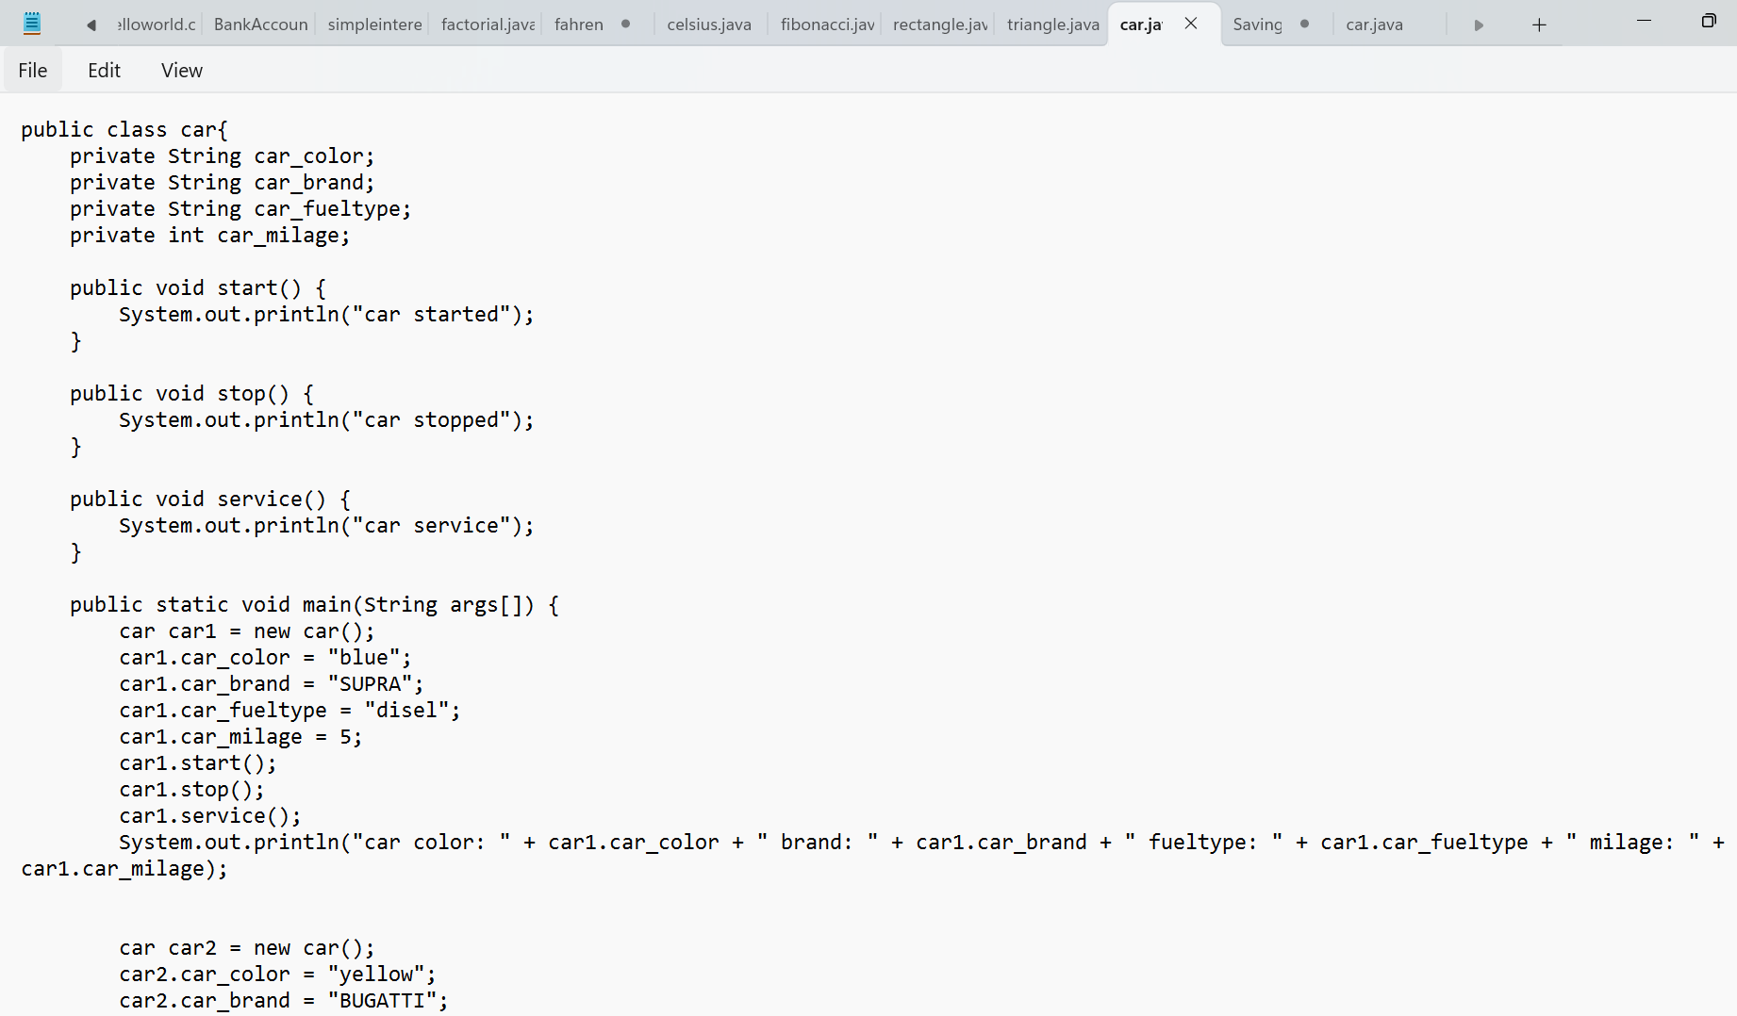

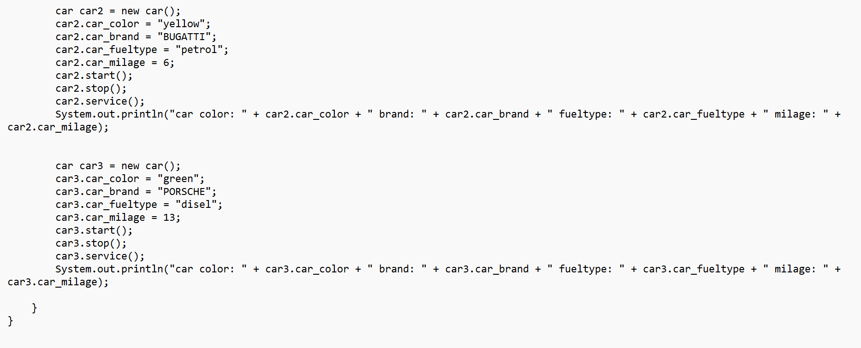

Output:

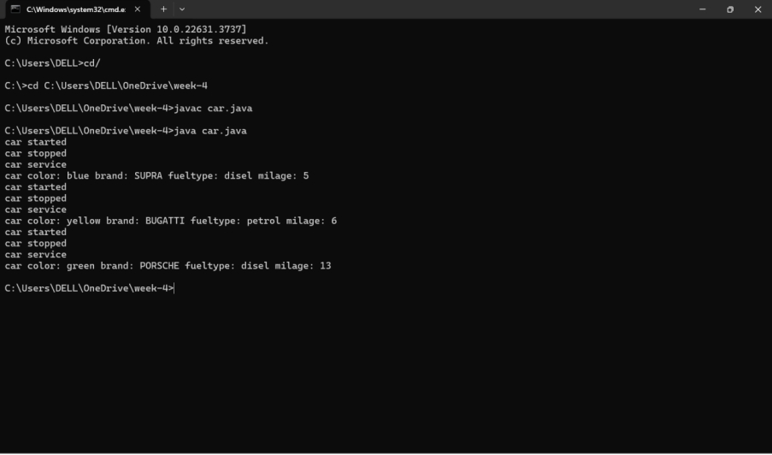

Error table

|  |  |
| --- | --- |
| Error | rectification |
| 1 . car.java:26: error: ';' expected  car1.stop():  ^  1 error  2. car.java:23: error: cannot find symbol  car1.car_fueltyper = "disel";  ^  symbol: variable car_fueltyper  location: variable car1 of type car | Need to keep semicolon instead I kept colon  Car1.stop();  Need to keep which car fuel we are reffering in the line  Car1_fueltyper |

Class diagram:

|  |
| --- |
| Class car |
| -car_ color: String  -car_brand: String  -car_fuel : String  -car_milage:String |

|  |
| --- |
| +start(): void  +stop(): void  +service(): void |

4.b)***AIM***: to design a class bank account with methods deposit and withdrawl.create objects and perform transactions

Constructor should be created.”This ”keyword should be used.

PROCEDURE:

IMPORTANT POINTS:

Top of Form

This code defines a bank account class with a constructor for initializing account number and balance.it also has deposit() and withdraw() methods to perform transactions.Objects account1,account2 and account3 are created and transactions are performed using these objects.

Program:

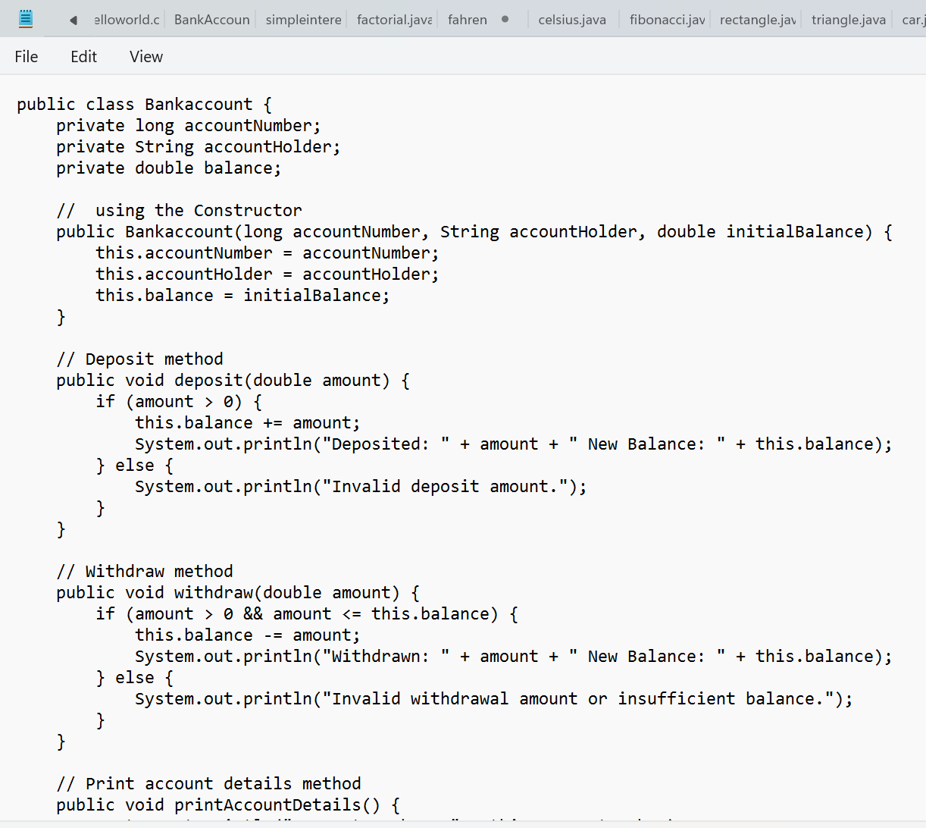

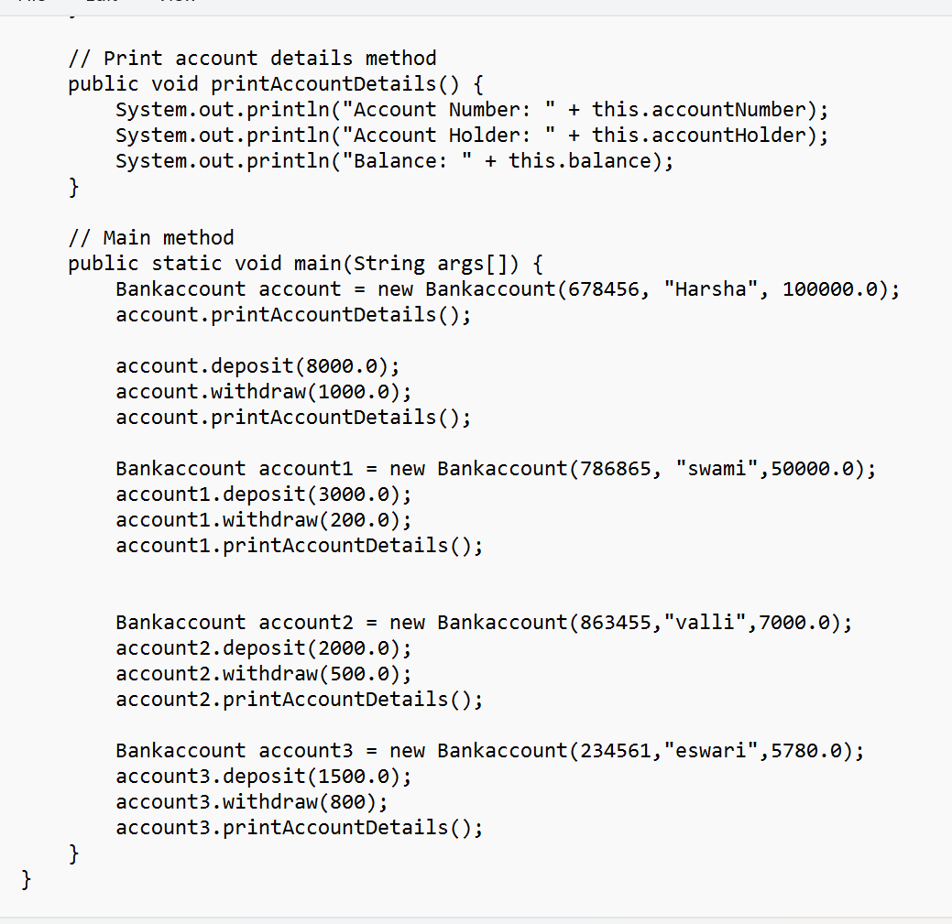

Output:

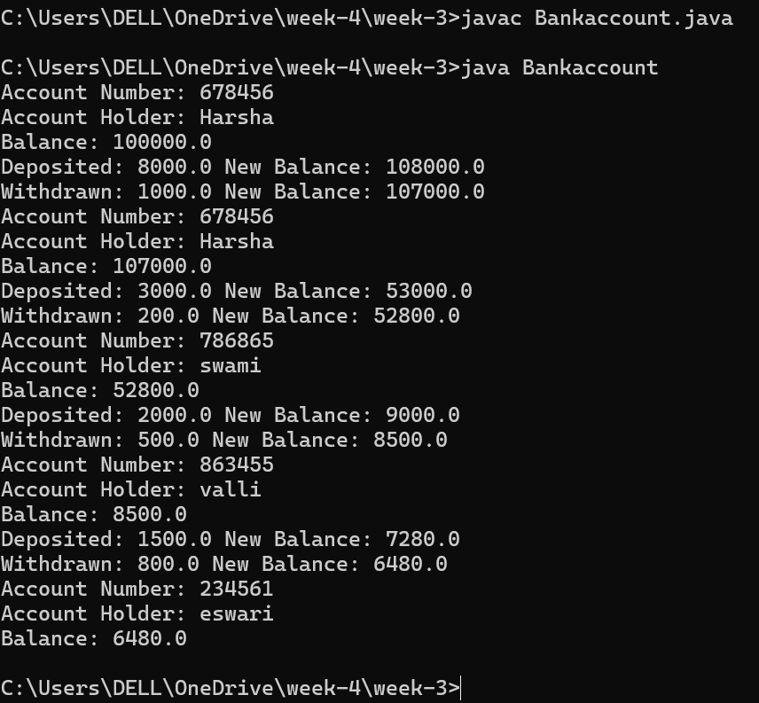

Class diagram :

|  |
| --- |
| Class bank account |
| -ACCNAME : STRING  - ACCNO : int  -Currentbalance : float |
| +withdraw() :void  +deposit() : void |

Error table:

|  |  |
| --- | --- |
| Error | rectification |
| Bankaccount.java:42:  error: illegal character:  Bankaccount account = new BankAccount(678456, ?Harsha", 100000.0);  ^ | Forgot to keep punctuation |

Week – 4

1. AIM: Write a java program with class named “book”. The class should contain various attributes such as “title, author, yearofpublication”. It should also contain a “constructor” with parameters which initializes “title”, ”author”, and “yearofpublication”.Create a method which displays the details of the book i.e. “author, title, yearofpublication”.(Display the details of two books i.e. create 2 objects and display their details).

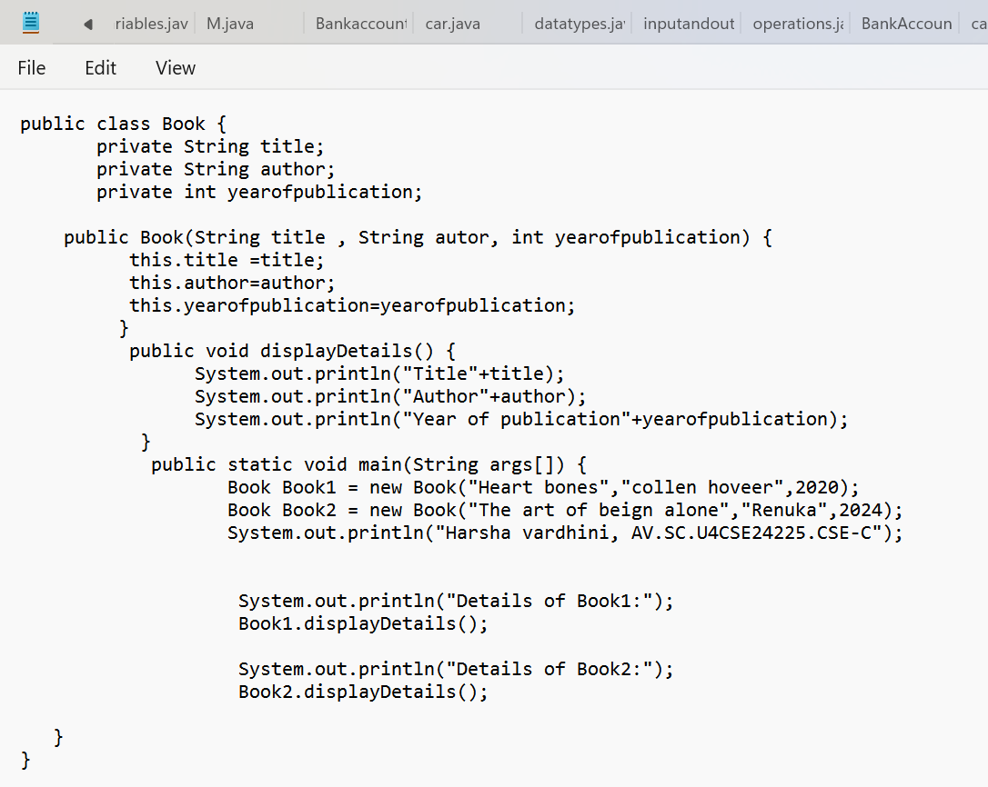

Output:

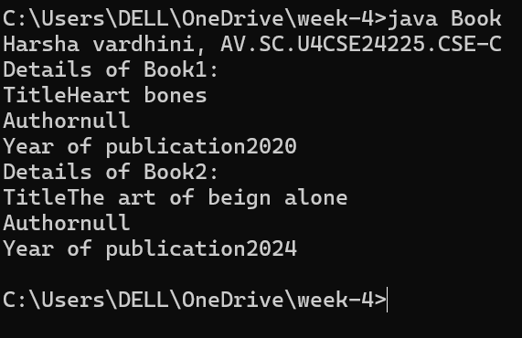· **Class Definition:** The code defines a class named Book that represents a book. The class has three attributes: title, author, and year_of_publication.

· **Constructor:** The class has a constructor that initializes the attributes of a Book object. The constructor takes three arguments: title, author, and year_of_publication.

· **Book Details Method:** The class has a method named book_details that prints the details of a book object. The method prints the title, author, and year of publication of the book.

· **Main Method:** The code has a main method that creates two instances of the Book class: one for the and one for the heart bones comic. The main method then calls the book_details method on each book object to print its details.

Error table:

|  |  |
| --- | --- |
| Error | Rectification |
| Book.java:19: error: ';' expected  System.out.println("Harsha vardhini, AV.SC.U4CSE24225.CSE-C")  ^  Book.java:23: error: ';' expected  Book1.displayDetails():  ^  2 errors | After the line need to keep  Semicolon(;)  Book1.displayDetails(); |

Class diagram:

|  |
| --- |
| Book |

|  |
| --- |
| - Title: String  - Author: String  - Year of publication: int |
| + Book(title: String,  Author: String;  Year of publication: int  + displayDetails( ): void |

Program -2

Aim: Write a java program with class named “MyClass”, with a static variable “count” of “int” type, initialized to “0” and a constant variable “PI” of type “double” initialized to 3.14159 as attributes of that class. Now define a constructor for “MyClass” that increments the “count” variable each time an object of “MyClass” is created. Finally, print the final values of “count” and “PI” variables.

Code

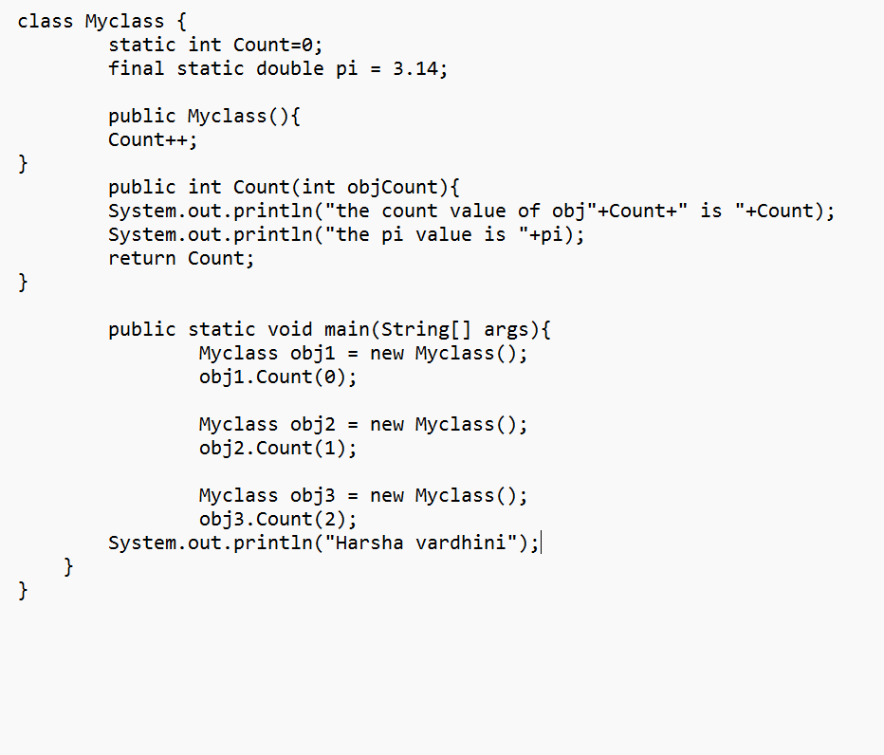

**Important points:**

1. **Class Variable count:**
   * It's declared as static, meaning there's only one copy shared by all objects of the MyClass class.
   * It's initialized to 0, keeping track of the number of instantiated objects.
   * It's incremented by 1 in the constructor (MyClass()) whenever a new object is created.
2. **Constructor MyClass():**
   * It's a public constructor, accessible from anywhere in the code.
   * It increments the count variable to track object creation.
3. **Main Method:**
   * The main method is the entry point of the program.
   * It creates an object c1 of the MyClass class, triggering the constructor and incrementing count.

Output:

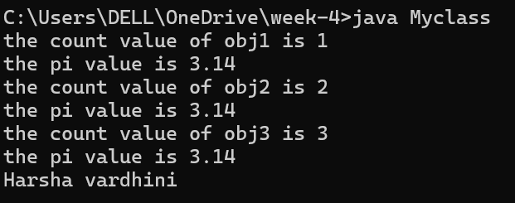

Error table:

|  |  |
| --- | --- |
| Code error | Code rectification |
| 1.not keeping semicolon  After calling a function | 1.put semicolon after calling a function |

Class diagram:

|  |
| --- |
| My class |
| Count:int  Pi : double |
| +my class()  +main(args:String[]):void |

Week – 5

Aim : create a calculator using operations including addition, subtraction, multiplication and division using multilevel inheritance display desired output .Each class should have method it should pass a parameter.

Code:

class calculator {

    protected double a, b;

    public calculator(double a, double b) {

        this.a = a;

        this.b = b;

    }

}

class Addition extends calculator {

    public Addition(double a, double b) {

        super(a, b);

    }

    public double add() {

        return a + b;

    }

}

class Subtraction extends Addition {

    public Subtraction(double a, double b) {

        super(a, b);

    }

    public double subtract() {

        return a - b;

    }

}

class Multiplication extends Subtraction {

    public Multiplication(double a, double b) {

        super(a, b);

    }

    public double multiply() {

        return a * b;

    }

}

class Division extends Multiplication {

    public Division(double a, double b) {

        super(a, b);

    }

    public double divide() {

        if (b != 0) {

            return a / b;

        } else {

            System.out.println("Error");

            return Double.NaN;

        }

    }

}

class Final extends Division {

    public Final(double a, double b) {

        super(a, b);

    }

    public void displayResults() {

        System.out.println("Addition: " + add());

        System.out.println("Subtraction: " + subtract());

        System.out.println("Multiplication: " + multiply());

        System.out.println("Division: " + divide());

    }

}

import java.util.Scanner;

public class allcalculator {

    public static void main(String[] args) {

        Scanner input = new Scanner(System.in);

        System.out.println("Enter a number: ");

        double a = input.nextDouble();

        System.out.println("Enter b number: ");

        double b = input.nextDouble();

        Final calc = new Final( a,  b);

        calc.displayResults();

        System.out.println("Harsha vardhini");

        input.close();

    }

}

Output:

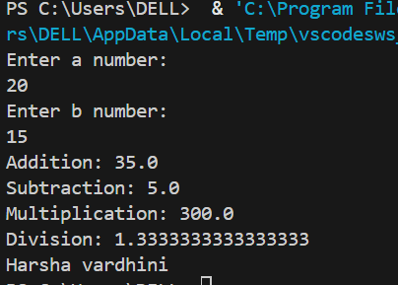

Error table

|  |  |
| --- | --- |
| Code error | Code rectification |
| 1.not providing the return method correctly  2.not mentioning super to obtain the super class constructor | 1.After declaring methods,we must provide the return method correctly   1. 2. To obtain the super class we need to mention super. |

IMPORTANT POINTS:

1. To get the inputs from the user we use import java.util.Scanner; this is a package.
2. Scanner class is used to get the user input.
3. in java.util.Scanner, the java.util is a package while Scanner is a class of the java.util package.
4. to import a whole package, end the sentence with an asterisk sign(*).

Class diagram :

Program -2

AIM: A vehicle rental company wants to develop a system that maintains information about different types of vechicles available for rent the company rents out cars and bikes, and they need a program to store details about each vehicle, such as brand and speed( should be in super class)

1. cars should have an additional property: no.of doors
2. Bikes should have a property indicating whether they have gears or not.
3. The system should also include a function to display details about each vehicle and indicate when a vehicle is starting.

Every class should have a constructor

Question:

1. Which oops concept is used in the above program
2. If the company decides to add a new type of vehicle, Truck, how would you modify the program?
3. Truck should include an additional property capacity (in tons)
4. Create a showTruckdetails() method to display the truck’s capacity.
5. Write a constructor for Truck that initializes all properties
6. Implement the truck class and update the main method to create a Truck object and also create an object for car and bike sub classes Finally, display the details.

Code:

public class vehicle {

    public String brand;

    public int speed;

    public vehicle(String brand, int speed) {

        this.brand = brand;

        this.speed = speed;

    }

    public void start() {

        System.out.println(brand + " is starting");

    }

    public void showDetails() {

        System.out.println("Brand: " + brand);

        System.out.println("Speed: " + speed + " km/h");

    }

}

class Car extends vehicle {

    private int noOfDoors;

    public Car(String brand, int speed, int noOfDoors) {

        super(brand, speed);

        this.noOfDoors = noOfDoors;

    }

    public void showDetails() {

        super.showDetails();

        System.out.println("Number of Doors: " + noOfDoors);

    }

}

class Bike extends vehicle {

    private boolean hasGears;

    public Bike(String brand, int speed, boolean hasGears) {

        super(brand, speed);

        this.hasGears = hasGears;

    }

    public void showDetails() {

        super.showDetails();

        System.out.println("Has Gears: " + (hasGears ? "Yes" : "No"));

    }

}

class Truck extends vehicle {

    private int capacity;

    public Truck(String brand, int speed, int capacity) {

        super(brand, speed);

        this.capacity = capacity;

    }

    public void showTruck() {

        super.showDetails();

        System.out.println("Capacity: " + capacity + " tons");

    }

}

public static void main(String[] args) {

        Car car = new Car("Toyota", 150, 4);

        Bike bike = new Bike("Yamaha", 120, true);

        Truck truck = new Truck("Volvo", 90, 10);

        System.out.println("Car Details");

        car.start();

        car.showDetails();

        System.out.println("Bike Details");

        bike.start();

        bike.showDetails();

        System.out.println("Truck Details");

        truck.start();

        truck.showTruck();

        System.out.println("Harsha vardhini");

    }

}

Output:

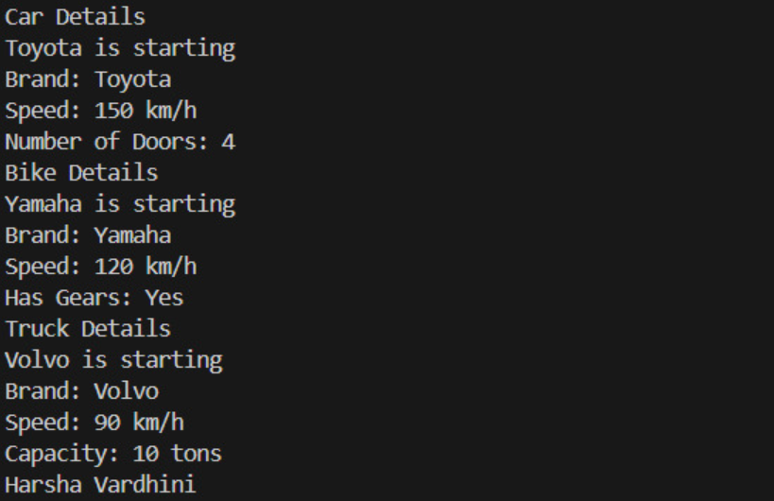

IMPORTANT POINTS:

1. a constructor helps in initializing an object that doesn't exist.
2. a method performs functions on pre-constructed or already developed objects.
3. a double method can represent more decimal point numbers than float method.
4. the void keyword in java is used to specify that a method does not return any value. it is a return type that indicates the method performs a function and doesn't produce a result.

Answer:

The oops concepts used in the above program are:

Inheritance, encapsulation, polymorphism, abstraction.

To add a new vehicle type truck we need to create a truck class that will:

* Include an additional property capacity (in tons).
* Implement a showtruckdetials() method to display the truck's capacity.
* Implement a constructor for the truck class to initialize all its properties.

Error code :

|  |  |
| --- | --- |
| **Code Error** | **Code rectification** |
| 1. Declaring two superclasses inside the same file.   2.Not declaring the variable using ‘this’ keyword inside the constructor. | 1. Make two separate files to save the two super classes. 2. Declare the variable using this keyword to run the program. |