ASSISTIVE TECHNOLOGY AND ACCESSIBILITY GUIDE USING AI

Project Type: CSE Capstone Project

Project Objective

The objective of this project is to study and evaluate AI-powered accessibility tools that help students and teachers with disabilities access digital content more easily.

Target Audience
The target audience for this project includes students with disabilities, faculty members, and campus IT teams. The project explains how AI-powered assistive technologies can improve access to educational content.

- Students with disabilities: To access learning materials through screen readers, captions, text-to-speech, and image descriptions.
- Faculty members: To create accessible notes, presentations, and learning resources.
- Campus IT teams: To improve the accessibility of college websites and digital learning platforms.
Project Focus
- Screen readers and text-to-speech
- Automatic captions
- AI-generated image descriptions
- Accessibility guidelines
- Testing and verification of AI tools
- A simple AI-powered accessibility workflow
1. INTRODUCTION AND RESEARCH SUMMARY

1.1 Introduction

Assistive technology helps people with disabilities access information, communicate, and participate in learning activities. Artificial Intelligence (AI) can improve accessibility by converting speech into text, reading digital text aloud, and generating descriptions of images.

This project explores AI-powered accessibility tools and evaluates how effectively they support students and teachers in educational environments.

1.2 Types of Assistive Technologies

1. Screen Readers: These tools read on-screen text aloud or present it through a refreshable Braille display.

2. Text-to-Speech: This technology converts written text into spoken audio.

3. Automatic Captions: These tools convert spoken words into text, supporting people who are deaf or hard of hearing.

4. AI Image Descriptions: AI can generate descriptions of images to help people who cannot easily see visual content.

5. Accessibility Guidelines: Guidelines such as the Web Content Accessibility Guidelines (WCAG) help developers make digital content more accessible.

1.3 Benefits of AI in Accessibility

- Improves access to educational materials.
- Supports different learning needs.
- Helps users understand audio and visual information.
- Can reduce the effort required to create accessible content.

1.4 Limitations

AI-generated captions and image descriptions may contain errors. Some tools may not support every language or disability-related need. Therefore, AI outputs must be checked by humans before being used in important educational materials.

1.5 Research Conclusion

AI-powered accessibility tools can support inclusive education when they are selected carefully, tested with suitable examples, and reviewed by people who understand accessibility requirements.

2. ACCESSIBILITY CHECKLIST

Purpose

This checklist helps teachers, students, and content creators check whether digital learning materials are accessible to people with different needs.

2.1 Text and Documents

- ☐ Use clear and readable fonts.
- ☐ Use headings in the correct order.
- ☐ Provide meaningful link descriptions.
- ☐ Add alternative text to meaningful images.
- ☐ Use sufficient contrast between text and background.
- ☐ Use simple and understandable language.

2.2 Images and Visual Content

- ☐ Describe important images using alternative text (alt text).
- ☐ Avoid placing essential information only inside images.
- ☐ Check whether AI-generated image descriptions are accurate.
- ☐ Include text descriptions for important charts and diagrams.

2.3 Audio and Video
- ☐ Provide captions for videos containing speech.
- ☐ Check captions for spelling and accuracy.
- ☐ Provide transcripts for important audio content.
- ☐ Describe important visual information when necessary.
2.4 Navigation and Usability

- ☐ Ensure that interactive elements can be accessed using a keyboard.
- ☐ Use descriptive labels for buttons and forms.
- ☐ Check that screen readers can identify headings and controls.
- ☐ Make error messages clear and understandable.

2.5 Responsible Use of AI

- ☐ Verify AI-generated text, captions, and image descriptions.
- ☐ Correct inaccurate or misleading information.
- ☐ Protect personal and sensitive information.
- ☐ Ask users with accessibility needs for feedback when possible.

Conclusion

This checklist provides a practical starting point for improving digital accessibility. It does not replace a complete accessibility audit or testing with people who use assistive technologies.

3. ACCESSIBILITY TOOL TESTING

3.1 Tool 1: Windows Narrator

Purpose: Windows Narrator is a built-in screen reader that reads on-screen text aloud and helps users with visual impairments navigate digital content.

Test Procedure:

1. Opened Windows Narrator using the keyboard shortcut.
2. Opened the project report in Microsoft Word.
3. Used the continuous reading command to listen to the document.
4. Tested keyboard navigation to explore interactive controls.

Observation: Narrator successfully read the document content aloud when continuous reading was started.

Button Navigation Test: The Tab key can be used to move between interactive controls. The names announced by Narrator should be checked to determine whether users can identify each control.

Result: Continuous document reading was successful. Button identification requires separate verification.

Limitation: This was a basic test. Further testing is required to evaluate navigation across different applications and document elements.

3.1.1 Importance of the Test

Screen readers can help people with visual impairments access digital information. Clear headings, meaningful button labels, and keyboard navigation can make digital content easier to use.

A screen reader does not automatically make every document or website accessible. The content and interactive controls must also be designed and tested properly.

3.2 Tool 2: AI Image Description
Purpose: To explore how AI-generated image descriptions can help people with visual impairments understand visual content.

Tool Used: ChatGPT

Test Procedure:

1. Selected a clear image.
2. Submitted the image to ChatGPT.
3. Used a prompt requesting a clear and simple image description.
4. Compared the generated description with the original image.

Evaluation Criteria:

- Does the description identify the main objects correctly?
- Does it explain the main activity?
- Are important visual details missing?
- Does it include any incorrect or unsupported information?

Observation: To be completed after examining the generated description.

Result: To be recorded after verifying the AI output.

Limitation: AI-generated descriptions may omit important details or incorrectly interpret visual information. Human verification is necessary.
3.2.1 Test Evidence

Original Image:
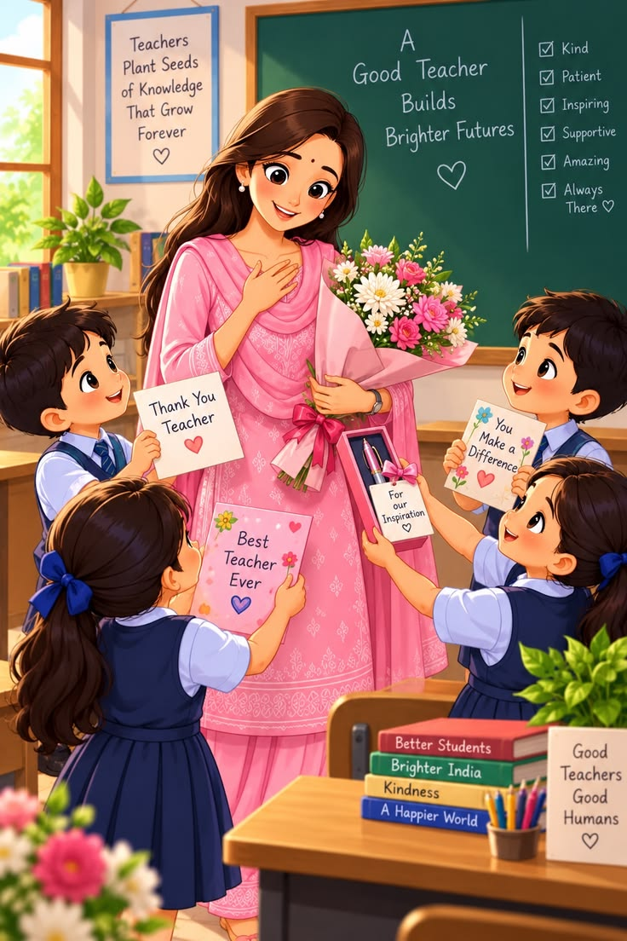
Prompt Used:

"Describe this image clearly for a person with visual impairment. Explain the main objects, people, activities, and important visual details. Use simple English and do not guess details that cannot be confirmed."

AI-Generated Description:
The image shows a warm, colourful classroom scene celebrating a teacher. A smiling female teacher stands in the centre, surrounded by four schoolchildren who are giving her flowers, greeting cards, and gifts to show their appreciation.
The teacher has long, dark brown hair and wears a pink traditional outfit with decorative patterns. She holds a large bouquet of pink, white, and yellow flowers wrapped in pink paper. One hand rests on her chest, showing a gesture of gratitude and emotion.
Two children stand on the left side and two on the right. They wear school uniforms consisting of white shirts and navy-blue clothing. The children look happy and excited as they present their gifts to the teacher. One child holds a card that says “Thank You Teacher,” another holds a card reading “Best Teacher Ever,” and a child on the right holds a card saying “You Make a Difference.” A small gift box with a card reading “For our Inspiration” is also visible.
Behind the teacher is a large green chalkboard with a message written in white chalk: “A Good Teacher Builds Brighter Futures.” A heart symbol appears beneath the message. On the right side of the board is a checklist describing a good teacher as kind, patient, inspiring, supportive, amazing, and always there.
On the left wall, a framed poster reads, “Teachers Plant Seeds of Knowledge That Grow Forever,” with a small heart underneath. A window nearby lets sunlight into the classroom. A potted green plant and several books sit on a shelf below the window.
In the foreground, there is a wooden classroom desk with colorful books stacked on it. The book titles include “Better Students,” “Brighter India,” “Kindness,” and “A Happier World.” A container filled with coloured pencils stands on the desk. A small sign nearby reads, “Good Teachers Good Humans,” followed by a heart.
The overall scene uses warm sunlight, bright colours, flowers, hearts, and cheerful expressions to create a feeling of love, respect, and gratitude. The main message is that teachers inspire students, help them learn, and contribute to a brighter future.
Verification:
Compare the description with the original image. Check whether the main objects and activities are described correctly, and note any missing or incorrect details.

Observation:
The AI-generated description correctly identifies the main objects in the image, including the teacher, four students, flowers, greeting cards, chalkboard, classroom desk, books, and plants. It explains the main activity of students expressing gratitude and respect to their teacher. It also describes the classroom messages and the warm, cheerful atmosphere. The description is clear and easy to understand. However, some small details and text in the image may not be fully covered.
Result:
The AI-generated description was mostly accurate. It successfully explained the main objects, activity, and overall message of the image. This test shows that ChatGPT can help people with visual impairments understand visual content. However, the description should be checked against the original image because some details may be missed or interpreted incorrectly.

3.3 Tool 3: AI Text-to-Speech (TTS)

Tool Used: ElevenLabs Text-to-Speech

Purpose:
To test how AI-powered text-to-speech technology helps people with visual impairments access written information through audio.

Procedure:

1. I copied the image description generated using ChatGPT in Tool 2.
2. I pasted the description into ElevenLabs Text-to-Speech.
3. I selected an English voice and generated the audio.
4. I listened to the audio and checked its clarity, pronunciation, and speaking speed.

Test Input:
The picture shows a cheerful classroom where a teacher is receiving gifts from her students. Four children stand around the teacher, holding flowers, greeting cards, and presents. The teacher smiles warmly and holds a beautiful bouquet of flowers. A green chalkboard behind them displays the message, “A Good Teacher Builds Brighter Futures.” Colourful books, a potted plant, and educational posters decorate the classroom. The students show love and respect for their teacher. The image highlights the importance of teachers in guiding students, sharing knowledge, and inspiring them to achieve their goals.
Audio Evidence:
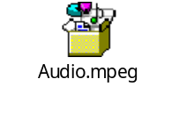

Observation:
The audio was generated successfully. The speech was clear, the words were easy to understand, and the pronunciation and speaking speed were suitable for listening.

Result:
ElevenLabs successfully converted the written image description into clear spoken audio. This can help people with visual impairments access visual information through audio descriptions.

Limitation:
The quality of speech may vary depending on the selected voice, language, and length of the text. Important information should still be checked for accuracy.

Conclusion:
AI-powered text-to-speech is a useful assistive technology that makes written information more accessible to people with visual impairments.
3.4 Tool 4: Windows Live Captions

Tool Used: Windows Live Captions

Purpose:
To test how live captions convert spoken audio into on-screen text and help people with hearing impairments.

Procedure:

1. I opened Windows Live Captions using the keyboard shortcut Windows + Ctrl + L.
2. I allowed the required language files to download.
3. I played the audio generated using ElevenLabs.
4. I observed the captions displayed on the screen.

Test Input:
Audio containing an English image description of a classroom scene.

Observation:
Windows Live Captions displayed text while the audio was playing. The captions helped me follow the spoken content visually.

Result:
The tool successfully displayed captions for the test audio, demonstrating how captions can make audio content more accessible.

Limitation:
Some words may be incorrectly recognized, especially when speech is unclear or contains unfamiliar terms.

Evidence:
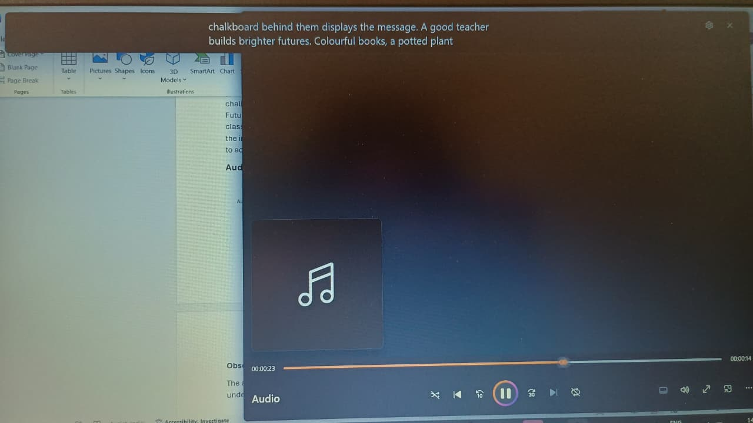

Conclusion:
Windows Live Captions can improve accessibility by allowing users to read spoken content on the screen.

