Phase 2

E-Commerce Application on IBM Cloud Foundry

**Problem Statement**:

Build a artisanal e-Commerce platform using IBM foundry. Connect the skilled artisans with the global audience. Showcase handmade products from exquisite jewellery to artistic home decor. Implement secure shopping carts, smooth payment gateway and an intuitive checkout process. Nurture creativity and support small business through an artisan's dream marketplace.

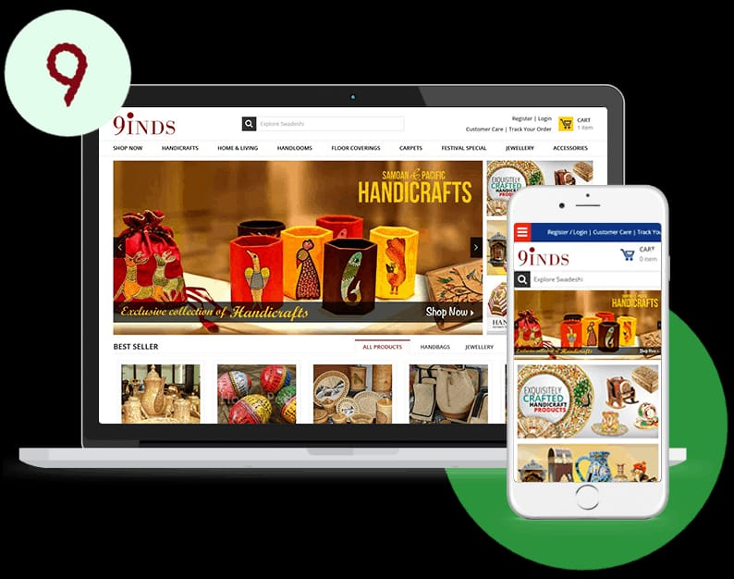

**INNOVATION PHASE**

***PERSONALIZED RECOMMENDATION***

**1. Data Collection:**

* The process begins with the collection of user data. This includes a wide range of information such as user demographics, past purchases, search history, products viewed, time spent on the platform, and more. The data can also extend to external sources, like social media profiles or user-generated content.

**2. Algorithm Selection:**

* There are various recommendation algorithms available, such as collaborative filtering, content-based filtering, and hybrid methods. The choice of algorithm depends on the e-commerce platform's needs and data.

**3. Content Analysis:**

* In content-based filtering, the system analyzes product attributes or characteristics. For instance, if the e-commerce platform is selling clothing, the system will examine details like color, size, brand, style, and material. This analysis helps create a profile for each product.

**4. Recommender Engine:**

* Behind the scenes, there's a recommender engine that processes the data and algorithms. This engine is responsible for matching user profiles with product profiles and generating a list of recommended products.

**5. Benefits:**

* Personalized recommendations offer several advantages. They help users discover new products they're likely to be interested in, which can lead to increased sales and customer engagement. It also makes the shopping experience more enjoyable, as users spend less time searching for products.

**6.Challenges:**

* Challenges in implementing personalized recommendations include data privacy concerns, potential filter bubbles, and ensuring that recommendations remain relevant as user behavior changes over time.

***WISHLIST***

**1. Personalization:**

* Wishlist contribute to the personalization of the user's shopping experience. They reflect the user's preferences, tastes, and interests in a particular product or category.

**2. Time and Budget Management:**

* Wishlist assist users in managing their time and budget. They can use wishlist to track products they like, monitor price changes, or plan for future occasions, such as birthdays or holidays.

**3. Customer Insights:**

* Wishlist provide valuable data for e-commerce platforms. They help in understanding user preferences, trending products, and demand for specific items.

**4. Social Sharing:**

* Some platforms allow users to share their wishlist on social media, enhancing product visibility and potentially driving traffic to the platform.

**5. Adding and Removing Items:**

* Users can easily add or remove items from their wishlist, giving them full control over the products they wish to track.

**6. Social Sharing:**

* Some platforms allow users to share their wishlist on social media, enhancing product visibility and potentially driving traffic to the platform.

***PRODUCT REVIEW***

**1. Quality Assurance:**

- Product reviews are a quality assurance mechanism. They serve as a check on the product's performance and accuracy of product descriptions provided by the platform.

**2. Feedback Loop:**

- Reviews create a feedback loop between customers and sellers. Sellers can use this feedback to improve their products or services, leading to a better overall shopping experience.

**3. Peer Recommendations:**

- Customers tend to trust peer recommendations more than marketing messages. Positive reviews from fellow customers act as endorsements, increasing the likelihood of a purchase.

**4. Improving Customer Satisfaction:**

- Sellers can respond to reviews, addressing any issues or concerns raised by customers. This responsiveness can lead to improved customer satisfaction and loyalty.

**5.Photo and Video Reviews:**

- Some platforms allow users to upload photos or videos along with their reviews, providing visual evidence of their experiences with the product.

**6. Personalization:**

- Personalization algorithms use reviews to offer users product recommendations based on their interests and preferences.

***FLOWCHART FOR IMPLEMENTING***

This flowchart represents the problem statement and my way of approaching the problem.

Start

User

Admin

Register

Login

nn

login

Search item

Add item category

Online pay

Payment

Wish

list

buy

Review

Logout

Order placed

COD

View item

Report

Add product

Check feedback

Manage order

Manage payment

stop