**Product Demand Prediction with Machine Learnings**

|  |  |
| --- | --- |
| **Date** | **04-10-2023** |
| **Team ID** | **3909** |
| **Project Name** | **Product Demand Prediction with ML** |

**Table of Contents**

|  |  |
| --- | --- |
| 1 | Introduction |
| 2 | Problem Statement |
| 3 | Design and Innovation Strategies |
| 3.1 | Data Collection and Feature Engineering |
| 3.2 | Data Pre-processing |
| 3.3 | Model Selection and Training |
| 3.4 | Geographic Analysis |
| 3.5 | Market Sentiment Analysis |
| 3.6 | Explainable AI (XAI) |
| 3.7 | Continuous Learning |
| 4 | Conclusion |

# Introduction

Product demand prediction is an essential task for businesses of all sizes. By accurately forecasting demand, businesses can ensure that they have the right products in the right place at the right time. This can help to reduce costs, improve customer satisfaction, and boost profits.

Machine learning (ML) is a powerful tool for product demand prediction. ML algorithms can learn from historical data to identify patterns and trends that can be used to forecast future demand. ML models can also take into account external factors such as economic conditions, competitor activity, and social media trends.

# Problem Statement

Traditional product demand forecasting methods are often inaccurate and time-consuming. These methods often rely on subjective judgment and historical data alone, which can lead to errors. Additionally, traditional methods may not be able to account for the dynamic nature of the market and the impact of external factors.

# Design and Innovation Strategies

This project will develop an innovative ML-based product demand prediction model. The model will be designed to be accurate, efficient, and scalable. The model will also be designed to be

able to account for external factors and the dynamic nature of the market. The project will use a variety of ML techniques, including:

* + Time series forecasting: To forecast demand based on historical sales data.
  + Regression analysis: To identify relationships between demand and external factors.
  + Machine learning algorithms: Such as random forests, gradient boosting machines, and neural networks to learn patterns and trends in the data.

The model will be evaluated on a variety of metrics, including accuracy, precision, recall, and F1 score.

## Data Collection and Feature Engineering

The project will collect a variety of data sources to train and evaluate the model. This data will include:

* + - Historical sales data
    - External data such as economic conditions, competitor activity, and social media trends

The data will be pre-processed to ensure that it is clean and in a format that can be used by the ML algorithm. The data will also be engineered to create new features that may be useful for forecasting demand.

## Data Pre-processing

The data will be pre-processed to ensure that it is clean and in a format that can be used by the ML algorithm. This may involve the following steps:

* + - Removing duplicate rows
    - Handling missing values
    - Converting categorical data to numerical data
    - Scaling the data

## Model Selection and Training

A variety of ML algorithms will be evaluated to select the best model for forecasting product demand. The model will be trained on a subset of the data, and its performance will be evaluated on a held-out test set.

## Geographic Analysis

The project will also explore the use of geographical analysis to improve the accuracy of the model. Geographical analysis can be used to identify regional trends in demand and to account for the impact of location on demand.

## Market Sentiment Analysis

The project will also explore the use of market sentiment analysis to improve the accuracy of the model. Market sentiment analysis can be used to identify trends in consumer sentiment and to

account for the impact of sentiment on demand.

## Explainable AI (XAI)

The project will also explore the use of explainable AI (XAI) to make the model more interpretable. XAI techniques can be used to identify the factors that have the greatest impact on the model's predictions and to explain how the model makes its predictions.

## Continuous Learning

The model will be continuously updated with new data to ensure that it remains accurate. This can be done using a variety of techniques, such as online learning and batch learning.

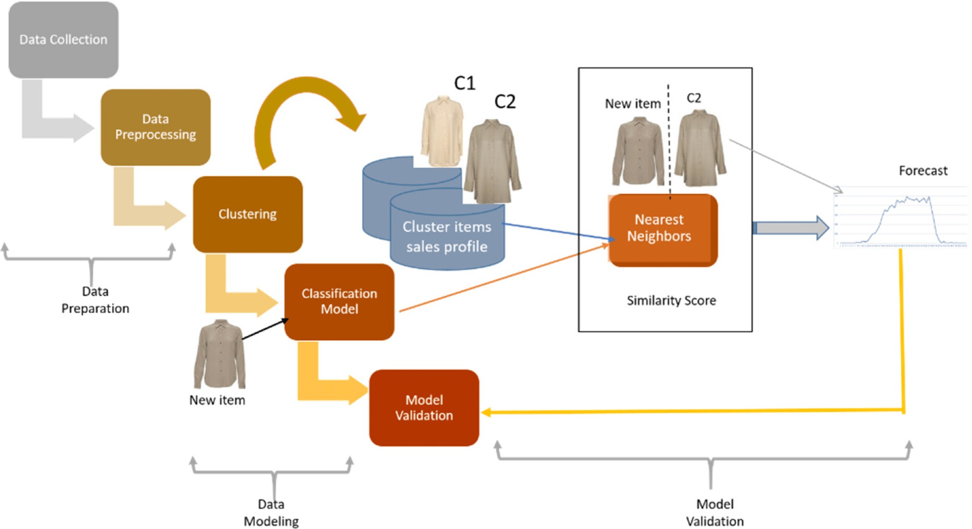

**Figure 1:** Process Flow

## Conclusion

This project will develop an innovative ML-based product demand prediction model. The model will be designed to be accurate, efficient, and scalable. The model will also be designed to be

able to account for external factors and the dynamic nature of the market. The project will benefit a variety of stakeholders, including:

* + Businesses: Businesses can use the model to improve their inventory management and production planning. This can help to reduce costs, improve customer satisfaction, and boost profits.
  + Consumers: Consumers can benefit from the model by having access to the products they need when they need