**WEEK 7**

**9)App.js**import React from 'react';

import ListofPlayers from './ListofPlayers';

import IndianPlayers, { OddPlayers, EvenPlayers } from './IndianPlayers';

function App() {

  const flag = false; // Change to false to test second output

  return (

    <div className="App">

      {flag ? <ListofPlayers /> : (

        <>

          <OddPlayers players={["Sachin1", "Dhoni2", "Virat3", "Rohit4", "Yuvaraj5", "Raina6"]} />

          <EvenPlayers players={["Sachin1", "Dhoni2", "Virat3", "Rohit4", "Yuvaraj5", "Raina6"]} />

          <IndianPlayers />

        </>

      )}

    </div>

  );

}

export default App;

**ListofPlayers.js**  
import React from 'react';

function ListofPlayers() {

  const players = [

    { name: "Jack", score: 50 },

    { name: "Michael", score: 70 },

    { name: "John", score: 40 },

    { name: "Ann", score: 61 },

    { name: "Elisabeth", score: 61 },

    { name: "Sachin", score: 95 },

    { name: "Dhoni", score: 100 },

    { name: "Virat", score: 84 },

    { name: "Jadeja", score: 64 },

    { name: "Raina", score: 75 },

    { name: "Rohit", score: 80 }

  ];

  const playersBelow70 = [];

  players.map((item) => {

    if (item.score <= 70) {

      playersBelow70.push(item);

    }

  });

  return (

    <div>

      <h2>List of Players</h2>

      {players.map((item, index) => (

        <div key={index}>

          <li>Mr. {item.name} <span> {item.score} </span></li>

        </div>

      ))}

      <h2>List of Players having Scores Less than 70</h2>

      {playersBelow70.map((item, index) => (

        <div key={index}>

          <li>Mr. {item.name} <span> {item.score} </span></li>

        </div>

      ))}

    </div>

  );

}

**IndianPlayers.js**

export default ListofPlayers;

import React from 'react';

export function OddPlayers({ players }) {

  const [first, , third, , fifth] = players;

  return (

    <div>

      <h2>Odd Players</h2>

      <li>First: {first}</li>

      <li>Third: {third}</li>

      <li>Fifth: {fifth}</li>

    </div>

  );

}

export function EvenPlayers({ players }) {

  const [, second, , fourth, , sixth] = players;

  return (

    <div>

      <h2>Even Players</h2>

      <li>Second: {second}</li>

      <li>Fourth: {fourth}</li>

      <li>Sixth: {sixth}</li>

    </div>

  );

}

const T20Players = ['First Player', 'Second Player', 'Third Player'];

const RanjiTrophyPlayers = ['Fourth Player', 'Fifth Player', 'Sixth Player'];

const IndianPlayers = () => {

  const allPlayers = [...T20Players, ...RanjiTrophyPlayers];

  return (

    <div>

      <h2>List of Indian Players Merged</h2>

      {allPlayers.map((player, index) => (

        <li key={index}>Mr. {player}</li>

      ))}

    </div>

  );

};

export default IndianPlayers;

**output:  
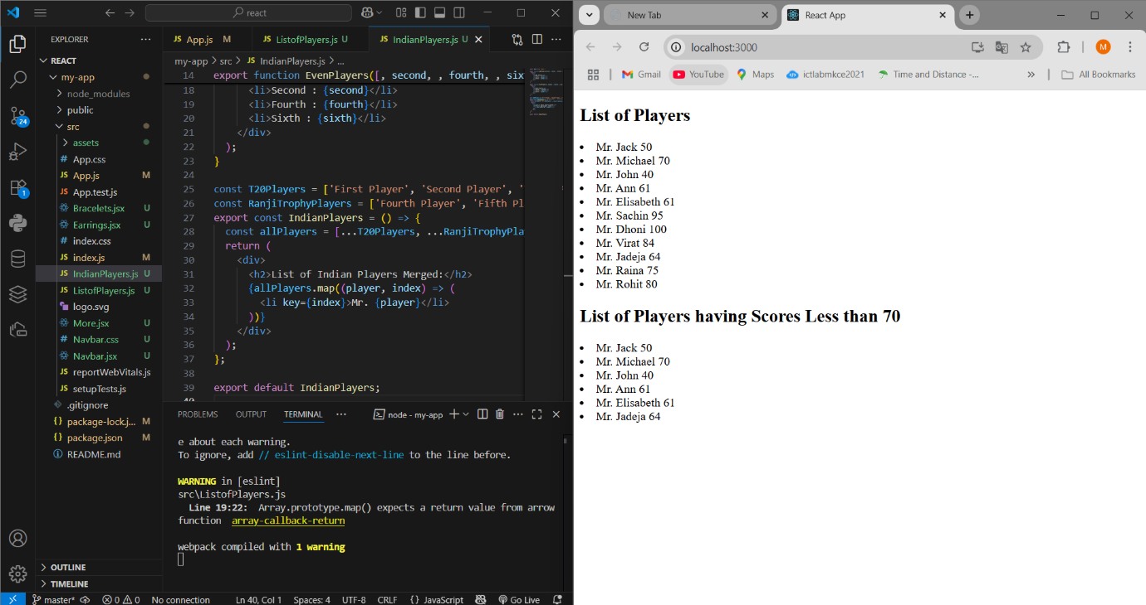**

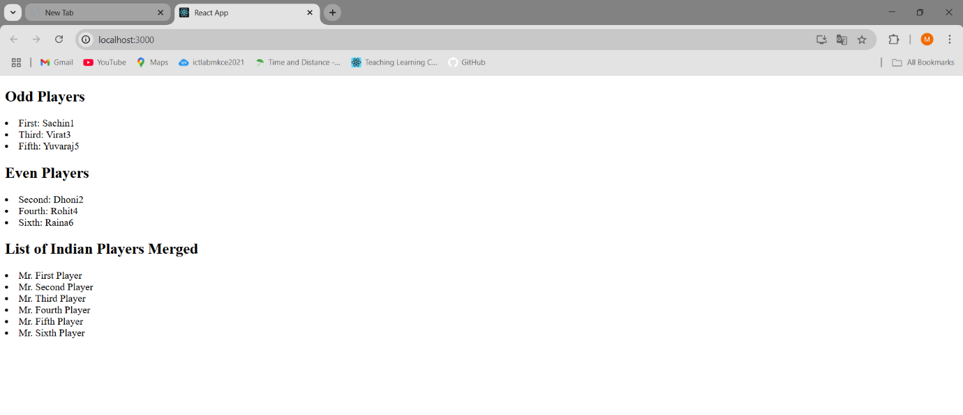

10)App.js

import React from "react";

import officeImage from "./office.jpg";

function App() {

const office = {

name: "DBS",

rent: 50000,

address: "Chennai",

image: officeImage,

};

const rentStyle = {

color: office.rent < 60000 ? "red" : "green",

fontWeight: "bold",

};

return (

<div style={{ textAlign: "center", fontFamily: "Arial" }}>

<h1>Office Space , at Affordable Range</h1>

<img

src={office.image}

alt="Office"

style={{ width: "300px", height: "200px", borderRadius: "8px" }}

/>

<h2 style={{ textAlign: "left", marginLeft: "35%" }}>

Name: {office.name}

</h2>

<p style={{ ...rentStyle, textAlign: "left", marginLeft: "35%" }}>

Rent: Rs. {office.rent}

</p>

<p style={{ textAlign: "left", marginLeft: "35%" }}>

Address: {office.address}

</p>

</div>

);

}

export default App;  
**App.css**.App {

  text-align: center;

}

.App-logo {

  height: 40vmin;

  pointer-events: none;

}

@media (prefers-reduced-motion: no-preference) {

  .App-logo {

    animation: App-logo-spin infinite 20s linear;

  }

}

.App-header {

  background-color: #282c34;

  min-height: 100vh;

  display: flex;

  flex-direction: column;

  align-items: center;

  justify-content: center;

  font-size: calc(10px + 2vmin);

  color: white;

}

.App-link {

  color: #61dafb;

}

@keyframes App-logo-spin {

  from {

    transform: rotate(0deg);

  }

  to {

    transform: rotate(360deg);

  }

}

**OUTPUT**

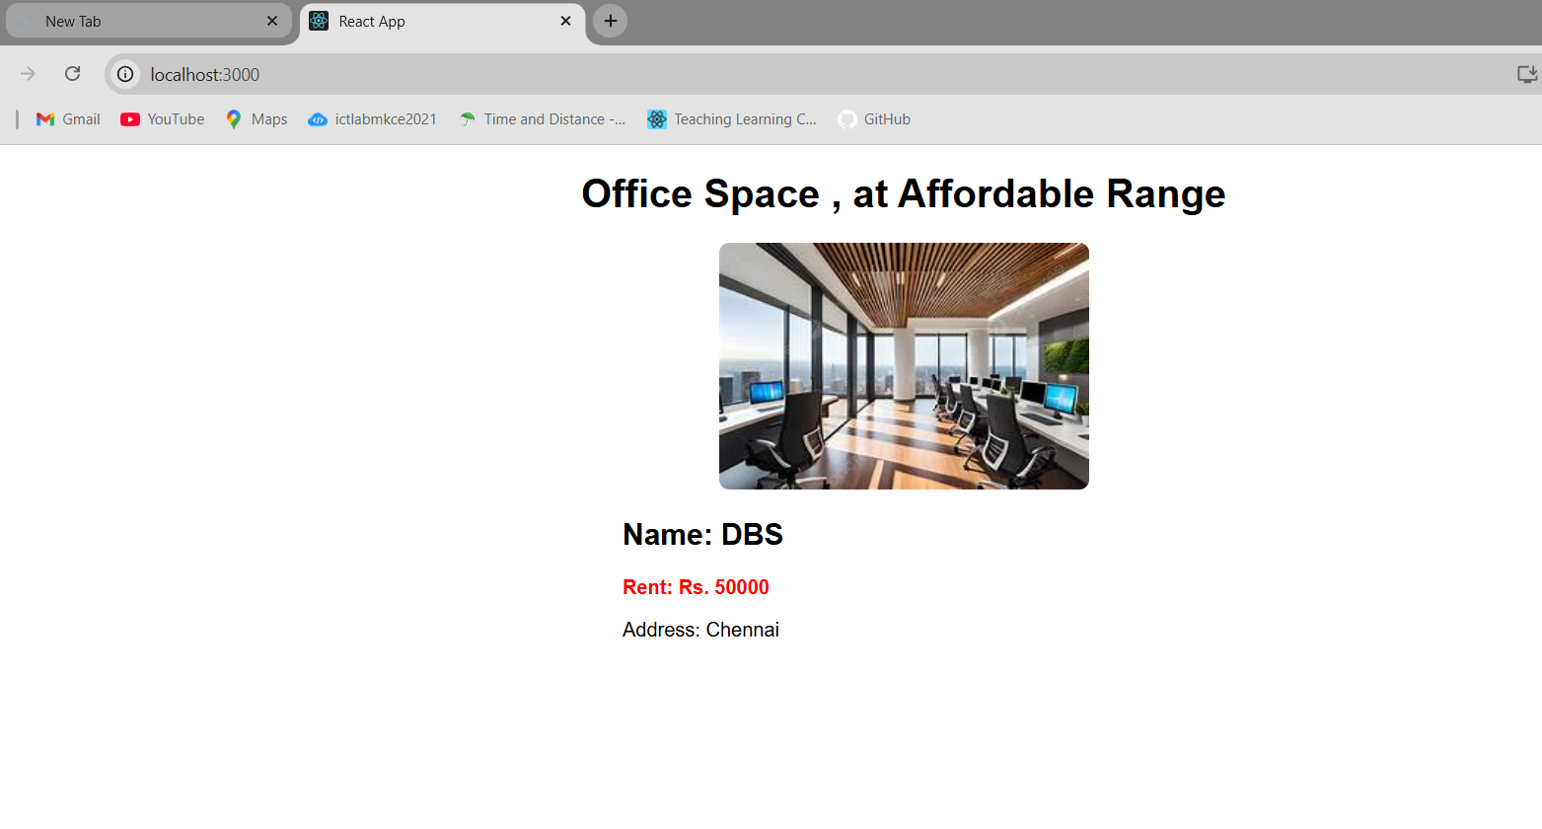

11)App.js  
import React, { useState } from "react";

import CurrencyConvertor from "./CurrencyConvertor";

function App() {

const [count, setCount] = useState(1);

// Handle Increment - Calls two functions

const handleIncrement = () => {

increment();

sayHello();

};

const increment = () => {

setCount(count + 1);

};

const sayHello = () => {

console.log("Hello from Increment function!");

};

const handleDecrement = () => {

setCount(count - 1);

};

// Welcome Message

const sayWelcome = (msg) => {

alert(msg);

};

// Synthetic Event

const handleSyntheticClick = () => {

alert("I was clicked");

};

return (

<div style={{ fontFamily: "Arial" }}>

<h1>{count}</h1>

<button onClick={handleIncrement}>Increment</button>

<br></br>

<br />

<button onClick={handleDecrement}>Decrement</button>

<br></br>

<br />

<button onClick={() => sayWelcome("Welcome")}>Say welcome</button>

<br></br>

<br />

<button onClick={handleSyntheticClick}>click me</button>

<hr />

<CurrencyConvertor />

</div>

);

}

export default App;  
App.css  
.App {

text-align: center;

}

.App-logo {

height: 40vmin;

pointer-events: none;

}

@media (prefers-reduced-motion: no-preference) {

.App-logo {

animation: App-logo-spin infinite 20s linear;

}

}

.App-header {

background-color: #282c34;

min-height: 100vh;

display: flex;

flex-direction: column;

align-items: center;

justify-content: center;

font-size: calc(10px + 2vmin);

color: white;

}

.App-link {

color: #61dafb;

}

@keyframes App-logo-spin {

from {

transform: rotate(0deg);

}

to {

transform: rotate(360deg);

}

}  
**CurrencyConvertor.js**import React, { useState } from "react";

function CurrencyConvertor() {

const [amount, setAmount] = useState("");

const [currency, setCurrency] = useState("Euro");

const handleSubmit = () => {

if (currency === "Euro") {

// Your example assumes 1 Euro = 80 INR, so conversion is: INR * 80

const converted = amount * 80;

alert(`Converting to ${currency} Amount is ${converted}`);

}

};

return (

<div style={{ textAlign: "left", marginLeft: "40px", fontFamily: "Arial" }}>

<h2 style={{ color: "green", fontWeight: "bold" }}>

Currency Convertor!!!

</h2>

<p>

<label>Amount: </label>

<input

type="number"

value={amount}

onChange={(e) => setAmount(e.target.value)}

/>

</p>

<p>

<label>Currency: </label>

<select value={currency} onChange={(e) => setCurrency(e.target.value)}>

<option value="Euro">Euro</option>

</select>

</p>

<button onClick={handleSubmit}>Submit</button>

</div>

);

}

export default CurrencyConvertor;  
**OUTPUT:**

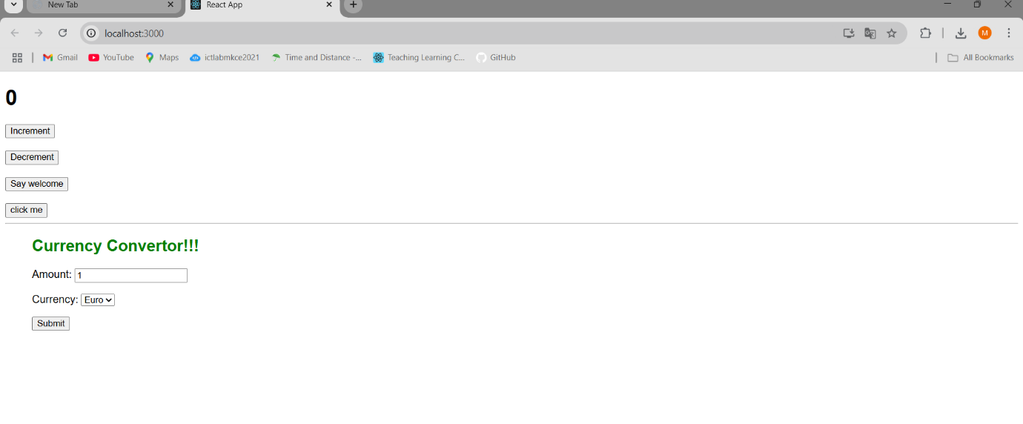

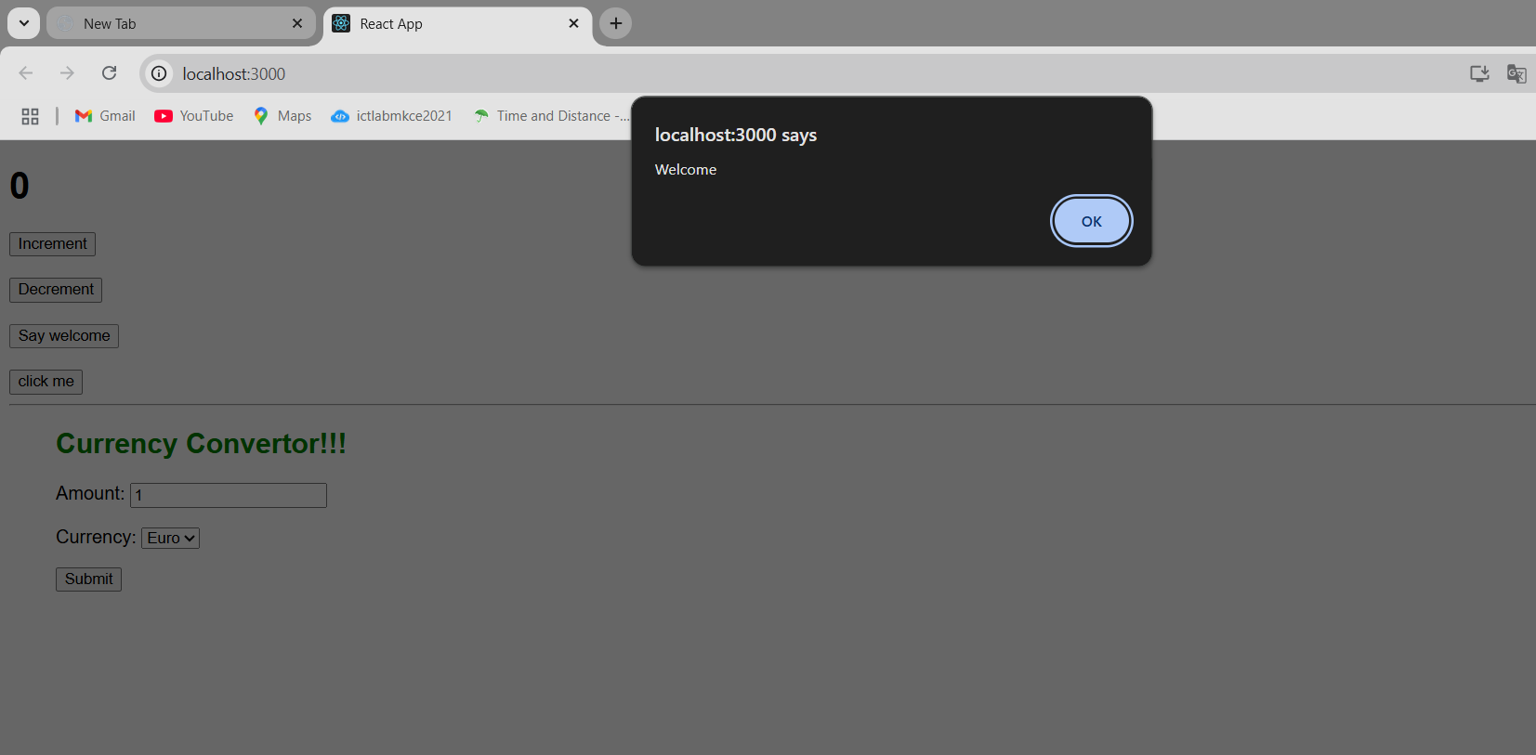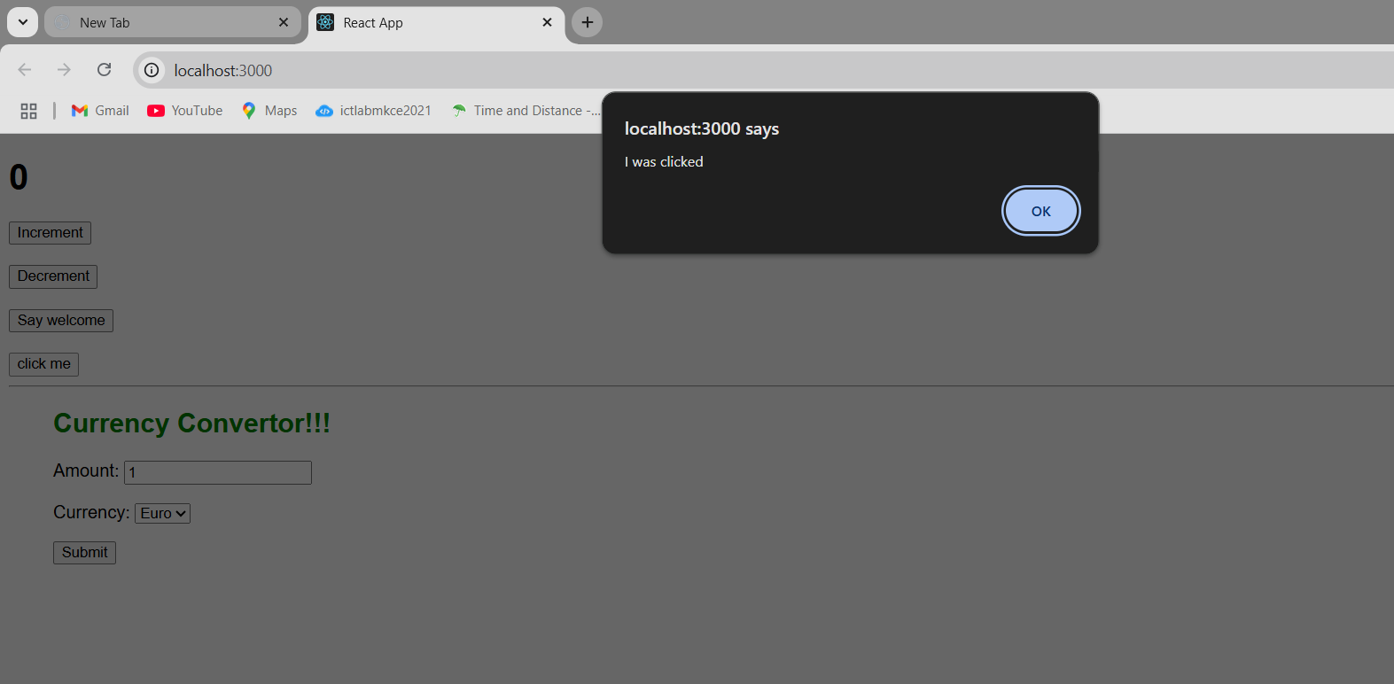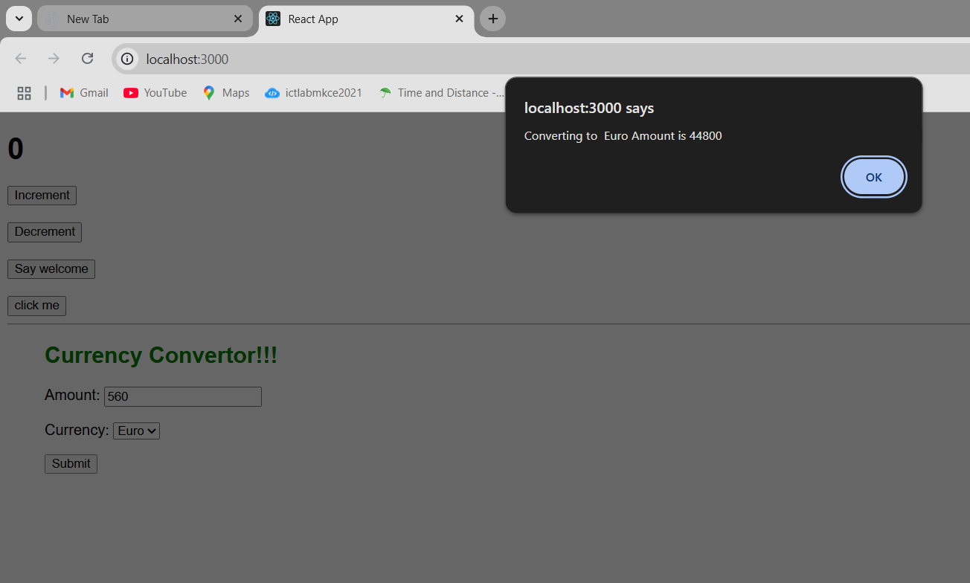

12)**App.js**  
import React, { useState } from "react";

import GuestPage from "./components/GuestPage";

import UserPage from "./components/UserPage";

function App() {

const [isLoggedIn, setIsLoggedIn] = useState(false);

const handleLogin = () => setIsLoggedIn(true);

const handleLogout = () => setIsLoggedIn(false);

return (

<div style={{ padding: "20px" }}>

<h1>Ticket Booking App</h1>

{isLoggedIn ? (

<>

<button onClick={handleLogout}>Logout</button>

<UserPage />

</>

) : (

<>

<button onClick={handleLogin}>Login</button>

<GuestPage />

</>

)}

</div>

);

}

export default App;

**App.css**  
.App {

text-align: center;

}

.App-logo {

height: 40vmin;

pointer-events: none;

}

@media (prefers-reduced-motion: no-preference) {

.App-logo {

animation: App-logo-spin infinite 20s linear;

}

}

.App-header {

background-color: #282c34;

min-height: 100vh;

display: flex;

flex-direction: column;

align-items: center;

justify-content: center;

font-size: calc(10px + 2vmin);

color: white;

}

.App-link {

color: #61dafb;

}

@keyframes App-logo-spin {

from {

transform: rotate(0deg);

}

to {

transform: rotate(360deg);

}

}

**components**

**FlightCard.js**import React from "react";

const FlightCard = ({ flight }) => (

<div style={{ border: "1px solid #ccc", padding: "10px", margin: "10px" }}>

<h3>{flight.name}</h3>

<p>

From: {flight.from} → To: {flight.to}

</p>

<p>Price: ₹{flight.price}</p>

</div>

);

export default FlightCard;  
**GuestPage.js**import React from "react";

import FlightCard from "./FlightCard";

const flights = [

{ name: "IndiGo 202", from: "Chennai", to: "Bangalore", price: 3200 },

{ name: "Air India 101", from: "Delhi", to: "Mumbai", price: 4500 },

];

const GuestPage = () => (

<div>

<h2>Welcome Guest!</h2>

<p>Browse flights below. Please login to book tickets.</p>

{flights.map((flight, index) => (

<FlightCard key={index} flight={flight} />

))}

</div>

);

export default GuestPage;  
**UserPage.js**import React from "react";

import FlightCard from "./FlightCard";

const flights = [

{ name: "IndiGo 202", from: "Chennai", to: "Bangalore", price: 3200 },

{ name: "Air India 101", from: "Delhi", to: "Mumbai", price: 4500 },

];

const UserPage = () => (

<div>

<h2>Welcome Back, User!</h2>

{flights.map((flight, index) => (

<div key={index}>

<FlightCard flight={flight} />

<button>Book Ticket</button>

</div>

))}

</div>

);

export default UserPage;

**OUTPUT:**

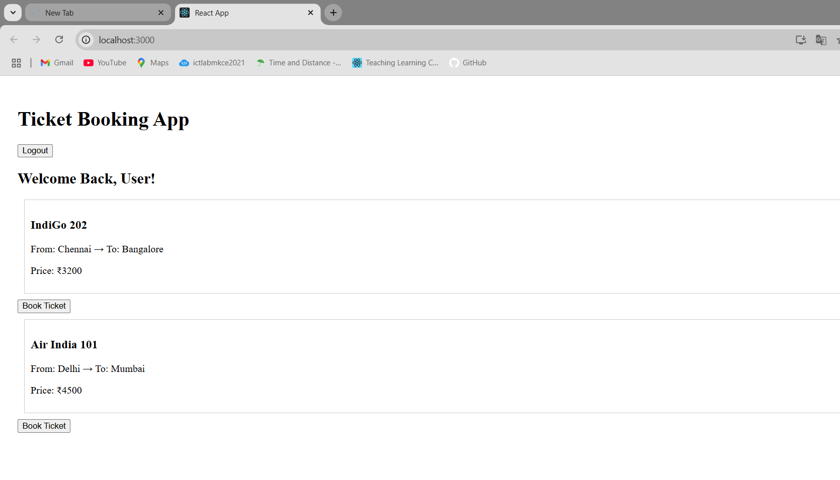

13)  
**App.js**  
import React from "react";

import { books } from "./data/books";

import { blogs } from "./data/blogs";

import { courses } from "./data/courses";

import "./App.css";

function App() {

const bookdet = books.map((book) => (

<div key={book.id}>

<strong>{book.bname}</strong>

<p>{book.price}</p>

</div>

));

const content = blogs.map((blog) => (

<div key={blog.id}>

<strong>{blog.title}</strong>

<p>

<em>{blog.author}</em>

</p>

<p>{blog.body}</p>

</div>

));

const coursedet = courses.map((course) => (

<div key={course.id}>

<strong>{course.cname}</strong>

<p>{course.date}</p>

</div>

));

return (

<div>

<div style={{ display: "flex", justifyContent: "space-around" }}>

<div className="st2">

<h1>Book Details</h1>

{bookdet}

</div>

<div className="v1">

<h1>Blog Details</h1>

{content}

</div>

<div className="mystyle1">

<h1>Course Details</h1>

{coursedet}

</div>

</div>

</div>

);

}

export default App;  
**App.css**  
.st2,

.v1,

.mystyle1 {

border-left: 5px solid green;

padding: 10px;

min-width: 200px;

}  
**data**  
**blogs.js**export const blogs = [

{

id: 1,

title: "React Learning",

author: "Stephen Biz",

body: "Welcome to learning React!",

},

{

id: 2,

title: "Installation",

author: "Schwezdneier",

body: "You can install React from npm.",

},

];  
**books.js**export const books = [

{ id: 101, bname: "Master React", price: 670 },

{ id: 102, bname: "Deep Dive into Angular 11", price: 800 },

{ id: 103, bname: "Mongo Essentials", price: 450 },

];  
**courses.js**export const courses = [

{ id: 1, cname: "Angular", date: "4/5/2021" },

{ id: 2, cname: "React", date: "6/3/20201" },

];

**Output:  
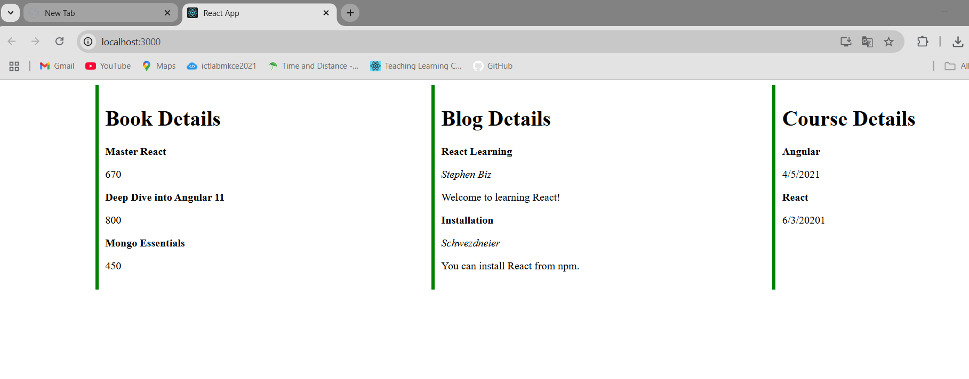**

**14)App.js**

import "./App.css";

import { EmployeesData } from "./Employee";

import EmployeesList from "./EmployeesList";

import { useState } from "react";

import ThemeContext from "./ThemeContext";

function App() {

const [theme, setTheme] = useState("light");

const Employees = EmployeesData;

return (

<ThemeContext.Provider value={theme}>

{" "}

{/* wrap in context */}

<div>

<label>SELECT A THEME </label>

<select onChange={(e) => setTheme(e.target.value)}>

<option value="light">Light</option>

<option value="dark">Dark</option>

</select>

</div>

<EmployeesList employees={Employees} /> {/* no more theme prop */}

</ThemeContext.Provider>

);

}

export default App;

**App.css**a {

display: inline-block;

margin: 3px 5px;

padding: 5px 5px;

border-radius: 3px;

text-decoration: none;

}

a.dark {

background-color: #333;

color: #eee;

}

a.light {

background-color: #eee;

color: #333;

}

.light {

background-color: white;

color: black;

padding: 5px;

text-decoration: none;

margin-right: 10px;

}

.dark {

background-color: black;

color: white;

padding: 5px;

text-decoration: none;

margin-right: 10px;

}

**Employee.js**class Employee {

constructor(id, name, email, phone){

this.id=id;

this.name=name;

this.email=email;

this.phone=phone;

}

}

const EmployeesData=[

new Employee(101,'Jojo','jojo@congizant.com','98238971234'),

new Employee(102,'Sam','sam@congizant.com', '9981184126'),

new Employee(103,'Elisa','elisa@cognizant.com','9989389735')

];

export default Employee;

export {EmployeesData};

**EmployeeCard.js**import { useContext } from "react";

import ThemeContext from "./ThemeContext"; // ✅ import

import Styles from "./EmployeeCard.module.css";

function EmployeeCard(props) {

const theme = useContext(ThemeContext); // ✅ get current theme

return (

<div className={Styles.Card}>

<h3>{props.employee.name}</h3>

<p>{props.employee.email}</p>

<p>{props.employee.phone}</p>

<p>

<button className={theme}>Edit</button>

<button className={theme}>Delete</button>

</p>

</div>

);

}

export default EmployeeCard;  
**EmployeeCard.module.cs**.Card{

display: inline-block;

width: 25%;

border:1px solid #999;

border-radius: 5px;

margin:10px;

padding:10px;

}  
**EmployeesList.js**import EmployeeCard from "./EmployeeCard";

function EmployeesList(props) {

return (

<div>

<h1>Employees List</h1>

{props.employees.map((employee) => (

<EmployeeCard employee={employee} key={employee.id} />

))}

</div>

);

}

export default EmployeesList;  
**ThemeContext.js**import React from "react";

const ThemeContext = React.createContext("light");

export default ThemeContext;

**OUTPUT:**

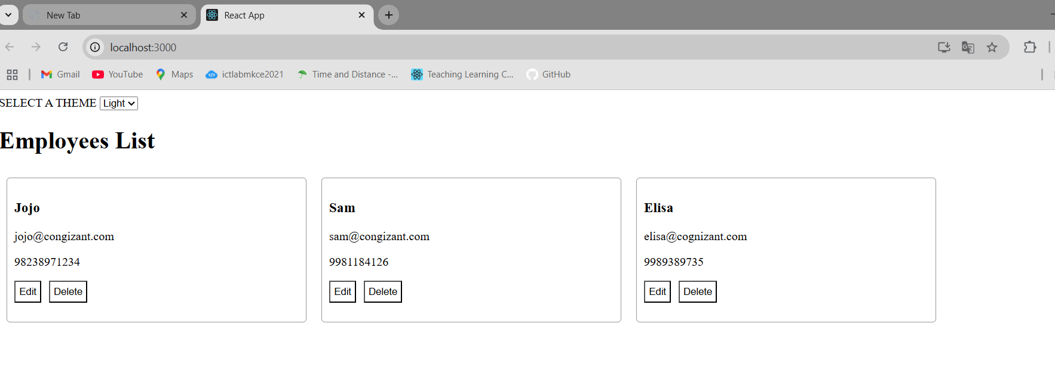

**15)App.js**import React from "react";

import ComplaintRegister from "./ComplaintRegister";

function App() {

return (

<div className="App">

<ComplaintRegister />

</div>

);

}

export default App;  
**App.css**.App {

text-align: center;

}

.App-logo {

height: 40vmin;

pointer-events: none;

}

@media (prefers-reduced-motion: no-preference) {

.App-logo {

animation: App-logo-spin infinite 20s linear;

}

}

.App-header {

background-color: #282c34;

min-height: 100vh;

display: flex;

flex-direction: column;

align-items: center;

justify-content: center;

font-size: calc(10px + 2vmin);

color: white;

}

.App-link {

color: #61dafb;

}

@keyframes App-logo-spin {

from {

transform: rotate(0deg);

}

to {

transform: rotate(360deg);

}

}

**ComplaintRegister.js**

import React, { useState } from "react";

const ComplaintRegister = () => {

const [name, setName] = useState("");

const [complaint, setComplaint] = useState("");

const handleSubmit = (e) => {

e.preventDefault();

if (!name || !complaint) {

alert("Please fill out both fields.");

return;

}

const referenceNumber = "REF" + Math.floor(Math.random() * 1000000);

alert(

`Complaint registered successfully!\nEmployee: ${name}\nReference No: ${referenceNumber}`

);

// Reset form

setName("");

setComplaint("");

};

return (

<div style={styles.container}>

<h2 style={{ color: "red" }}>Register your Complaints here!!!</h2>

<form onSubmit={handleSubmit} style={styles.form}>

<label>Name:</label>

<input

type="text"

value={name}

onChange={(e) => setName(e.target.value)}

placeholder="Enter your name"

required

/>

<label>Complaint:</label>

<textarea

value={complaint}

onChange={(e) => setComplaint(e.target.value)}

placeholder="Describe your complaint"

required

></textarea>

<button type="submit">Submit</button>

</form>

</div>

);

};

const styles = {

container: {

width: "400px",

margin: "50px auto",

padding: "20px",

},

form: {

display: "flex",

flexDirection: "column",

gap: "10px",

},

};

export default ComplaintRegister;

**OUTPUT:  
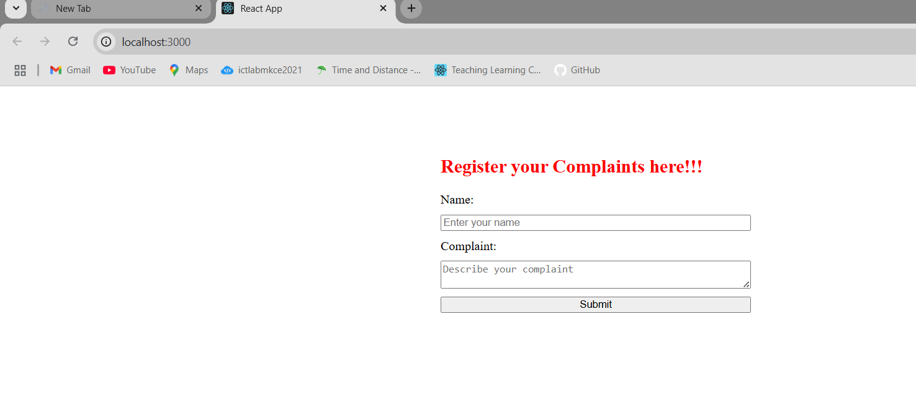**

**16)App.js**import React from "react";

import Register from "./Register";

function App() {

return (

<div className="App">

<Register />

</div>

);

}

export default App;  
**App.css**.App {

text-align: center;

}

.App-logo {

height: 40vmin;

pointer-events: none;

}

@media (prefers-reduced-motion: no-preference) {

.App-logo {

animation: App-logo-spin infinite 20s linear;

}

}

.App-header {

background-color: #282c34;

min-height: 100vh;

display: flex;

flex-direction: column;

align-items: center;

justify-content: center;

font-size: calc(10px + 2vmin);

color: white;

}

.App-link {

color: #61dafb;

}

@keyframes App-logo-spin {

from {

transform: rotate(0deg);

}

to {

transform: rotate(360deg);

}

}

**Register.js**import React, { useState } from "react";

const Register = () => {

const [formData, setFormData] = useState({

name: "",

email: "",

password: "",

});

const [errors, setErrors] = useState({});

const validate = () => {

const newErrors = {};

if (formData.name.length < 5) {

newErrors.name = "Name must be at least 5 characters";

}

if (!formData.email.includes("@") || !formData.email.includes(".")) {

newErrors.email = "Email must contain @ and .";

}

if (formData.password.length < 8) {

newErrors.password = "Password must be at least 8 characters";

}

setErrors(newErrors);

// If no errors, return true

return Object.keys(newErrors).length === 0;

};

const handleChange = (e) => {

setFormData({

...formData,

[e.target.name]: e.target.value,

});

};

const handleSubmit = (e) => {

e.preventDefault();

if (validate()) {

alert("Registration successful!");

setFormData({ name: "", email: "", password: "" });

setErrors({});

}

};

return (

<div style={styles.container}>

<h2 style={{ color: "red" }}>Register Form!!!</h2>

<form onSubmit={handleSubmit} style={styles.form}>

<label>Name:</label>

<input

type="text"

name="name"

value={formData.name}

onChange={handleChange}

placeholder="Enter your name"

/>

{errors.name && <span style={styles.error}>{errors.name}</span>}

<label>Email:</label>

<input

type="email"

name="email"

value={formData.email}

onChange={handleChange}

placeholder="Enter your email"

/>

{errors.email && <span style={styles.error}>{errors.email}</span>}

<label>Password:</label>

<input

type="password"

name="password"

value={formData.password}

onChange={handleChange}

placeholder="Enter your password"

/>

{errors.password && <span style={styles.error}>{errors.password}</span>}

<button type="submit">Submit</button>

</form>

</div>

);

};

const styles = {

container: {

width: "400px",

margin: "50px auto",

padding: "20px",

},

form: {

display: "flex",

flexDirection: "column",

gap: "10px",

},

error: {

color: "red",

fontSize: "14px",

},

};

export default Register;

**OUTPUT:**

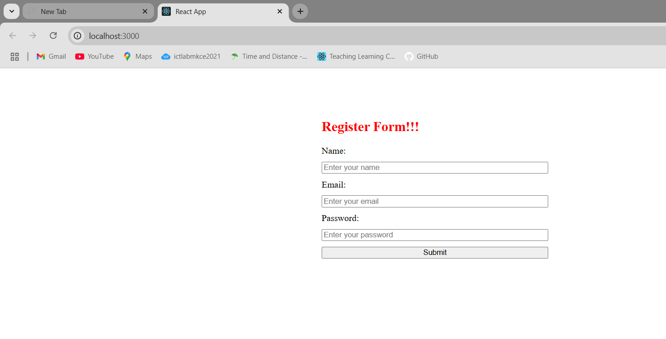

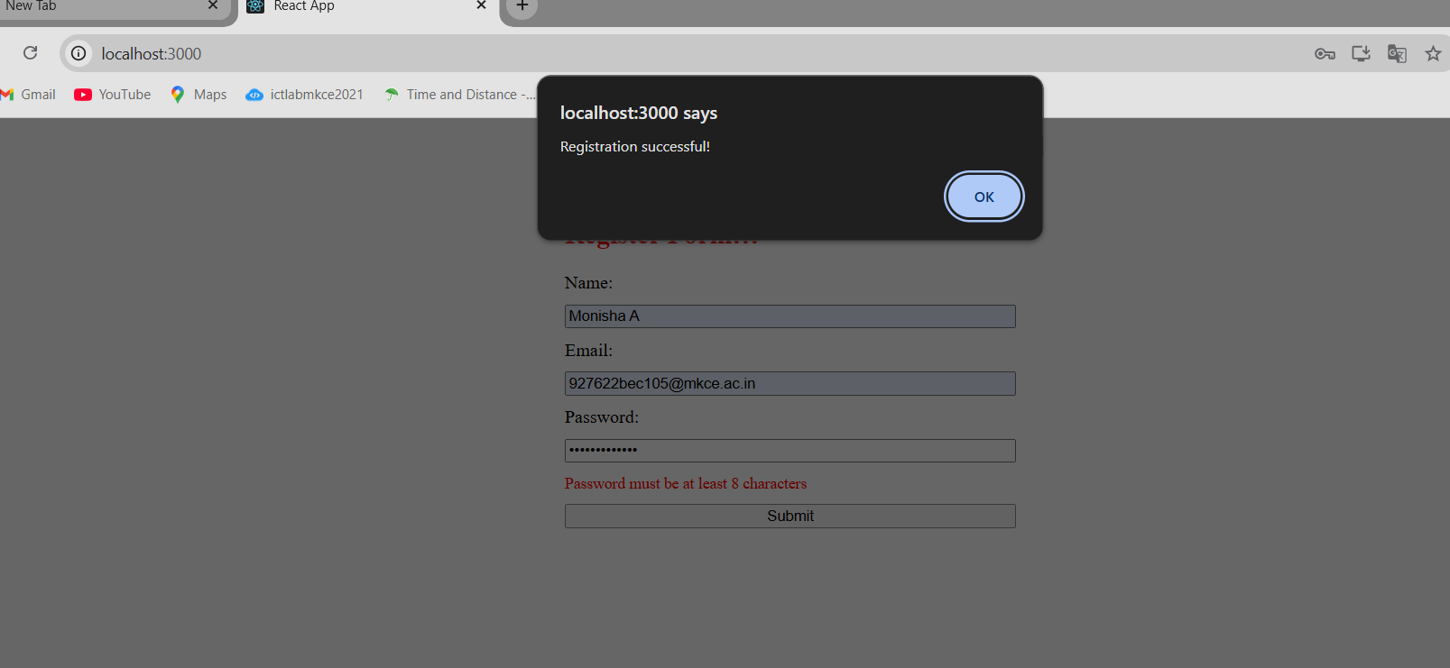

**17)App.js**import React from "react";

import Getuser from "./Getuser";

function App() {

return (

<div className="App">

<Getuser />

</div>

);

}

export default App;

**App.css**.App {

text-align: center;

}

.App-logo {

height: 40vmin;

pointer-events: none;

}

@media (prefers-reduced-motion: no-preference) {

.App-logo {

animation: App-logo-spin infinite 20s linear;

}

}

.App-header {

background-color: #282c34;

min-height: 100vh;

display: flex;

flex-direction: column;

align-items: center;

justify-content: center;

font-size: calc(10px + 2vmin);

color: white;

}

.App-link {

color: #61dafb;

}

@keyframes App-logo-spin {

from {

transform: rotate(0deg);

}

to {

transform: rotate(360deg);

}

**}**

**Getuser.js**

import React, { Component } from "react";

class Getuser extends Component {

constructor(props) {

super(props);

this.state = {

person: {},

loading: true,

};

}

async componentDidMount() {

const url = "https://api.randomuser.me/";

const response = await fetch(url);

const data = await response.json();

this.setState({ person: data.results[0], loading: false });

console.log(data.results[0]);

}

render() {

const { person, loading } = this.state;

if (loading) {

return <h2>Loading...</h2>;

}

return (

<div style={{ padding: "20px" }}>

<h1>

Mr {person.name.first} {person.name.last}

</h1>

<img src={person.picture.medium} alt="User" />

</div>

);

}

}

export default Getuser;

**OUTPUT:  
