Experiment -2
Name: Harshavarthini A Roll No: 240701181

Problem Statement :
Design a UI where users recall visual elements (e.g., icons or text chunks). Evaluate the effect of chunking on user memory.

Frame 1: Instruction Screen – Memory Recall Task
Overview
The Instruction Screen is the first interface presented to the user in the experiment. It introduces the memory recall task and provides clear guidance on how the user should proceed. The design is kept simple and focused to ensure easy understanding without distractions.
Purpose of the Frame
- To introduce the experiment
- To explain the task clearly
- To inform users about the time constraint
- To ensure all users start with the same understanding

UI Elements and Features
1. Title (Memory Recall Task)
- Placed prominently at the top/center
- Bold and clearly visible
- Indicates the purpose of the task
2. Instructional Text
- Explains that users will view and recall visual elements
- Mentions limited viewing time
- Uses simple and concise language
- Center-aligned for readability
3. Time Constraint Information
- Clearly mentioned within the instructions
- Prepares users for a short-term memory task
4. Call-to-Action Button (Start)
- Positioned at the bottom center
- Clearly labeled and easy to identify
- Uses contrast to stand out
5. Layout and Alignment
- Centrally aligned elements
- Proper spacing between sections
- Clean and balanced structure
6. Color Scheme
- Minimal and consistent colors
- Good contrast between text and background
- Button color stands out
7. Typography
- Clear and readable font
- Larger title, smaller body text
- Maintains visual hierarchy
8. Minimal Design
- No unnecessary elements
- Focus only on instructions
- Reduces cognitive load
User Interaction Flow
- User reads instructions
- Understands the task
- Clicks “Start” to proceed
Conclusion:
This frame ensures that users clearly understand the experiment before beginning. It’s simple and structured design improves usability and prepares users effectively for the memory recall task.

Frame 2: Memorization Screen – Visual Exposure
Overview
The Memorization Screen is the core part of the experiment where users are exposed to visual elements that they must remember. This frame is designed to test short-term memory by presenting icons for a limited duration, with a focus on evaluating the effect of chunking.
Purpose of the Frame
- To display visual elements for memorization
- To apply chunking through grouping of icons
- To test how users encode information into memory
- To create time-based memory pressure
UI Elements and Features
1. Visual Elements (Icons)
- A set of icons is displayed at the center
- Icons are simple, recognizable, and distinct
- Limited number of elements to avoid overload
2. Chunking (Grouping of Icons)
- Icons are arranged in small groups (clusters)
- Each group forms a meaningful visual unit
- Some spacing is used to separate different groups
3. Timer / Time Indicator
- Displays limited viewing duration (e.g., 5 seconds)
- Can be shown as text or progress bar
- Creates urgency and simulates short-term memory conditions
4. Layout and Spacing
- Icons are evenly spaced and well aligned
- Groups are visually separated using gaps
- Balanced layout avoids clutter
5. Color Usage
- Icons may use consistent or subtle colors
- Background remains simple to maintain focus
- No excessive or distracting color usage
6. Minimal Distraction Design
- No unnecessary text or buttons
- Focus entirely on memorization task
- Clean interface to reduce cognitive load
Design Reasoning (Chunking Effect)
- Grouping icons helps users process multiple elements as a single unit
- Reduces the number of items the brain needs to remember individually
- Improves recall efficiency compared to random placement
User Interaction Flow
- User views the icons for a limited time
- Mentally processes and memorizes the elements
- Observes grouped (chunked) vs ungrouped arrangement
- Automatically transitions to the recall frame after time ends
Usability Considerations
- Easy to visually scan
- Avoids overload by limiting number of icons
- Clear grouping improves comprehension
- Time constraint ensures realistic memory testing
Conclusion
This frame plays a crucial role in evaluating memory performance. By presenting icons in grouped formats, it demonstrates how chunking can improve information processing and retention in short-term memory.

Frame 3: Recall Screen – Memory Evaluation
Overview
The Recall Screen is designed to evaluate the user’s ability to remember the visual elements presented in the previous frame. It tests how effectively the user has retained information, particularly focusing on the impact of chunked versus unchunked elements.

Purpose of the Frame
- To assess the user’s memory recall
- To measure accuracy of remembered elements
- To compare recognition of grouped and ungrouped icons
- To ensure active participation in the recall process

UI Elements and Features
1. Icon Selection Area
- Displays a set of icons for selection
- Includes both previously shown icons and new distractor icons
- Icons are arranged clearly in a grid format

2. Selection Mechanism
- Users can select icons using checkboxes or clickable options
- Multiple selections are allowed
- Selected icons are visually highlighted

3. Distractor Elements
- Additional icons not shown in the memorization frame
- Increase the difficulty of the task
- Prevent random guessing and improve accuracy of results

4. Call-to-Action Button (Submit)
- Positioned clearly below the selection area
- Labeled as “Submit”
- Allows users to confirm their choices

5. Layout and Alignment
- Icons are evenly spaced and well aligned
- Clear separation between rows and columns
- Organized structure improves usability

6. Color and Visual Feedback
- Selected icons are highlighted using contrast or borders
- Background remains simple and non-distracting
- Visual cues help users track their selections

Design Reasoning
- Providing both correct and distractor icons ensures genuine recall
- Structured layout supports easy scanning and selection
- Highlighting selections reduces user errors

User Interaction Flow
- User views the set of icons
- Identifies and selects the icons they remember
- Reviews their selections
- Clicks “Submit” to proceed

Usability Considerations
- Simple and intuitive interaction
- Clear visual feedback on selection
- Avoids confusion through organized layout
- Supports accurate and efficient recall

Conclusion
This frame effectively measures the user’s memory performance by requiring active recall. The inclusion of distractor elements and a structured selection system ensures reliable evaluation of how chunking influences memory retention.

Frame 4: Result Screen – Performance Feedback

Overview
The Result Screen is the final stage of the experiment, where the user is provided with feedback based on their recall performance. This frame summarizes the outcome and reflects how effectively the user remembered the visual elements.
Purpose of the Frame
- To display the user’s recall performance
- To provide clear and immediate feedback
- To conclude the experiment
- To reinforce user engagement
UI Elements and Features
1. Result Display Message
- Shows the number of correctly recalled items (e.g., “You recalled 4/5 items correctly”)
- Presented in a clear and prominent manner
- Easy to understand at a glance
2. Feedback Text
- Provides a simple response such as “Good job” or similar message
- Encourages user engagement
- Adds a positive user experience
3. Visual Emphasis
- Result text is highlighted using size or contrast
- Key information stands out from the rest of the screen
- Ensures immediate visibility of performance
4. Layout and Alignment
- Centrally aligned content
- Proper spacing between result and feedback text
- Clean and balanced design
5. Color Usage
- Uses simple and consistent colors
- May use positive colors (e.g., green tones) for success indication
- Avoids excessive or distracting visuals
6. Minimal Design
- No unnecessary elements included
- Focus only on performance outcome
- Keeps interface simple and clear
Design Reasoning
- Clear feedback helps users understand their performance instantly
- Highlighting results ensures important information is not missed
- Minimal design maintains focus on the outcome
User Interaction Flow
- User views their result
- Understands performance level
- Completes the experiment
Usability Considerations
- Easy to interpret results
- No confusion in understanding performance
- Provides closure to the task
Conclusion
This frame effectively concludes the experiment by presenting clear and concise feedback. It reinforces the results of the memory recall task and highlights the impact of chunking on user performance in a simple and user-friendly manner.

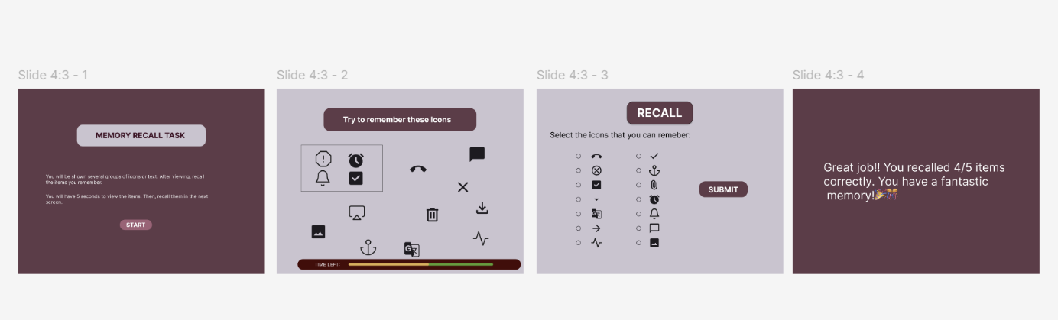

PROTOTYPE LINK:
https://www.figma.com/proto/QSc8R7bjH0uqdHlyv6wlG2/Untitled?t=pgIL52zZY26ZdwFf-1

