Key Value System over HTTP

Name : Harshay Bairagi
Roll no : 25m0792

Phase 1 Submission

Project Overview
This project implements a minimal HTTP-based Key–Value (KV) system in C++ using library cpp httplib for the web layer. Now we just focuses on a working server exposing simple endpoints to set, get, and delete keys. For the final system architecture, the HTTP server communicates with an in memory cache (for fast access) backed by a persistent MySQL database.

System Architecture

High level architecture for the final design is shown below. The client sends HTTP requests to the C++ server, which interacts with an in memory KV cache and persists data to a MySQL database.

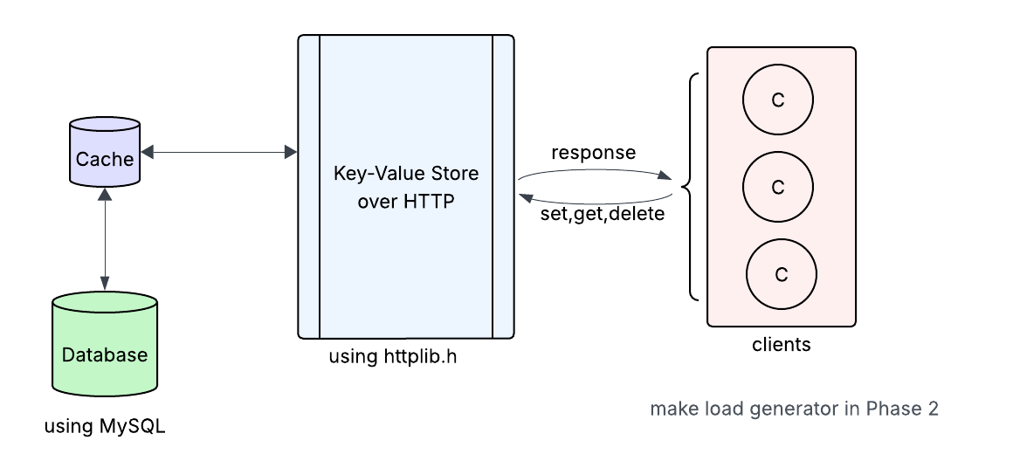

HTTP Endpoints (Phase 1)

Method | Path | Query Parameter | Description
GET | /set | key, value | Insert or update the value for a key.
GET | /get | key | Fetch the value for the given key.
GET | /delete | key | Delete the given key if present.

Implementation Notes
- Language & HTTP: C++ with cpp httplib
- Cache and Main DB : Database used as the in memory KV sftore with MySQL
- Persistence (Phase 1 working): persistence database to retain values across restarts.
- Final Backend: MySQL database for durable storage and future scaling.

Github Repository : https:/ /github.com/harshay922/DECS_PROJECT

Future Plans -

- Replace file persistence with direct MySQL storage using MySQL Connector/C++.
- Implement basic benchmarking multi client load and simple metrics endpoints.(Load Generator)

