CS744 Phase 2 Report — HTTP Key-Value Server
Harhay Bairagi (25m0792)
IIT Bombay — DECS (CS744)

Overview
The goal was to extend the basic HTTP key-value server from Phase 1 into a system that can be load-tested and measured properly. For this phase, I implemented a closed-loop load generator, ran controlled load tests at different concurrency levels, and find throughput and latency. These results helped estimate the server’s capacity and identify bottlenecks under different workloads.

System Architecture
The overall architecture remains simple: the load generator sends HTTP requests to the server, which processes them using a thread pool. Frequently accessed key-value pairs are stored in an in-memory LRU cache, while all data is stored persistently in a MySQL database. This combination gives two clear execution paths: (1) cache hits (fast, CPU-bound), and (2) cache misses or write requests (slower, DB-bound).
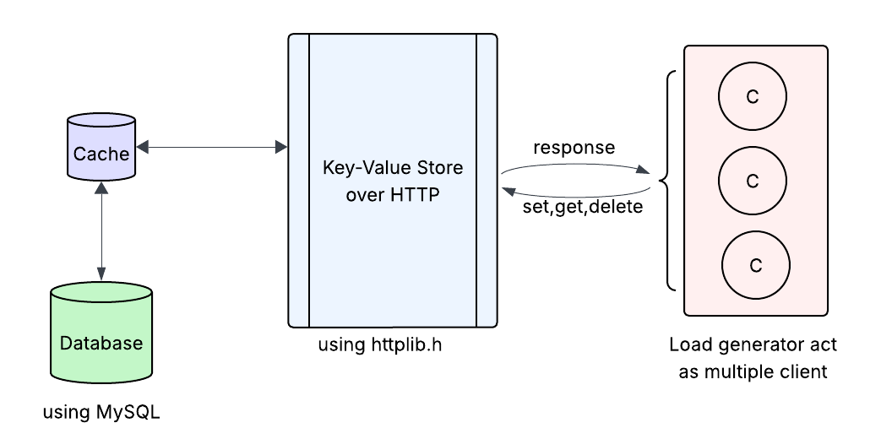

Load Generator
The load generator is written as a multi-threaded closed-loop client. Each thread behaves like one independent user: it sends a request, waits for the response, and immediately sends the next request.
- Workloads: get popular (small hot set), get all (unique keys, forces cache misses), put all (create/delete for every request), get put (mix of reads and writes).
- Metrics collected: throughput (req/s), average latency (ms).
Latency is measured on the client side using timestamps, and throughput is calculated from the total number of successful operations over time.

Load Test Setup
- The server was run with HTTP THREADS=8, which matches the number of local CPU cores.
- The server and load generator were run in separate terminals (or separate machines/CPUs as recommended).

EndPoint and Bottlenecks

PUT-ALL Workload
Every request writes to the MySQL database. Cache updates happen, but the bottleneck becomes the disk I/O of MySQL.

Database as Bottleneck

GET-ALL Workload

Most keys are not in cache → cache miss.
Every request hits the database for a read.

Cache as Bottleneck

GET-POPULAR Workload

First request loads the data from DB → cache fill
After that: 100% cache hits

CPU and memory as Bottleneck

CPU-BOUND Workload

No DB access
No cache access
Pure CPU work

CPU core as Bottleneck

