NAME – HARSH BADHAN

ROLL NO – 102317140

GROUP – 2Q16

**COGNITIVE COMPUTING**

**ASSIGNMENT NO. 11**

Step 1 – Project Creation Page

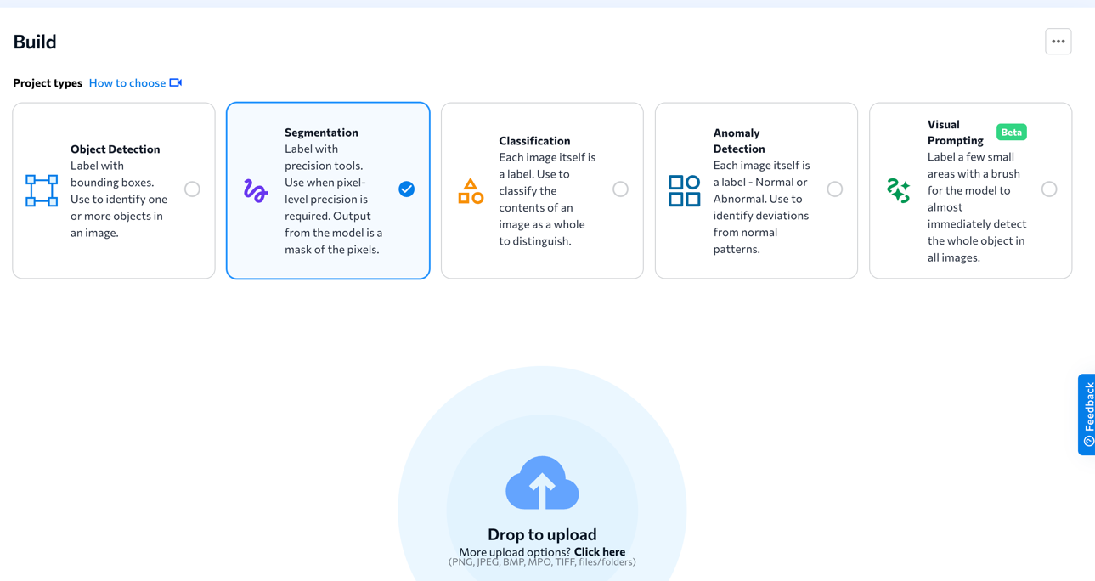

Step 2 - Uploading images

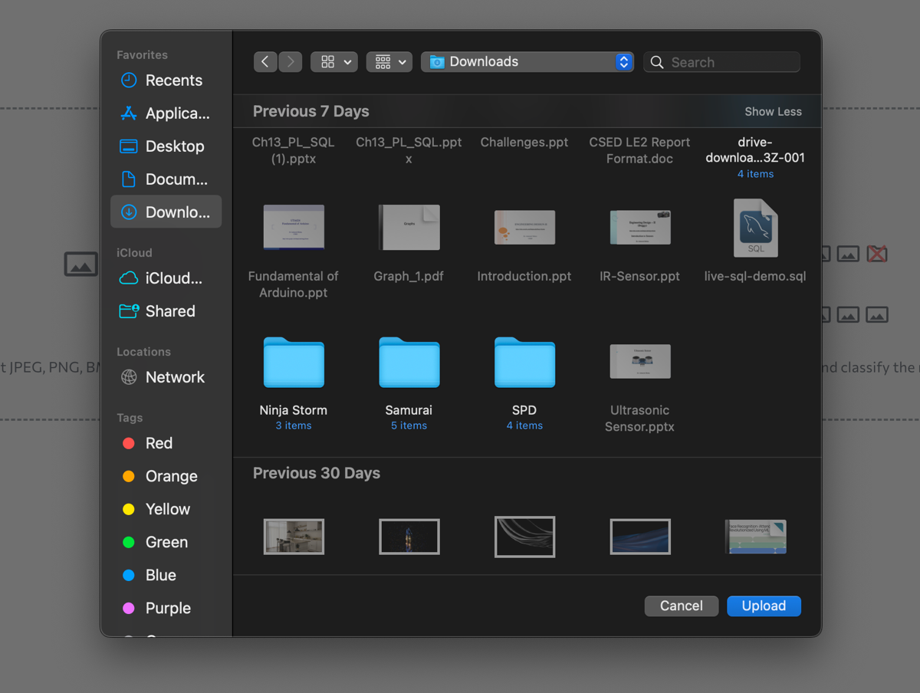

Step 3 – Labelling Classes

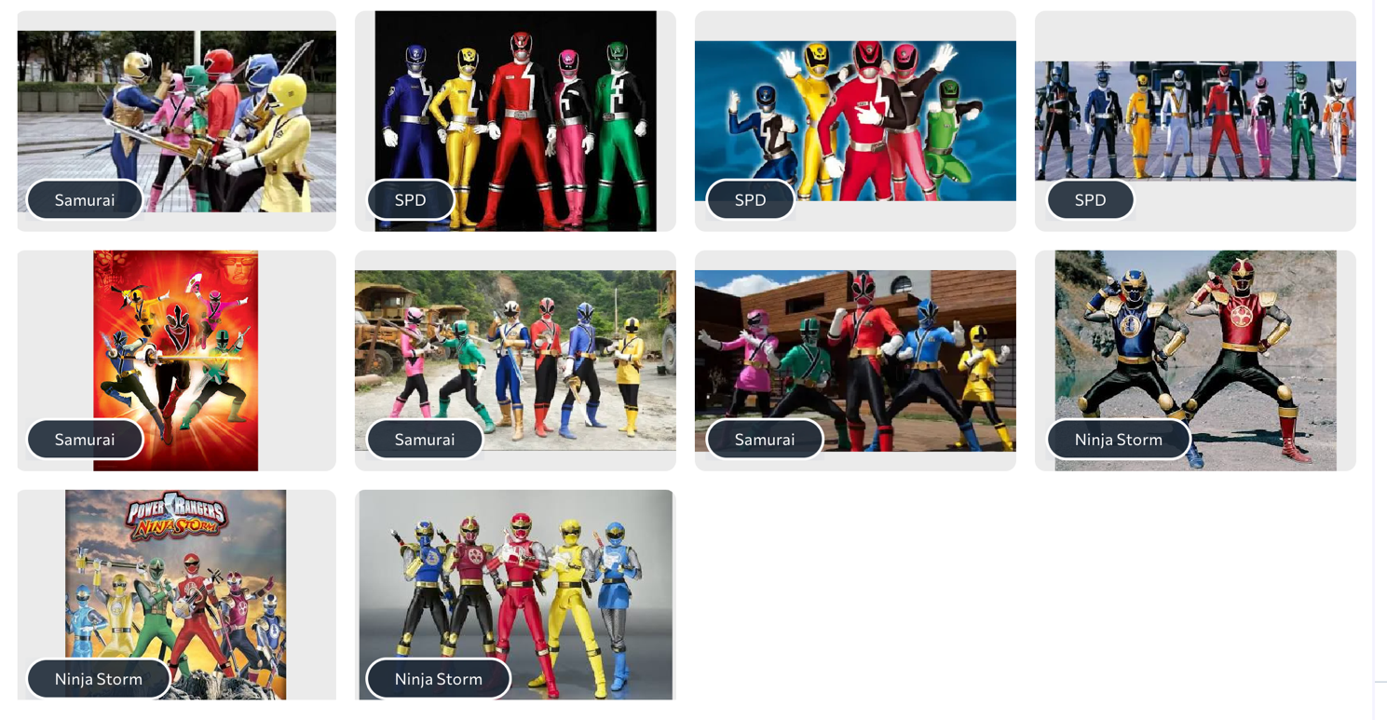

Step 4 – Lables

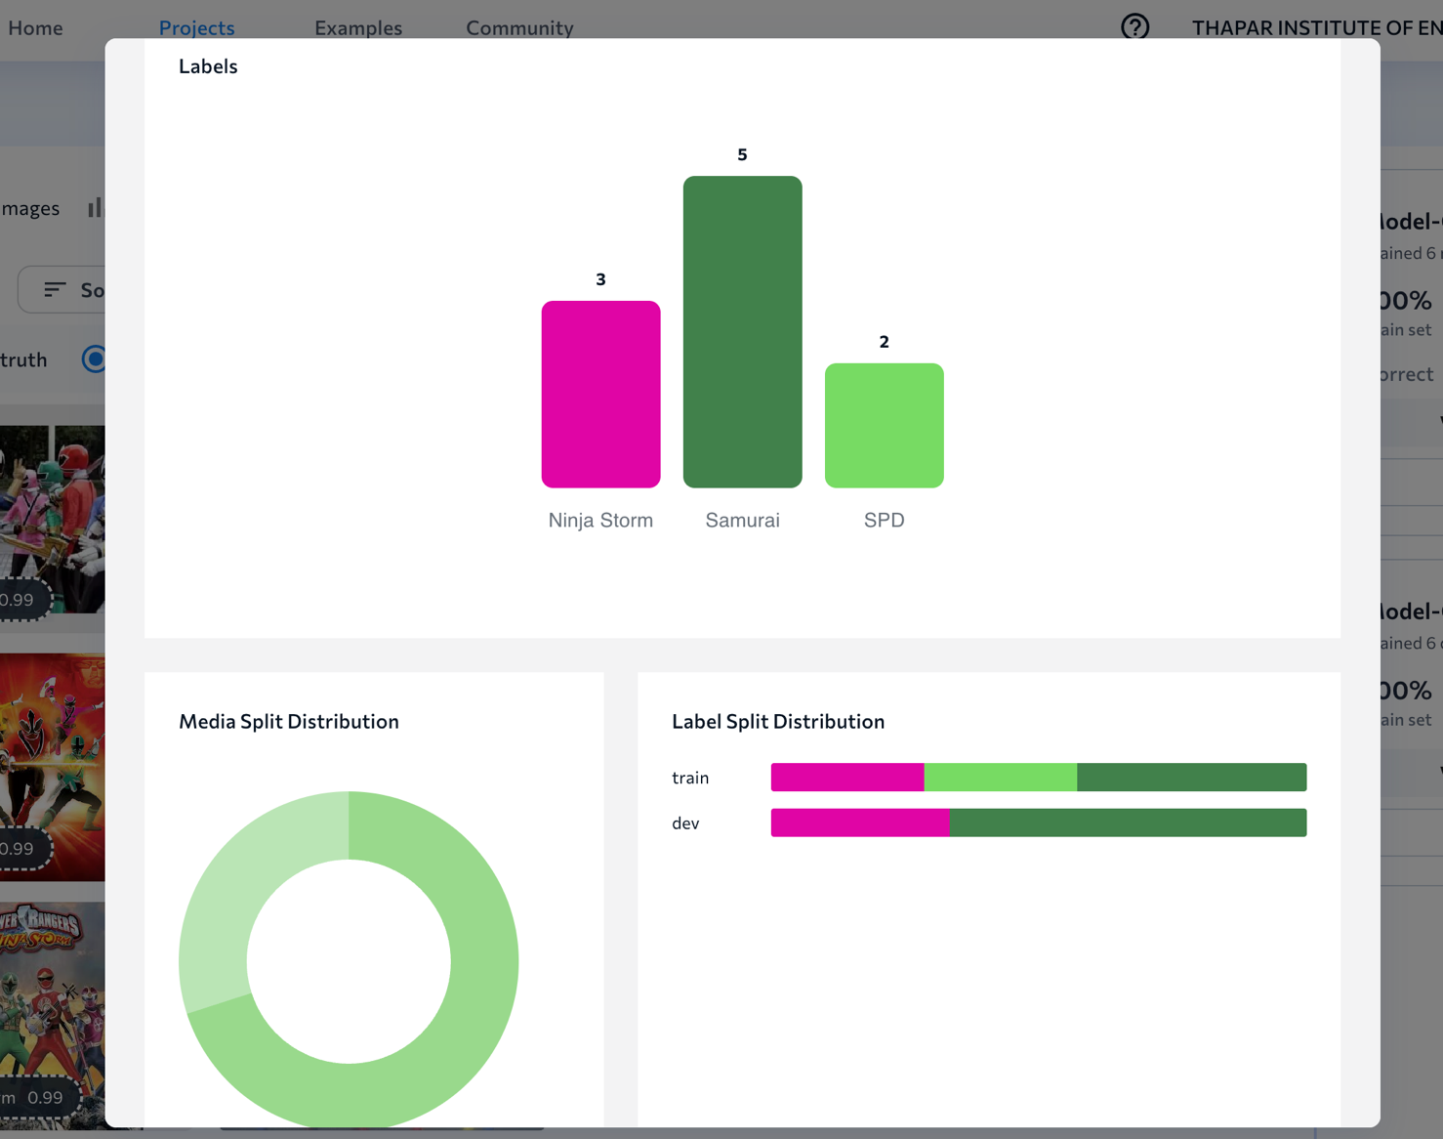

Step 5 – Training Model

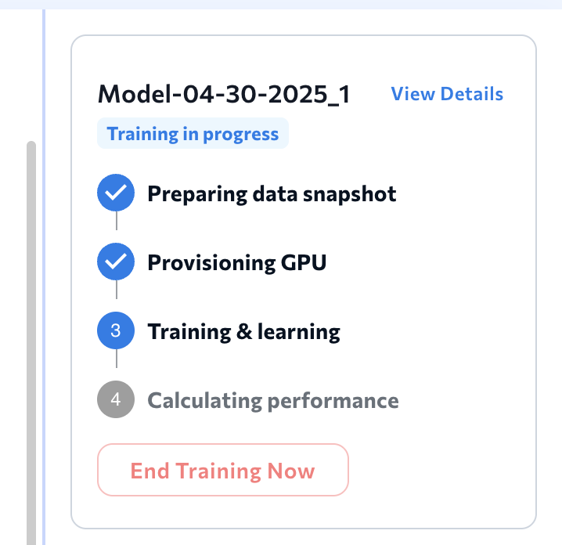

Step 6 – Testing the Model

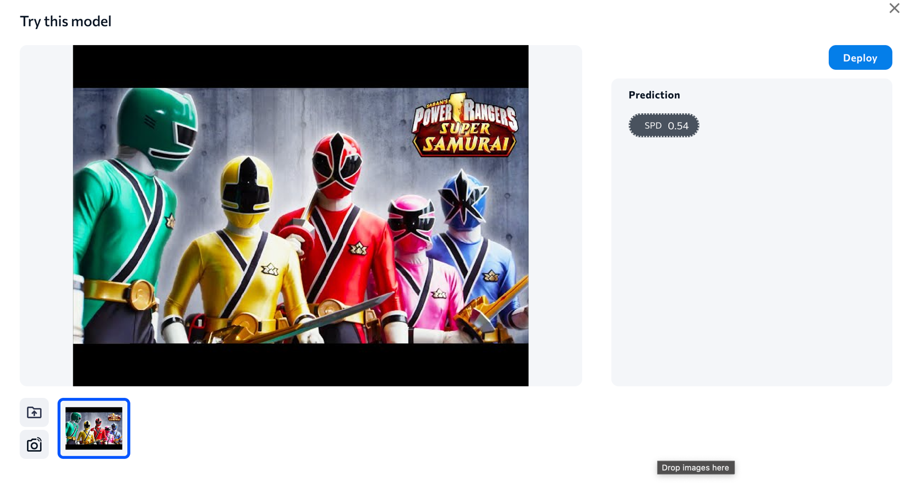

Step 7 – Deploy