SMART INDIA HACKATHON 2026 • SYSTEM ARCHITECTURE SPECIFICATION
SVI — Smart Victim Intelligence
Technical Flow & Architecture Specification
National Helpline Against Atrocities (NHAA 14566) • Ministry of Social Justice & Empowerment

1. Executive Summary & Architectural Overview
SVI (Smart Victim Intelligence) is an enterprise-grade, multimodal AI triage and crisis assessment system designed to augment India's National Helpline Against Atrocities (NHAA 14566). The platform processes inbound multi-channel communications (PSTN telephony, web portal, progressive web app, mobile application, and interactive voice response systems) to perform real-time, non-diagnostic stress and trauma classification while strictly preserving victim confidentiality in full compliance with the Digital Personal Data Protection (DPDP) Act 2023.
Unlike conventional conversational bots, SVI implements a dual-stream analytical pipeline: Stream A extracts acoustic biomarkers and prosodic tremors directly from raw telephony audio via openSMILE (eGeMAPS), while Stream B performs clinical NLP semantic matching against DSM-5 and PCL-5 acute trauma criteria using a LangGraph ReAct agent powered by Groq LLM (gpt-oss-120b). A mathematical late-fusion layer synthesizes these orthogonal signals into an actionable 0–100 Risk Score, feeding an authorized Human-in-the-Loop (HITL) triage dashboard.
2. End-to-End Technical Architecture Flow Diagram
The complete technical architecture flow diagram is illustrated below:
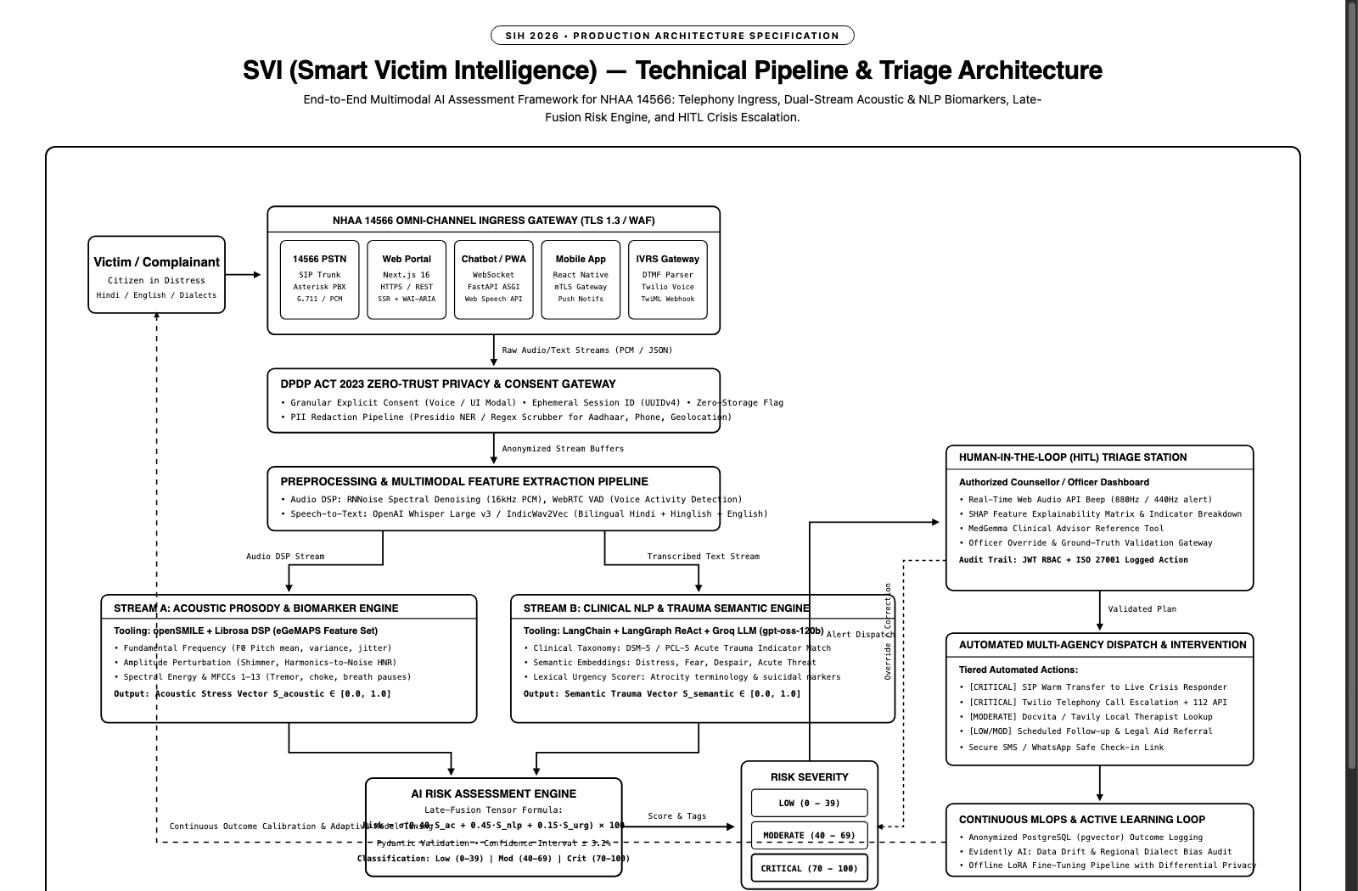
Figure 1: SVI Production Technical Flow & System Architecture (Monochrome Specification)
3. Omni-Channel Ingress Gateway Layer
All victim touchpoints are routed through an enterprise ingress layer protected by Cloudflare Web Application Firewall (WAF) with TLS 1.3 encryption and token-bucket rate limiting:
- 14566 PSTN Telephony: SIP Trunking via Asterisk PBX for G.711 / Linear PCM audio capture from national PSTN telecom operators.
- Web Portal: Next.js 16 App Router interface providing responsive, server-side rendered citizen reporting forms adhering to GIGW and WAI-ARIA standards.
- Chatbot / PWA: Real-time bi-directional messaging powered by FastAPI ASGI WebSockets with browser Web Speech API integration for Hindi (hi-IN) and English (en-IN).
- Mobile App: Cross-platform React Native client with mutual TLS (mTLS) and encrypted local secure enclave storage.
- IVRS Gateway: Twilio Voice TwiML gateway with dual-tone multi-frequency (DTMF) menu parsing and live call audio streaming.
4. DPDP Act 2023 Compliance & Zero-Trust Privacy Gateway
Because atrocity disclosures involve sensitive personal data, SVI enforces a zero-trust architecture before any data reaches AI inference models:
- Dynamic Consent Management: Prior to processing, users are presented with a granular consent state machine (explicit verbal consent for voice calls or interactive UI modal for digital channels).
- Automated PII Scrubber: Inbound text streams pass through a Microsoft Presidio / spaCy NER pipeline that scrubs Aadhaar numbers, 10-digit phone numbers, personal names, and specific GPS coordinates, replacing them with generic entity tokens (e.g., <AADHAAR_REDACTED>).
- Ephemeral Session Management: All session data is indexed exclusively by ephemeral UUIDv4 tokens stored in Redis with a 30-minute Time-To-Live (TTL). When zero-retention mode is toggled, call audio and transcripts are purged immediately following triage.
- Cryptographic Envelope: Payloads at rest are secured with AES-256-GCM envelope encryption using hardware security module (HSM) managed keys.
5. Signal Preprocessing & Feature Extraction
Inbound data is bifurcated into synchronized audio and text streams:
- Audio DSP Pipeline: Incoming 16kHz linear PCM audio is filtered through RNNoise recurrent neural network spectral denoising and WebRTC Voice Activity Detection (VAD) to eliminate background noise and isolate speech segments.
- Speech-to-Text (STT): Cleaned speech is transcribed in real-time using OpenAI Whisper Large v3 / IndicWav2Vec models fine-tuned on Indian accented English, Devanagari Hindi, and regional code-mixed Hinglish.
- Text Normalization: Text undergoes Devanagari script normalization, lemmatization, and schema validation via Pydantic models.
6. Dual-Stream AI Inference Engine
SVI avoids reliance on text-only sentiment by evaluating both physiological voice indicators and clinical semantic intent simultaneously:
Stream A: Acoustic Prosody & Biomarker Engine (openSMILE / Librosa)
Stream A analyzes vocal acoustics using the Extended Geneva Minimalistic Acoustic Parameter Set (eGeMAPS):
- Fundamental Frequency (F0): Evaluates pitch mean, local jitter, and vocal fold instability signaling acute panic.
- Shimmer & Harmonics-to-Noise Ratio (HNR): Quantifies cycle-to-cycle amplitude perturbation and high-frequency turbulence.
- MFCCs 1–13 & RMS Energy: Captures acoustic spectral tilt and breathlessness, producing a normalized acoustic stress vector S_acoustic ∈ [0.0, 1.0].
Stream B: Clinical NLP & Trauma Semantic Engine (LangGraph / Groq)
Stream B deploys a LangGraph ReAct agent backed by Groq's high-speed inference engine (gpt-oss-120b) with specialized clinical directives:
- Clinical Trauma Taxonomy: Semantic embeddings are cross-referenced against DSM-5 and PCL-5 acute stress criteria (dissociation, acute helplessness, panic, hyperarousal).
- Atrocity & Urgency Lexicon: Identifies statutory violation markers, caste-based abuse keywords, and acute danger terminology, outputting a semantic trauma vector S_semantic ∈ [0.0, 1.0].
7. Multimodal Late-Fusion Risk Engine
The AI Risk Assessment Engine performs calibrated late fusion across acoustic, semantic, and heuristic urgency vectors using the following formulation:
Risk Score = σ(0.40 · S_acoustic + 0.45 · S_semantic + 0.15 · S_urgency) × 100
The resulting score categorizes cases into three distinct operational triage tiers:
- LOW SEVERITY: Score 0–39. Routine case handling, automated informational guidance, and standard complaint registration.
- MODERATE SEVERITY: Score 40–69. Prioritized queue placement, assignment to tele-counselling officers, and legal aid referral dispatch.
- CRITICAL SEVERITY: Score 70–100. Immediate crisis protocol: acoustic alert on counsellor consoles, automated supervisor notification, and emergency dispatch readiness.
8. Human-in-the-Loop (HITL) Triage Station
To eliminate algorithmic hallucination risks in high-stakes public safety decisions, SVI implements strict Human-in-the-Loop governance:
- Live Counsellor Console: Built on Next.js 16 with Server-Sent Events (SSE) / WebSockets for sub-second alert delivery to authorized helpline officers.
- Real-Time Acoustic Alert: Plays an acoustic warning beep (880Hz / 440Hz oscillator) directly via the browser Web Audio API upon critical case arrival, requiring no external audio assets.
- Explainability Inspector: Provides counsellors with SHAP feature contribution charts, highlighted trauma keywords, and prosody anomaly graphs explaining why the AI assigned the score.
- MedGemma Clinical Advisor: Integrated tool allowing counsellors to query the MedGemma clinical medical model for differential diagnosis notes and clinical coping protocols.
- Officer Override & Audit Trail: Counsellors maintain absolute authority to adjust risk scores, validate findings, or override recommendations. All override actions are cryptographically signed and logged for ISO 27001 audit compliance.
9. Automated Multi-Agency Dispatch & Intervention
Validated triage assessments trigger automated downstream intervention workflows:
- Critical Dispatch: Critical cases trigger an immediate SIP warm-transfer to an on-duty senior crisis psychologist, while initiating an automated Twilio telephony dispatch to local emergency services and posting webhooks to the National Emergency 112 / CCTNS network.
- Moderate Support: Moderate cases trigger automated geolocation queries via Docvita and Tavily Search APIs to identify certified nearby therapists, schedule follow-ups, and generate legal aid appointment links.
- Informational Support: Low cases receive self-help mental health grounding exercises (4-7-8 breathing, sensory grounding) and standard helpline complaint tracking numbers via encrypted SMS/WhatsApp links.
10. MLOps, Active Learning & Continuous Model Governance
The system continuously evolves through privacy-preserving active learning loops:
- Ground-Truth Ingestion: Officer validation feedback and override labels are stored in an anonymized PostgreSQL database with pgvector extensions.
- Drift & Fairness Auditing: Evidently AI monitors data drift, concept drift, and regional dialect parity to ensure consistent scoring accuracy across diverse demographic populations in India.
- Differential Privacy Retraining: Models are periodically updated via parameter-efficient LoRA / DPO fine-tuning using differential privacy techniques, ensuring no individual victim interaction can be reconstructed from model weights.

