Academic Workflow Management System
A project submitted to
UKA TARSADIA UNIVERSITY
in partial fulfilment of the requirements
for the degree of

Master of Science in Information Technology
for 8th Semester
2025-26
Group Number: 14

Submitted By:
Meet Patel 202206100110021
Harsh Bhagat 202206100110092
Parangi Panchal 202504102510005

Guided By:
Mr. Rakesh savant


Babu Madhav Institute of Information Technology
Uka Tarsadia University
Bardoli – 394350
May 2026

CERTIFICATE

This is to certify that the project report entitled “Academic Workflow Management System ” has been carried out by Meet Patel 202206100110021, Harsh Bhagat 202206100110092 and Parangi Panchal 202504102510005 under my guidance in partial fulfillment of the requirement for the Master of Science in Information Technology during the academic year 2025-26.

Date: xx-xx-2026

____________________ ____________________
Mr . Rakesh Savant Dr. Jitendra Nasriwala
Project Guide Programme Coordinator

External Examiner(s)

___________________

___________________



BABU MADHAV INSTITUTE OF
INFORMATION TECHNOLOGY
Table of Contents
Chapters | Particulars |  |  | Page No.
1 | Introduction
 | 1.1 | Problem Definition
 | 1.2 | Purpose
 | 1.3 | Scope
2 | Overall Description
 | 2.1 | Product Perspective/ Environment Description
 |  | 2.1.1 | Hardware Interface/ Hardware Specification
 |  | 2.1.2 | Software Interface/ Software Specification
3 | System Specific Requirements
 | 3.1 | Functional Requirement
 | 3.2 | Non-functional Requirement
4 | System Analysis /System Flow
 | 4.1 | Use case Diagram
 | 4.2 | Activity Diagrams
5 | System Design /Data Set
 | 5.1 | Database Design
 |  | 5.1.2 | Data Dictionary
6 | System Implementation
 | 6.1 | Screenshots
7 | Testing
 | 7.1 | Test Cases
8 | Future Enhancement
9 | Conclusion
10 | Bibliography

List of Figures and Diagrams

Figure No. | Figure Description | Page No.

Chapter 1: Introduction
  - Problem Definition

The Academic Workflow Management System is a web-based system used to manage academic activities in a college or university. It allows administrators, faculty members, and students to use one platform to manage student information, attendance, assessments, and academic performance.
The system helps reduce manual work by automating tasks such as student enrollment, attendance tracking, assessment management, and result monitoring. This makes the process faster, reduces workload for staff, and improves transparency in academic management.

  - Project Purpose

The purpose of the Academic Workflow Management System is to make academic management easier by using a digital system instead of manual work.
The system aims to:
  - Provide one platform to manage all academic information.
  - Allow administrators to manage students, faculty, courses, and subjects.
  - Help faculty record attendance and assessments easily.
  - Allow students to view their academic progress and performance.
  - Reduce manual work and paperwork in the academic management process.

  - Project Scope

The scope of the Academic Workflow Management System is limited to managing and automating academic activities within an educational institution. The system provides functionalities such as user authentication, student and faculty management, attendance tracking, assessment management, academic request processing, timetable management, and mentorship communication for administrators, faculty members, and students. The system is developed as a web-based application accessible through standard web browsers and does not include modules related to fee management, library management, hostel management, or other non-academic administrative activities

Chapter 2: Overall Description
2.1 Product Perspective/Environment Description

The Academic Workflow Management System is a web-based application developed using the MERN (MongoDB, Express.js, React.js, Node.js) technology stack.

The system follows a client-server architecture where users interact with the system through a web browser. The frontend developed in React.js communicates with the backend server developed using Node.js and Express.js through REST APIs. The backend interacts with MongoDB for storing and retrieving academic information.

The system consists of three primary user roles: Administrator, Faculty, and Student. Each user role is provided with specific functionalities based on role-based access control.

The application operates in an online environment and requires an internet connection for accessing academic services.

2.1.1 Hardware Interface/ Hardware Specification

Component | Specification
Processor | Dual Core Processor or higher
RAM | 2 GB minimum
Storage | 1 GB free disk space
Display | 1024 × 768 resolution
Internet | Stable Internet Connection

2.1.2 Software Interface/ Software Specification

Software Component | Technology Used
Frontend | React.js
Backend | Node.Js With Express.Js
Database | MongoDB
Authentication | JSON Web Token (JWT)
Version Control | Git And GitHub

Chapter 3: System Specific Requirements

3.1 Functional Requirements
3.1.1 User Authentication Module :

Requirement No. | Description | Comment
FR1 | Users shall be able to log into the system using their login credentials. | Login
FR2 | Users shall be able to log out from the system securely. | Logout
FR3 | Users shall be able to view their profile information. | View Profile
FR4 | Users shall be able to change their password securely. | Change Password
FR5 | The system shall verify user identity using OTP during password updating process. | Verify OTP
FR6 | Users shall be able to recover their account using the forgot password feature. | Forgot Password

3.1.2 Admin Management Module :

Requirement No. | Description | Comment
FR1 | Admin shall be able to create new users such as students and faculty. | Create User
FR2 | Admin shall be able to upload multiple users using bulk upload. | Bulk Upload User
FR3 | Admin shall be able to manage subjects offered in the system. | Manage Subject
FR4 | Admin shall be able to manage sections for different semesters. | Manage Section
FR5 | Admin shall be able to create and manage class timetables. | Manage Timetable
FR6 | Admin shall be able to assign counsellor to students. | Assign counsellor

3.1.3 Faculty Module :

Requirement No. | Description | Comment
FR1 | Faculty shall be able to view the list of students. | View Students
FR2 | Faculty shall be able to view their assigned counsellees | View – counselees
FR3 | Faculty shall be able to communicate with students through mentorship chat. | Mark Attendance
FR4 | Faculty shall be able to mark student attendance. | Create Assessment
FR5 | Faculty shall be able to create assessments for subjects. | Create Assessment
FR6 | Faculty shall be able to enter student marks for assessments. | Enter Marks
FR7 | Faculty shall be able to review academic requests submitted by students. | Review Student Request
FR8 | Faculty shall be able to approve or reject student requests. | Approve / Reject Request

3.1.4 Student Module :

Requirement No. | Description | Comment
FR1 | Students shall be able to view their attendance records. | View Attendance
FR2 | Students shall be able to view their assessment marks. | View Assessment Marks
FR3 | Students shall be able to submit academic requests to faculty. | Submit Academic Request
FR4 | Students shall be able to check the status of submitted requests. | View Request Status
FR5 | Students shall be able to view their assigned counsellor. | View Assigned counsellor
FR6 | Students shall be able to communicate with their counsellor through chat. | Mentorship Chat
FR7 | The system shall restrict certain academic request types based on the student semester | Semester – Based Access

3.2 Non- Functional Requirements

Requirement No. | Description | Comment
NFR1 | The system shall support multiple users accessing the system at the same time without performance issues. | Performance
NFR2 | The system shall ensure secure authentication using encrypted passwords and role-based access control. | Security
NFR3 | The system interface shall be simple and easy to use for students, faculty, and administrators. | Usability
NFR4 | The system shall allow easy maintenance and updates without affecting existing functionality. | Maintainability
NFR5 | The system shall provide skeleton loading screens during data fetching operations to improve user experiences and perceived performance | User Experience

Chapter 4: System Analysis
4.1 Use Case Diagrams – 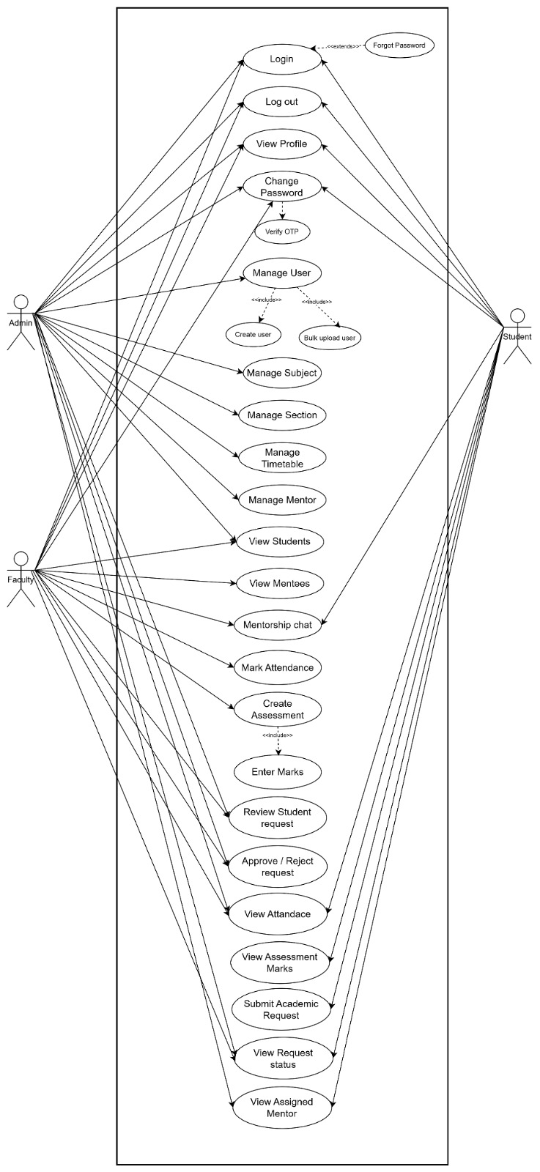

4.2 Activity Diagrams
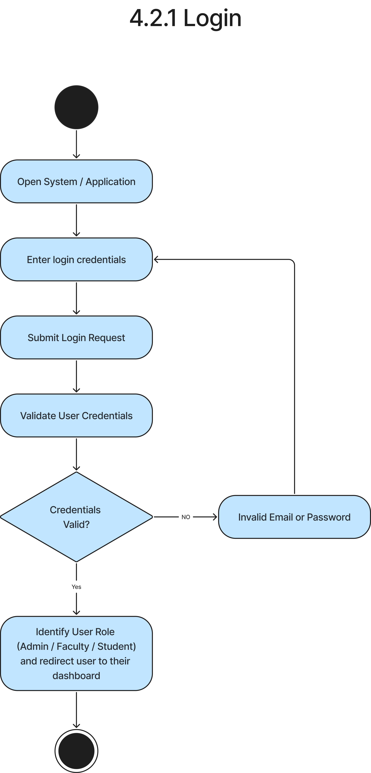
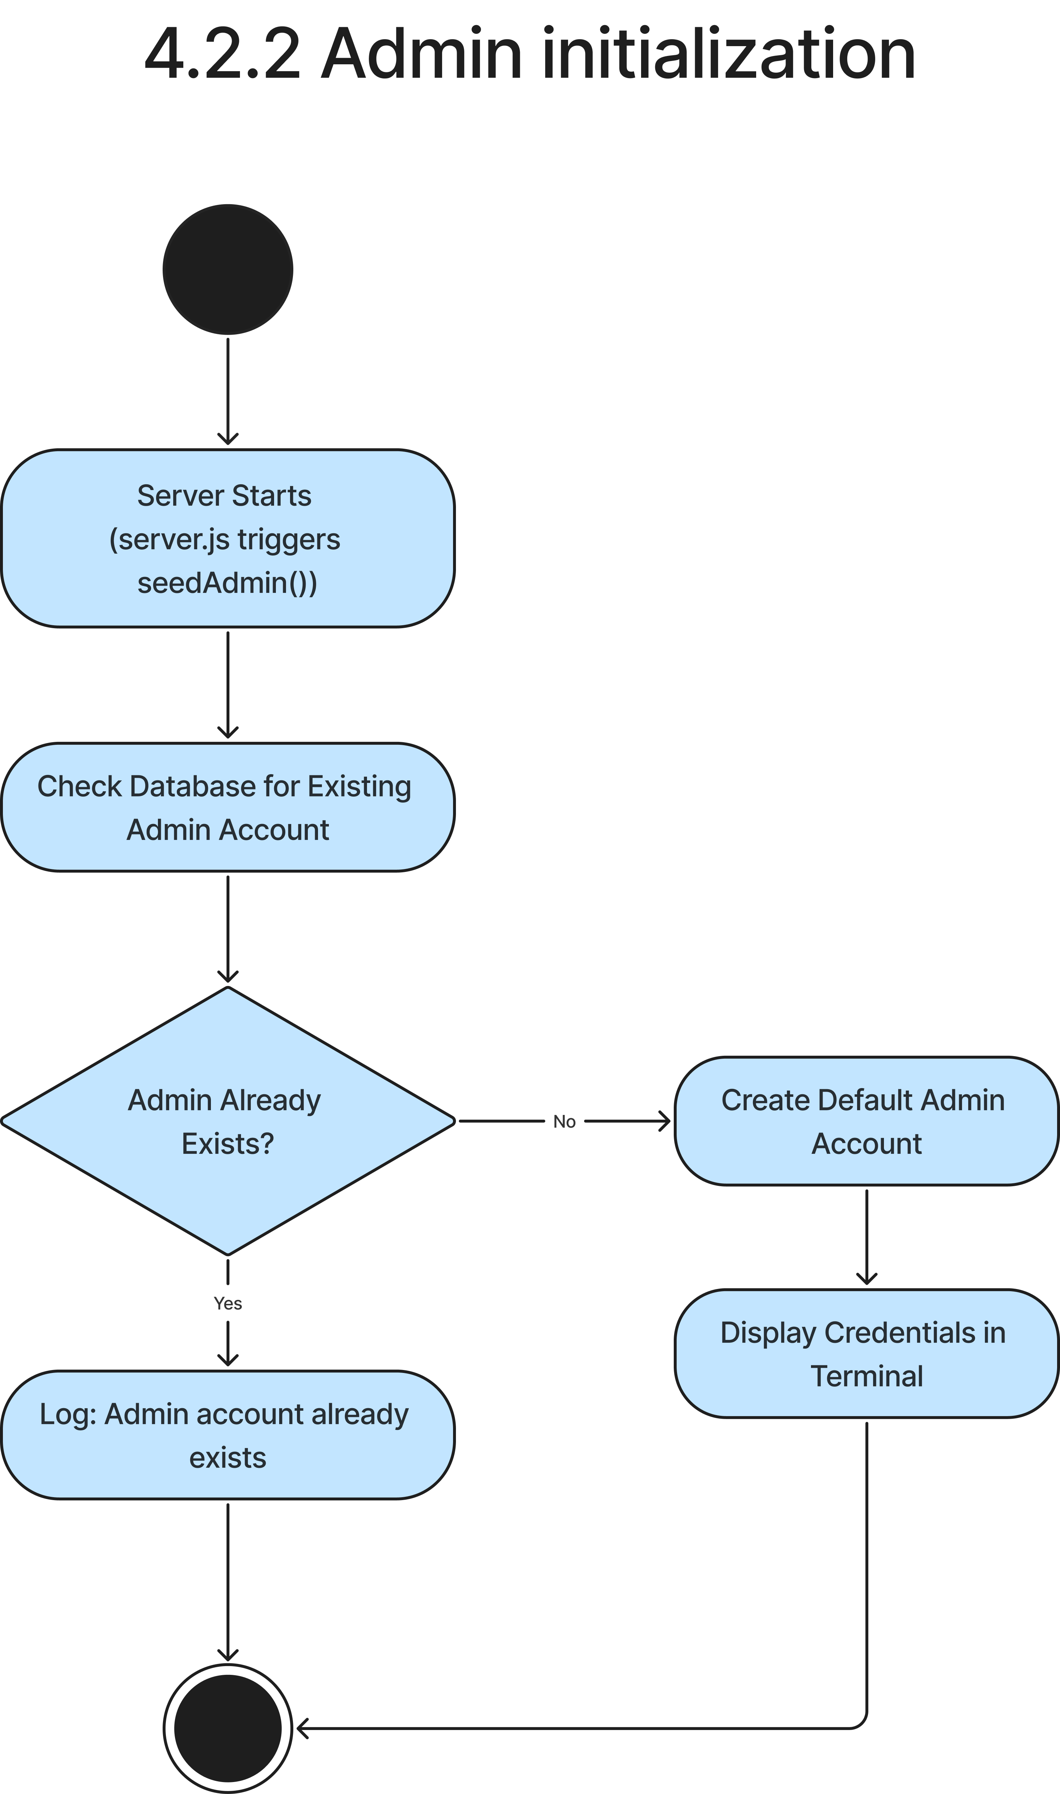
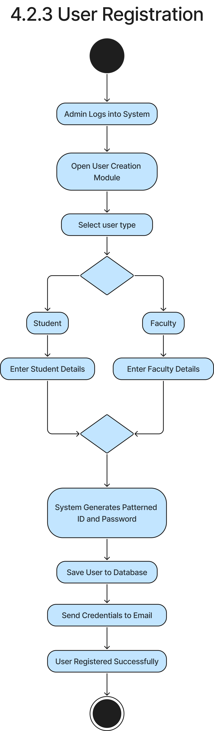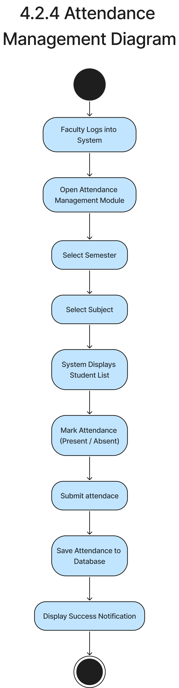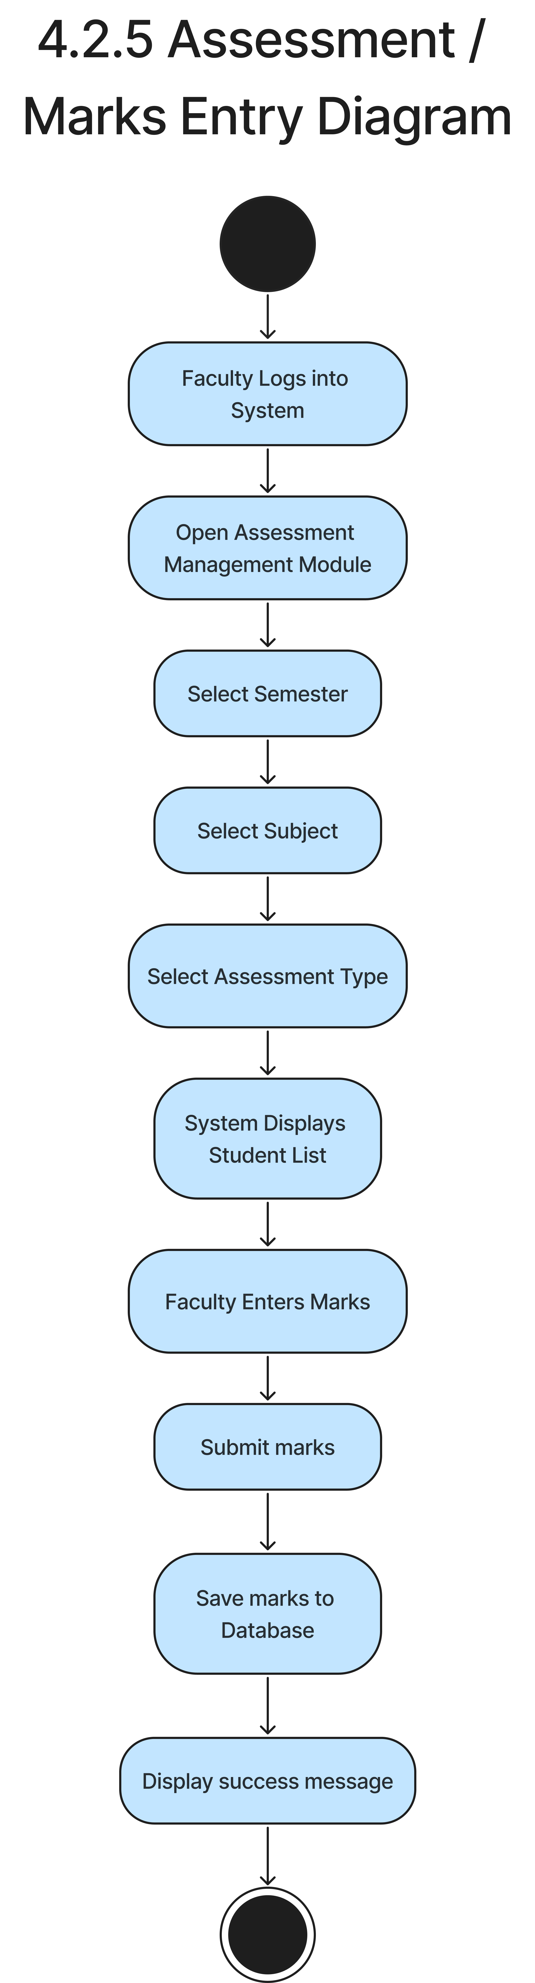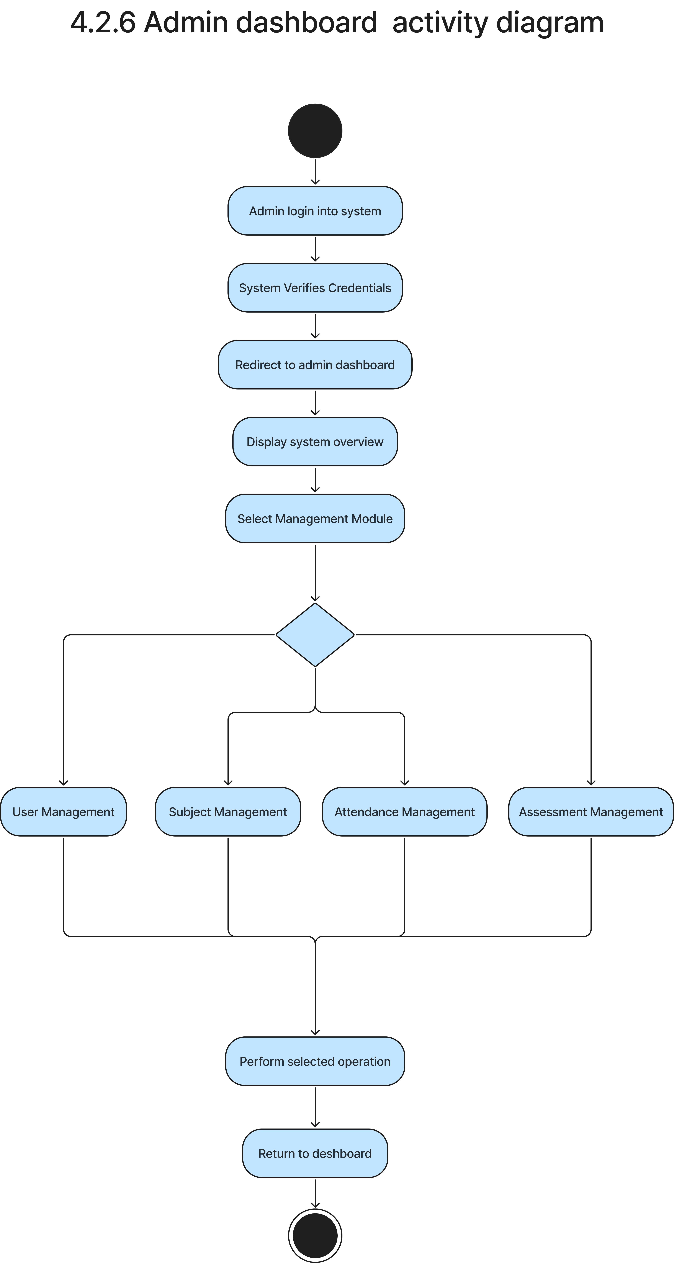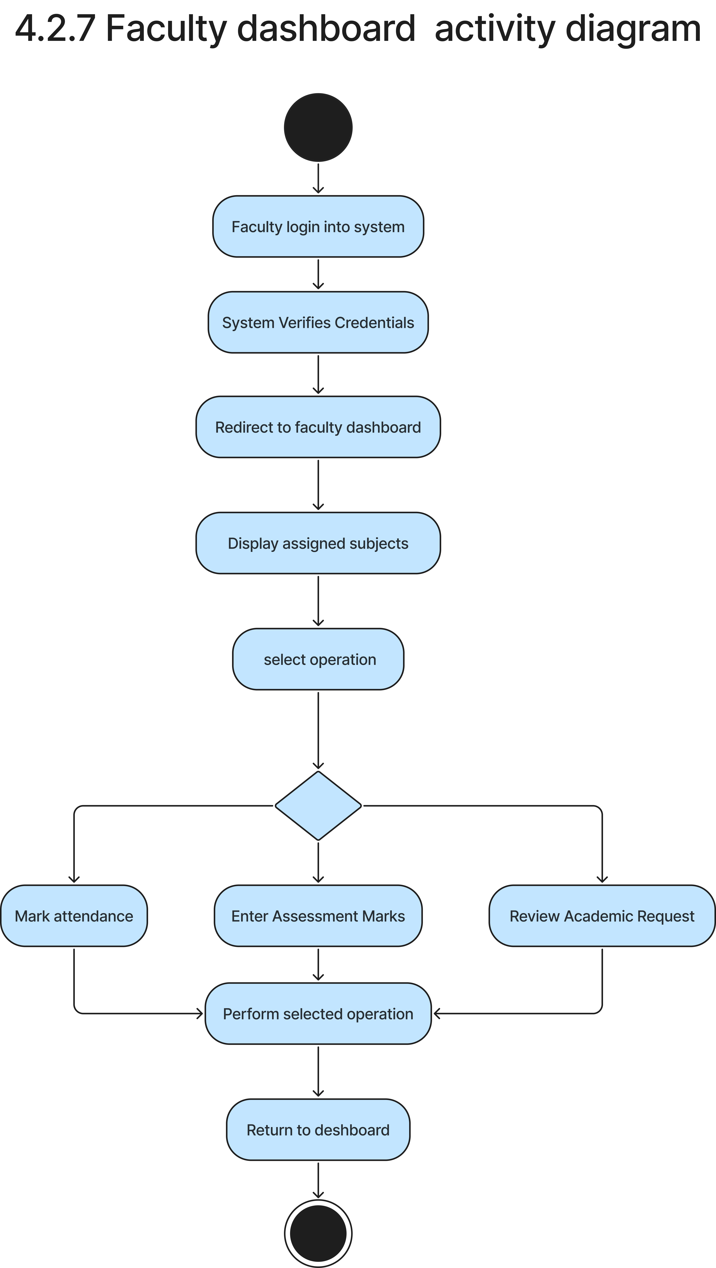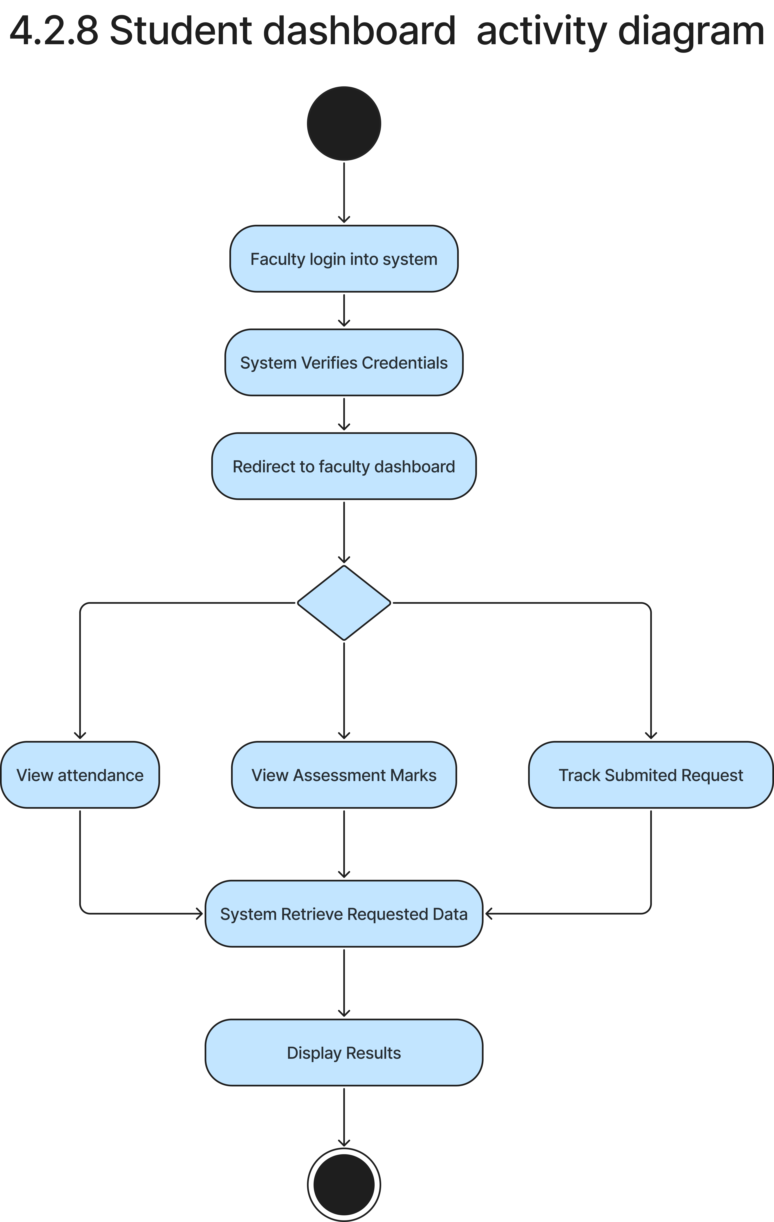

Chapter 5: System Design
5.1 System Design (Describes the database structure.)
5.1.1 Data Dictionary (List all database entities, attributes, and their descriptions.)
Field Name | Datatype | Size | Constraint | Description

Chapter 6: System Implementation
6.1 Screenshots
(Include relevant screenshots that demonstrate the system's interfaces and functionalities.)

Chapter 7: Testing
7.1 Test cases
7.1.1 Login, Password Control , Recovery
Test Case ID | Test Case | Inputs | Expected Output | Actual Output | Status
TC1 | Verify Login Functionality with valid credentials | Username: admin@college  Password: Admin@123 | User is redirected to the dashboard | Match as expected | Pass
TC2 | Verify Login Functionality with Invalid credentials | Username: admin@college  Password: Wrongpass | An alert message displaying "Invalid credentials" is rendered. User remains on the Login screen. | Match as expected | Pass
TC3 | Verify password length validation on setup page (Validation) | On the password change form, enter New Password: "123" , click Save | Form validation error is displayed: "Password must be at least 6 characters long." | Match as expected | Pass
TC4 | Verify OTP request for password recovery (Forgot Password - Positive) | Click Forgot Password, input Email: "22bmiit092@gmail.com" , click the Send OTP button | Notification toast displays "OTP sent to your registered email" . The verification OTP field becomes visible and enabled. | Match as expected | Pass
7.1.2 Profile & Setting Management

Test Case ID | Test Case | Inputs | Expected Output | Actual Output | Status
TC1 | Verify interface theme settings toggle (Positive) | Navigate to the Settings panel, click the Theme dropdown, select "Dark Mode" , and click Save Settings. | The application styling shifts to Dark Mode color theme instantly. Selection persists upon page reload. | Match as expected | Pass
TC2 | Verify user profile details update (Positive) | Navigate to Profile, edit details , update phone number "9988776655" , click Save Details. | Success popup displays "Profile updated successfully" , and the user profile header updates with the new number. | Match as expected | Pass

7.1.3 User Management & Enrolment
Test Case ID | Test Case | Inputs | Expected Output | Actual Output | Status
TC1 | Manual user registration | Select "Faculty" role, fill required fields | Alert "User created successfully" | Match as expected | Pass
TC2 | Bulk upload wrong file type | Upload non-CSV/Excel file | Warning "Invalid file format" shown | Match as expected | Pass
TC3 | Deactivate user account | Click "Deactivate" next to user list item | Status changes to "Deactivated" | Match as expected | Pass

7.1.4 Subject & Timetable Scheduling
Test Case ID | Test Case | Inputs | Expected Output | Actual Output | Status
TC1 | Add new subject | Fill Code, Name, assign Faculty, click save | Subject is successfully added to the list | Match as expected | Pass
TC2 | Schedule weekly lecture slot | Select semester, day, time, click Add | Lecture slot appears on the timetable grid | Match as expected | Pass
TC3 | Schedule that faculty’s lecture which is already assigned to some other class at same time | Select semester, day, time, click Add | Warning "faculty already assigned to some other lecture" shown | Match as expected | Pass

7.1.5 Attendance Tracking
Test Case ID | Test Case | Inputs | Expected Output | Actual Output | Status
TC1 | Mark student attendance | Select class, mark checkboxes, click save | Banner "Attendance recorded successfully" shown | Match as expected | Pass
TC2 | Check attendance summary | Open Student Attendance screen | Visual progress bar shows attendance average | Match as expected | Pass
7.1.6 Grading & Assessments
Test Case ID | Test Case | Inputs | Expected Output | Actual Output | Status
TC1 | Save Assessment draft grades | Select Test, enter marks, click save draft | Grade input values are saved as "Draft" | Match as expected | Pass
TC2 | Lock assessment grades sheet | Click "Lock Marks" on graded sheet | All score inputs become permanently read-only | Match as expected | Pass
7.1.7 Academic Requests Workflow
Test Case ID | Test Case | Inputs | Expected Output | Actual Output | Status
TC1 | Submit academic request | Fill type, description, click submit | Request appears in student list as "Submitted" | Match as expected | Pass
TC2 | Faculty review of request | Select student request, click approve | Request status changes to "Faculty Approved" | Match as expected | Pass
TC3 | Admin final request approval | Select Faculty Approved request, click approve | Request status updates to "Approved" | Match as expected | Pass
7.1.8 Mentorship Chat
Test Case ID | Test Case | Inputs | Expected Output | Actual Output | Status
TC1 | Send chat message to mentor | Type message, click send icon | Message appears immediately in chat window | Match as expected | Pass

Chapter 8: Future Enhancement
(Describe potential future improvements, scalability options, or new features to be added.)
Chapter 9: Conclusion
(Summarize the key points of the project and highlight the achievements.)
Chapter 10: Bibliography
(List all sources, references, and materials used during the project.)

