2
Inheritance, Java Packages

Topics Covered
- Universal class
- Access specifiers
  - Public
  - Private
  - Protected
  - Default
  - Private protected
- Doing inheritance
- Constructor in inheritance
- Method overriding
- Interface
- Nested and inner class
- Abstract and final class
- Normal import and static import
- Introduction to java api packages and imp. Classes
  - Java.lang
  - Java.util
  - Java.io
  - Java.net
  - Java.awt
  - Java.awt.event
  - Java.applet
  - Java.swing
- java.lang package classes
  - Math
  - Wrapper
  - String
  - StringBuffer
- java.util package classes
  - Random
  - Date
  - GregorianCalendar
  - Vector
  - HashTable
  - StringTokenizer
- Creating and using user defined package and sub-package

Universal class(Object class)
- It is the main class of java program.
- In this objects of all classes are declared and initializes.
- From this class we can call the method of any class.
- In it we can create object of every class so it is also known as Object class.
- If we create a java program with more than one class than the class file will create of the universal class.

Access Specifier
- Sometimes it is necessary to restrict the access to certain variables and method from outside the class.
- We don’t want that object of a class directly alter the value of a variable or method.
- We can specify visibility control.
1)Private
2)Public
3) protected
Private:
- Private Field has the highest degree of protection and they are accessible only within their own class.
- Private members can not be inherited into the subclass.
Public:
- When any member is declared as public, it is visible to entire class in which it is defined.
- If you want to make it visible to all the class or entire for the program then declare that member as public.

Protected:
- The visibility level of protected field lies in between the public and private access.
- The protected applies only when the inheritance is involved.
- Members declared as protected only accessible to that class and the sub class of that class.
Default access/friendly access
- When no access modifier is specified then it is default access, which has limited version of public accessibility known as friendly level of access.
- The difference between the public access and friendly access is that the public modifier makes fields visible in all classes.

Visibilty of fields in a class
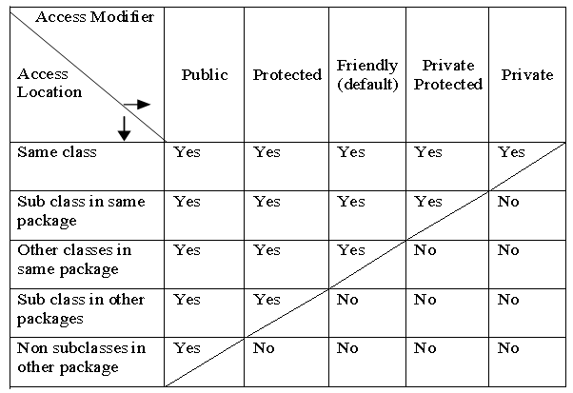

Doing Inheritance
- The meaning of inheritance is to take characteristic of one class into another class.
- The mechanism of deriving new class from old class is known as inheritance.
- The old class is known as base class or super class or parent class.
- The new class is known as sub class, derived class or child class.
- Java allows different types of inheritance which are as follow:
1)Single inheritance
- It has only one super class and only one sub class.
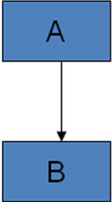

2)Multilevel inheritance
- one derived class can be derived from another class.

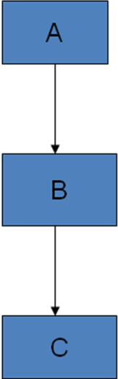

3) Hierarchical inheritance
It has one super class and more than one subclass.
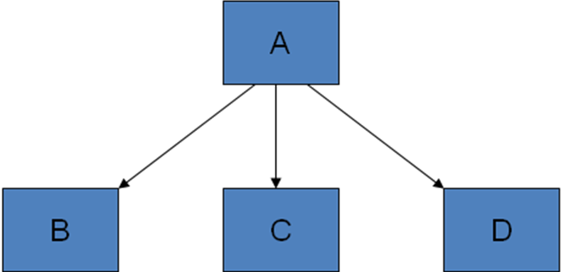
Syntax:
class subclass-name extends superclassname
{
variables declaration;
method declaration;
}
- The keyword extends signifies that the properties of the superclass name are extended to the subclass name.
Example
Class A
{
……
……
}
Class B extends A
{
……
……
}
- Here, class B extend the properties of class A.
- That means all properties of class A can go in the class B.
- We can use the object of class B for use the properties of class A.

Constructor in inheritance
- A subclass constructor is used to construct the instance variables of both the subclass and the superclass.
- The subclass constructor uses the keyword super to invoke the constructor method of the superclass.
- The following conditions are used to use super keyword.
1)Super may be used within a subclass constructor method.
2)The call to superclass constructor must appear as the first statement within the s ubclass constructor.
3)The parameter in the super call must match the order and type of the instance variable declared in the super class.
Example
class A1
{
int a,b;
A1(int x,int y)
{
a=x;
b=y;
}
void sum()
{
int c=a+b;
System.out.println("The sum is ::"+c);
}
}
class B1 extends A1
{
int d;
B1(int p,int q,int r)
{
super(p,q);
d=r;
}
void mul()
{
int z=a*b*d;
System.out.println("The multiplication is ::"+z);
}
}
class Super1
{
public static void main(String s[])
{
B1 b1=new B1(5,10,20);
b1.sum();
b1.mul();
}
}

Method overriding
- We know that a method defined in a superclass is inherited by its subclass and is used by the objects created by the subclass.
- There may be some situation when we want an object to respond the same method but have different behavior when that method is called.
- It is possible by defining a method in the subclass that has the same name, same arguments and same return type in the superclass.
- When that method is called, the method defined in the subclass is invoked and executed instead of the one in the superclass.
- This is known as overriding.
Class A
{
void display()
{
System.out.println(“base class”);
}
}
class B extends A
{
void display()
{
System.out.println(“derived class”):
}
}
Class ride
{
public static void main(String s[])
{
B b1=new B();
B1.display();
}
}
Output
Derived class

Interface
- Java does not support multiple inheritance means that classes in java can not have more than one super class.
- Java provides an alternet approach known as interface to support the concept of multiple inheritances.
- Interface is syntactically similar to classes but they contain instance variable and their methods are declared without anybody.
- The major difference between class and interface is that interface defines only abstract methods and final fields.
- Interface is designed to support dynamic method resolution at runtime.
- It is the responsibility of the class that implements an interface to define the code for implementation of these methods.
Syntax:
interface interface-name
{
variable declaration;
method declaration;
}
- Here, interface is the keyword and interface name is any valid java identifier.
- Here all variables are declared as constant.
- Method declaration will contain only a list of methods without any statements.
- Methods in interface have no definition.
- Variable declared inside the interface are implicitly final and static so it cannot be changed by implementing a class.

Implementing an interface
- Interfaces are used as superclass whose properties are inherited by a class.
Syntax
Class classname extends superclass implements interface1,interface2
{
body of class
}
- We can implement number of interface.
- When a class implements more than one interface they are represented by comma.

Nested and Inner class
- You can define a class within another class.
- These classes are known as nested classes.
- If a class B is defined in class A, the class B is known to A, but not outside the class A.
- The outer class can access all the members of inner class, even the private member also.

Abstract and final class
- All methods and variables can be overridden by default in subclass from overriding the members of the superclass, we can declare them as final using final keyword.
Example:
Final int size=100;
Final void show();
- This method can not be altered in any way.
- The value of a final variable can never be changed.
Abstract methods and classes
- We know that a method declare as final is not redefined in a subclass.
- We can declare abstract method with using the keyword abstract.
- We can not create the objects of abstract class directly.
- The abstract method of an abstract class must be defined in its subclass.
- We cannot declare abstract constructors or abstract static methods.
Example
Abstract class A
{
abstract void put();
void putdata()
{
System.out.println(“normal method”);
}
}
Class B extends A
{
void put()
{
System.out.println(“implementation of abstract method”);
}
}
Class impl
{
public static void main(String s[])
{
B b1=new B();
b1.put();
b1.putdata();
}
}
- Abstract class cannot directly instantiated with new operator because abstract class cannot be fully defined.
- Any subclass of an abstract class either implement all of the abstract method in the super class or the class method declared as abstract.
- You cannot declared abstract constructor or abstract static methods.
- The abstract methods of an abstract class must be defined in its subclass.
Explain static import
- Static import is use to avoid unnecessary use of static class members like Math and System.
- It is also use to reduce code size.
- By the use of static import you can directly write the name of method name.
- You can write import static .
Example
- We can write ad follow to print hello world.
System.out.println(“hello world”);
- But now if we use static import then we write as follow.
Import static java.lang.System.out;
Out.println(“hello world”);

Introduction to java API packages and imp. Classes
- Packages are Java’s way of grouping a variety of classes and/or interfaces together.
- The grouping is usually done according to functionality.
- In fact, Packages act as “Containers” for classes.
- By organizing our classes into packages, we achieve the following benefits.
  - The classes contained in the packages of other programs can be used.
  - In packages, classes can be unique compared to classes in other packages. That is, two classes in two different packages can have the same name. They may be referred by their fully qualified name, comprising the packages name and the class name
  - Packages provide a way to “hide” classes thus preventing other programs or packages from accessing a class that are meant for internal use only.
  - Packages also provide a way for separating “design” from “Coding”.
  - We may have to build our own classes for handling our data and use existing class libraries for designing user interface.
Java packages are therefore classified into two types.
- The first category is known as Java API packages.
- Second is known as user defined packages
- Java API provides a large number of classes grouped into different packages according to functionality.
- Most of the time we use the packages available with the Java API is as below

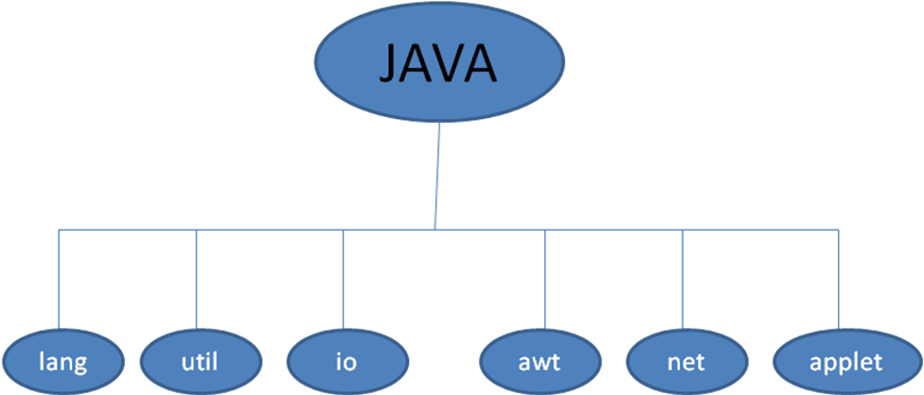

java.lang :- Language support classes
Java.util :- Language utility classes such as vector, hash tables, random number, date etc….
Java.io :- Input/out support classes.They provide facilities for the input and output of data
Java.awt:- Set of classes for implementing graphical user interface.
Java.net : - classes for networking. They including classes for communicating with local computers as well as with internet servers.
Java.applet :- Classes for creating and implementing applets.

How to use packages?
- There are two ways of accessing the classes in a packages.
- The first approach is to use the fully qualified class name of the class that we want to use.
- This is done by using the package name containing the class and then appending the class name to it using the dot operator.
Sy : - import packagename.classname
OR
import packagename.*;
- These are known as import statements and must appear at the top of the file before any class declaration and import is a keyword
Eg : import java.awt.Color;
import java.awt.*;

Naming Convertions
- Package can be named using the standard java naming rules.
- By conversion, however packages begin with lowercase letters.
- This makes it easy for users to distinguish packages names from class name when looking at an explicit reference to a class.
- We know that all class names, again by conversion, begin with an uppercase letter.
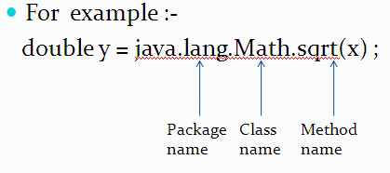

Java.lang package class
- Java.lang package contain the following classes.

Object class
- Object class defines the following methods which mean that they are available in every objects.

Methods | Purpose
Object clone() | Creates a new object that is the same as the object being cloned
Boolean equals(Object ) | Determines whether one object is equal to another
Void finalize() | Called before an unused object is recycled
string tostring() | Returns a string that describes the object
Void wait | Waits on another thread of execution

Math Class
- The math class contains all the floating point functions that are used for geometry and trigonometry as well as general purpose.

Sr.No. | Methods | Description
 | Static double exp(double arg) | Returns e to the arg
 | Static double log(double arg) | Returns the natural logarithm of arg
 | Static double pow(double y, double x) | It returns y raised to x
 | Static double sqrt(double arg) | Returns the square root of arg.
 | Static int abs(int arg) | Returns the absolute value of arg.
 | Static double ceil(double arg) | Returns the whole number greater than or equal to arg.
 | Static double floor(double arg) | Returns the whole number less than or equal argument.
 | Static int max(int x,int y) | It returns the maximum value from x and y.
 | Static int min(int x,int y) | It returns the minimum value from x and y.
 | Static int round(float arg) | Returns arg rounded up to nearest int.

Number class
- The java.lang.Number class is the superclass of classes BigDecimal, BigInteger, Byte, Double, Float, Integer, Long, and Short.The Subclasses of Number must provide methods to convert the represented numeric value to byte, double, float, int, long, and short.

Sr.No. | Method | Description
1 | byte byteValue() | This method returns the value of the specified number as a byte.
2 | abstract double doubleValue() | This method returns the value of the specified number as a double.
3 | abstract float floatValue() | This method returns the value of the specified number as a float.
4 | abstract int intValue() | This method returns the value of the specified number as a int.
5 | abstract long longValue() | This method returns the value of the specified number as a long.
6 | short shortValue() | This method returns the value of the specified number as a short.

Package class
- The java.lang.Package class contain version information about the implementation and specification of a Java package

Sr. No. | Method | Description
 | Annotation[] getAnnotations() | This method returns all annotations present on this element.
 | String getImplementationTitle() | This method returns the title of this package.
 | String getImplementationVendor() | This method returns the name of the organization, vendor or company that provided this implementation.
 | String getName() | This method return the name of this package.
 | static Package getPackage(String name) | This method find a package by name in the callers ClassLoader instance.
 | static Package[] getPackages() | This method get all the packages currently known for the caller's ClassLoader instance.
 | String getSpecificationVendor() | This method return the name of the organization, vendor, or company that owns and maintains the specification of the classes that implement this package.
 | String getSpecificationVersion() | This method returns the version number of the specification that this package implements.
 | boolean isCompatibleWith(String desired) | This method compares this package's specification version with a desired version.
 | String toString() | This method returns the string representation of this Package.

Example:

class PackageInfo{
public static void main(String args[]){

Package p=Package.getPackage("java.lang");

System.out.println("package name: "+p.getName());

System.out.println("Specification Title: "+p.getSpecificationTitle());
System.out.println("Specification Vendor: "+p.getSpecificationVendor());
System.out.println("Specification Version: "+p.getSpecificationVersion());

System.out.println("Implementaion Title: "+p.getImplementationTitle());
System.out.println("Implementation Vendor: "+p.getImplementationVendor());System.out.println("Implementation Version: "+p.getImplementationVersion());

}
}
Output:package name: java.lang
Specification Title: Java Plateform API Specification
Specification Vendor: Sun Microsystems, Inc.
Specification Version: 1.6
Implemenation Title: Java Runtime Environment
Implemenation Vendor: Sun Microsystems, Inc.
Implemenation Version: 1.6.0_30

String class
- It is the most commonly used class in java’s class library.
- Once a string object is created, its content cannot be altered.
- If you need to change a string, you can always create a new object
- java defines a peer class of string which is known as string buffer, which allows string to be altered.

Sr. No. | Methods | Description
 | Boolean equals(String object) | You can test two string for equality.
 | Int length() | You can obtain length of a string.
 | Char charAt(int index) | You can obtain a character at a specified index.
 | String concat() | You can concat two string.
 | String toLowerCase() | Converts all uppercase character to lowercase.
 | String toUpperCase() | Converts all lowercase character to uppercase.
 | String replace(cahr original,char replacement) | It replaces all occurance of one character in the invoking string with another character.

StringBuffer class
- It is a subclass of string class.

Sr. No. | Methods | Description
 | StringBuffer append(String object) | It concates the string representation of any other type of data.
 | insert(int index,value to be inserted) | It insert one string to another string.
 | delete(int S, int E) | It will delete the string.
 | Reverse | It will reverse the string
 | substring(int startIndex) | It returns the substring that start at startIndex and runs to the end of the object.

Wrapper Class

Wrapper classes in Java
The wrapper class in Java provides the mechanism to convert primitive into object and object into primitive.
Since J2SE 5.0, autoboxing and unboxing feature convert primitives into objects and objects into primitives automatically. The automatic conversion of primitive into an object is known as autoboxing and vice-versa unboxing.
The eight classes of the java.lang package are known as wrapper classes in Java. The list of eight wrapper classes are given below:
Primitive Type | Wrapper class
boolean | Boolean
char | Character
byte | Byte
short | Short
int | Integer
long | Long
float | Float
double | Double

Autoboxing
The automatic conversion of primitive data type into its corresponding wrapper class is known as autoboxing, for example, byte to Byte, char to Character, int to Integer, long to Long, float to Float, boolean to Boolean, double to Double, and short to Short.
Since Java 5, we do not need to use the valueOf() method of wrapper classes to convert the primitive into objects.
Wrapper class Example: Primitive to Wrapper
//Java program to convert primitive into objects
//Autoboxing example of int to Integer
public class WrapperExample1{
public static void main(String args[]){
//Converting int into Integer
int a=20;
Integer i=Integer.valueOf(a);//converting int into Integer explicitly
Integer j=a;//autoboxing, now compiler will write Integer.valueOf(a) internally

System.out.println(a+" "+i+" "+j);
}}
Output:
20 20 20

Unboxing
The automatic conversion of wrapper type into its corresponding primitive type is known as unboxing. It is the reverse process of autoboxing. Since Java 5, we do not need to use the intValue() method of wrapper classes to convert the wrapper type into primitives.
Wrapper class Example: Wrapper to Primitive
- //Java program to convert object into primitives
- //Unboxing example of Integer to int
- public class WrapperExample2{
- public static void main(String args[]){
- //Converting Integer to int
- Integer a=new Integer(3);
- int i=a.intValue();//converting Integer to int explicitly
- int j=a;//unboxing, now compiler will write a.intValue() internally

- System.out.println(a+" "+i+" "+j);
- }}
Output:
3 3 3

Java Wrapper classes Example
- //Java Program to convert all primitives into its corresponding
- //wrapper objects and vice-versa
- public class WrapperExample3{
- public static void main(String args[]){
- byte b=10;
- short s=20;
- int i=30;
- long l=40;
- float f=50.0F;
- double d=60.0D;
- char c='a';
- boolean b2=true;

- //Autoboxing: Converting primitives into objects
- Byte byteobj=b;
- Short shortobj=s;
- Integer intobj=i;
- Long longobj=l;
- Float floatobj=f;
- Double doubleobj=d;
- Character charobj=c;
- Boolean boolobj=b2;

- //Printing objects
- System.out.println("---Printing object values---");
- System.out.println("Byte object: "+byteobj);
- System.out.println("Short object: "+shortobj);
- System.out.println("Integer object: "+intobj);
- System.out.println("Long object: "+longobj);
- System.out.println("Float object: "+floatobj);
- System.out.println("Double object: "+doubleobj);
- System.out.println("Character object: "+charobj);
- System.out.println("Boolean object: "+boolobj);

- //Unboxing: Converting Objects to Primitives
- byte bytevalue=byteobj;
- short shortvalue=shortobj;
- int intvalue=intobj;
- long longvalue=longobj;
- float floatvalue=floatobj;
- double doublevalue=doubleobj;
- char charvalue=charobj;
- boolean boolvalue=boolobj;

- //Printing primitives
- System.out.println("---Printing primitive values---");
- System.out.println("byte value: "+bytevalue);
- System.out.println("short value: "+shortvalue);
- System.out.println("int value: "+intvalue);
- System.out.println("long value: "+longvalue);
- System.out.println("float value: "+floatvalue);
- System.out.println("double value: "+doublevalue);
- System.out.println("char value: "+charvalue);
- System.out.println("boolean value: "+boolvalue);
- }}
Output:
---Printing object values---
Byte object: 10
Short object: 20
Integer object: 30
Long object: 40
Float object: 50.0
Double object: 60.0
Character object: a
Boolean object: true
---Printing primitive values---
byte value: 10
short value: 20
int value: 30
long value: 40
float value: 50.0
double value: 60.0
char value: a
boolean value: true

Java.util package

Date class
- the Date class encapsulates the current date and time.
- class Date support the constructor Date().
- We can also use method getTime() that give us number of millisecond that have from january 1,1970.

Random class
- The random class is a generator of auto number.
- They are simply uniformly distributed in sequence.
- it has two types of constructors:
1) Random ()
2) Random (long value)
- The first version creates a number generator that uses the current time as the starting value.
- The second form allows you to specify a value manually.

Sr.No. | Methods | Description
 | Double nextDouble() | It returns the next double random number.
 | Float nextFloat() | It returns the next float value.
 | Int nextInt() | It returns the next integer value.

Vector class
- Vector implements a dynamic array.
- Followings are the vector constructors.
1) Vector ()
2) Vector (int size)
3) Vector (int size, int incr)
- The first form creates a default vector, which has initial size of 10.
- The second form creates a vector whose initial capacity is specified by size.
- The third form creates a vector whose initial capacity is specified by size and whose increment is specified by incr.

Java Vector Methods
The following are the list of Vector class methods:
SN | Method | Description
01 | add() | It is used to append the specified element in the given vector.
02 | addElement() | It is used to append the specified component to the end of this vector. It increases the vector size by one.
03 | capacity() | It is used to get the current capacity of this vector.
04 | clear() | It is used to delete all of the elements from this vector.
05 | contains() | It returns true if the vector contains the specified element.
06 | containsAll() | It returns true if the vector contains all of the elements in the specified collection.
07 | copyInto() | It is used to copy the components of the vector into the specified array.
08 | equals() | It is used to compare the specified object with the vector for equality.
09 | firstElement() | It is used to get the first component of the vector.
10 | indexOf() | It is used to get the index of the first occurrence of the specified element in the vector. It returns -1 if the vector does not contain the element.
11 | insertElementAt() | It is used to insert the specified object as a component in the given vector at the specified index.
12 | isEmpty() | It is used to check if this vector has no components.
13 | lastElement() | It is used to get the last component of the vector.
14 | lastIndexOf() | It is used to get the index of the last occurrence of the specified element in the vector. It returns -1 if the vector does not contain the element.
15 | removeElementAt() | It is used to delete the component at the specified index.
16 | setElementAt() | It is used to set the component at the specified index of the vector to the specified object.
17 | size() | It is used to get the number of components in the given vector.
18 | sort() | It is used to sort the list according to the order induced by the specified Comparator.

import java.util.*;
public class VectorExample1 {
public static void main(String args[]) {
//Create an empty vector with initial capacity 4
Vector<String> vec = new Vector<String>(4);
//Adding elements to a vector
vec.add("Tiger");
vec.add("Lion");
vec.add("Dog");
vec.add("Elephant");
//Check size and capacity
System.out.println("Size is: "+vec.size());
System.out.println("Default capacity is: "+vec.capacity());
//Display Vector elements
System.out.println("Vector element is: "+vec);
vec.addElement("Rat");
vec.addElement("Cat");
vec.addElement("Deer");
//Again check size and capacity after two insertions
System.out.println("Size after addition: "+vec.size());
System.out.println("Capacity after addition is: "+vec.capacity());
//Display Vector elements again
System.out.println("Elements are: "+vec);
//Checking if Tiger is present or not in this vector
if(vec.contains("Tiger"))
{
System.out.println("Tiger is present at the index " +vec.indexOf("Tiger"));
}
else
{
System.out.println("Tiger is not present in the list.");
}
//Get the first element
System.out.println("The first animal of the vector is = "+vec.firstElement());
//Get the last element
System.out.println("The last animal of the vector is = "+vec.lastElement());
}
}
Output:
Size is: 4
Default capacity is: 4
Vector element is: [Tiger, Lion, Dog, Elephant]
Size after addition: 7
Capacity after addition is: 8
Elements are: [Tiger, Lion, Dog, Elephant, Rat, Cat, Deer]
Tiger is present at the index 0
The first animal of the vector is = Tiger
The last animal of the vector is = Deer

Stack class
- Stack is a subclass of vector class that implements a standard last-in,first-out stack.
- Stack includes all the methods defined by Vector.
- The stack data structure has the two most important operations that are push and pop. The push operation inserts an element into the stack and pop operation removes an element from the top of the stack. Let's see how they work on stack.
- 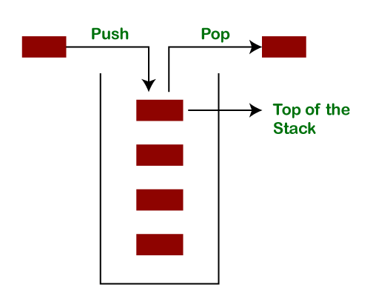

The following table shows the different values of the top.
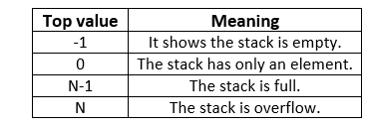

Creating a Stack
If we want to create a stack, first, import the java.util package and create an object of the Stack class.
- Stack stk = new Stack();
Or
- Stack<type> stk = new Stack<>();
Where type denotes the type of stack like Integer, String, etc.

Methods of the Stack Class
We can perform push, pop, peek and search operation on the stack. The Java Stack class provides mainly five methods to perform these operations. Along with this, it also provides all the methods of the Java Vector class.
Method | Modifier and Type | Method Description
empty() | boolean | The method checks the stack is empty or not.
push(E item) | E | The method pushes (insert) an element onto the top of the stack.
pop() | E | The method removes an element from the top of the stack and returns the same element as the value of that function.
peek() | E | The method looks at the top element of the stack without removing it.
search(Object o) | int | The method searches the specified object and returns the position of the object.

import java.util.Stack;
public class StackEmptyMethodExample
{
public static void main(String[] args)
{
//creating an instance of Stack class
Stack<Integer> stk= new Stack<>();
// checking stack is empty or not
boolean result = stk.empty();
System.out.println("Is the stack empty? " + result);
// pushing elements into stack
stk.push(78);
stk.push(113);
stk.push(90);
stk.push(120);
//prints elements of the stack
System.out.println("Elements in Stack: " + stk);
result = stk.empty();
System.out.println("Is the stack empty? " + result);
}
}
Output:
Is the stack empty? true
Elements in Stack: [78, 113, 90, 120]
Is the stack empty? false

GregorianCalendar class
- It is a subclass of Calendar class.
- It provides the logic manage of date and time according to the rules of Gregorian calendar.
- It provides the following constructors.
1)GregorianCalendar()
2)GregorianCalendar(int year,int month,int date)
3)GregorianCalendar(int year,int month,int date,int hour,int min,int sec)
4)GregorianCalendar(int year,int month,int date,int hour,int minute)
- The first form creates an object initialized with the current date and time.the other form allows you to specify how various date and time components are initialized.

Enumeration Interface
- It defines the method by which you can enumerate the elements in a collection of objects.
- It is used by several classes such as vector and other API classes.
- It specify the following two methods.
1)boolean hasMoreElements()
2)object nextElement
- The first method return true while there are more elements are there.
- The second method call the next object.

Hashtable class
- It creates a data structure in which you can store a data as key – values pairs.
- A hashtable has two columns named key and value.
- The records are rows of Hashtable.
- The following are the constructor.
Hashtable()
Hashtable(int size)
Hashtable(int size,float ratio)
- The first constructor is the default constructor.
- The second constructor creates a Hashtable of specified size. When the number of records reaches the specified size,the size of Hashtable is increased by 75 percent of initial size.it is the default ratio.
- The third constructor you can specify size as well as the increment ratio.
- Following are the methods of Hashtable.

Sr.No. | Methods | Description
 | Object put(Object key,Object value) | It insert the key/value pair specified by key and value.
 | Object get(Object key) | It returns the value associated with the specified key.
 | Object remove(Object key) | It removes the key and value of the record specified by key.
 | Int size() | It returns the number of records in hashtable.
 | Boolean isEmpty() | Returns true if the Hashtable is empty,otherwise returns false.
 | Void clear() | It removes all the records from the Hashtable.

Java Hashtable Example
- import java.util.*;
- class Hashtable1{
- public static void main(String args[]){
- Hashtable<Integer,String> hm=new Hashtable<Integer,String>();

- hm.put(100,"Amit");
- hm.put(102,"Ravi");
- hm.put(101,"Vijay");
- hm.put(103,"Rahul");

- for(Map.Entry m:hm.entrySet()){
- System.out.println(m.getKey()+" "+m.getValue());
- }
- }
- }
Output:
103 Rahul
102 Ravi
101 Vijay
100 Amit

StringTokenizer class
- For divison of text into a different parts is known as tokens.
- The StringTokenizer class provides the first step in this parsing process, often called lexer.
- StringTokenizer enumerate the individual tokens contained in it using StringTokenizer.
- To use StringTokenizer, you specify an input string and a string that contains delimiters.
- Delimiters are characters that separate tokens.
- For example , ; :
- The constructor of this class is as follow:
    - StringTokenizer(String str)
    - StringTokenizer(String str,String delimiter)
- In the first version default delimiter is used.
- In the second version delimiters is specified by delimiter.

Sr.No. | Method | Description
 | Int countTokens() | It count and return the number of token
 | Boolean hasMoreElements() | It returns true if one or more token in string otherwise return false.
 | Boolean hasMoreTokens() | It returns true if one or more token in string otherwise return false.
 | Object nextElement() | Return the next object
 | String nextToken() | Return the next token

Example of StringTokenizer Class
Let's see an example of the StringTokenizer class that tokenizes a string "my name is khan" on the basis of whitespace.
Simple.java
import java.util.StringTokenizer;
public class Simple{
public static void main(String args[]){
StringTokenizer st = new StringTokenizer(“Wel come BCA semester 4"," ");
while (st.hasMoreTokens()) {
System.out.println(st.nextToken());
}
}
}
Output:
my
name
is
khan

Example of hasMoreTokens() method of the StringTokenizer class
This method returns true if more tokens are available in the tokenizer String otherwise returns false.
StringTokenizer1.java
- import java.util.StringTokenizer;
- public class StringTokenizer1
- {
- /* Driver Code */
- public static void main(String args[])
- {
- /* StringTokenizer object */
- StringTokenizer st = new StringTokenizer("Demonstrating methods from StringTokenizer class"," ");
- /* Checks if the String has any more tokens */
- while (st.hasMoreTokens())
- {
- System.out.println(st.nextToken());
- }
- }
- }
Output:
Demonstrating
methods
from
StringTokenizer
class

SimpleTimeZone class
- The java.util.SimpleTimeZone class is a concrete subclass of TimeZone that represents a time zone for use with a Gregorian calendar.Following are the important points about SimpleTimeZone −
- The class holds an offset from GMT, called raw offset.
- This class also holds start and end rules for a daylight saving time schedule.

- The getRawOffset() method of TimeZone class in Java is used to know the amount of time in milliseconds needed to be added to the UTC to get the standard time in this TimeZone.
- Syntax:
- public abstract int getRawOffset()

Scanner class
- The java.util.Scanner class is a simple text scanner which can parse primitive types and strings using regular expressions. Following are the important points about Scanner −
- A Scanner breaks its input into tokens using a delimiter pattern, which by default matches whitespace.
- A scanning operation may block waiting for input.

Sr.No. | Method | Description
 | void close() | This method closes this scanner.
 | Pattern delimiter() | This method returns the Pattern this Scanner is currently using to match delimiters.
 | String findInLine(String pattern) | This method attempts to find the next occurrence of a pattern constructed from the specified string, ignoring delimiters.
 | boolean hasNext() | This method returns true if this scanner has another token in its input.
 | boolean hasNextBigInteger() | This method returns true if the next token in this scanner's input can be interpreted as a BigInteger in the default radix using the nextBigInteger() method.
 | boolean hasNextLine() | This method returns true if there is another line in the input of this scanner.
 | String next() | This method finds and returns the next complete token from this scanner.
 | float nextFloat() | This method scans the next token of the input as a float.
 | int nextInt() | This method scans the next token of the input as an int.
 | long nextLong() | This method scans the next token of the input as a long.
 | void remove() | The remove operation is not supported by this implementation of Iterator.
 | Scanner reset() | This method resets this scanner.
 | String toString() | This method returns the string representation of this Scanner.

- import java.util.*;
- public class ScannerExample {
- public static void main(String args[]){
- Scanner in = new Scanner(System.in);
- System.out.print("Enter your name: ");
- String name = in.nextLine();
- System.out.println("Name is: " + name);
- in.close();
- }
- }

import java.util.*;
public class ScannerClassExample1 {
public static void main(String args[]){
String s = "Hello, This is JavaTpoint.";
//Create scanner Object and pass string in it
Scanner scan = new Scanner(s);
//Check if the scanner has a token
System.out.println("Boolean Result: " + scan.hasNext());
//Print the string
System.out.println("String: " +scan.nextLine());
scan.close();
System.out.println("--------Enter Your Details-------- ");
Scanner in = new Scanner(System.in);
System.out.print("Enter your name: ");
String name = in.next();
System.out.println("Name: " + name);
System.out.print("Enter your age: ");
int i = in.nextInt();
System.out.println("Age: " + i);
System.out.print("Enter your salary: ");
double d = in.nextDouble();
System.out.println("Salary: " + d);
in.close();
}
}
Output:
Boolean Result: true
String: Hello, This is JavaTpoint.
-------Enter Your Details---------
Enter your name: Abhishek
Name: Abhishek
Enter your age: 23
Age: 23
Enter your salary: 25000
Salary: 25000.0

How to create packages?
- We must first declare the name of the package using the package keyword followed by a package name.
- This must be the first statement in a java source file.
- For example:-
package firstpackage; //Package Declare
public class FirstClass // Class definition
{
………………….
………………….(Body of class)
………………….
}
- Here the package name is firstpackage. The class FirstClass is now considered a part of this package.
- This listing would we saved as a file called FirstClass.java and located in a directory named firstpackage.
- When the source file is complied, java will create a.class file and store it in the same directory.
- Follow the steps to create packages:
- Declare at the beginning of a file using the form.
package packagename;
- Define the class that is to be put in the package and declare it public.
- Create a subdirectory under the directory where the main source files are stored.
- Store the listing as the classname.java file in the subdirectory created.
- Compile the file . This creates .class file in the subdirectory.
- A java package file can have more than one class definitions. In such cases, only one of the classes may be declared public and that class name .java extension is the source file name.

Using a Package
- The listing below shows a package named package1 containing a class classA.
package package1;
public class ClassA
{
public void displayA()
{
System.out.println(“Class A”);
}
}
- This source file should be named ClassA.java in the subdirectory package1 as stated earlier.
- Now compile this java file.
- The resultant ClassA.class will be stored in the samesubdirectory.
Now consider the listing shown below:-
import package1.ClassA;
class packageTest1
{
public static void main(String args[])
{
ClassA objectA= new ClassA();
objectA.display();
}
}
- The ClassA import from the package package1.
- The source file should be saved as packageTest1.java and compiled.
package package2;
public class ClassB
{
protected int m=10;
public void displayB()
{
System.out.println(“Class B”);
System.out.println(“m = ”+m);
}
}
- As usual, the source file and the compiled file of this package are located in the subdirectory package2.
- Program to importing classes from other packages is as given :
import package1.ClassA;
import package2.*;
class packageTest2
{
public static void main(String args[])
{
classA objectA=new classA();
classB objectB=new classB();
objectA.displayA();
objectB.displayB();
}
}
Adding a class to a package
Package p1;
public class A
{
//body of A
}
- The package p1 contains one public class by name A. Suppose we want to add another classB to this package.
- Follow the steps.
- Define the class and make it public.
- Place the package statement
package p1;
before the class definition as follows
package p1;
public class B
{
//Body of B
}
- Store this as B.java file under the directory p1
- Compile B.java file. This will create a B.class file and place it in the directory p1.

