**SIH1633**

**Problem Overview**

The Technical Education Department of the Govt. of Rajasthan faces several challenges in fostering meaningful and effective connections between alumni and current students. The lack of a centralized system for managing alumni data, structured avenues for interaction, and mentorship opportunities hinders the potential for students to gain real-world insights and career guidance. To address these issues, the department needs a platform that enables seamless alumni-student interaction, career mentorship, and guidance, while ensuring privacy, authenticity, and safety.

**Key Problems Identified**

1. **Lack of Centralized System**:
   * No centralized database for storing and updating alumni information, making it difficult to track alumni career paths, skills, and availability for mentorship.
   * Alumni engagement is sporadic, and opportunities for interaction are fragmented.
2. **Need for Structured Interaction**:
   * Without an organized platform, students miss out on structured opportunities for mentorship, career advice, and real-world learning experiences.
3. **Need for Motivation and Guidance**:
   * Many students lack clarity on career paths and professional development, and alumni could play a crucial role as mentors and guides.
4. **Ensuring Authenticity and Safety**:
   * The platform must ensure the authenticity of profiles and prevent fraudulent activities.
   * It must also filter out inappropriate content from forums and comments.

**Objectives of the Solution**

* **Alumni Database**: Centralized repository for alumni information, including career paths, expertise, and contact details.
* **Engagement Platform**: A platform for interactions between alumni and students, supporting discussions, mentorship, career guidance, placement assistance, and academic support.
* **Mentorship and Guidance**: Provide a structured system for alumni to offer career advice, mentorship, and support to students.
* **Safe and Authentic Environment**: Ensure profile verification and prevent fraud, and use AI-driven moderation tools to filter harmful content.
* **Networking Opportunities**: Create a supportive, collaborative ecosystem where alumni and students can engage, share experiences, and build professional networks.

**Proposed Solution Design**

**1. Centralized Alumni Database**

The first step is to create a centralized database that stores the following information:

* **Personal Details**: Name, contact info, etc.
* **Career Path**: Current job, career progression, industry, skills, and specialization.
* **Mentorship Availability**: Whether an alumnus is available for mentorship, and areas of expertise they can offer.
* **Engagement Level**: Metrics to track the level of engagement by each alumni (e.g., interactions, webinars attended, mentoring sessions provided).

**Technology**:

* **Backend**: Use cloud-based relational databases (e.g., MySQL, PostgreSQL) to securely store alumni data.
* **Frontend**: Alumni can register and update their profiles via a user-friendly web interface or mobile app.

**2. Engagement Platform**

The core of the platform would be an interactive web/mobile app with the following features:

* **Discussion Forums**: Where alumni and students can engage in conversations on various topics (e.g., career development, industry trends, academic challenges).
* **Mentorship Program**: A matching system that pairs students with alumni based on shared interests, skills, or career goals.
* **Career Guidance and Placement Assistance**: Alumni can offer advice on internships, job opportunities, and career transitions. Automated job matching can help students find relevant positions.
* **Academic Support**: Alumni can provide guidance in specialized academic areas, helping students with difficult subjects or research projects.

**Technology**:

* **Backend**: Node.js, Python (Flask/Django) for server-side operations, with integration to the database for real-time interactions.
* **Frontend**: A user-friendly, responsive interface built with React or Angular for the web, and a mobile application using React Native or Flutter.
* **AI Algorithms**: Machine learning algorithms can be implemented to suggest mentors and relevant content to students based on their interests, skills, and goals.

**3. Mentorship and Career Guidance**

**Structured Mentorship Programs**:

* Students can request mentorship from alumni through the platform.
* A recommendation system can pair students with alumni based on career interests, skills, and needs.
* Communication channels for mentorship could include one-on-one chat, video calls, and even project collaboration.

**Career Guidance**:

* Periodic webinars or panel discussions could be organized where alumni share industry insights and career advice.
* The platform can have an AI-driven "career assistant" chatbot that helps students explore potential career paths, offer guidance based on their academic background, and suggest appropriate learning resources.

**Technology**:

* **AI & NLP**: Natural Language Processing (NLP) algorithms for chatbots to answer queries, suggest mentors, and filter content.
* **Video Integration**: Integrate video conferencing tools (e.g., Zoom, Google Meet) for live mentorship or career sessions.

**4. Safe and Authentic Environment**

**Profile Authentication**:

* Use **blockchain** or **secure login systems** (e.g., OAuth2, biometrics) to ensure profile authenticity.
* Integration with professional platforms like LinkedIn for alumni verification and to verify career details.

**Content Moderation**:

* Implement AI-driven content moderation tools (e.g., using models like OpenAI's GPT or Google's Perspective API) to filter harmful or inappropriate language in forums, chats, and comments.
* Manual reporting and moderation options for users to flag inappropriate behavior or content.

**Technology**:

* **Blockchain**: Decentralized profiles with cryptographic signatures to ensure data integrity and authenticity.
* **AI-driven Moderation**: Use machine learning models for content moderation in real-time.

**5. Interactive Sessions & Events**

To facilitate regular interaction between alumni and students:

* **Alumni Meetups**: Organize both virtual and physical meetups to allow alumni to network and share experiences.
* **Webinars and Panel Discussions**: Regularly scheduled events where alumni can share industry insights and experiences.
* **Q&A Sessions**: Alumni can answer student queries about career development, industry trends, and life after graduation.

**Technology**:

* **Event Management**: Use platforms like Eventbrite or integrate an in-built event scheduling and management system.
* **Streaming Tools**: Use YouTube, Zoom, or other streaming services for live sessions, with automatic archiving for later viewing.

**6. AI and ML for Enhanced User Experience**

* **AI-Powered Recommendations**: Use machine learning to suggest mentors, discussion topics, webinars, and career opportunities that are relevant to each student based on their profile and activities.
* **Automated Chatbots**: Deploy AI-driven chatbots to guide students through the platform, answer common questions, and assist in profile updates.

**Technology**:

* **ML Algorithms**: TensorFlow or Scikit-learn for building recommendation systems.
* **Chatbot Framework**: DialogFlow, Rasa, or custom NLP-based solutions for building intelligent chatbots.

**Technologies Stack Overview**

1. **Frontend**:
   * React or Angular (Web)
   * React Native or Flutter (Mobile)
2. **Backend**:
   * Node.js, Django/Flask (API)
   * MySQL, PostgreSQL (Database)
   * AWS, Google Cloud, or Microsoft Azure (Cloud Hosting)
3. **AI & Machine Learning**:
   * Python (for ML, AI models)
   * TensorFlow, Scikit-learn (Machine Learning)
   * NLP (Hugging Face, GPT)
4. **Blockchain**:
   * Ethereum or Hyperledger (for profile verification)
5. **Video and Event Management**:
   * Zoom API, YouTube Live, Eventbrite

**Expected Outcomes**

* **Improved Alumni Engagement**: Increased participation and ongoing communication between alumni and current students.
* **Enhanced Student Support**: Structured mentorship programs and career guidance sessions leading to better student outcomes.
* **Safe and Authentic Platform**: Assurance of authenticity with secure profiles and content moderation.
* **Stronger Alumni-Student Network**: Creation of a lifelong, mutually beneficial network.

**Conclusion**

This solution will bridge the gap between current students and alumni in Rajasthan’s technical education ecosystem, providing students with valuable guidance, mentorship, and career opportunities, while offering alumni a structured and rewarding way to engage with their alma mater. By leveraging cutting-edge technologies such as AI, ML, and blockchain, the platform will be an innovative, scalable, and secure solution that enhances the learning and career development experience for students.

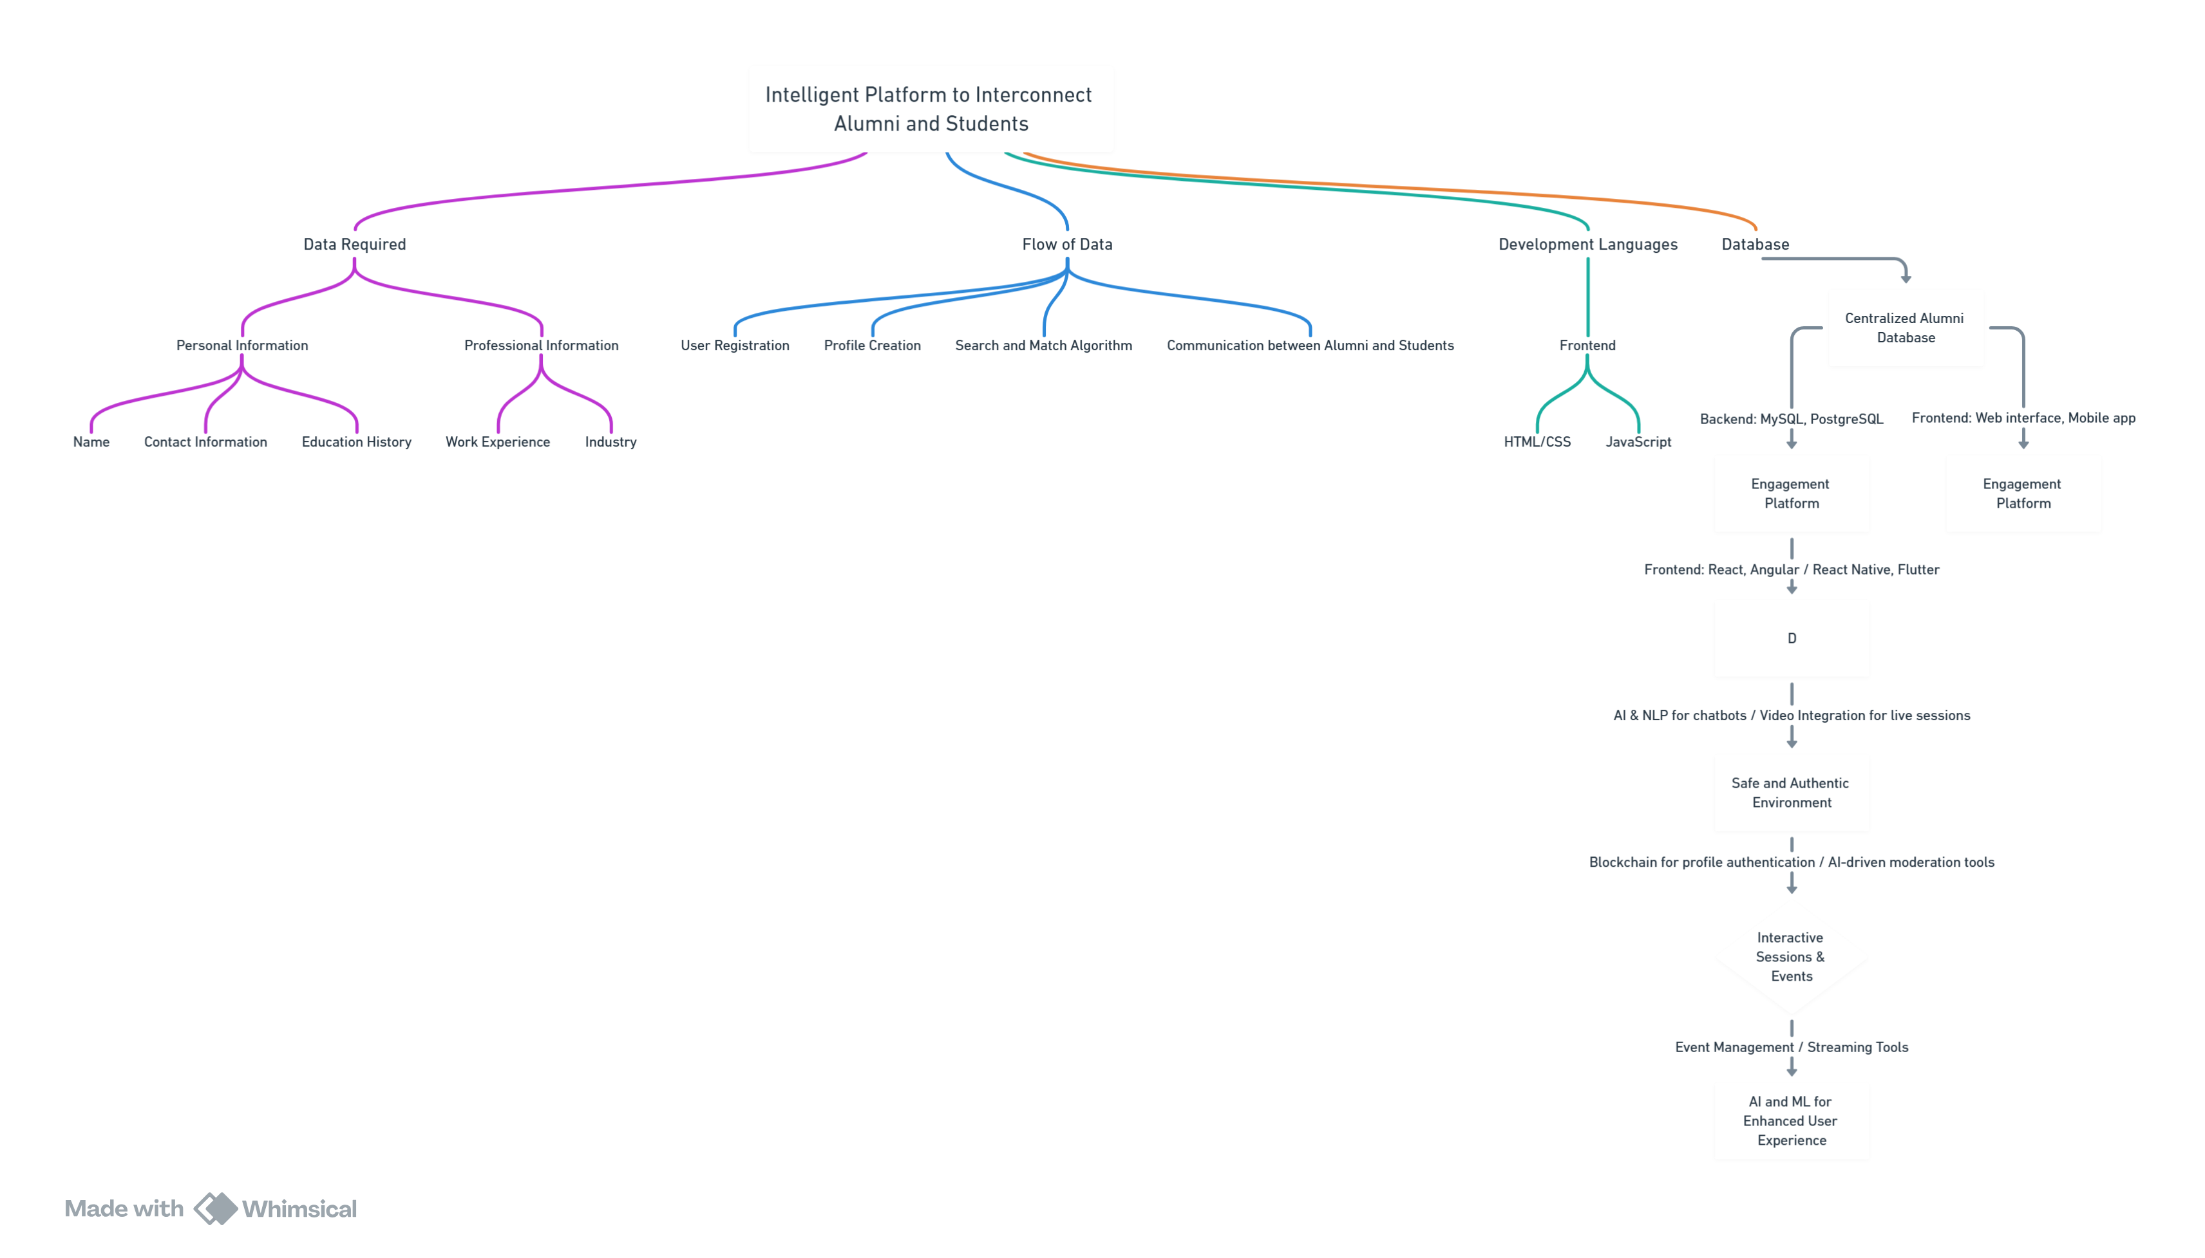

Ideas

1)can you please make me chat bot for this platform so that if some student want have a conversation with the alumni the chat bot can just ask alumni that when they can have the conversation with the student and also if any alumni want to share his experience or knowledge the chat bot can just send all students msg about alumni)

2) i want that you can make a platform where all users can share there achivement just like you do in twitter both photo text and tighter

**3) Mentorship Program Matching**

Implement a **mentorship program** feature where:

* Students can fill out a form specifying the areas they need guidance in (e.g., career advice, industry insights, skill development).
* Alumni can volunteer to be mentors, indicating their areas of expertise and availability.
* The system automatically matches students with suitable alumni based on interests, expertise, and availability.

**Additional Features:**

* **One-on-One Sessions:** Allow alumni to schedule one-on-one mentoring sessions with students via integrated calendar invites.
* **Group Discussions:** Create virtual discussion rooms where alumni can host group mentoring sessions for multiple students.

**4) Event Management and Notifications**

Add an **events module** where alumni and students can:

* Post upcoming webinars, workshops, or conferences.
* RSVP to events directly on the platform.
* Receive notifications for new events matching their interests.

**Extensions:**

* Use your chatbot to remind users about upcoming events or prompt users to register for events based on their profile.

**5) Knowledge Sharing Forums**

Introduce **discussion forums** for collaborative learning:

* Alumni and students can start discussions on topics of interest (e.g., "Resume Tips," "Breaking into Tech," "Job Market Trends").
* Tag discussions with categories (e.g., Career Advice, Technical Help, Research Topics).
* Upvoting or marking the most helpful answers for visibility.

**6) Skill-Building Challenges**

Create **challenges or competitions**:

* Alumni can sponsor challenges (e.g., coding challenges, innovation contests).
* Students can participate, showcase their skills, and get recognition from alumni and potential employers.

**Incentives:**

* Badges for participation.
* Certificate generation for winners or top contributors.

**7) Job Board and Internship Listings**

Build a **job and internship board** for alumni and students:

* Alumni can post job or internship opportunities in their organizations.
* Students can browse and apply directly through the platform.

**Features:**

* **Resume Builder:** Allow students to create and upload resumes on the platform.
* **Recommendation System:** Recommend opportunities to students based on their skills and profile.

**8) Networking and Messaging System**

Enhance networking with a **messaging feature**:

* Allow students and alumni to message each other directly (separate from the chatbot).
* Enable group messaging for projects or interests (e.g., "Tech Enthusiasts," "Entrepreneurship Club").

**9) Alumni Directory**

Create a **searchable alumni directory**:

* Allow students to search for alumni based on location, industry, or expertise.
* Alumni can control their visibility and share professional information like LinkedIn profiles or portfolios.

**10) Scholarships and Funding Opportunities**

Allow alumni to **sponsor scholarships** or funding opportunities for students:

* Alumni can pledge donations or create scholarships for specific fields or students in need.
* Students can apply with essays or project proposals.

**11) Recognition Wall**

Add a **recognition wall** to highlight achievements:

* Automatically feature top achievements shared by users.
* Display awards for alumni or students making significant contributions to the platform or community.

**12) Data-Driven Insights**

Provide **analytics dashboards**:

* Alumni can view how many students they’ve mentored or inspired.
* Students can track their participation in challenges, events, and skill development programs.

**13) Integrated Learning Resources**

Introduce **learning resources** like:

* Free courses and certifications curated by alumni.
* Reading recommendations or skill guides shared by experts