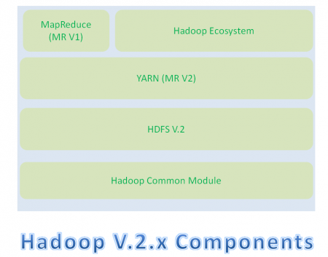

* Hadoop Common Module is a Hadoop Base API (A Jar file) for all Hadoop Components. All other components works on top of this module.
* HDFS stands for Hadoop Distributed File System. It is also know as HDFS V2 as it is part of Hadoop 2.x with some enhanced features. It is used as a Distributed Storage System in Hadoop Architecture.
* YARN stands for Yet Another Resource Negotiator. It is new Component in Hadoop 2.x Architecture. It is also know as “MR V2”.
* MapReduce is a Batch Processing or Distributed Data Processing Module. It is also know as “MR V1” as it is part of Hadoop 1.x with some updated features.
* Remaining all Hadoop Ecosystem components work on top of these three major components: HDFS, YARN and MapReduce.

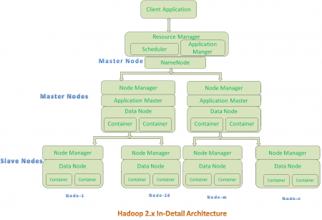

**Hadoop 2.x Architecture Description**

**Resource Manager:**

* Resource Manager is a Per-Cluster Level Component.
* Resource Manager is again divided into two components:
  1. Scheduler
  2. Application Manager
* Resource Manager’s Scheduler is :
  1. Responsible to schedule required resources to Applications (that is Per-Application Master).
  2. It does only scheduling.
  3. It does care about monitoring or tracking of those Applications.

**Application Master:**

* Application Master is a per-application level component. It is responsible for:
  1. Managing assigned Application Life cycle.
  2. It interacts with both Resource Manager’s Scheduler and Node Manager
  3. It interacts with Scheduler to acquire required resources.
  4. It interacts with Node Manager to execute assigned tasks and monitor those task’s status.

**Node Manager:**

* Node Manager is a Per-Node Level component.
* It is responsible for:
  1. Managing the life-cycle of the Container.
  2. Monitoring each Container’s Resources utilization.

**Container:**

* Each Master Node or Slave Node contains set of Containers. In this diagram, Main Node’s Name Node is not showing the Containers. However, it also contains a set of Containers.
* Container is a portion of Memory in HDFS (Either Name Node or Data Node).
* In Hadoop 2.x, Container is similar to Data Slots in Hadoop 1.x.