**Practical 3**

**Aim:** Replace the missing values for given automobile dateset “imports-85.data” with mean value of each attribute class. (Consider no. of doors as the class attribute - 6th attribute)

**Code:**

file=open("Dataset.csv","r")  
Data=[]  
def Mean(lst):  
 sum=0.0  
 length=len(lst)  
 mylen=0  
 for i in range(length):  
 if not lst[i]=="?":  
 if float(lst[i]) or int(lst[i]):  
 sum += float(lst[i])  
 mylen += 1  
 else:  
 mylen=1  
 return sum/float(mylen)  
for line in file:  
 subdata=line.split(",")  
 Data.append(subdata)  
  
Twodoors=[]  
Fourdoors=[]  
  
maintwoindex=[]  
mainfourindex=[]  
for d in Data:  
 if d[5] == "two":  
 maintwoindex.append(Data.index(d))  
 Twodoors.append(d)  
 elif d[5] == "four":  
 mainfourindex.append(Data.index(d))  
 Fourdoors.append(d)  
rez = [[Twodoors[j][i] for j in range(len(Twodoors))] for i in range(len(Twodoors[0]))]  
dumytwodoor=[]  
for t in rez:  
 if "?" in t:  
 mean=Mean(t)  
  
 for n, i in enumerate(t):  
 if i == "?":  
 t[n] = mean  
  
 dumytwodoor.append(t)  
  
  
rez1 = [[Fourdoors[j][i] for j in range(len(Fourdoors))] for i in range(len(Fourdoors[0]))]  
dumyfourdoor=[]  
for t1 in rez1:  
 if "?" in t1:  
 mean=round(Mean(t1),2)  
  
 for n, i in enumerate(t1):  
 if i == "?":  
 t1[n] = mean  
  
 dumyfourdoor.append(t1)  
finalTwodoor = [[dumytwodoor[j][i] for j in range(len(dumytwodoor))] for i in range(len(dumytwodoor[0]))]  
finalFourdoor= [[dumyfourdoor[j][i] for j in range(len(dumyfourdoor))] for i in range(len(dumyfourdoor[0]))]  
FinalList=[]  
for line in Data:  
 FinalList.append(line)  
 break  
counter=0  
for i in maintwoindex:  
 FinalList.insert(i,finalTwodoor[counter])  
 counter+=1  
counter=0  
for i in mainfourindex:  
 FinalList.insert(i,finalFourdoor[counter])  
 counter+=1  
f1=open("Output.csv","w")  
print()  
for item in FinaList:

print(item)  
for item in FinalList:  
 flenth1= len(item)  
 for i in range(flenth1):  
 if i == flenth1-1:  
 f1.write(str(item[i]))  
 else:  
 f1.write(str(item[i])+",")

**Output:**

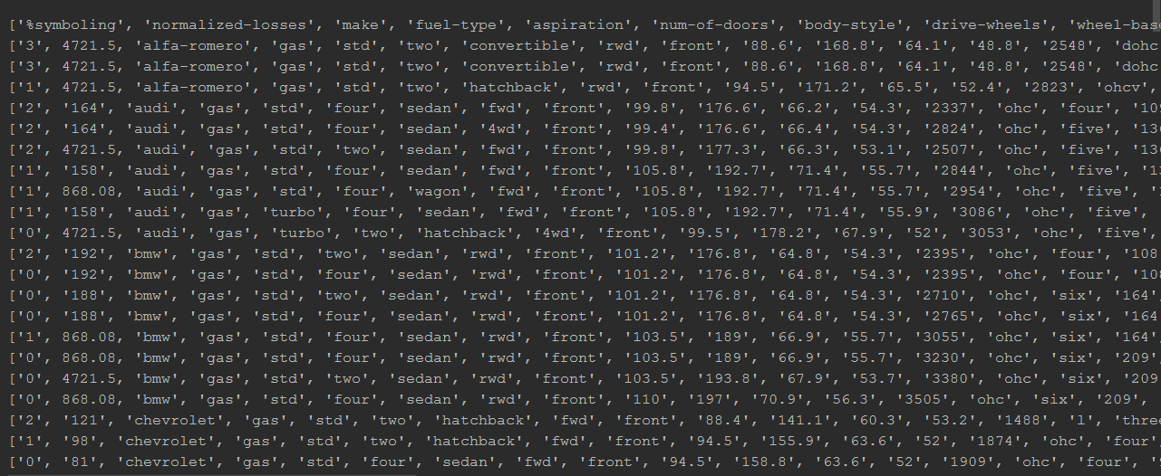

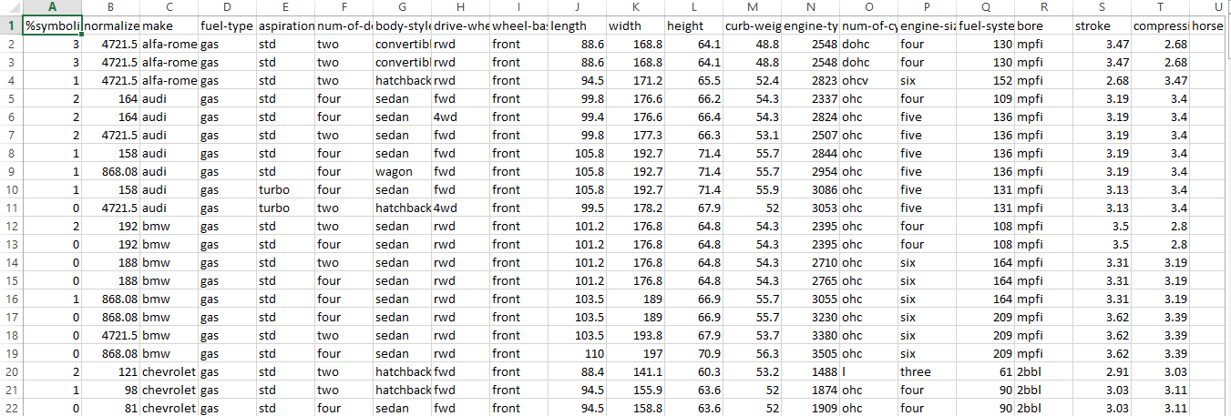Output.csv