Web based audio player

Written by

Harsh Dinesh Chokshi

2018

Contents

Main Page 2

Audio player 2

Add song 3

Previous Song 3

Next Song 3

Playlist 3

Database Management System 3

Software Testing 3

Version 4

Future scope of work 4

References 4

# Main Page

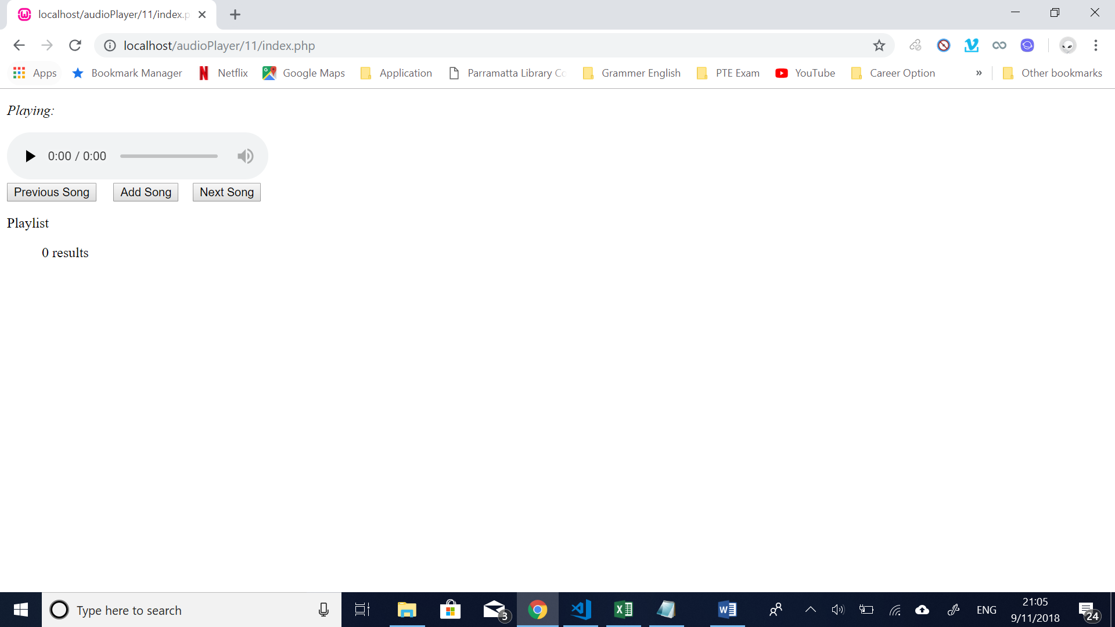

The main page consists of following things:

* HTML audio player
* User interacting buttons such as Add song, previous song and next song
* Display list of songs

# Audio player

* The function of audio player is to play list of song one by one without any interruption.
* Audio player is controlled by Java script. Java script files gave ability to an audio player to switch from one song to another of list of songs

# Add song

* The function of add song is to ensure that user can able to add song without interrupting on going track.
* There is no limitation to add song user can add song as much as they wish at point of time.
* AJAX is used to prevent form for redirecting to any other form action page.

# Previous Song

* Enhance an ability of audio player to play previous song off the current song at point of user preference.
* This button will execute previous track function written in J Query.

# Next Song

* Enhance an ability of audio player to play previous song off the current song at point of user preference.
* This button will execute previous track function written in J Query.

# Playlist

* Playlist section communicates with database written in PHP and MY SQL
* The database comprises of list of songs added by user which include song title, artist and link.
* The song is added with the help of add button and information filled in form.

# Database Management System

* For managing database WAMP Server is used using PHP MY ADMIN
* The database provides ability to audio player access songs information such as title and link.

# Software Testing

* The code has been written in VISUAL STUDIO CODE environment and tested on Google Chrome.
* At the current the code has not been testing in any other browser due to lack of time to complete the project.

# Version

* The software is still under beta version.

# Future scope of work

* The current version of application system lacks interactive design and has not implemented because focus is given too on obtaining functionality rather than design
* Drag and drop feature require instead of fill in track information inside form for its easy of use.

# References

* Software Stack Exchange, W3school.com, You Tube.

# Functionality Testing

|  |
| --- |
| 1. **Add Song** |
| This will allow user to add song into audio player without interrupting any ongoing music.  User can add song at any time and there is no limitation to add number of songs.  When song will reach the length of visual screen scroll bar will automatically appear.  User can able to play the song without refreshing the page.  Audio player continue to work normally and able to play added track as normal previously added track. |

|  |
| --- |
| 1. **Previous Track** |
| User can switch to previous track using Previous Song button.  If there is not previous track in playlist then alert box appear saying “This is the first song of the playlist” |

|  |
| --- |
| 1. **Next Track** |
| User can switch to next track using Next Song button.  If there is not next track in playlist then it played begin playing first song of the list. Whenever, playlist gets ends it will repeat itself without interrupting music. |

|  |
| --- |
| 1. **On Click Track** |
| Whenever user clicked on any track that song will play. |