**Database Engineering Lab**

**Experiment-1**

**(Installation of Oracle Database)**

**Name: Harshavardhan Bamane**

**PRN: 22510112**

**BATCH: S7**

**Steps to download and configure database in local host =>**

1) Download the Oracle Database XE 11g software unzip the file and run

2) Accept licence and agreement.

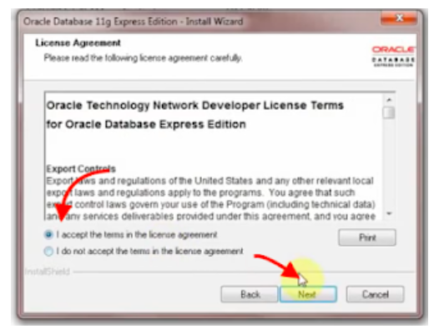

3) Configure the password for database.

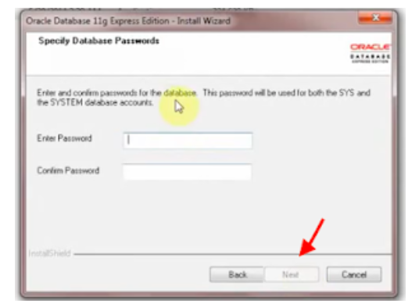

4) Save the summary that are details to connect with database.

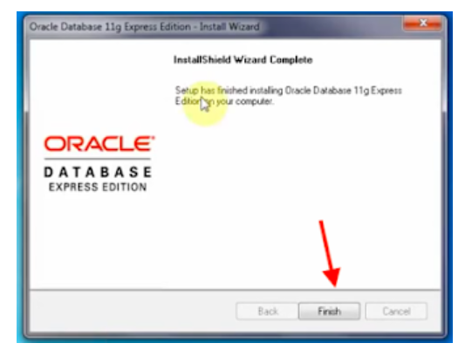

We can start database manually and choose connection name as SYSTEM and password that we configured to create and connect to database.

Create a table and run a test query.

