**Database Engineering Lab**

**Experiment-3**

**(DRAW AN ER DIAGRAM AS WELL AS RELATIONAL DATABASE DESIGN DIAGRAM OF ALLOTTED SYSTEM)**

**Name: Harshavardhan Anil Bamane**

**PRN: 22510112**

**BATCH: S7**

1. **Trading System Management:**

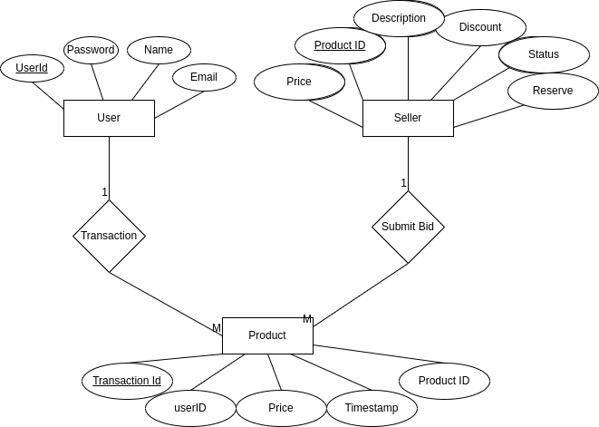

Relational Database Design Diagram

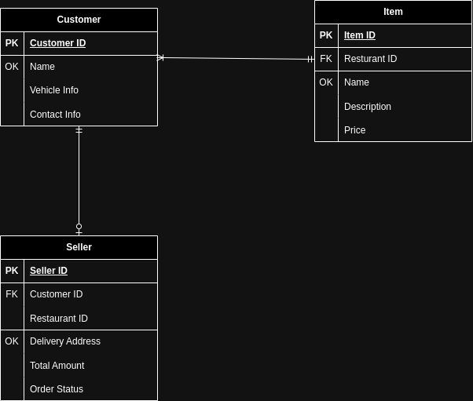

1. **FOOD DELIVERY SYSTEM:**

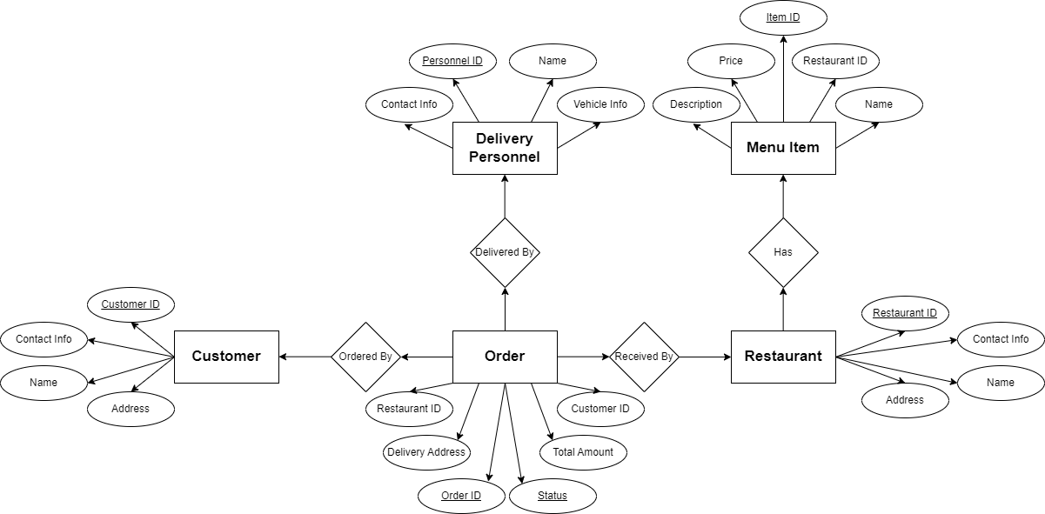

Relational Database Design Diagram

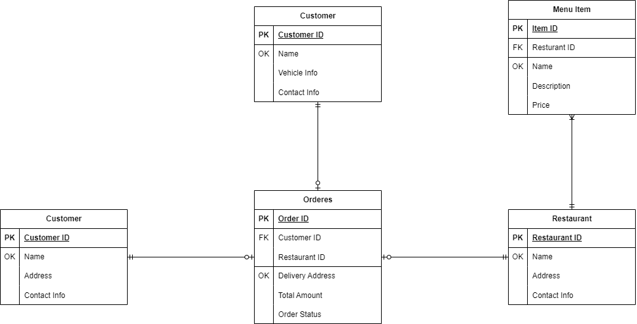

1. **AIRLINES MANAGEMENT SYSTEM:**

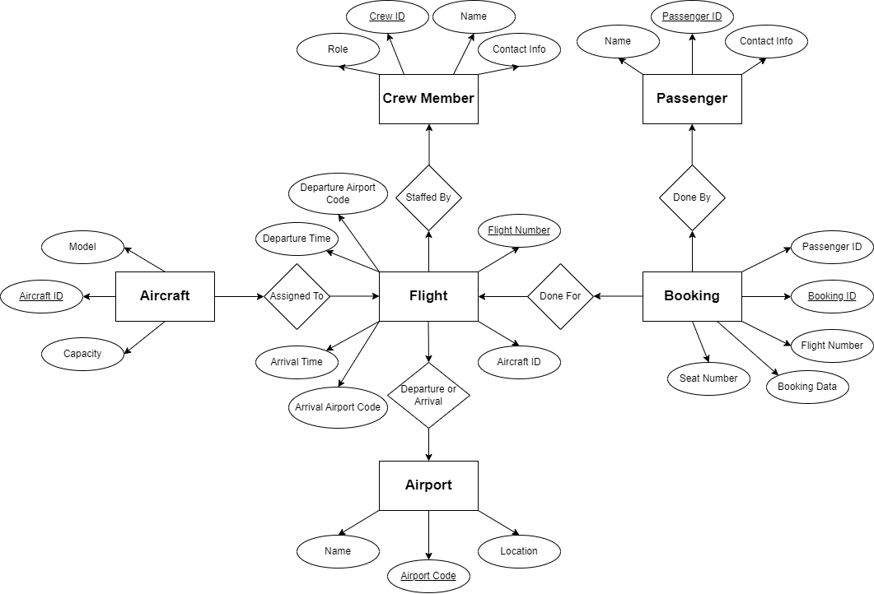

Relational Database Design Diagram

