**Database Engineering Lab**

**Experiment-4**

**(Implementation of DDL & DML queries)**

**Name: Harshavardhan Anil Bamane**

**PRN: 22510112**

**BATCH: S7**

**Q1. Create the following tables:**

1. Client_Master:

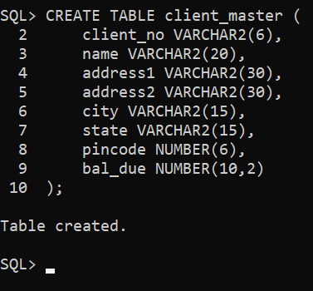

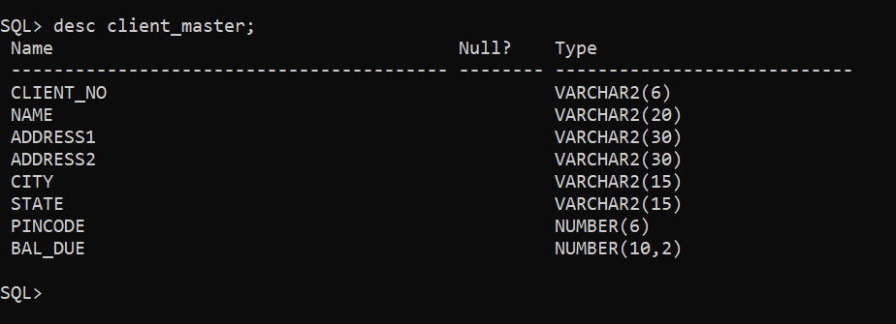

1. Product_Master:

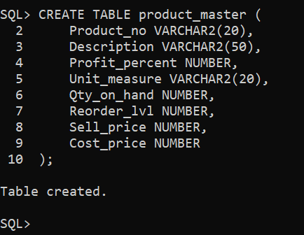

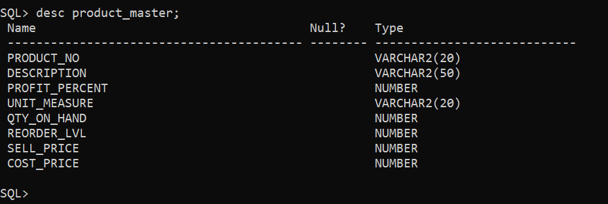

**Q2. Insert the following data into their respective tables:**

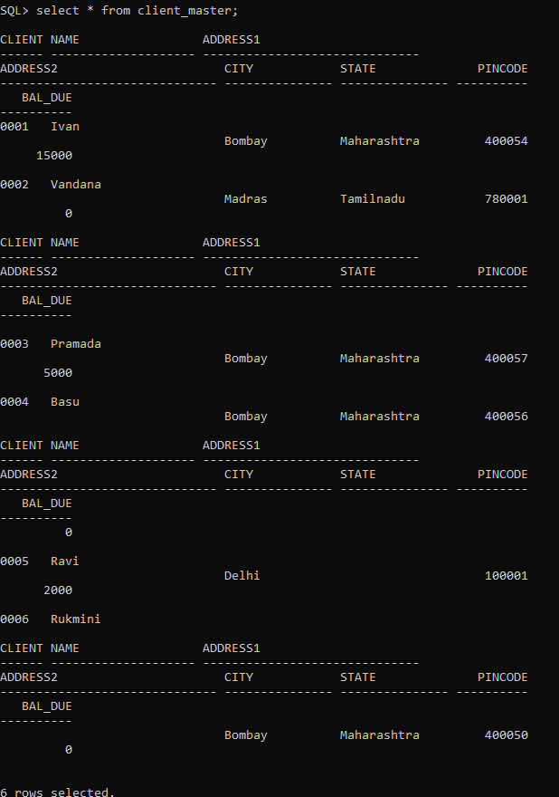

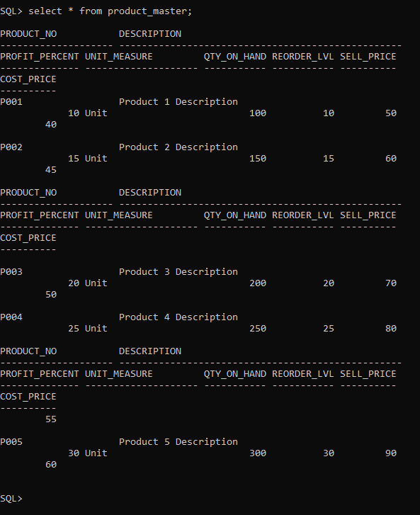

**Q3. On the basis of above two tables answer the following Questionries:**

1. **Find out the names of all the clients.**

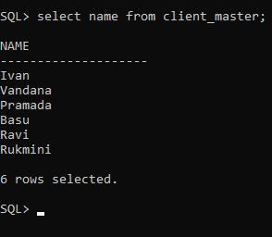

1. **Retrieve the list of names and cities of all the clients.**

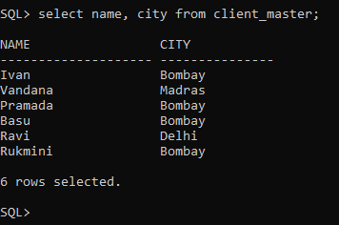

1. **List the various products available from the product_master table.**

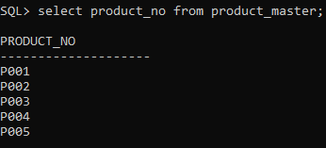

1. **List all the clients who are located in Bombay.**

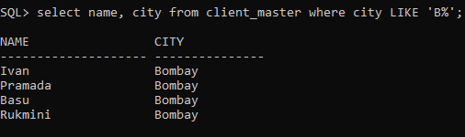

1. **Display the information for client no 0001 and 0002.**

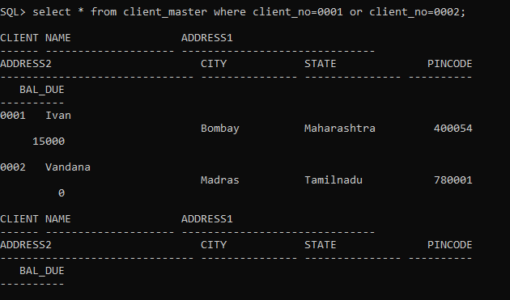

1. **Find the products with description as ‘1.44 drive’ and ‘1.22 Drive’**

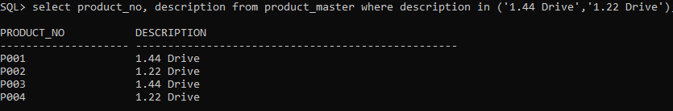

1. **Find all the products whose sell price is greater than 5000.**

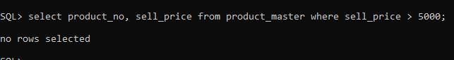

1. **Find the list of all clients who stay in in city ‘Bombay’ or city ‘Delhi’ or ‘Madras’**

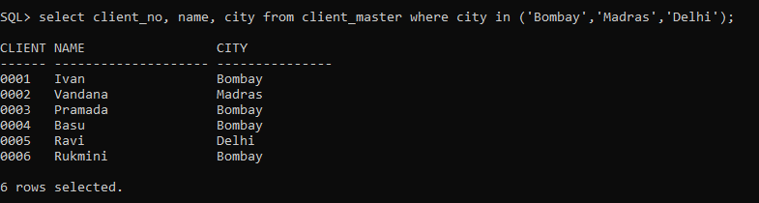

1. **Find the product whose selling price is greater than 2000 and less than or equal to 5000.**

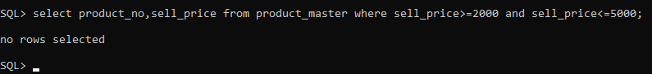

1. **List the name, city and state of clients not in the state of ‘Maharashtra’.**

