**Lab Experiment 6**

**Date: 03/03/2024**

**Name : Harshavardhan Anil Bamane**

**PRN : 22510112**

**Name: Implement queries on Constraints.**

Question 1. Create the following tables:

1. **Sales_master**

|  |  |  |  |
| --- | --- | --- | --- |
| **Columnname** | **Datatype** | **Size** | **Attributes** |
| Salesman_no | varchar2 | 6 | Primary key/first letter |
|  |  |  | must start with ‘s’ |
| Sal_name | varchar2 | 20 | Not null |
| Address | varchar2 |  | Not null |
| City | varchar2 | 20 |  |
| State | varchar2 | 20 |  |
| Pincode | Number | 6 |  |
| Sal_amt | Number | 8,2 | Not null, cannot be 0 |
| Tgt_to_get | Number | 6,2 | Not null, cannot be 0 |
| Ytd_sales | Number | 6,2 | Not null, cannot be 0 |
| Remarks | Varchar2 | 30 |  |

SQL Querry :

CREATE TABLE Sales_master (

Salesman_no VARCHAR2(6) CONSTRAINT pk_salesman_no PRIMARY KEY CHECK (Salesman_no LIKE 's%'),

Sal_name VARCHAR2(20) NOT NULL,

Address VARCHAR2(50) NOT NULL,

City VARCHAR2(20),

State VARCHAR2(20),

Pincode NUMBER(6),

Sal_amt NUMBER(8,2) NOT NULL CHECK (Sal_amt <> 0),

Tgt_to_get NUMBER(6,2) NOT NULL CHECK (Tgt_to_get <> 0),

Ytd_sales NUMBER(6,2) NOT NULL CHECK (Ytd_sales <> 0),

Remarks VARCHAR2(30)

);

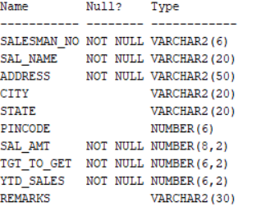

1. **Sales_order**

|  |  |  |  |
| --- | --- | --- | --- |
| **Columnname** | **Datatype** | **Size** | **Attributes** |
|  |  |  |  |
| S_order_no | varchar2 | 6 | Primary/first letter must be 0 |
|  |  |  |  |
| S_order_date | Date | 6 | Primary key reference clientno |
|  |  |  | of client_master table |
|  |  |  |  |
| Client_no | Varchar2 | 25 |  |
| Dely_add | Varchar2 | 6 |  |
|  |  |  |  |
| Salesman_no | Varchar2 | 6 | Foreign key references |
|  |  |  | salesman_no of |
|  |  |  | salesman_master table |
|  |  |  |  |
| Dely_type | Char | 1 | Delivery part(p)/full(f),default f |
|  |  |  |  |
| Billed_yn | Char | 1 |  |
| Dely_date | Date |  | Can not be lessthan |
|  |  |  | s_order_date |
| Order_status | Varchar2 | 10 | Values (‘in |
|  |  |  | process’;’fulfilled’;back |
|  |  |  | order’;’canceled |

**SQL Querry :**

CREATE TABLE Sales_order (

S_order_no VARCHAR2(6) CONSTRAINT pk_s_order_no PRIMARY KEY CHECK (S_order_no LIKE '0%'),

S_order_date DATE,

Client_no VARCHAR2(25),

Dely_add VARCHAR2(6),

Salesman_no VARCHAR2(6),

Dely_type CHAR(1) DEFAULT 'f' CHECK (Dely_type IN ('p', 'f')),

Billed_yn CHAR(1),

Dely_date DATE,

Order_status VARCHAR2(10) CHECK (Order_status IN ('in process', 'fulfilled', 'back-order', 'canceled')),

FOREIGN KEY (Salesman_no) REFERENCES Sales_master(Salesman_no)

);

ALTER TABLE Sales_order

ADD CONSTRAINT chk_dely_date CHECK (Dely_date >= S_order_date);

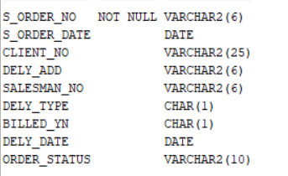

**iii). Sales_order_details**

|  |  |  |  |
| --- | --- | --- | --- |
| **Column** | **Datatype** | **Size** | **Attributes** |
|  |  |  |  |
| S_order_no | Varchar2 | 6 | Primary key/foreign |
|  |  |  | key references |
|  |  |  | s_order_no of |
|  |  |  | sales_order |
| Product_no | Varchar2 | 6 | Primary key/foreign |
|  |  |  | key references |
|  |  |  | product_no of |
|  |  |  | product_master |
| Qty_order | Number | 8 |  |
| Qty_disp | Number | 8 |  |
| Product_rate | Number | 10,2 |  |

**SQL Querry :**

CREATE TABLE Sales_order_details (

S_order_no VARCHAR2(6),

Product_no VARCHAR2(6),

Qty_order NUMBER(8),

Qty_disp NUMBER(8),

Product_rate NUMBER(10,2),

PRIMARY KEY (S_order_no, Product_no),

FOREIGN KEY (S_order_no) REFERENCES Sales_order(S_order_no)

FOREIGN KEY (Product_no) REFERENCES Product_master2(Product_no)

);

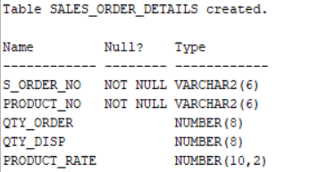

**Data for sales_man master table**

|  |  |  |  |  |  |  |  |  |  |
| --- | --- | --- | --- | --- | --- | --- | --- | --- | --- |
| **Salesman_** | **Salesman** | **Address** | **City** | **Pin** | **State** | **Salamt** | **Tgt_to_get** | **Ytd** | **Rem** |
| **no** | **name** |  |  | **code** |  |  |  | **Sales** |  |
| 500001 | Kiran | A/14 | Bom | 400002 | Mah | 3000 | 100 | 50 | Good |
|  |  | worli | bay |  |  |  |  |  |  |
| 500002 | Manish | 65,narim | Bom | 400001 | Mah | 3000 | 200 | 100 | Good |
|  |  | an | bay |  |  |  |  |  |  |
| 500003 | Ravi | P-7 | Bom | 400032 | Mah | 3000 | 200 | 100 | Good |
|  |  | Bandra | bay |  |  |  |  |  |  |
| 500004 | Ashish | A/5 | Bom | 400044 | Mah | 3500 | 200 | 150 | Good |
|  |  | Juhu | bay |  |  |  |  |  |  |

SQL Querry

INSERT INTO Sales_master (Salesman_no, Sal_name, Address, City, Pincode, State, Sal_amt, Tgt_to_get, Ytd_sales, Remarks)

VALUES ('s00001', 'Kiran', 'A/14 worli', 'Bombay', 400002, 'Mah', 3000, 100, 50, 'Good'),

('s00002', 'Manish', '65, nariman', 'Bombay', 400001, 'Mah', 3000, 200, 100, 'Good'),

('s00003', 'Ravi', 'P-7Bandra', 'Bombay', 400032, 'Mah', 3000, 200, 100, 'Good'),

('s00004', 'Ashish', 'A/5Juhu', 'Bombay', 400044, 'Mah', 3500, 200, 150, 'Good');

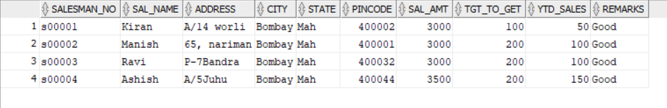

(ii)

**Data for salesorder table:**

|  |  |  |  |  |  |  |  |
| --- | --- | --- | --- | --- | --- | --- | --- |
| S_orderno | S_orderdate | Client no | Dely | Bill | Salesman no | Delay | Orderstatus |
|  |  |  | type | yn |  | date |  |
| 019001 | 12-jan-96 | 0001 | F | N | 50001 | 20-jan- | Ip |
|  |  |  |  |  |  | 96 |  |
| 019002 | 25-jan-96 | 0002 | P | N | 50002 | 27-jan- | C |
|  |  |  |  |  |  | 96 |  |
| 016865 | 18-feb-96 | 0003 | F | Y | 500003 | 20-feb- | F |
|  |  |  |  |  |  | 96 |  |
| 019003 | 03-apr-96 | 0001 | F | Y | 500001 | 07-apr- | F |
|  |  |  |  |  |  | 96 |  |
| 046866 | 20-may-96 | 0004 | P | N | 500002 | 22- | C |
|  |  |  |  |  |  | may-96 |  |
| 010008 | 24-may-96 | 0005 | F | N | 500004 | 26- | Ip |
|  |  |  |  |  |  | may-96 |  |

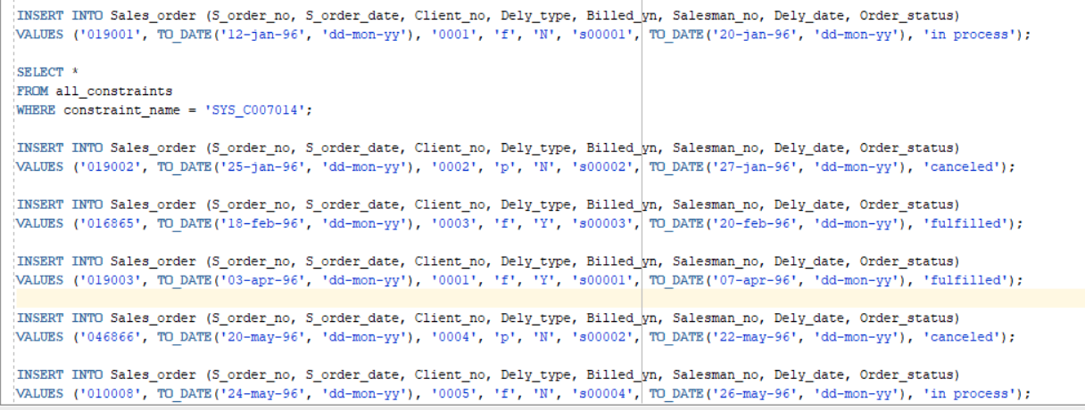

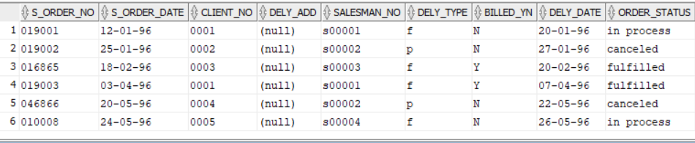

(iii)

**Data for sales_order_details table:**

|  |  |  |  |  |
| --- | --- | --- | --- | --- |
| S_order no | Product no | Qty ordered | Qty disp | Product_rate |
| 019001 | P00001 | 4 | 4 | 525 |
| 019001 | P07965 | 2 | 1 | 8400 |
| 019001 | P07885 | 2 | 1 | 5250 |
| 019002 | P00001 | 10 | 0 | 525 |
| 016865 | P07868 | 3 | 3 | 3150 |
| 016865 | P07885 | 10 | 10 | 5250 |
| 019003 | P00001 | 4 | 4 | 1050 |
| 019003 | P03453 | 2 | 2 | 1050 |
| 046866 | P06734 | 1 | 1 | 12000 |
| 046866 | P07965 | 1 | 0 | 8400 |
| 010008 | P07975 | 1 | 0 | 1050 |
| 010008 | P00001 | 10 | 5 | 525 |

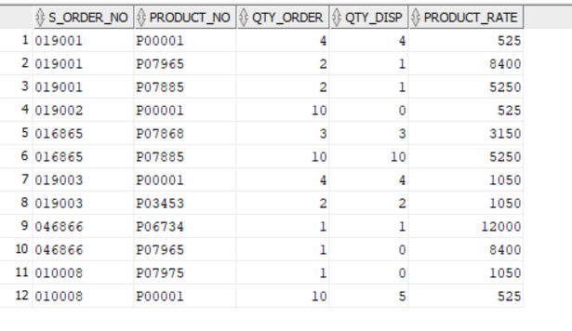

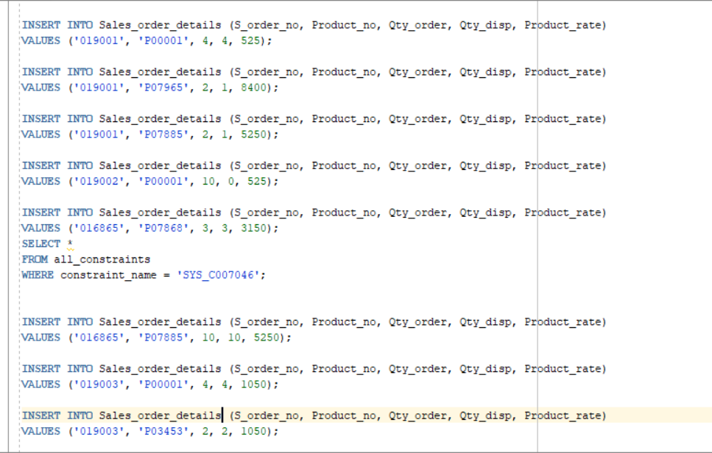

**Challan_Header**

|  |  |  |  |
| --- | --- | --- | --- |
| **Column name** | **data type** | **size** | **Attributes** |
| Challan_no | varchar2 | 6 | Primary key |
| s_order_no | varchar2 | 6 | Foreign key references s_order_no of sales_order table |
| challan_date | date |  | not null |
| billed_yn | char | 1 | values (‘Y’,’N’). Default ‘N’ |

CREATE TABLE Challan_Header (

Challan_no VARCHAR2(6) PRIMARY KEY,

S_order_no VARCHAR2(6),

Challan_date DATE NOT NULL,

Billed_yn CHAR(1) DEFAULT 'N' CHECK (Billed_yn IN ('Y', 'N')),

FOREIGN KEY (S_order_no) REFERENCES Sales_order(S_order_no)

);

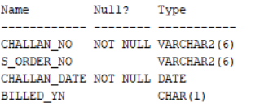

**Table Name : Challan_Details**

|  |  |  |  |
| --- | --- | --- | --- |
| Column name | data type | size | Attributes |
| Challan_no | varchar2 | 6 | Primary key/Foreign key references Product_no of product_master |
| Qty_disp | number | 4,2 | not null |

CREATE TABLE Challan_Details (

Challan_no VARCHAR2(6),

Product_no VARCHAR2(6),

Qty_disp NUMBER(4,2) NOT NULL,

PRIMARY KEY (Challan_no, Product_no),

FOREIGN KEY (Challan_no) REFERENCES Challan_Header(Challan_no),

FOREIGN KEY (Product_no) REFERENCES Product_master2(Product_no)

);

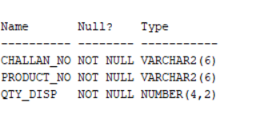

**Q2. Insert the following values into the challan header and challan_details tables:**

|  |  |  |  |
| --- | --- | --- | --- |
| Challan No | S_order No | Challan Date | Billed |
| CH9001 | 019001 | 12-DEC-95 | Y |
| CH865 | 046865 | 12-NOV-95 | Y |
| CH3965 | 010008 | 12-OCT-95 | Y |

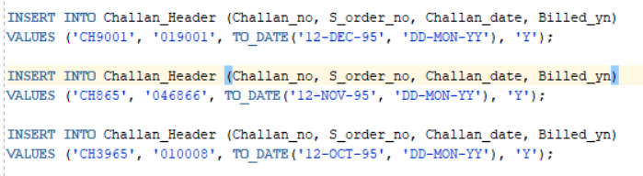

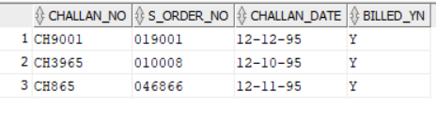

**Data for challan_details table**

|  |  |  |
| --- | --- | --- |
| Challan No | Product No | Qty Disp |
| CH9001 | P00001 | 4 |
| CH9001 | P07965 | 1 |
| CH9001 | P07885 | 1 |
| CH865 | P07868 | 5 |
| CH865 | P03453 | 3 |
| CH865 | P00001 | 4 |
| CH3965 | P07975 | 10 |

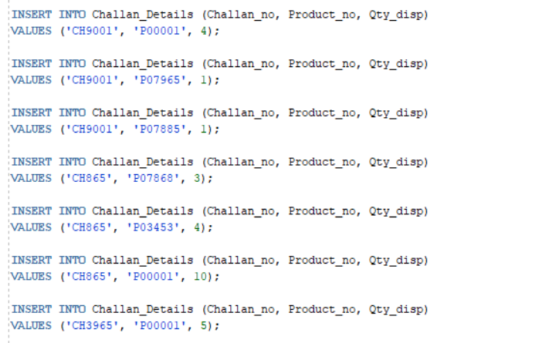

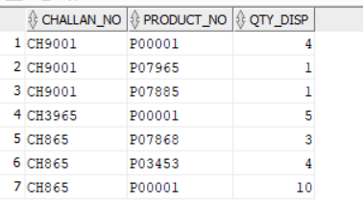

**Answer the following Questionries**

Q1. Make the primary key to client_no in client_master.

Q2. Add a new column phone_no in the client_master table.

Q3. Add the not null constraint in the product_master table with the columns description, profit percent , sell price and cost price.

Q4. Change the size of client_no field in the client_master table.

Q5. Select product_no, description where profit percent is between 20 and 30 both inclusive.